Test of Wired Network Connection Service in Student Hostels
(For Windows Users testing Wired Network)
A. Purpose
This is for testing the Wired Network Connection Services in Student Hostels. The test is conducted to identify the possible reasons of the poor Wired performance, such as:
- Slow speed
- Disconnection
B. Problem report - Please perform the following step for fast checking.
Fill in your personal information | Details
Date & Time:
Student Name and student Id:
Hostel, Room and floor number :
Port label or
Wifi Access Point (AP in-room) if any (may take photo and attach to report)
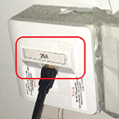 OR 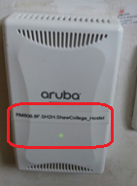
WinOS
Turn on your computer and follow steps below | Expected Screen
- This is to identify network setting:  (please disable wifi connection)  - On the search bar, type cmd  - Then open “Command Prompt”  - When there is a black windows screen opened. Type ipconfig supposing that the IPV4 is 10.0.x.x | 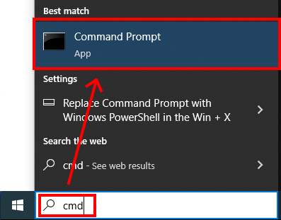  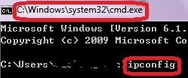

- Perform simple speed test by visiting  - OFCA link of speed test:  http://speedtest.ofca.gov.hk  Please follow the instructions on right and capture the result screen.  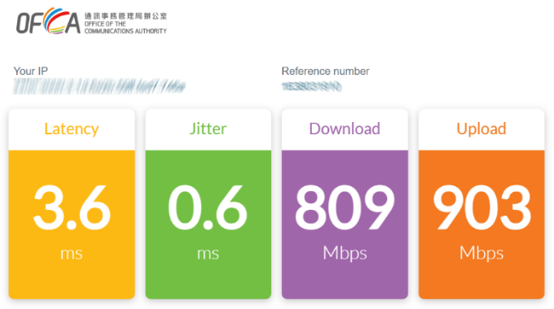 | Check speed step:  - Scroll down until to the bottom  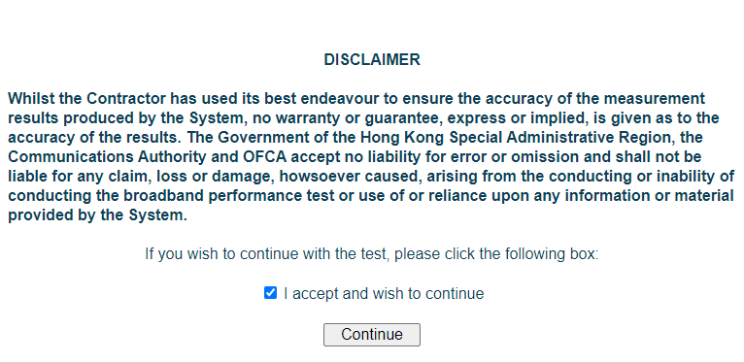  - Check “I accept and wish to continue”. Then click “Continue” button  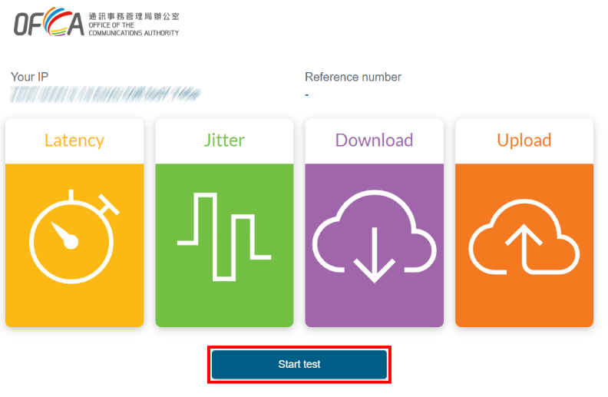  - Press “Press to Begin Test” button for start the test  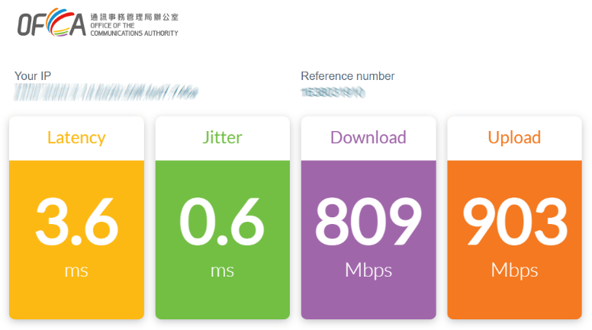
C. Submit this report
- Save this file and name it with “Hostel-Name-Wired-testdate-room-number”
- Complete the information listed in “C. Problem report”
- Write to ITSC Service Desk at https://servicedesk.itsc.cuhk.edu.hk/
  - Use “Hostel Wired Connection Report” as the Problem/Request Subject
  - Submit the above Word document
- For any enquiries, please contact the ITSC Service Desk listed above.
End
Thank you for your cooperation!
Remember to turn your notebook’s Wi-Fi back on!

