Test of Wired Network Connection Service in Student Hostels
(For MacOS Users testing Wired Network)
A. Purpose
This is for testing the Wired Network Connection Services in Student Hostels. The test is conducted to identify the possible reasons of the poor Wired performance, such as:
- Slow speed
- Disconnection
B. Quick test - Please perform the following steps for fast checking.
Fill in your personal information | Details
Date & Time:
Student Name and student Id:
Hostel, Room and floor number :
Port label - Port number (Take picture of your setup such as in below)
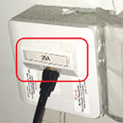 OR 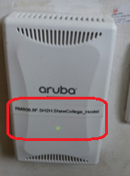
Shutdown and turn on your computer and follow steps below | Expected Screen
- Click MacOS and get the OS version | 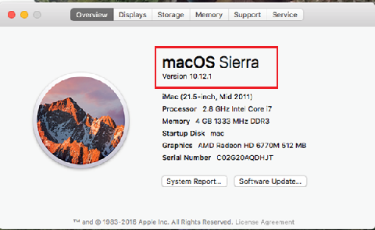
- Disable Wi-Fi adaptor  Some laptops have an On/Off button or a switch for the Wi-Fi connection, like the button shown in the picture.  It is usually on the front edge of the laptop or just above the keyboard. Find the button or the switch and make sure it is disabled. | 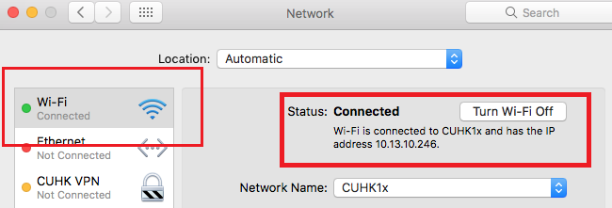
- Capture the screen of Network Connection Status  - Click Network -> Advance -> TCPIP  - Capture the screen of Network Connection  supposing that the IPV4 is 10.0.x.x | 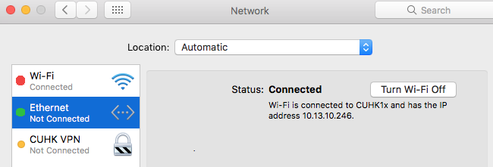
- Perform simple speed test by visiting  - OFCA link of speed test:  http://speedtest.ofca.gov.hk  Please follow the instructions on right. And capture the result screen.  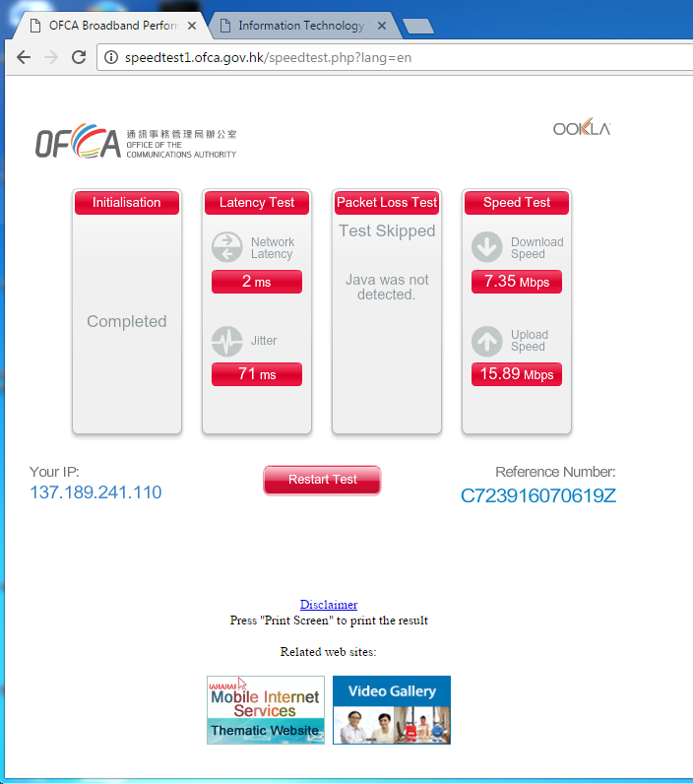 | Check speed step:  - Scroll down until to the bottom  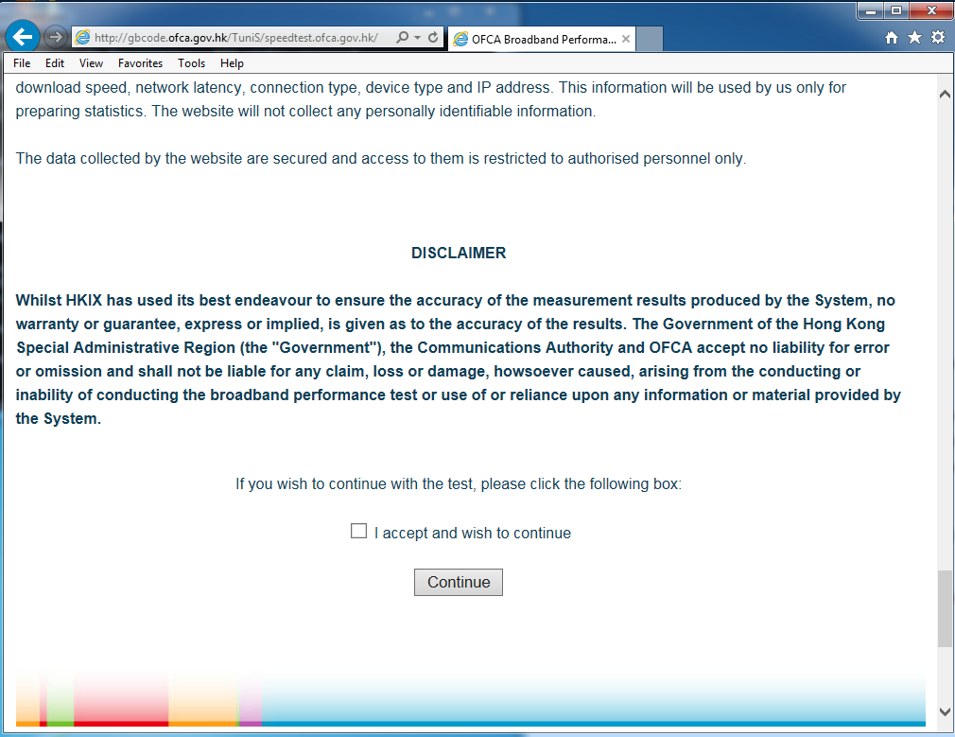  - Check “I accept and wish to continue”. Then click “Continue” button  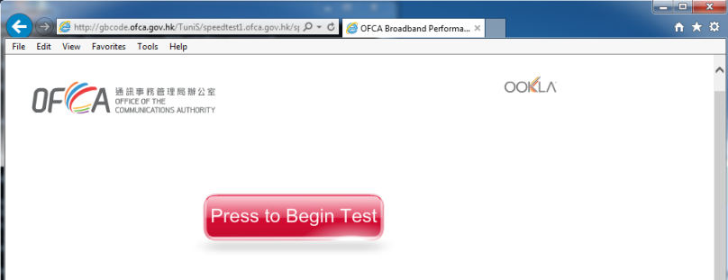  - Press “Press to Begin Test” button for start the test. The result should like this.

C. Submit your Problem report
- Save this file and name it with “Hostel-Name-Wired-testdate-room-number”
- Complete the information listed in “C. Problem report”
- Write to ITSC Service Desk at https://servicedesk.itsc.cuhk.edu.hk/
  - Use “Hostel Wired Connection Report” as the Problem/Request Subject
  - Submit the above Word document

End
Thank you for your cooperation!
Remember to turn your notebook’s Wi-Fi back on!

