Speed Test in Student Hostels
(For Windows Users testing Wi-Fi Network)

A. Purpose
The test is to identify the possible reasons of poor wi-fi performance in student hostels, such as:
- Weak WiFi signal, Slow speed
- Frequent disconnection

B. Problem report
Fill in your personal information | Details
Date/Time:
Student Name and student Id:
Hostel, Room and floor number :
Label of WiFi Access Point (Take picture of your setup such as in below)
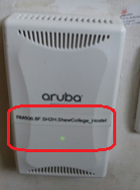
SSID connected (CUHK, CUHK1x or Eduroam/CSL/Y5ZONE):
Turn on your computer and follow steps below | Expected Screen
- Step 1 & 5 are to identify network setting:  - On the search bar, type cmd  - Then open “Command Prompt”  - When there is a black windows screen opened. Type ipconfig  supposing that the IPV4 is 10.0.x.x | 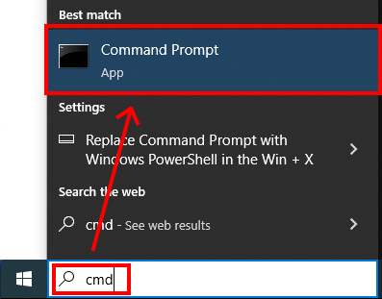  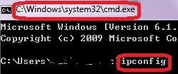

- Perform simple speed test by visiting  - OFCA link of speed test:  http://speedtest.ofca.gov.hk  Please follow the instructions on right and capture the result screen.  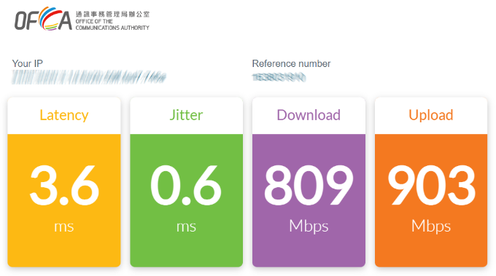 | Check speed step:  - Scroll down until to the bottom  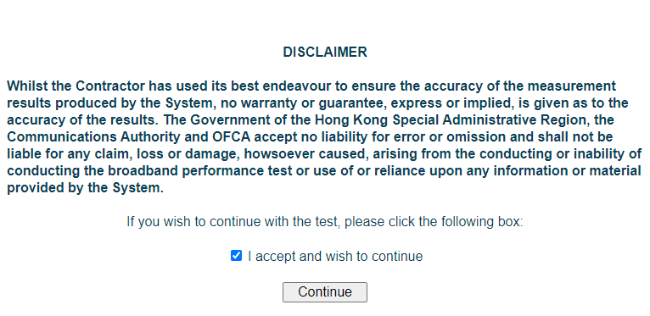  - Check “I accept and wish to continue”. Then click “Continue” button  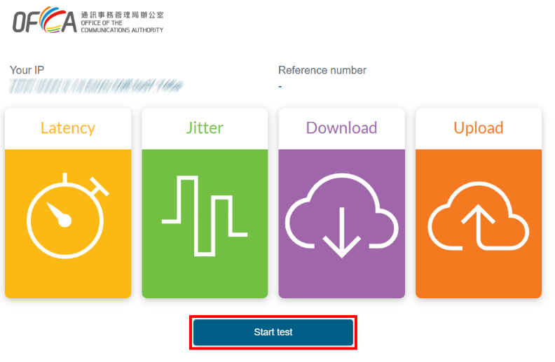  - Press “Press to Begin Test” button for start the test  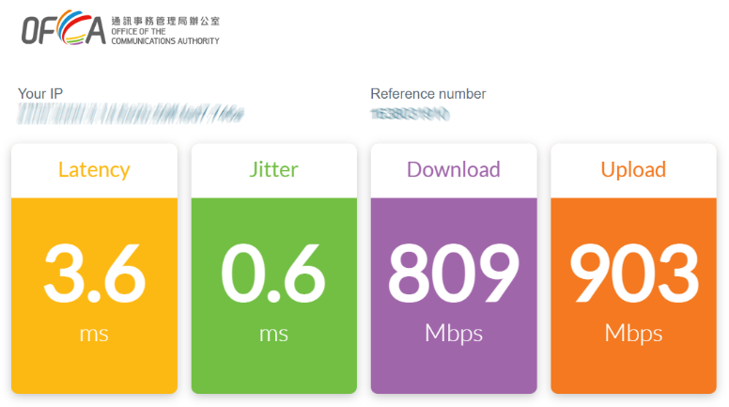
- Count the number of Wi-Fi users if possible | The number of Wi-Fi in the same location

C. Submit your Problem report
- Save this file and name it with “Hostel-Name-Wi-Fi-testdate-room-number”
- Complete the information listed in “B. Problem report”
- Write to ITSC Service Desk at https://servicedesk.itsc.cuhk.edu.hk/
  - Use “Hostel Wi-Fi Report” as the Problem/Request Subject
  - Submit the above Word document

End
Thank you for your cooperation!

