Speed Test in Student Hostels
(For Mac OS Users testing Wi-Fi Network)

A. Purpose
The test is to identify the possible reasons of poor wi-fi performance in student hostels, such as:
- Weak WiFi signal, Slow speed
- Frequent disconnection

B. Problem report
Fill in your personal information | Details
Date & Time:
Student Name and student Id:
Hostel, Room and floor number :
Label of WiFi Access Point (Take picture of your setup such as in below)
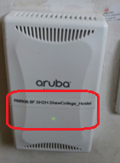

SSID connected 9 CUHK, CUHK1x or Eduroam/CSL/Y5ZONE)

Shutdown and turn on your computer and follow steps below | Expected Screen
- Click MacOS and get the OS version | 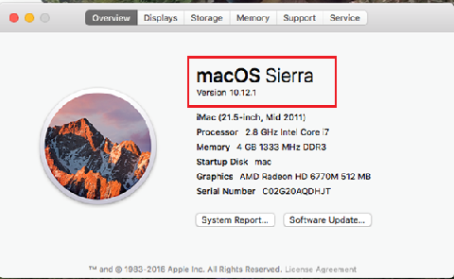
- Step 2 & 3 are to identify network setting:  Type System Preference -> Network  - Wi-Fi -> CUHK / CUHK1x  - supposing that the IP is 10.0.x.x  Click on the network name (SSID)  - Capture the screen of all detected Wi-Fi signals at the moment  - Right click on the SSID you connected, e.g. CUHK, and choose Status. | 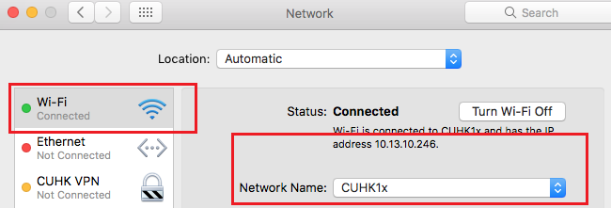
- Perform simple speed test by visiting  - OFCA link of speed test:  http://speedtest.ofca.gov.hk  Please follow the instructions on right. And capture the result screen as below.  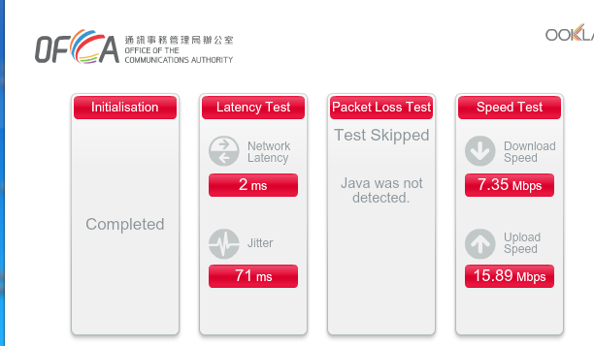 | Check speed step:  - Scroll down until to the bottom  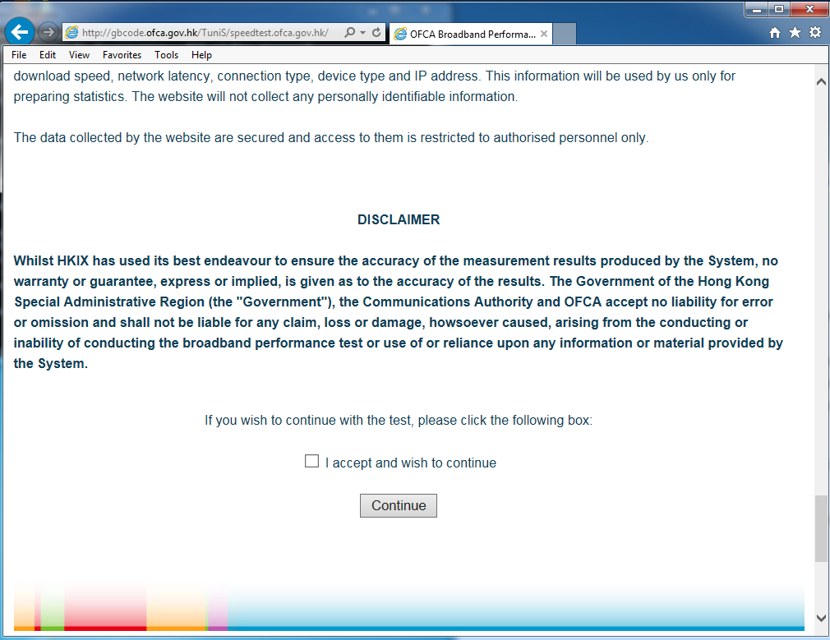  - Check “I accept and wish to continue”. Then click “Continue” button  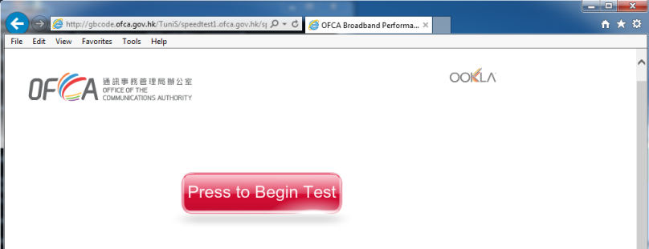  - Press “Press to Begin Test” button for start the test. and copy the screen here.
- Count the number of Wi-Fi users if possible

D. Submit your Problem report
- Save this file and name it with “Hostel-Name-Wi-Fi-testdate-room-number”
- Complete the information listed in “B. Problem report”
- Write to ITSC Service Desk at https://servicedesk.itsc.cuhk.edu.hk/
  - Use “Hostel Wi-Fi Report” as the Problem/Request Subject
  - Submit the above Word document
End
Thank you for your cooperation!

