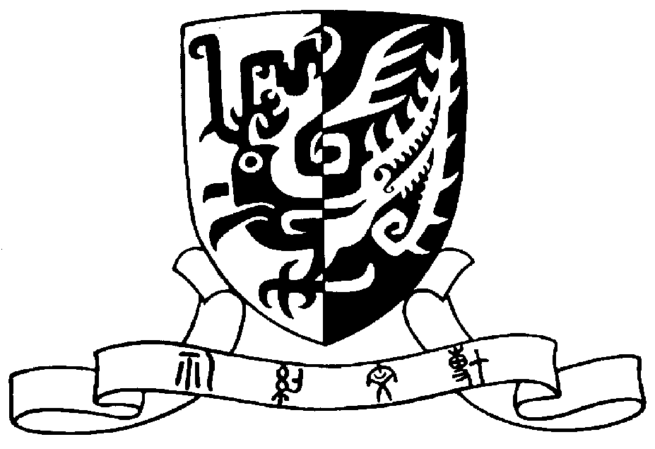
The Chinese University of Hong Kong

CUHK Research Summit Series
Request for Amendment

This form is to be used where an amendment to a Research Summit Series grant is requested. Please complete this form and return it to the Office of Academic Links (oal_schemes@cuhk.edu.hk).

Title (Mr./Ms./Dr./Prof.) & Name of awardee
Department/Unit/Faculty
Contact details | Email: | Phone:
Project code
Year awarded
Fund received
Workshop name
Request  [Please tick the appropriate box(es) and provide details.] | Revise workshop period  - Original workshop dates:  - New workshop dates (If the exact dates have not been confirmed, please indicate the tentative month and year):
Revise workshop name

- New workshop name:
Revise budget *Please submit this form together with a revised budget.
- Please specify details:
 | Others (Please specify):
Reason for amendment
Signature of awardee | I hereby confirm all of the above information is true.  Date:
For use by the Office of Academic Links
Approved Not Approved

Signature:
Name:
Date:

