CENG4480 Embedded System Development and Applications
Computer Science and Engineering Department
The Chinese University of Hong Kong
Lab manual: Laboratory 1: Op Amp
Introduction
This lab session introduces some very basic concepts of operational amplifier “ op amp” that every engineering student should know about. The op amp IC used in this lab is LM324 which contains 4 op amps modules; we only use one of them in this exercise.
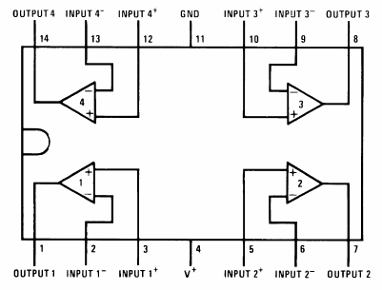
Figure 1. Pinout for the LM324.
Objectives
By completing this lab session, you should know:
1. how to use op amp circuits to interface between sensors and MCU;
2. how to design amplifier circuit using op amp and
3. how to design integrator and differentiator circuit using an op amp.
Procedures and what to submit:
Follow the procedures of each experiment. Submit a lab report sheet with your name and student ID, to the tutor after the lab. The lab report sheet should have the measurements or plots of your experiments, and answers of the questions asked in this lab manual. You may prepare the report using a computer document and use a camera to capture the waveforms and insert them in your report.
Experiment 1. Inverting Amplifier
In this experiment, you will construct and observe the inverting amplifier. Record the input and output waveforms.
The following apparatus will be provided:
1. a power supply
2. an oscilloscope
3. a breadboard
4. resistors: 2 x 1 KΩ, 1 x 2 KΩ
5. one LM324 IC

Experimental Procedures:
- Use pinout diagram for LM324 op amp IC shown in Figure 1 to construct the inverting amplifier circuit as shown in Figure 2.

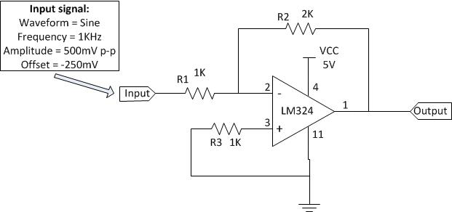
Figure 2. Inverting amplifier

- Configure the waveform generator on the oscilloscope with following settings:
Waveform = Sine
Frequency = 1KHz
Amplitude = 500mV p-p
Offset = -250mV

- Connect the waveform generator output to the input of inverting amplifier.

- Connect channel 1 input (X) of the oscilloscope to the output of inverting amplifier and connect channel 2 (Y) input of the oscilloscope to the input of inverting amplifier.

- In your lab report sheet record:
  - Record the input and output waveforms displayed on the oscilloscope.
  - Record the peak-to-peak voltage of the output.
  - Give your derivation of the input output relation of the amplifier, and comment if the measured output voltage agrees with the theoretical predication.
  - Why this amplifier is called an inverting amplifier?
  - Discuss an application of this circuit.

Experiment 2. Non-inverting Amplifier
In this experiment, you will construct and observe the non-inverting amplifier. Record the input and output waveforms.
The following apparatus will be provided:
1. a power supply
2. an oscilloscope
3. a breadboard
4. resistors: 1 x 1 KΩ, 1 x 2 KΩ
5. one LM324 IC

Procedures:
- Use pinout diagram for LM324 op amp IC shown in Figure 1 to construct the non-inverting amplifier circuit as shown in Figure 3.

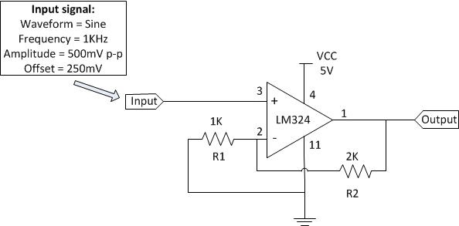
Figure 3. Non-inverting amplifier

- Configure the waveform generator on the oscilloscope with following settings:
Waveform = Sine
Frequency = 1KHz
Amplitude = 500mV p-p
Offset = 250mV

- Connect the waveform generator output to the input of non-inverting amplifier.

- Connect channel 1 input (X) of the oscilloscope to the output of non-inverting amplifier and connect channel 2 (Y) input of the oscilloscope to the input of non-inverting amplifier.

- In your lab report sheet:

  - Record the input and output waveforms displayed on the oscilloscope.
  - Give your derivation of the input output relation of the amplifier, and comment if the measured output voltage agrees with the theoretical predication. That means use your measured data to verify the equation$$\frac{Vo}{Vin}≈1+\frac{R2}{R1}$$
  - Why this amplifier is called a non-inverting amplifier?
  - Discuss an application of this circuit.

Experiment 3. Differential Amplifier
In this experiment, you will construct and observe the differential amplifier. Record the input and output waveforms.
The following apparatus will be provided:
1. a power supply
2. an oscilloscope
3. a breadboard
4. resistors: 2 x 1 KΩ, 2 x 2 KΩ
5. one LM324 IC

Procedures:
- Use pinout diagram for LM324 op amp IC shown in Figure 1 to construct the differential amplifier circuit as shown in Figure 4.

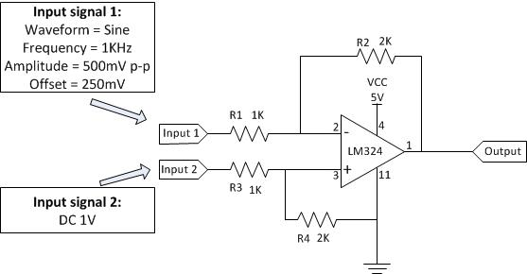
Figure 4. Differential amplifier

- Configure the waveform generator on the oscilloscope with following settings:
Waveform = Sine
Frequency = 1KHz
Amplitude = 500mV p-p
Offset = 250mV

- Connect the waveform generator output to the input 1 of differential amplifier.

- Connect 1 V dc from power supply to the input 2 of differential amplifier.

- Connect channel 1 input (X) of the oscilloscope to the output of differential amplifier and connect channel 2 (Y) input of the oscilloscope to the input 1 of differential amplifier.

- In your lab report sheet:

  - Record the input and output waveforms displayed on the oscilloscope.
  - Give your derivation of the input output relation of the amplifier, and comment if the measured output voltage agrees with the theoretical predication.
  - Why this amplifier is called a differential amplifier?
  - Discuss an application of this circuit.

Experiment 4. Voltage follower
In this experiment, you will construct and observe the voltage follower. Record the input and output waveforms.
The following apparatus will be provided:
1. a power supply
2. an oscilloscope
3. a breadboard
4. resistors: 1 x 2 KΩ
5. one LM324 IC

Procedures:
- Use pinout diagram for LM324 op amp IC shown in Figure 1 to construct the voltage follower circuit as shown in Figure 5.
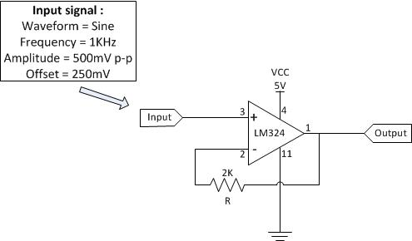

Figure 5. Voltage follower

- Configure the waveform generator on the oscilloscope with following settings:
Waveform = Sine
Frequency = 1KHz
Amplitude = 500mV p-p
Offset = 250mV

- Connect the waveform generator output to the input of voltage follower.

- Connect channel 1 input (X) of the oscilloscope to the output of voltage follower and connect channel 2 (Y) input of the oscilloscope to the input of voltage follower.

- In your lab report sheet:

  - Record the input and output waveforms displayed on the oscilloscope.
  - Give your derivation of the input output relation of the amplifier, and comment if the measured output voltage agrees with the theoretical predication.
  - Why this amplifier is called a voltage follower?
  - Discuss an application of this circuit.

Experiment 5. Current to voltage converter
In this experiment, you will construct and observe the current to voltage converter. Measure the output voltages of the current to voltage converter under different lighting conditions.
The following apparatus will be provided:
1. a power supply
2. an oscilloscope
3. a breadboard
4. resistors: 1 x 10MΩ
5. an LDR (Light Dependent Resistor)
6. one LM324 IC

Procedures:
- Use pinout diagram for LM324 op amp IC shown in Figure 1 to construct the current to voltage converter circuit as shown in Figure 6.
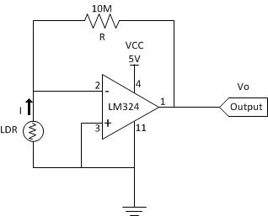
Figure 6. Current to voltage converter

- Connect channel 1 input (X) of the oscilloscope to the output of current to voltage converter.

- Measure the output voltage of current to voltage converter under room lighting condition.

- Measure the output voltage of current to voltage converter to create a without lighting condition (cover the LDR with your hand).

- In your lab report sheet:

  - Record the output voltage of current to voltage converter under room lighting condition.

  - Record the output voltage of current to voltage converter under no light condition (cover the LDR with your hand).

  - Use your measured data to verify the equation Vo = -IR (Hint: the resistance of LDR rise when it is covered)

  - Discuss an application of this circuit.
Experiment 6. Summing amplifier
In this experiment, you will construct and observe the summing amplifier. Record the input and output waveforms.
The following apparatus will be provided:
1. a power supply
2. an oscilloscope
3. a breadboard
4. resistors: 3 x 1KΩ
5. one LM324 IC

Procedures:
- Use pinout diagram for LM324 op amp IC shown in Figure 1 to construct the summing amplifier circuit as shown in Figure 7.

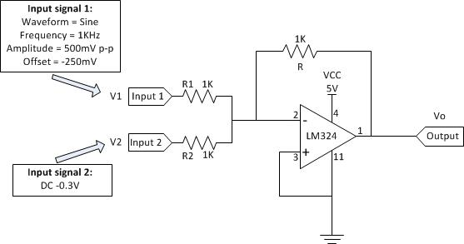
Figure 7. Summing amplifier

- Configure the waveform generator on the oscilloscope with following settings:
Waveform = Sine
Frequency = 1KHz
Amplitude = 500mV p-p
Offset = -250mV

- Connect the waveform generator output to the input 1 of summing amplifier.

- Connect -0.3 V dc from power supply (positive connect to GND, negative as the supply output) to the input 2 of summing amplifier.

- Connect channel 1 input (X) of the oscilloscope to the output of summing amplifier and connect channel 2 (Y) input of the oscilloscope to the input 1 of summing amplifier.
- In your lab report sheet:

  - Record the input and output waveforms displayed on the oscilloscope.
  - Give your derivation of the input output relation of the amplifier, and comment if the measured output voltage agrees with the theoretical predication. That means use your measured data to verify the equation$$Vo=-\left\{\frac{V1}{R1}\right.+\left.\frac{V2}{R2}\right\}R$$
  - Why this amplifier is called a summing amplifier?
  - Discuss an application of this circuit.
Experiment 7. Op amp LM324 slew rate measurement
In this experiment, you will construct the inverting amplifier and measure the slew rate of op amp LM324.
The following apparatus will be provided:
1. a power supply
2. an oscilloscope
3. a breadboard
4. resistors: 2 x 1KΩ
5. one LM324 IC
Procedures:
- Use pinout diagram for LM324 op amp IC shown in Figure 1 to construct the inverting amplifier circuit as shown in Figure 8.

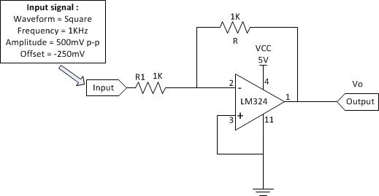
Figure 8. Inverting amplifier for slew rate measurement

- Configure the waveform generator on the oscilloscope with following settings:
Waveform = Square
Frequency = 1KHz
Amplitude = 500mV p-p
Offset = -250mV

- Connect the waveform generator output to the input of inverting amplifier.

- Connect channel 1 input (X) of the oscilloscope to the output of inverting amplifier and use Cursor measurement on the oscilloscope to measure ∆y and ∆x of the rising edge of the output waveform.

- In your lab report sheet:

  - Plot the output voltage and

  - Calculate the Slew rate = $\frac{∆y}{∆x}$ (V/µs).

  - Discuss why we need to know the slew rate of a circuit.

Experiment 8. Integrator
In this experiment, you will construct the integrator and record the output waveform.
The following apparatus will be provided:
1. a power supply
2. an oscilloscope
3. a breadboard
4. resistors: 2 x 1KΩ
5. capacitor: 1 x 0.1uF
6. one LM324 IC
Procedures:
- Use pinout diagram for LM324 op amp IC shown in Figure 1 to construct the integrator circuit as shown in Figure 9.
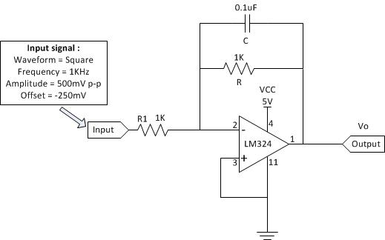
Figure 9. Integrator
- Configure the waveform generator on the oscilloscope with following settings:
Waveform = Square
Frequency = 1KHz
Amplitude = 500mV p-p
Offset = -250mV

- Connect the waveform generator output to the input of integrator.

- Connect channel 1 input (X) of the oscilloscope to the output of integrator and connect channel 2 (Y) input of the oscilloscope to the input of integrator.

- Record the input and output waveforms displayed on the oscilloscope.

- In your lab report sheet:
  - Plot the input and output voltages.
  - Discuss one application of this circuit.
Experiment 9. Differentiator
In this experiment, you will construct the differentiator and record the output waveform.
The following apparatus will be provided:
1. a power supply
2. an oscilloscope
3. a breadboard
4. resistors: 2 x 1KΩ
5. capacitor: 1 x 0.01uF
6. one LM324 IC

Procedures:
- Use pinout diagram for LM324 op amp IC shown in Figure 1 to construct the differentiator circuit as shown in Figure 10.
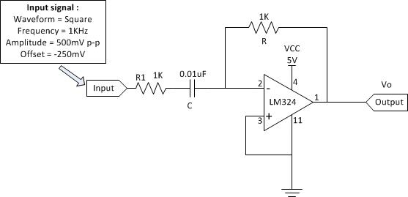
Figure 10. Differentiator
- Configure the waveform generator on the oscilloscope with following settings:
Waveform = Square
Frequency = 1KHz
Amplitude = 500mV p-p
Offset = -250mV

- Connect the waveform generator output to the input of differentiator.

- Connect channel 1 input (X) of the oscilloscope to the output of differentiator and connect channel 2 (Y) input of the oscilloscope to the input of differentiator.

- Record the input and output waveforms displayed on the oscilloscope.

- In your lab report sheet:

- Plot the input and output voltages.
- Discuss one application of this circuit.

END

