The 4th Forum on
Environmental Remote Sensing for Pearl River Delta Region
The Chinese University of Hong Kong 24-25 February, 2012
Registration Form
PART I: Personal Information
Title |  | ◻ Prof. ◻ Dr. ◻ Mr. ◻ Ms. ◻ Mrs.
Name(English) |  |  |  |  | Name(Chinese)
Position |  |  |  |  | Department
Organization/ Affiliation
Address
Postal Code |  |  |  |  | Country
Tel No. |  |  |  |  | Mobile No.
Email Address
PART II: Information of Your Paper (if applicable)
Title of Your Paper  (Paper Code) |  |  | ( )
PART III: Registration Fee
□ | Pre-Registration HK$800 (≈US$100) [Pre-registration Deadline: 15 January 2012]  [Please fill the following information and return the registration form on or before 15 January, 2012]
For PRE-REGISTRATION, please choose either one of the following payment types:
- by Crossed Cheque (Cheque No: __________)
[Please make the crossed cheque payable to “The Chinese University of Hong Kong” and return the crossed cheque together with the registration form]
- by Credit Card
[Please fax the registration form with cardholder signature to (852) 2603 7470 OR
return the original copy with cardholder signature]
Card Type | ◻ Visa ◻ Master | Cardholder Name
Card Number |  | Expiry Date
Total Amount | HK$ | Cardholder Signature

□ | Onsite and late-Registration HK$1200 (≈US$150)  [Only HK Dollar CASH will be accepted for onsite registration; no exchange of currency can be provided onsite]
□ | Student HK$500 (≈US$65)  [Please submit copy of your student card together with the registration form]
PART IV: Invitation Letter
□ | A formal invitation letter is required to apply for the visa to Hong Kong.  (it will be sent to the mailing address provided in Part I; if the invitation letter in Chinese is required, please provide your name and organization in Chinese)
□ | No invitation letter is required, thanks.
PART V: Accommodation Reservation
Note:
Participants are advised to make their reservations at the earliest convenience before 15 January 2011.
Rooms will be offered upon availability after this date. All room reservations are first-come-first-served ONLY.
□ | Yes, I would like to make room reservation (please complete the following information)
□ | No, I will make my own hotel arrangement
OPTION 1: UNIVERSITY GUEST HOUSE
Location: Chan Kwan Tung Building, The Chinese University of Hong Kong, Shatin, Hong Kong
Website: http://www.cuhk.edu.hk/ugh/ Tel: 2603 6411

Room Type
□ Twin Room (HK$550* per room per night including TWO buffet breakfasts)
* All the above rates are subject to 10% service charge and prevailing government tax (if applicable).

Reservation Information
Check-in Date  (at 1pm or after) |  |  | Check-out Date  (before 12noon)
Name for Check-in | Prof/ Dr/ Mr/ Ms/ Mrs | (Last Name) |  |  | (First Name)
Roommate Name  (if applicable) | Prof/ Dr/ Mr/ Ms/ Mrs | (Last Name) |  |  | (First Name)
Address
Telephone Number | (office) |  |  | (mobile)
Email Address

OPTION 2: REGAL RIVERSIDE HOTEL
Address: 34-36 Tai Chung Kiu Road, Shatin, Hong Kong
Telephone: (852) 2649 7878 Fax: (852) 2637 4748
Email: rrh.info@regalhotel.com
Room Type
□ Queen Size Bed □ Twin Beds □ Smoking □ Non-Smoking
Rate & Breakfast
□ HK$650* per room per night (Room only)
□ HK$750* per room per night (Room rate including ONE buffet breakfast)
□ HK$850* per room per night (Room rate including TWO buffet breakfasts)
* All the above rates are subject to 10% service charge and prevailing government tax (if applicable).

Reservation Information
Check-in Date  (at 2pm or afte | ) |  |  |  | Check-out Date  (before 12noon)
Name for Check-in: | Prof/ Dr/ Mr/ Ms/ Mrs | (Last Name) |  |  | (First Name)
Roommate Name  (if applicable) | Prof/ Dr/ Mr/ Ms/ Mrs | (Last Name) |  |  | (First Name)
Address
Telephone Number | (office) |  |  | (mobile)
Email Address

ACCOMMODATION RESERVATION GUARANTEE (Required)_
Credit card information and cardholder signature must be required for accommodation reservation.
NO booking will be made if incompleted or no credit card information and cardholder signature are provided.

Please note that the following credit card information is required for RESERVATION purpose ONLY, but NOT for deducting the room rental directly from the credit card provided. You are required to pay the room charge when you check in onsite.

Booking Guaranteed By |  | ◻ Visa ◻ Master
Cardholder Name |  | Card Number
Expiry Date |  | Cardholder Signature
Important Note:
If any cancellation is made after 15 January 2011, one night room rental with service charge and government tax (if applicable) will be charged and the hotel is reserved the right for deducting this one night room rental with service charge and government tax (if applicable) from the credit card provided without any notification.

PLEASE RETURN THIS REGISTRATION FORM TO:
Dr. Matthew Pang
Institute of Space and Earth Information Science
Fok Ying Tung Remote Sensing Science Building,
The Chinese University of Hong Kong, Shatin, Hong Kong
Tel: (852) 31634195 Fax: (852) 26037470 Email: pangyc@cuhk.edu.hk

A registration and hotel booking confirmation will be sent to your email address after the pre-registration deadline.
Pre-registration Deadline: 15 January, 2012
Location of University Guest House

Location: Chan Kwan Tung Building, The Chinese University of Hong Kong, Shatin, Hong Kong
Website: http://www.cuhk.edu.hk/ugh/guesthouse/acc.html Tel: 2603 6411

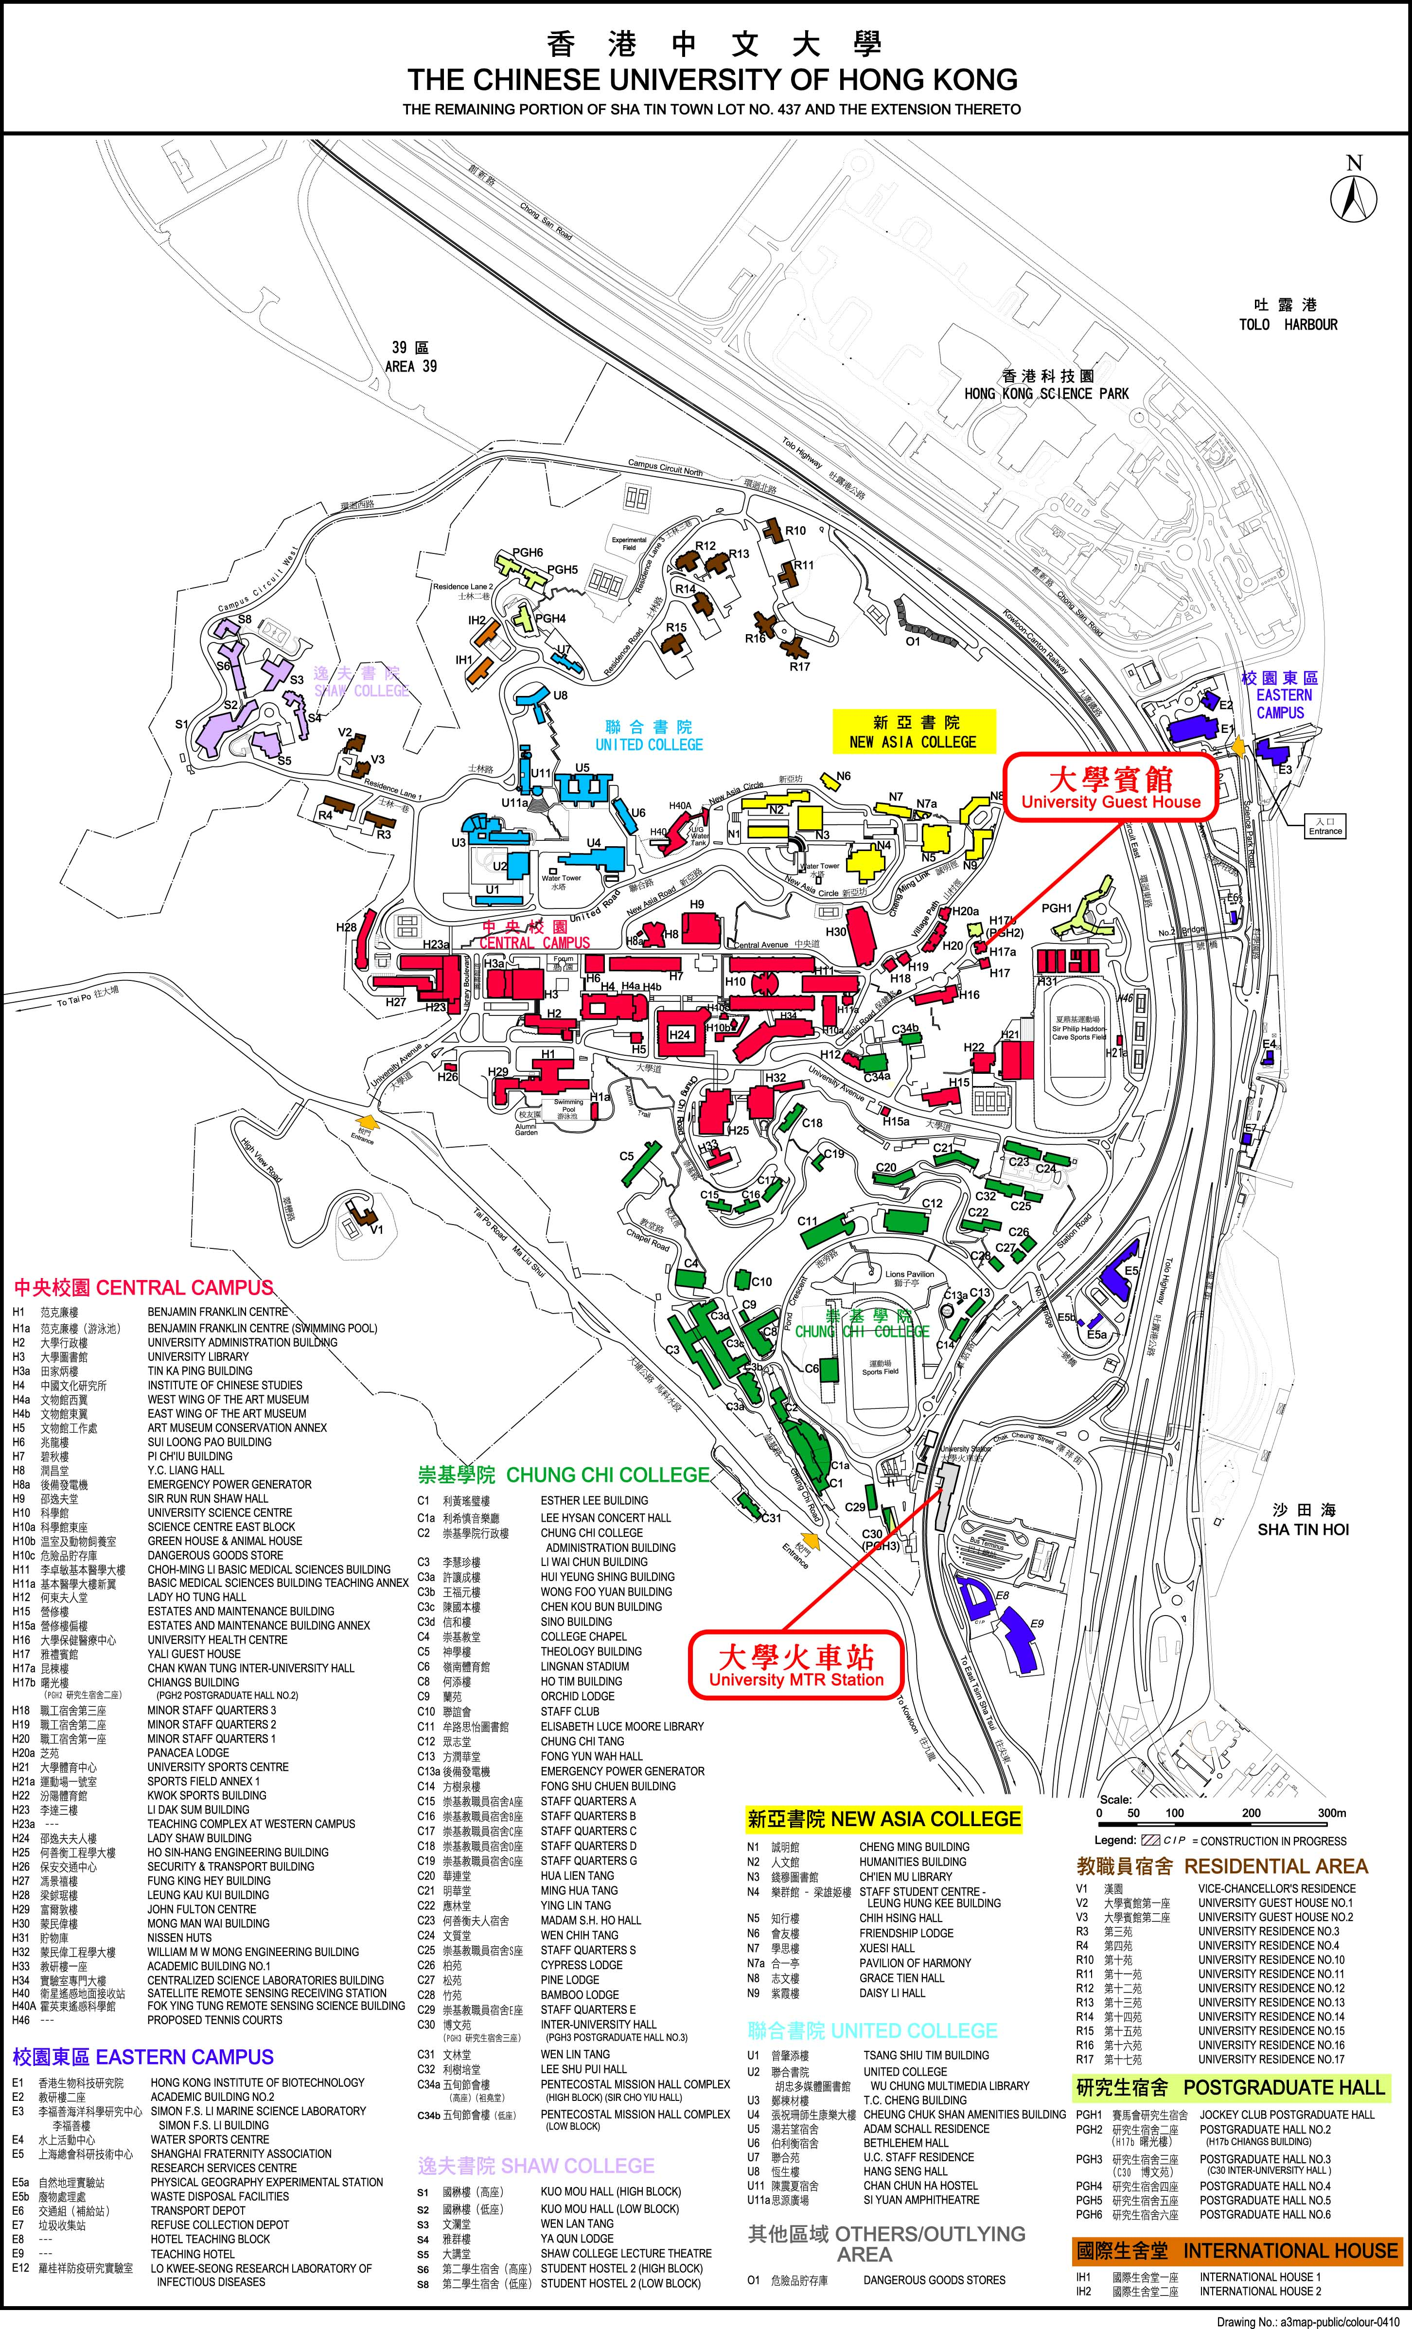

Location of Regal Riverside Hotel
Address: 34-36 Tai Chung Kiu Road, Shatin, Hong Kong
Telephone: (852) 2649 7878 Fax: (852) 2637 4748

