ECLT5820 –Distributed and Mobile Systems
Topic 8: Fault Tolerance

Consider the following transaction log from the start of the run of a database system that is capable of running undo/redo logging with checkpointing:

1) <T1 Start>
2) <T1, A, 45, 10>
3) <T2 Start>
4) <T2, B, 5, 15>
5) <T2, C, 35, 10>
6) <T1, D, 15, 5>
7) <T1 Commit>
8) <T3 Start>
9) <T3, A, 10, 15>
10) <BEGIN CHKPT (T2, T3)>
11) <T2, D, 5, 20>
12) <T2 Commit>
13) <END CHKPT>
14) <T4 Start>
15) <T4, D, 20, 30>
16) <T3, C, 10, 15>
17) <T3 Commit>
18) <T4 Commit>

Assume the log entries are in the format
<Tid, Variable, Old value, New value>

1) What is the value of the data items A, B, C, and D on disk after recovery:
a) if the system crashes just before line 6 is written to disk?
b) if the system crashes just before line 10 is written to disk?
c) if the system crashes just before line 12 is written to disk?
d) if the system crashes just before line 13 is written to disk?
e) if the system crashes just before line 16 is written to disk?
f) if the system crashes just before line 18 is written to disk?

2) Does the checkpointing have any effect on the value of the data items?
If yes, please explain how would the values be different if the checkpointing is removed. If no, then what is the purpose of the checkpointing.

(1)
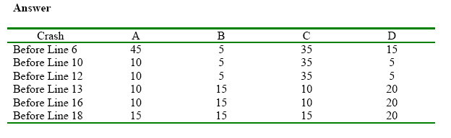
(2) The checkpointing does not have any effect on the value of the data items.

Checkpointing is for shortening the time for recovery. It avoids the system from looking at the entire log as we know that all transactions prior to a recorded checkpoint have committed and they do not need be undone.

