**Dream Big**

**By**

**Ho Pok Jing**

*Open my eyes; it was only just a dream.* I am usually not into hip-hop, but the lyrics here are a spot-on description of what I dreaded before leaving Hong Kong. They say going on exchange is like a dream. You can make some sense out of it, but at the end it is nothing more than a giant colourful bubble. It can be a wonder to behold, what with all the uncertainties and surprises ahead of the journey. Oh, do go abroad and revel in the new-found excitement. Before you know it, your student visa is expiring and the OAL sent you an end-of-year questionnaire on exchange experience. *Poof*. The bubble bursts and off you go.

I never wanted to be just a dream. My bubble, if there was ever any, did not go *poof*. On my arrival at Heathrow, I knew the whole experience would mean something. For that I counted myself extremely lucky. There I was, after a 13-hour plane ride, dragging a 30kg luggage stuffed with clothes I would not be wearing. I barely made it to the coach, randomly picked a seat and was going to sleep through the journey. Then a young blonde chap boarded the bus and politely asked if he could sit next to me. Little did I know that this 18-year-old Norwegian had all the energy in the world. I thought we would only have a brief conversation about each other’s culture. We did exchange information about our backgrounds at first. It turned out that he was doing Film and Creative Writing. In his words, he was an “all-in-one deal” (an actor, a director and a screenwriter). For the sake of chitchatting, I asked the wunderkind about his degree, like the length of his study and the modules he would take. He was curious about why I would be interested in those details, because the degree was merely a bonus. To him it was a means to pursue the life he wanted for himself, not an end. From then on, we began to reach beyond the surface of an ice-breaking conversation. I asked him about his dreams, which he was more than enthusiastic to answer. When he directed the questions back to me though, I was hesitant. *What do you want to do?* The difference between *wanting to do* and *going to do* hardly mattered to me, but it did to him. For the remaining hour I was cornered by the stranger three years younger than me and left speechless. He told me how he left his country to follow his passions and encouraged me to find mine. I listened intently. When I compared myself to him, my plans seemed so short-sighted when I laid them bare. Something out there was greater than graduating and finding a good job. I just could not see it.

Meeting such an inspiring person was indeed the best way to start a new life abroad. I remember telling my parents about this extraordinary encounter and joking about how cultural shocks hit me fast. As I got to meet new people though, I realised that the difference in our mindsets might be more personal than cultural. In either case, a multicultural environment could certainly help gaining perspectives and broadening the mind. Easy enough for me, the university I attended was one of the most culturally diverse in the UK. In the autumn term I took the course run by the International Academy, and it was the smartest choice I have made. The class was full of exchange students. We learned the history and culture of Britain, embracing the novelty of studying abroad together. The mingling then extended itself from the classroom to the campus pub, where we went from classmates to a tight-knit group of friends. They were the best group I could ask for. We talked about literally everything from personal experience to world issues. It was amazing how new friends could take meon a path of self-discovery. Thanks to them, I came to recognise the blind spots that I had so willingly dismissed. On a Friday, we were having dinner together as usual when someone touched on the inevitable topic: dreams and aspirations. My Japanese friend, an English major like me, said he would like to teach in the UK as a professor. I could hear the snide comments in my head right after he said it. *Get real. What are the odds of a non-native speaker becoming a professor of English in an English-speaking country?* Almost immediately I regretted thinking in a way so petty. I thought it easier to settle for the attainable than strive for the less attainable, and I forced this upon everyone else. I could make all kinds of excuses for myself, but none of them could justify what I thought. The debts to pay and a family to support could never chain me to the ground; the absence of aspirations could. My friend had nothing to lose dreaming the dream, while I had nothing to gain giving up dreaming.

In Hong Kong, the prevailing expression “these opportunities do not belong to me” essentially attributes one’s failure to fate. It is easy to become fixated on that, because forfeiting an opportunity is always easier than fighting for it. Not everyone would fall into the trap though. In the UK I met two friends who refused to opt for the easier path. They were both from the Czech Republic and shared one noble dream: to go into diplomacy. On a trip to their country, I saw the great perseverance in them and it put me to shame. One of them lived in a village of some 400 residents far away from the capital city. Near his house was a small field where his family grew their own potatoes and fruit trees. While I had much fun ploughing the field (and making a mess) for half an hour, my friend had to manage it every day. The exhaustion alone was discouraging enough, let alone how much time it would cost him. It was interesting how he compared pursuing a dream to making a good lager. Now brace yourself for an analogy very much Czech. He said, before he could enjoy the golden delight, he would have to grow the hops and barley first and go through all the trouble of brewing. But eventually it would be worth the hard work. The key was that he set his eyes only on the good beer and never settle for less. For the first time I felt that my world was ever so small compared to his, despite that I lived in a metropolitan city with 7 million people. To pursue a dream was about seeking than accepting opportunities. I believe his vision would take him further, and I believe the same with my other friend. She came from Frymburk, a small town bordering Austria. Since her universitywas in Prague, she took on a part-time job and rented a flat on her own in the city. She was generous enough to put me up in her living room while I was there. The flat was in fact a loft. I could not even stand straight in the shower because the ceiling was slanted. My friend was at least six inches taller than me, so she had to kneel in the bathtub to have a shower. “It comes with the good price”, she laughed. Life hasn’t killed the dream she dreamed, and I doubt if it ever could.

I was never a huge believer of dreams. They sounded too good to be true, too ideal to be realistic. The fact is, dreams are not wishes. My friends abroad did not just gaze at the stars and pray that they come true. One thing I learned from them is that dreams are closer to ambitions, which give the dreamer something to work towards. I have been thinking of the moment when my Norwegian friend asked me about my dreams. I would love to tell him that now I dare to dream. I *want* to teach. I *want* to go back to England and perhaps settle there, for it is such a culturally vibrant country. The ten months abroad can be a dream or a colourful bubble, but why can’t it be real as well?

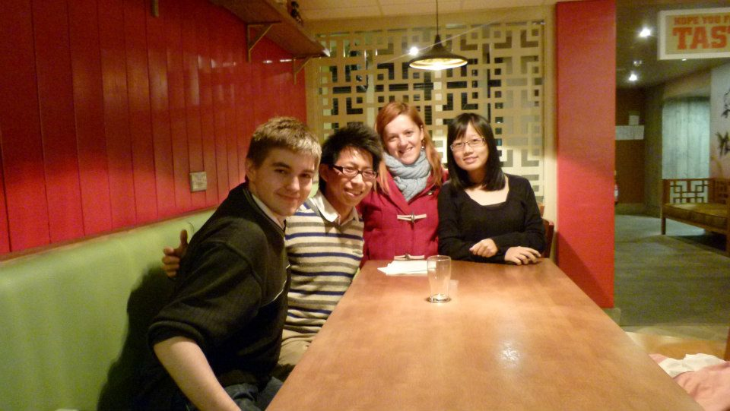

**‘The Friday Dinner’ with friends from Japan and the Czech Republic**

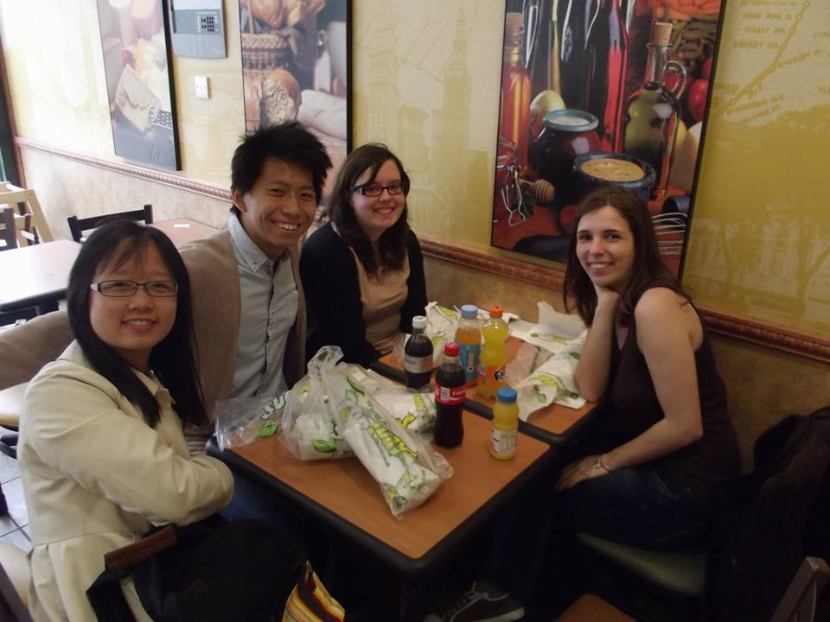

**Day trip to Clacton-on-Sea in Eastern England**

**About the author**

Ho Pok Jing is a fourth-year student majoring in English Studies and English Education at CUHK. From September 2012 to June 2013, she participated in a full-year exchange program at the University of Essex in the U.K. During her time abroad, she took literature, sociology and philosophy courses.