Exercise and answer for op-amp and analogue interfacing (appendix 1 of ceg3480_A2.ppt)
- A magnetic sensor is used to detect the magnetic flux density (in K Gauss) of an environment. The resistance of the sensor is proportional to the flux density detected with a gradient of 4 KΩ per K Gauss, and when there is no magnetic flux the resistance is 2K. The range of the magnetic flux density in the environment is between 0 and 5 K Gauss, and the flux density changes at a rate of not more than 10 K Gauss per second. The smallest change in flux density detectable is required to be 5 Gauss or less. The system uses an Analogue-to-Digital Converter (ADC) to convert the magnetic flux density into digital data, and the power supply used for this system is 5 Volt.

  - Draw the circuit diagram of the operational amplifier circuit needed to transform the flux density detected to an output voltage. The output voltage is proportional to the flux density. When the flux density is 0 the output is 0 Volt; when the flux density is 5 K Gauss the output is 5 Volts.

ANSWER
ANSWER: Use a bridge of 1 sensor and three 1K resistors.
5V=V_{b}
R
R
Sensor=dR+R

R
V2
R=2KΩ
V1
|V2-V1=5V{[(dR+R] /(dR+2*R)]-(1/2)}
dR=F*(4KΩ/K Gauss), where F=flux in K Gauss detected
At F=0, dR =0, hence Vi=5{(1/2)-(1/2)}=0,
At F=5K Guass (full flux),
Vi=5{[( 5K Guass *(4KΩ/K Gauss)+2KΩ] /( 5K Guass *(4KΩ/K Gauss)+4KΩ]-(1/2)}
=5{[(20KΩ+2KΩ)/(20KΩ+4KΩ)]-1/2}
=5{[22/24]-1/2}
=2.083
Also for the op-amp output
At F=0 Vout should be 0,
At F=full glux (5K Guass), Vout should be 5Volts, so the gain of the op-amp is 5/2.083=2.4
The gain of the differential opamp is about 2.4

So use differential amp as shown below, R2/R1=2.4, say R2=24K, R1=10K
Also make R1//R2=R3//R4

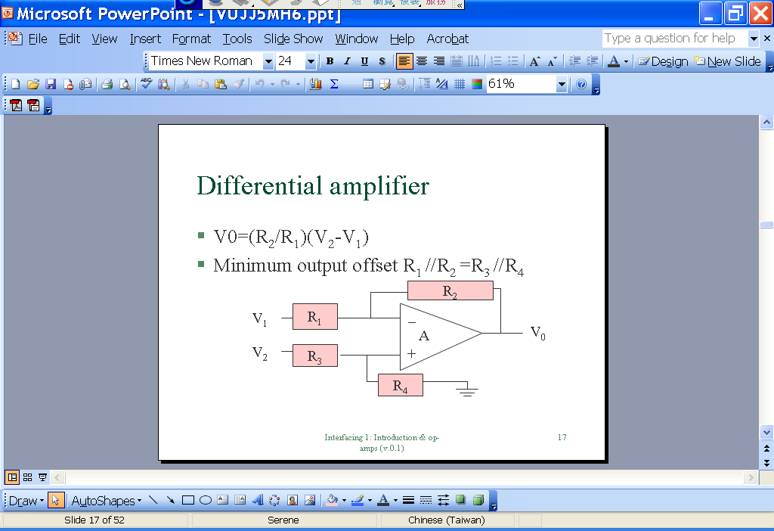

  - What is the suitable resolution (number of out bits) of the ADC?

ANSWER: The whole span is 5KGuass, resolution is 5 Gauss, so 5/5K is 1/1000, use 10 bit 2^10=1024 is enough to get that accuracy.

  - What is the maximum sampling rate of the Analogue-to-Digital Converter (ADC) needed?

ANSWER:

Flux change rate of 10 K Gauss per second, 10 Gauss per ms, 5 Gauss per 0.5 ms. Change at most 1 bit per 0.5ms, so it means 2 K samples per second. 2 KHz data. Make it 4 KHz sampling rate for the ADDA.

** Flux rate change is 10 K Gauss per second (or 2K changes of 5 Gauss per second), that means you can observe the change (at least one bit=5 Gauss) within 0.5ms, so the data rate is 2KHz.

