A Self-study Guide to Using Audacity 1.0
Audacity is a program that manipulates digital audio waveforms in multi-tracks. In addition to recording sounds directly from within the program, it can edit sound files including WAV, AIFF, AU, IRCAM, MP3, and Ogg Vorbis. Audacity, a free audio editor, can be downloaded from http://audacity.soureforge.net.

1. Recording with Audacity
Save an empty project. All recordings, edit and other files will be written to directory set in the Directories preferences.
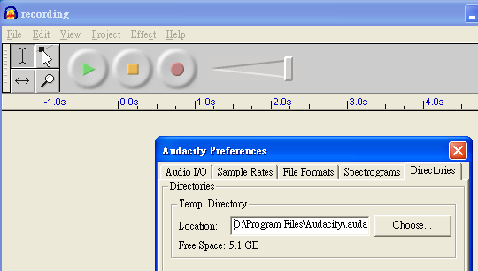
Click on the red Record button  and click on the yellow Stop button  to cease recording. You can now play around with your recording and explore the editing.
2. Duplicate and Cut
In this activity, you are going to cut the four sentences of a Chinese poem into four files each of which is a sentence. Select Project > Import Audio from the menu. Get the poemfullc.wav from the demo.
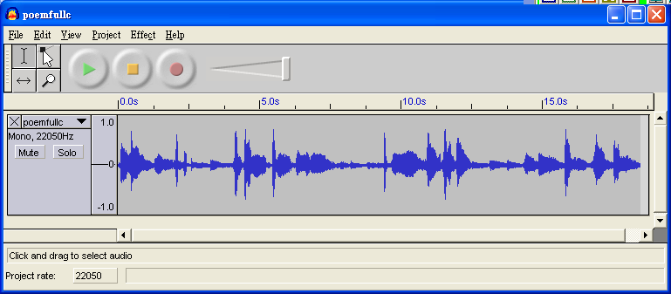

First select the part which is the first sentence of the poem by using the selection tool . Now press and hold the left mouse button while you drag the mouse to mark the area. This area is darker than the surrounding. Then select Edit > Duplicate from the menu.
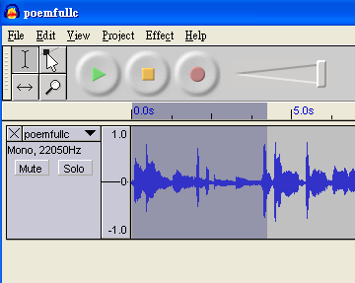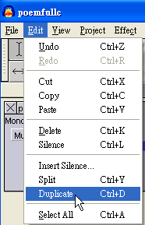
The selected area gets copied, a new track is created and the copied material is pasted in to that new track at the same point in the timeline.
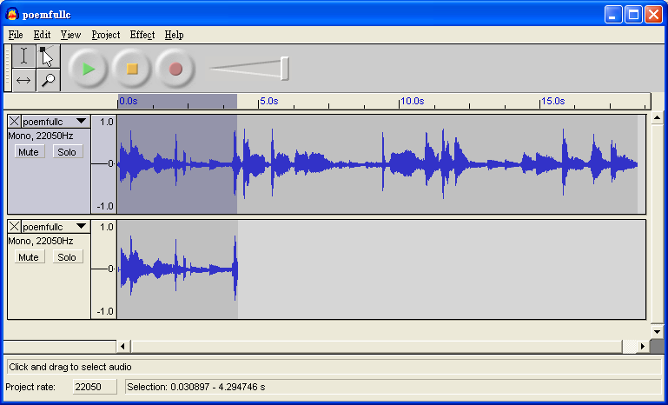

Click the Mute Button in the first and play the second track to listen whether it is a complete sentence or attached with the beginning of the second sentence. If it is not complete one, you have to duplicate once. If there is extra words at the end, by selecting these extra words, use Edit > Cut to remove them. Finally, select File > Export Selection as WAV to output the first sentence.

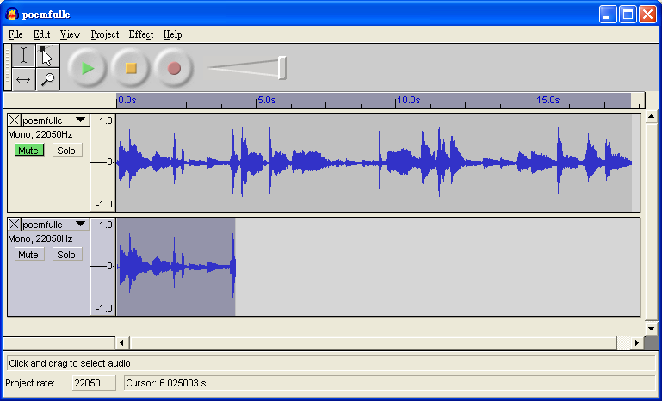
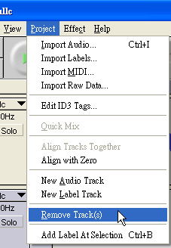

Select Project > Remove Track(s) to remove the second track. You can repeat the above procedures to get the second, third and fourth sentences.

3. Mix
In this activity, you are going to add the title at the beginning of the poem. Select Project > Import Audio to get the file titlec.wav.
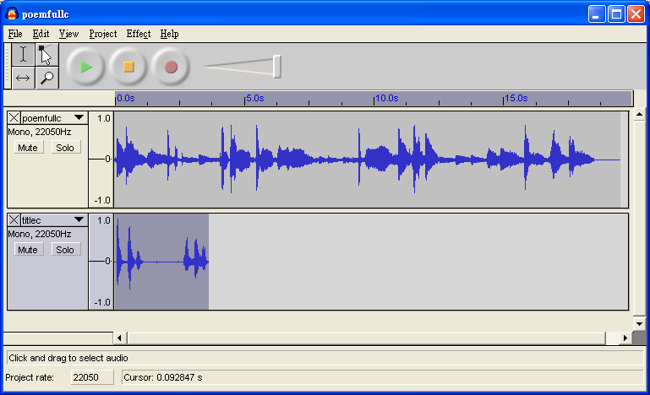

The Time Shift Tool is selected and the audio on the lower track is moved left
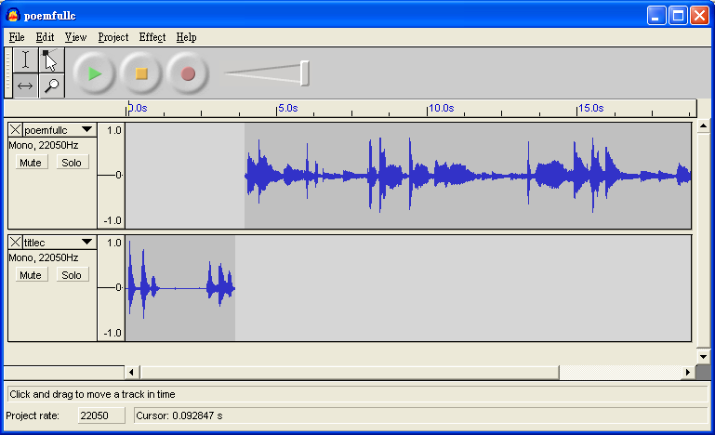

Play and listen to check it forms a good combination of the two sounds. Now, select the tracks you want to mix together: pressing the shift key, click on the track panels.
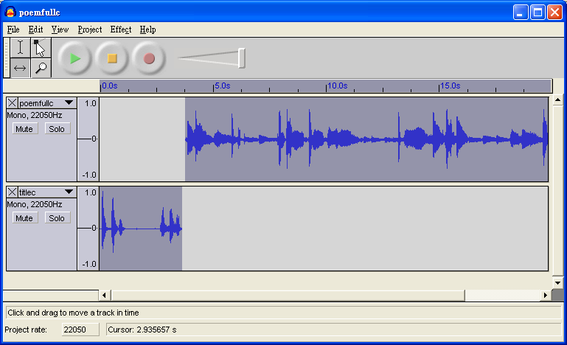

Finally, select Project > Quick Mix to get a single track that combines the title sound. Select File > Output as Wav to save the file.

.