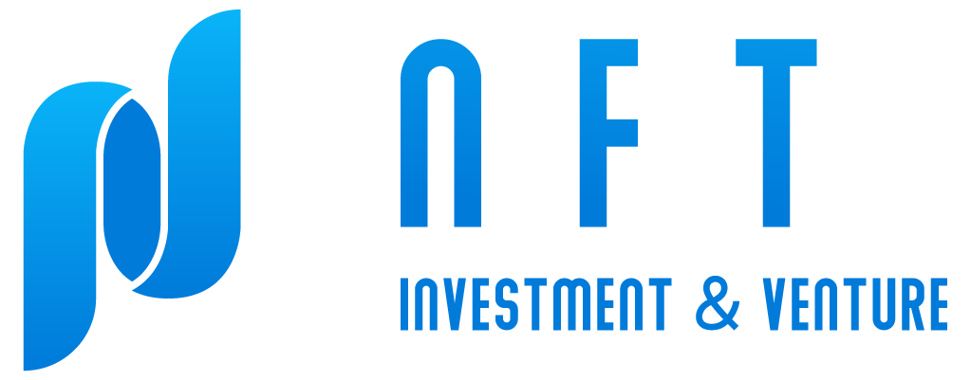
Full Stack Engineer
Company name: NFT Investment & Venture Limited
Job location: Hong Kong, Hong Kong SAR (Hybrid)

Job description
- Minimum 1 year of experience in
- HTML5, css, js, PHP
- CSS (SCSS, Bootstrap, Tailwind CSS)
- JS framework (Vue.js / React.js) (Next.js / NestJS)
- PHP framework (Laravel)
- databases (MySQL, MongoDB, PostgreSQL)
- docker (Docker image, Docker compose)
- Kubernetes
- CI/CD tools (Jenkins, Github action)
- Git
- AWS cloud service (Operational experience)
- API (RESTful API, connect 3rd party tools)
- Great sense of responsibility and good interpersonal skills
- Strong team player and self-motivated
Via Email to anthony@nft-investment.io

