LRP Panel Meeting (29 Sept 2016 notes)
What is LRP Panel meeting?
- A half day meeting every 3-4 months for government and industry to update and discuss HK Medical Device regulatory issues
- This forum was organized since 2007 with great success
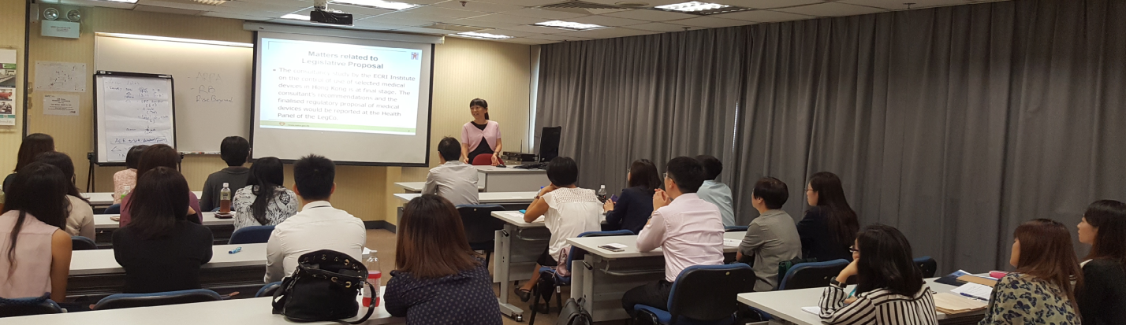
Average approval time statistic gather from industry members:
- New registration: 12-15 months (Class IV may be longer)
- Change registration: 6+ months
- Renew : suggest to do it 6 months before licence expiry
Update on Medical Device Regulation
- The proposed regulation aim to have control on premarket, post market and use
- The consultancy study by the ECRI Institute on the control of use of selected medical devices in Hong Kong is at final stage. The consultant’s recommendations and the finalized regulatory proposal of medical devices would be reported at the Health Panel of the LegCo (tentatively by end 2016). With support from the Panel, the legislative process will proceed and a grace or transition period is planned before full implementation of the Medical Device Ordinance.
Discussion - The forum also discuss the following potential changes
- MDCO website
  - The status of the renewal application is included in the MDCO website
  - Addition of intended use at website of MDCO
- Renewal process
  - The renewal will be mainly an administrative process, through provision of essential document ( business registration & etc)
  - Will involve a declaration on application details
  - Will need to submit the overdue change application within a short time period if applicable
  - ‘Change’ will be handled separately and to be submitted when situation arise
- Importer requirement
  - Evaluation of the capability of the medical devices manufacturer
  - Evaluation of the safety, efficacy and quality of the medical devices to be imported
  - Incoming and outgoing goods inspection

- We also have an initiative to develop a product listing checklist to remind common mistakes during registration. Draft version will be shared around Oct/Nov.

