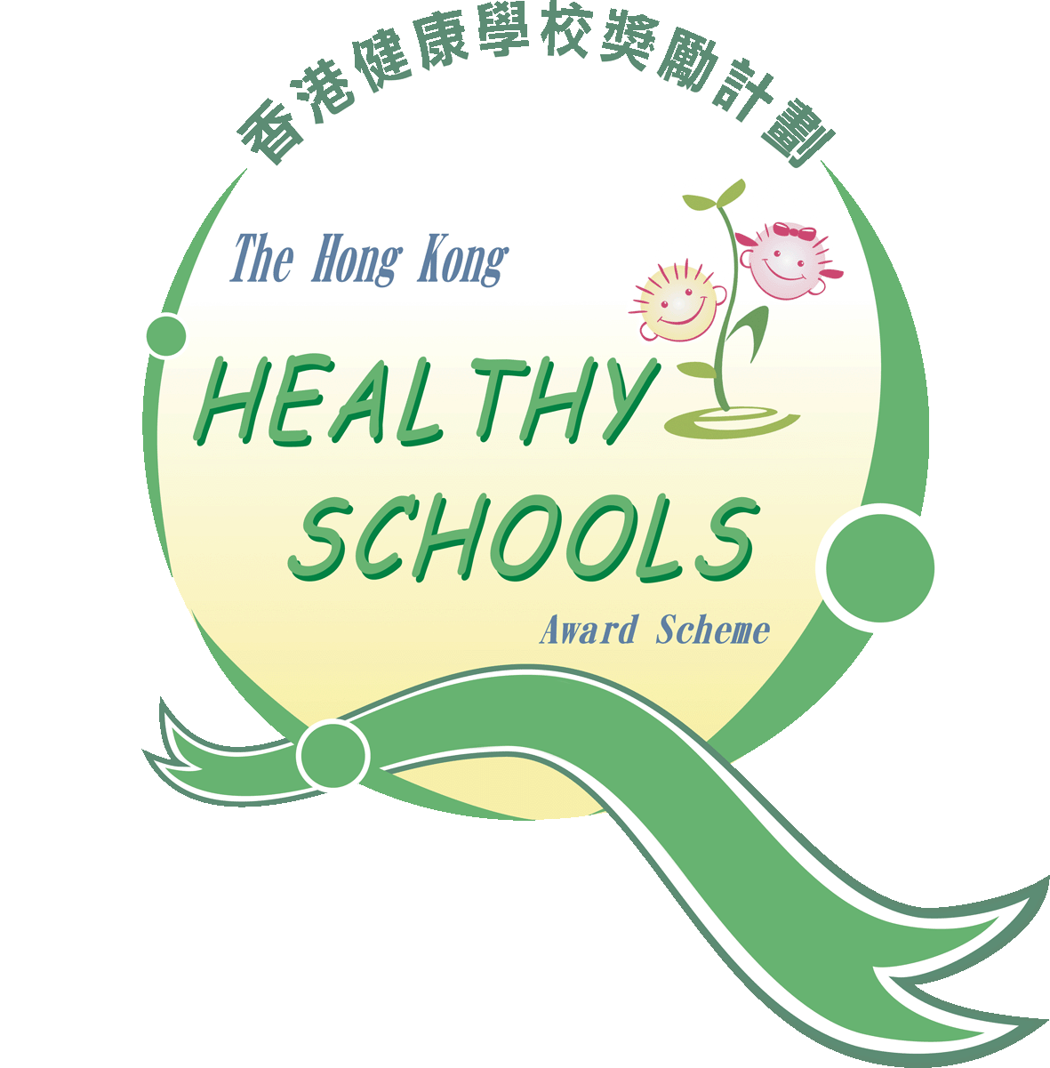International Benchmarking for Health Promoting Schools (Hong Kong)

**獎項續領表格**

**Reaccreditation Form**

**香港健康促進學校認證系統**

**指示Direction**

* **本「獎項續領表格」祇適用於已持有獎項並有意申請維持原有評級之學校，如學校首次申請、曾申請惟未達到任何評級或申請進階評級之學校，請運用「獎項申請表格」。This application form can be used for school applying for Reaccreditation to maintain an existing Healthy School Award. For school with her first attempt in QA; attempted QA in the past years but did not achieve any award or applied for a higher award, please use the “Award Application Form” instead.**
* **請於適當的方格內填上🗹號，並提供所需資料。Please put a tick in appropriate boxes and provide information as required.**

|  |  |  |  |  |  |  |  |  |  |  |  |  |  |  |  |  |  |  |  |  |  |  |  |  |  |  |  |  |  |  |  |  |
| --- | --- | --- | --- | --- | --- | --- | --- | --- | --- | --- | --- | --- | --- | --- | --- | --- | --- | --- | --- | --- | --- | --- | --- | --- | --- | --- | --- | --- | --- | --- | --- | --- |
| **1.** | **申請學校界別︰**  **Applicant Sector:** | | | | |  | | | | | 中學  Secondary School | | |  | 小學  Primary School | | | | | | |  | | 特殊教育學校  Special School | | | | | |  | 幼稚園∕幼兒園  Pre-School | |
| **2.** | **申請學校資料Details of Applicant School** | | | | | | | | | | | | | | | | | | | | | | | | | | | | | | | |
| 2.1 | 申請學校名稱Name of Applicant School | | | | | | | | | | | | | | | | | | | | | | | | | | | | | | | |
|  | (中文)  (Chinese) | | |  | | | | | | | | | | | | | | | | | | | | | | | | | | | | |
|  | (英文)  (English) | | |  | | | | | | | | | | | | | | | | | | | | | | | | | | | | |
| 2.2 | 通訊地址 Correspondence Address | | | | | | | | | | | | | | | | | | | | | | | | | | | | | | | |
|  | (中文)  (Chinese) | | | |  | | | | | | | | | | | | | | | | | | | | | | | | | | | |
| 2.3 | 校長姓名 Name of School Principal | | | | | | | | | | | | | | | | | | | | | | | | | | | | | | | |
|  | (中文)  (Chinese) | | |  | | | | | | | | | | | | | | | (英文)  (English) | | | | | |  | | | | | | | |
| 2.4 | 曾獲頒最高獎項Highest award achieved | | | | | | | | | | | | | | | | | | | | | | | | | | | | | | | |
|  |  | 金獎  Gold | | | | | | |  | | | 銀獎  Silver | | | |  | | | | 銅獎  Bronze | | | | | | | | | | | | | |
| 2.5 | 得獎年度Year of Award | | | | | | | | | | | | | | | | | | | | | | | | | | | | | | | |
| **3.** | **學校健康學校統籌資料 Details of the Healthy School Coordinator** | | | | | | | | | | | | | | | | | | | | | | | | | | | | | | | |
| 3.1 | 學校健康學校統籌姓名 Name of the Healthy School Coordinator | | | | | | | | | | | | | | | | | | | | | | | | | | | | | | | |
|  | (中文)  (Chinese) | | |  | | | | | | | | | | | | | | | (英文)  (English) | | | | | |  | | | | | | | |
| 3.2 | 職銜 Title | | | | | | | | | | | | | | | | | | | | | | | | | | | | | | | |
| 3.3 | 聯絡方法 Contacts | | | | | | | | | | | | | | | | | | | | | | | | | | | | | | | |
|  | 電話號碼︰(辦公時間)  Tel. No.:(Office hours) | | | | | | | | |  | | | | | | | (非辦公時間）  (outside office hours) | | | | | | | | |  | | | | | |
|  | 傳真號碼︰  Fax No.: | | | | | | | | |  | | | | | | | 電郵地址︰  E-mail Address: | | | | | | | | |  | | | | | |
| **4.** | **學校組織架構 Organizational Structure of School** | | | | | | | | | | | | | | | | | | | | | | | | | | | | | | | |
| 4.1 | 教職員組合 Staff composition | | | | | | | | | | | | | | | | | | | | | | | | | | | | | | | |
|  | 教員數目:  No. of teaching staff: | | | | | | |  | | | | | | | | | | 非教員數目:  No. of non-teaching staff: | | | | | | | | |  | | | | | |
|  |  | | | | | | |  | | | | | | | | | |  | | | | | | | | |  | | | | | |
| 4.2 | 班級架構 Class structure | | | | | | | | | | | | | | | | | | | | | | | | | | | | | | | |
|  | 每級別之班級與學生數目︰  No. of classes and students in each grade: | | | | | | | | | | | | | | | | | | | | | | | | | | | | | | | |
|  |  | | | | | | **級別**  **Grade** | | | | | | **班級數目**  **No. of classes** | | | | | | | | | | **學生數目**  **No. of students** | | | | | |  | | | |
|  |  | | | | | |  | | | | | |  | | | | | | | | | |  | | | | | |  | | | |
|  |  | | | | | |  | | | | | |  | | | | | | | | | |  | | | | | |  | | | |
|  |  | | | | | |  | | | | | |  | | | | | | | | | |  | | | | | |  | | | |
|  |  | | | | | |  | | | | | |  | | | | | | | | | |  | | | | | |  | | | |
|  |  | | | | | |  | | | | | |  | | | | | | | | | |  | | | | | |  | | | |
|  |  | | | | | |  | | | | | |  | | | | | | | | | |  | | | | | |  | | | |
|  |  | | | | | |  | | | | | |  | | | | | | | | | |  | | | | | |  | | | |
|  |  | | | | | |  | | | | | |  | | | | | | | | | |  | | | | | |  | | | |
|  |  | | | | | |  | | | | | |  | | | | | | | | | |  | | | | | |  | | | |
|  |  | | | | | |  | | | | | |  | | | | | | | | | |  | | | | | |  | | | |
|  |  | | | | | |  | | | | | |  | | | | | | | | | |  | | | | | |  | | | |
|  |  | | | | | |  | | | | | |  | | | | | | | | | |  | | | | | |  | | | |
|  |  | | | | | |  | | | | | |  | | | | | | | | | |  | | | | | |  | | | |
|  |  | | | | | | 共Total: | | | | | |  | | | | | | | | | |  | | | | | |  | | | |
|  |  | | | | | | | | | | | | | | | | | | | | | | | | | | | | | | | |
| 4.3 | 貴校有否設立以下負責參與制定和推行有關健康學校政策和健康活動的組織、工作小組或委員會？  Does your school have the following association(s), working group(s) or committee(s) responsible for formulating and implementing school policies and activities related to healthy school? | | | | | | | | | | | | | | | | | | | | | | | | | | | | | | | |
|  |  | | 校園健康工作小組或委員會(請註明名稱)︰  Working group or committee for school health (please specify): | | | | | | | | | | | | | | | | | |  | | | | | | | (自 年成立)  (Since ) | | | | |
|  |  | | 危機處理小組  Crisis management team | | | | | | | | | | | | | | | | | |  | | | | | | |  | | | | |
|  |  | | 家長教師會(自 年成立)  Parent Teacher Association (since ) | | | | | | | | | | | | | | | | | | | | | | | | | | | | | |
|  |  | | 家長義工隊(隊員約 人)  Parents volunteer (Number of team members: ) | | | | | | | | | | | | | | | | | | | | | | | | | | | | | |
|  |  | | 職業安全健康委員會  Occupational safety and health committee | | | | | | | | | | | | | | | | | | | | | | | | | | | | | |
|  |  | | 小食部或膳食監察委員會  Tuck shop/ catering services supervising committee | | | | | | | | | | | | | | | | | | | | | | | | | | | | | |
|  |  | | 校車服務管理委員會(請註明名稱)︰  Committee on school bus management (please specify): | | | | | | | | | | | | | | | | | | | | | | | | | | | | | |
|  |  | | 學生會 / 學生議會  Student council | | | | | | | | | | | | | | | | | | | | | | | | | | | | | |
|  |  | | 學生健康大使組或學會(請註明名稱)︰  Student Health Ambassador training or Extra Curricular Activity (please specify): | | | | | | | | | | | | | | | | | | | | | | | | | | | | | |
|  |  | | 其他(請註明)︰  Others (please specify): | | | | | | | | | | | | | | | | | | | | | | | | | | | | | |

|  |  |  |
| --- | --- | --- |
| **5.** | **申請意向　Mode of application** | |
| 5.1 | **評估之發展領域Areas that wanted to be reassessed** | |
|  | 申請參與獎項續領之學校可就學校由上次認證至今的轉變和水平提昇，選擇於是次認證重新評估的發展領域，學校可選擇評估**一個至六個**領域，亦只需運用《健康促進學校自我評估及監察系統》為該領域作自我評估，以及準備相關的參考資料和佐證；其餘領域將維持原來的評級。  School may base on the development and changes made in between the two assessments to choose the key areas to be reassessed. School may choose **One to Six** key areas for Reaccreditation. School will only need to complete the “Health Promoting School Self-Evaluation System” for the chosen areas. The achievements obtained from the last assessment will be remained for those key areas that do not undergo reaccreditation. | |
|  |  | 持分者意見調查 Stakeholders’ Survey |
|  |  | 學校環境視察 School’s Physical Environment Observation |
|  |  | 學校健康教育記錄 School Health Education Record |
|  |  | 六大發展領域內增添的項目 Supplementary questions in the six key areas |
|  |  | 健康學校政策 Healthy School Policies |
|  |  | 學校環境 School’s Physical Environment |
|  |  | 校風與人際關係 School’s Social Environment |
|  |  | 健康生活技能與實踐 Action Competencies for Healthy Living |
|  |  | 家校與社區聯繫 Community Links |
|  |  | 學校保健與健康促進服務 School Health Care and Promotion Services |

|  |  |  |  |  |  |  |
| --- | --- | --- | --- | --- | --- | --- |
| **6.** | **聲明　Declaration** | | | | | |
| 6.1 | 本校現申請參與 年度的「香港健康促進學校認證」之獎項續領，並明白及了解其認證結果只包括︰（1）維持原有評級；或（2）因未達到標準而不獲續領獎項，並願意作出適當配合，讓中心委派評估人員到訪進行質素保證。Our school applies for Reaccreditation of the “System of Benchmarking for Health Promoting Schools (Hong Kong)” for academic year. We understand that the result of QA can only be: (1) Same level of Healthy School Award will be issued; (2) If the minimal requirements of such award were not reached, no award will be issued. Our school is also willing to cooperate with CHEP for arranging the auditors to a QA visit to our school. | | | | | |
|  | 校長簽署︰  Signature (Principal): |  | 姓名(正楷)︰Name in Block letters: |  | 日期︰  Date: |  |
|  | 健康學校統籌簽署︰  Signature (Healthy School Coordinator): |  | 姓名(正楷)︰Name in Block letters: |  | 日期︰  Date: |  |
|  |  |  |  |  |  |  |
| **7.** | **申請程序 Procedures of application** | | | | | |
|  | |  |  | | --- | --- | | 1. | 學校可將填妥的表格於十二月三十一日前以傳真形式遞交（852-2694 0004），申請者將於截止後一個月內獲書面通知申請結果。Completed form can be submitted via facsimile (852-2694 0004) no later than 31 December. Applicants will be informed by written confirmation within one month after closing of application. | | 2. | 查詢方式：電話852-2693 3708／傳真852-2694 0004／電子郵件chep@cuhk.edu.hk（聯絡人︰盧小姐）。For enquiry, please contact Miss Amelia Lo at 852-2693 3708, or via fax (852-2694 0004) and e-mail (chep@cuhk.edu.hk). | | | | | | |

|  |  |
| --- | --- |
| **8.** | **注意事項 Remarks** |
|  | |  |  | | --- | --- | | 1. | 中心在一般情況下接受學校在獎項有效期內或到期後一年內之的申請，但仍會酌情處理已過期超過一年以上之「獎項續領」申請。此外，如認證結果反映學校在該學年之表現只達到比原有評級以下的標準，中心將考慮酌情推薦該校獲頒原有評級以下的獎項。CHEP will accept application for Reaccreditation for schools holding a valid Healthy School Award or within 1 year of expiry. CHEP reserves the right to deny an application on renewal of a Healthy School Award after 1 year of expiry. CHEP reserves the right to issue an award lower than the one achieved in previous QA if the school could only meet the minimal requirements of an award in the lower level. | | 2. | 有關健康促進學校表現指標及認證程序之詳情，請參閱「香港健康促進學校認證系統」小冊子，內容亦可從<http://www.cuhk.edu.hk/med/hep/consultancy/c_audit.html>下載。For details of the Health Promoting Schools Performance Indicators, Accreditation Procedure, please refer to the booklet on “International Benchmarking for Health Promoting Schools (Hong Kong)”, the content of the booklet is in Chinese only and can be downloaded from the following website: <http://www.cuhk.edu.hk/med/hep/consultancy/c_audit.html>. | |