**I Bring My Home to Holland, Then I Bring Home My Holland**

**By**

**Emily CHEUNG**

*30 August, 2013*

You can take me out of Hong Kong, but you can’t take Hong Kong out of me.

I was overwhelmed. There was a big backpack on my back, and two suitcases by my side. I stayed alone in a hotel on my first night in Utrecht. The next morning, I carried my backpack and one of my suitcases, walked all the way to the bus stop, and took the bus to the Utrecht University accommodation office to pick up the key to my dormitory. I squeezed into the “Kruisstraat” van with 7 other people and 7 other suitcases. Then, I went back to the hotel’s storage room to move my second luggage to my new home. I was tired, nervous, tense and inactive. It was then that I met my French roommate, Lysiane. She kissed me on my cheeks, and I did not know how to react. “My culture doesn’t teach me how to respond to French greetings,” I confessed to Lysiane later. “I felt bad about that as well,” Lysiane said. From then on, we had cheek kissing every time we saw each other.

During my first week in Utrecht, I was wondering if I had made the right choice to go on exchange. I was wondering whether it was a dream coming true, or it was a dream becoming a nightmare. I did not have “exchange mates” from CUHK. I did not have Hong Kong friends in my dormitory. No one could speak Mandarin, let alone Cantonese. No one had sung Karaoke. No one had *yumcha-ed* or *hotpot-ed*. Everyone was from “the West”. Everyone socialized. Everyone partied the whole week. Everyone went wild. Everyone was dancing in my corridor, the “Kruisstraat” party base. Everyone was so excited about the coming semester - except me. *Am I welcomed?* *Would people mind living with a Hong Kong girl?* *How would I socialize like everyone else? How would I be energetic and party all week? Why am I not in Hong Kong heading home, or dining with my friends in canteens? Why am I here fearing “the West” and social events? Why am I here living with the English, Austrians, Italians, Spanish, Australians and Swedish? Why am I here struggling? Should I go socialize, or should I just stay in my room? Why am I here trying so hard to adjust to my new home? Why is there nothing familiar?* I had to seek comfort. I had to look for familiarity.

I was overjoyed when I bought a rice cooker for 15 euros, a pack of thai rice, and a bottle of light soy sauce. But no one else shared my joy in my dormitory.

“You can just use the cooking pot to cook rice.”

“What’s so special about thai rice?”

“That’s steamed egg? Tastes weird!”

“Did you just put condensed milk in your English Breaking Tea? But why?”

I spent my Fridays with my Hong Kong fellows cooking Asian food. We spent Mid-Autumn Festival together with mooncakes and glowing sticks. We had Asian all-you-can-eat. We went to the Chinese store every week to do grocery shopping.

But then I started to realize there was too much Hong Kong-ness in me. I brought too much of Hong Kong here. I was seeking another comfort zone from home. I was living in an environmental bubble - looking for friends with similar culture, food with familiar taste, lifestyle similar to that at home. It was always my dream to go on exchange. I was excited to meet people from all over the world, to experience different cultures, to befriend people with different nationalities. But now, however, I was reluctant to realize my own dream.

I lived in Kruisstraat during my 1-year exchange, at the heart of Utrecht - which is at the heart of the Netherlands. Utrecht is the fourth largest city in the Netherlands, after Amsterdam, Rotterdam, and The Hague - but it has less stardom than the Big Three. At the heart of Utrecht, there stands the signature Dom Tower, the tallest among all other Dom Towers in the Netherlands. Dom Tower is located at the centre of the old city centre, which is surrounded by canals. Along the canals, there are temperature-controlled tourist boats with 40 curious eyes, kayaks with lovers, and party boats with drunk lads, music and wine. Along the cobblestone streets at the old city centre, there are toddlers on the box-bikes, lovers on backseats, running puppies with springers attached to the bikes, commuters on the bikes carrying briefcases with one hand while eating apples with the other hand.

Cycling and bikes excited me throughout the year in this cycling nation. Cycling in winter was ice meeting fire. The wind came across the rain, and the chilliness struck the heat. It was 2 degrees outside of my jacket but 30 degrees in my jacket - so after a 20-minute ride, two streams of runny spouts were dangling on my nose. I cycled for 5 hours back and forth to visit the tulip fields in the spring. I cycled uphill with all my energy and cycled downhill with all my screams. I fell off from my bike, and I fell off from the backseat of my friend’s bike. My bike broke midway to school. I got lost while cycling off-path, but a big windmill surprised me. I was frustrated by the pedestrians who blocked my cycling path and was frustrated by the cyclers who blocked my walking path. Above all, I’m proud to say that I’ve lived in the Netherlands because I’ve experienced a bike theft. In this cycling nation, you’ll have a love-hate relationship with bikes.

There were many usual mornings and afternoons in Utrecht. Now when I think back, they became unusual. My flatmates and I stopped at Café Ludwig for a hot latte every Monday and Wednesday before Conflict Studies class. The cashier at Ludwig asked where we had been during our short term break. I studied at Café Duppio in most of the afternoons with another cup of hot latte. The owner of Duppio was a traveler who had been on Trans-Siberian Railway across the Asia-Pacific. In the other afternoons, we rode our bike around Utrecht to look for places we had never been. We accidentally found a pop-up café in the middle of a ring road, which was run by volunteers from the local community. It was a pop-up idea to collect opinions about the community’s future development. Everyone’s opinion mattered. We found a manmade beach one afternoon and enjoyed the rare sunshine. Another afternoon, we found a pancake restaurant in the middle of the farmlands in the outskirts, so we ended up eating Dutch pancakes, surrounded by dairy cows, mules, horses, sheep, and kayaks on the canals. We found a small park with a lake in the middle and with the Dutch having disposable barbecue on the grass, so that afternoon, we were reading while barbecuing on the grass. Another afternoon, we found a cherry orchard which served homemade cherry beer and freshly picked cherries on our way to a castle. There were many more afternoons that made me fall in love with the Netherlands and fall in love in the Netherlands.

I used to be afraid of being different among the “Westerners”, but I learnt to assimilate while keeping my unique identity. I used to be a shy girl, but I made a speech at the University Hall which was constructed in 1462. I stood on the stage in the historic hall, sharing my experience as an exchange student to a new batch of exchange students. My flatmates came to cheer for me. Several weeks after my speech, people still came to me and asked if I was the girl on stage. I used to be the not-so-sociable Asian girl, but I organized the International Kitchen in my dormitory.

Everyone placed their own dishes in the long table: Italian ratatouille, Japanese sushi, English shepherd’s pies, Vietnamese spring rolls, Swedish meat balls, Norwegian almond bunds, Austrian Apfelstrudel, Singaporean Bak Kut Teh, Australian ANZEC cookies, and Spanish sangria. It became a movable feast. Everyone moved along the table for the never-ending food tasting while exchanging recipes with friends from other countries. I had awkward ballet dance moves during parties, which were later known as “the Emily dance”. I painted my face white on Halloween while dressing up as an elephant for Carnaval. I was weird but special. I spent some afternoons alone in hipster cafés and was therefore said to be a “Hong Kong hipster”. Later, people started to ask me for a places-to-go-before-you-leave-Utrecht list. I preached light soy sauce and condensed milk to my flatmates. And now they are preaching the heavenly recipe of “light soy sauce with rice” to their home countries. When I stepped out of my comfort zone, the world became larger than I could ever imagined. It was the epitome of my exchange life.

“A life-changing experience” is the slogan for almost all exchange programs. Later I realized that you do not just wait there and anticipate the life-changing experience. It is only when you start to embrace your uniqueness and be yourself, does your life begin. Do not be afraid of being different. You will be known for your uniqueness. Your uniqueness will start off interesting conversations and adventures. Socialize while embracing your own identity. It is only when you leave your environmental bubble, does your world become big. Do not limit yourself to the “Hong Kong circle” or “Asian circle”. Be proud of your own cultures but do not be ethnocentric. Do not bring your home when you go on exchange and travel. Do not see the world with your own culture. Be open to other cultures and all possibilities. Look at the world as a global citizen. Understand others, appreciate, and learn from them. Introduce them your own dishes and learn how to make their dishes. Seize the opportunity of your proximity to people from different nationalities, with different worldviews, and cook different food. That is the opportunity then opens you up with a bigger world and many more possibilities.

I became the small little Asian girl who ate a lot. I became the small little Asian girl who cycled around the canals in Utrecht. I became the used-to-be-invisible who organized the International Kitchen. I became the used-to-be-shy Asian girl who went on stage fearlessly to give a speech. At the boarding gate of CX bounded to Hong Kong, a little girl smiled at me - smiling at a big girl who had two red swollen eyes filled with tears.

I still could not believe this had happened, and I still could not believe I had left Utrecht. But even if I had left, I brought Utrecht back. I become a different person. My parents are amazed at my cooking (I barely cooked before going abroad). My English accent has changed. I become more active and fearless. I am more aware of my surroundings. I look for new cafés in Hong Kong and spend time alone there reading. I talk to random people. I spare time for relaxing. I travel in Hong Kong as if the girl in Utrecht who was always looking for new places with her bike. I embrace every possibility (without being too stubborn like before). I keep up with world news (and spend less time with tabloid news). I remember all of this when I am suffocated by the polluted air, crowded MTR and the tense ambience. I will always remember the Utrecht-ness in me.

*30 June, 2014*

You can take me out of Utrecht, but you can’t take Utrecht out of me.

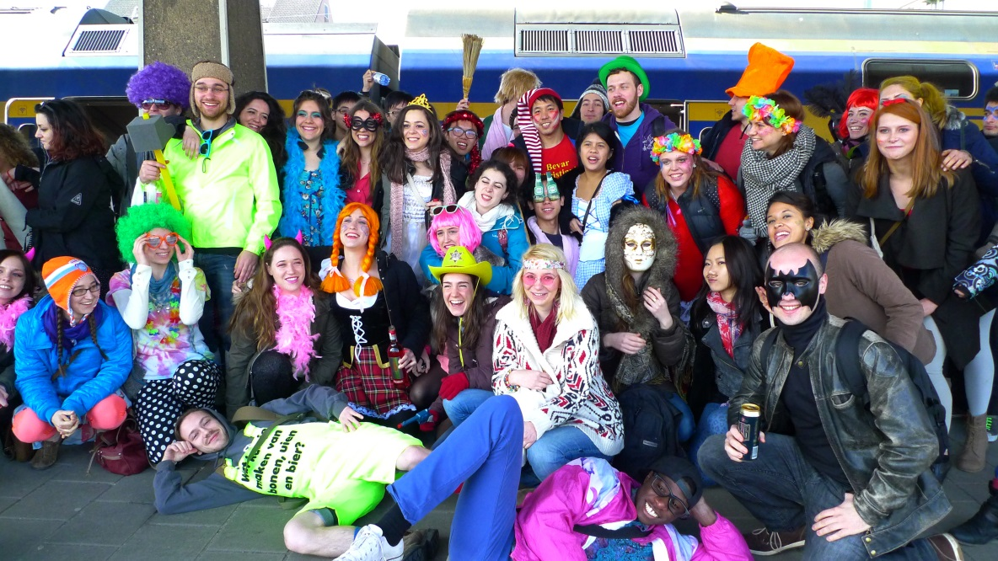

The “Kruisstraat crew” all dressed up for the annual Carnaval in Maastricht.

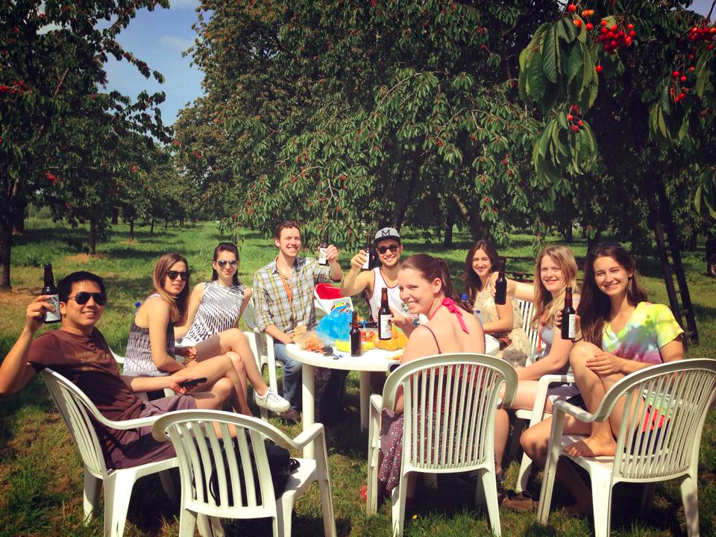

The “Kruisstraat” bike gang resting at cherry orchard.

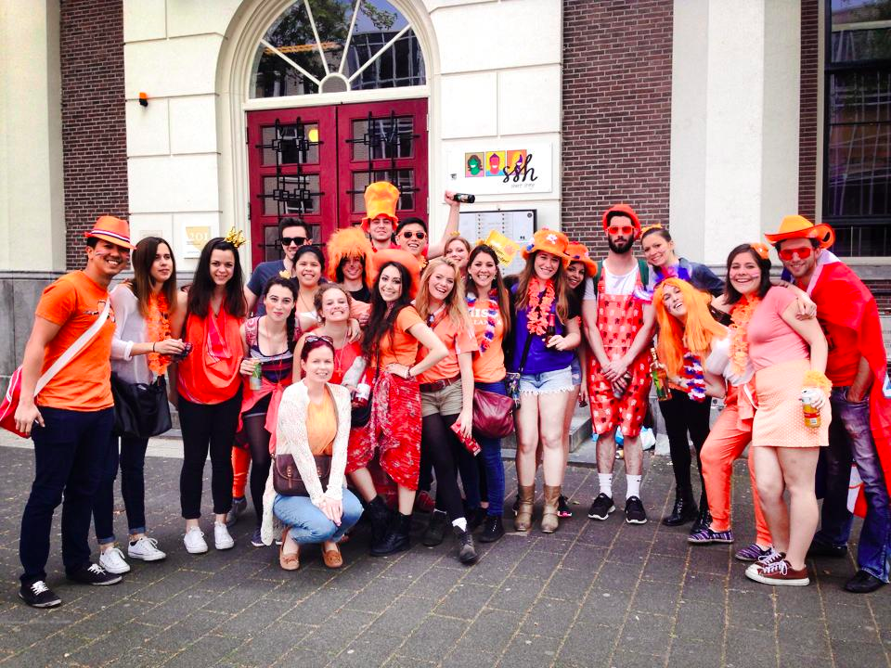

The “Kruisstraat” people dressing up orangey for King’s Day.

**About the author**

Emily Cheung is a 4th year English major addicted to backpacking and reading. In 2013-14, she went to Utrecht, the Netherlands for a year-long academic exchange with the U-Wide exchange program.