Summer Study Aboard Trip to Australia: A Pursuit of Happiness
By
Sy Wang Hin
It is said that the best way to see the life you are living in is to step out of it, to see it from an outside angle. Last summer I did just that, leaving Hong Kong for one month in a summer study abroad programme to Australia. Not only did I do many interesting things that I had never done before, but I finally experienced first-hand the differences between the two places. Through this, I have realised that there are many things that can be done to help make Hong Kong a happier place to live in.
I would like to begin by sharing the differences in the systems of values between Australia and Hong Kong. The first, and the most obvious facet of Australian values that a traveller like me would notice is their egalitarianism. Among the first instructions given by my course lecturer is to never call him "professor," instead, we were to call him by his first name, "James." Initially, this was disorientating, as I, like most Hong Kong students, have grown to look upon the teacher as an authority, not only in his/her own field of expertise, but on everything else as well. In Australia, I learned how to treat teachers as equals, deserving no greater yet no lesser respect than any other human being.
However, the most profound change was not in my attitude towards others, but towards myself. In my previous years as a student, I had become used to, almost trained to consider myself inferior to anyone who is higher in the hierarchy of the whatever institution I found myself in, be it family, school, university, or even part-time work; I considered myself as the weakest in terms of knowledge and ability and my purpose was only to serve and learn. I believe a lot of my fellow students and even graduates are no different. However, when I found out in Australia is that it is possible to address someone who is supposedly superior in such an equal way, I realised that I am no less worthy than anyone else. This newfound worthiness granted me the ability to respect myself, and helped me to cease the suppression of my own wishes and ideas due to a fabricated self-inferiority. I now find myself confident to stand up and state my point in front of people who are senior to me and may disagree. I now find it easy for me to sit down and listen to the stories and ideas of people who most people of my age and level would disregard.
If we link power with money, like most of us are inclined to, then it is easy to understand why Australians care relatively little about money. While I have not directly confirmed this by my experience, only knowing this through a primer on Australian culture that my host university provided at the start of my time in Australia, I find it very believable. The fact that Australians do not care about titles and social rank mean that they have very little need to strive for social power and wealth. Indeed, the only people who I have observed to comment and complain about prices throughout the entire trip were the foreign students such as myself. Even though I have taken a business course, the lecturer and all of the Australian people I met seemed to concern themselves with money-issues far less than their Hong Kong business faculty counterparts.
From this, I have come to realise that the Australians' laid-back and easy-going attitude towards work and their ignorance of the pursuit of power has made them very happy people. I have observed that the Australians are a friendly and humorous bunch; they would chat and laugh when they talk to others on the street, and they always wear a slight smile on their face. This smile is not a false, forced one, but one that comes naturally to them, an expression of satisfaction in life and hope in the future. Despite their carefreeness, however, I believe we cannot discount the fact that Australia is a respectable sovereign nation with a high degree of human and technological development. It seems to me that, overall, Australia is a happy nation that is highly developed and competitive in the international theatre.

 | 
It is possible to enjoy the best of both worlds: Sydney is a city with material comforts similar to Hong Kong, yet its people live far less stressful lives than Hong Kongers

Now I would like to take a break from my thoughts and observations in Australia and return to Hong Kong for just a moment. I would be stating the obvious when I say that despite enjoying all the latest gadgets, technology and material comfort the civilised world has to offer, the people of Hong Kong are far from happy. For a long time I have, like many other Hong Kongers, believed that a certain degree of stress and unhappiness is a price that must be paid to make our city an advanced and internationally competitive one. I was certain that this was a fair deal, as the material comfort available through our toil would be more than sufficient to make up for any emotional stress; I used to be told that the people of third-world countries suffer because they did not pay the price of effort and hardship, and die from famine and illness due to their own laziness; thus I had to work harder, in order to escape their fate. However, after understanding the Australian way of life, I think I am ready to say now that the unhappiness of the Hong Kongers and the happiness of the Australians stems from an ideological issue: Our lives are bound by an ideology in which the acquisition of wealth is considered the sole justification of our entire existence, one that promotes consumption as recreation and relaxation, yet one that is showing its faults and cracks in the stress-ridden Hong Kong of the twentieth-first century. On the other hand, the Australian ideology seems to accommodate considerable freedom, based on the principle that one should find the most personal happiness in life (while respecting the happiness of others;) it does not force people onto a certain "path to greatness" and judge success by one single parameter.
Therefore, I would like to propose, from what I have seen during my time in Australia, that Hong Kong can still be every bit as competitive, and materially and technologically advanced as it is today, but with a people that can live happy, satisfying lives. In order to do so we need two things: confidence and freedom. We need confidence in oneself; one's thought and ideals need not conform to the overarching ideology of the society in order to be "correct." We also need freedom, for without freedom to choose and live our own life, all our efforts would go to waste. Note that this freedom is not just a freedom in act, but a freedom in thought and the respect of others' freedom as well. Hong Kong has plenty of the former, but our thoughts and respect of others are lacking, to say the least.
The topic on choices and freedom brings us to the second part of my discussion: since a part of my trip involved a visit to the Australian Parliament in Canberra, and my visit coincided with the elections, I had the unique opportunity to observe the political atmosphere of Australia from both the government and the people's perspective.
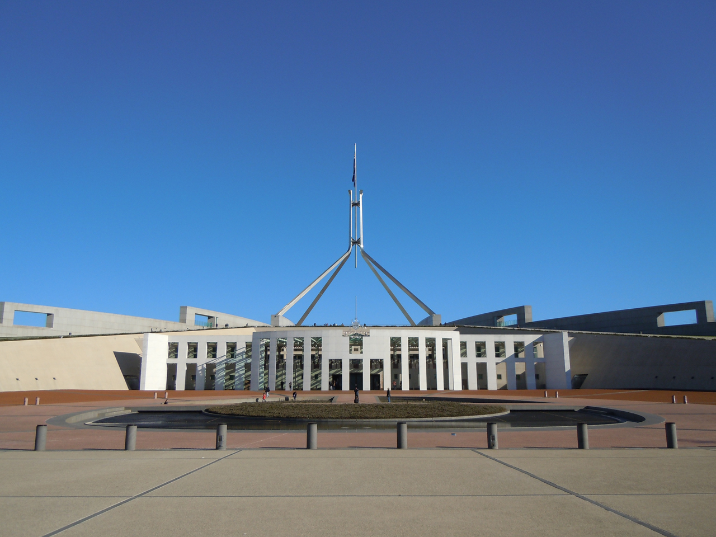
The Australian Parliament in Canberra

Perhaps the most interesting thing to note is that during my stay at Canberra and Sydney, I saw no demonstrations of the scale of the ones that take place in Hong Kong every weekend. In fact, even though I went into the city every day for weeks, I came across no protests at all. Something like this is unimaginable in Hong Kong, where demonstrations are the only practical way for Hong Kongers to voice their opinion to their government. Hong Kongers practise it without fail every week, even though its effectiveness in influencing the government's decisions is dubious at best, to the point that Hong Kong has earned the moniker "The City of Protests." The question I asked is "Why?"


This is the closest thing to a protest that I saw throughout my entire trip. It’s a creatively designed trailer calling for Coca Cola to cease its environmentally unfriendly activities. It seems that Australians care far more about their environment than their governance.

After listening to locals in restaurants, on the streets and in pubs, I came to the understanding that Australians care little about politics. In fact, the newspaper headings were all reporting on the Rugby games which happened to coincide with the elections, with news covering the elections hidden in the inner pages for those would deliberately look for them. There is compulsory voting in Australia, but interestingly, that seems to have little effect in making people more willing to vote. James, my Australian lecturer, for example, votes for "Mickey Mouse" every single time he was called to vote to avoid being fined, but at the same time not exercising his decision.

However, another observation I have made is that despite being apolitical, the Australians are nowhere near as "obedient" as the apolitical crowd in Hong Kong. In contrast, in Hong Kong, we have a highly active and vocal group struggling for democracy and a "silent majority" seemingly content with keeping the status quo and accepting the government as long as its policies do not conflict with their interests. I find the Australian people enjoying a unique confidence in their rights and power over their own lives and their government.
This power and confidence, I observe, is conferred by none other than the democratic vote. With the vote in the people's hands they know have the option to easily change their government should it prove dissatisfactory, rather than resorting to protests and disobedience. Even though they chose to exercise it sparingly does not mean that this power does not exist. While in Hong Kong, even though we enjoy great material comfort and a high degree of personal freedom, our political rights are extremely limited. Thus, the people of Hong Kong must cling to the use of disobedient actions and making rows as there is nothing else they can use to change their government. And since this right is not solid and back by law, Hong Kongers must exercise it often lest it disappears and be taken away.

Finally, the most important thing that I have learnt is not a lesson, nor a concept, but one single phrase: "There is no right or wrong, just difference." This phrase can apply to many areas, but I think it is best suited to how we all think of other people and ourselves right now. There can be no argument that everyone is born different, and so why must we go and find our happiness in one and the same way? We need to respect others' right to be different, to seek their goals in life in their own terms. By doing so we will also be doing ourselves a favour, by giving us room in our minds to search and walk on our own unique paths to happiness.
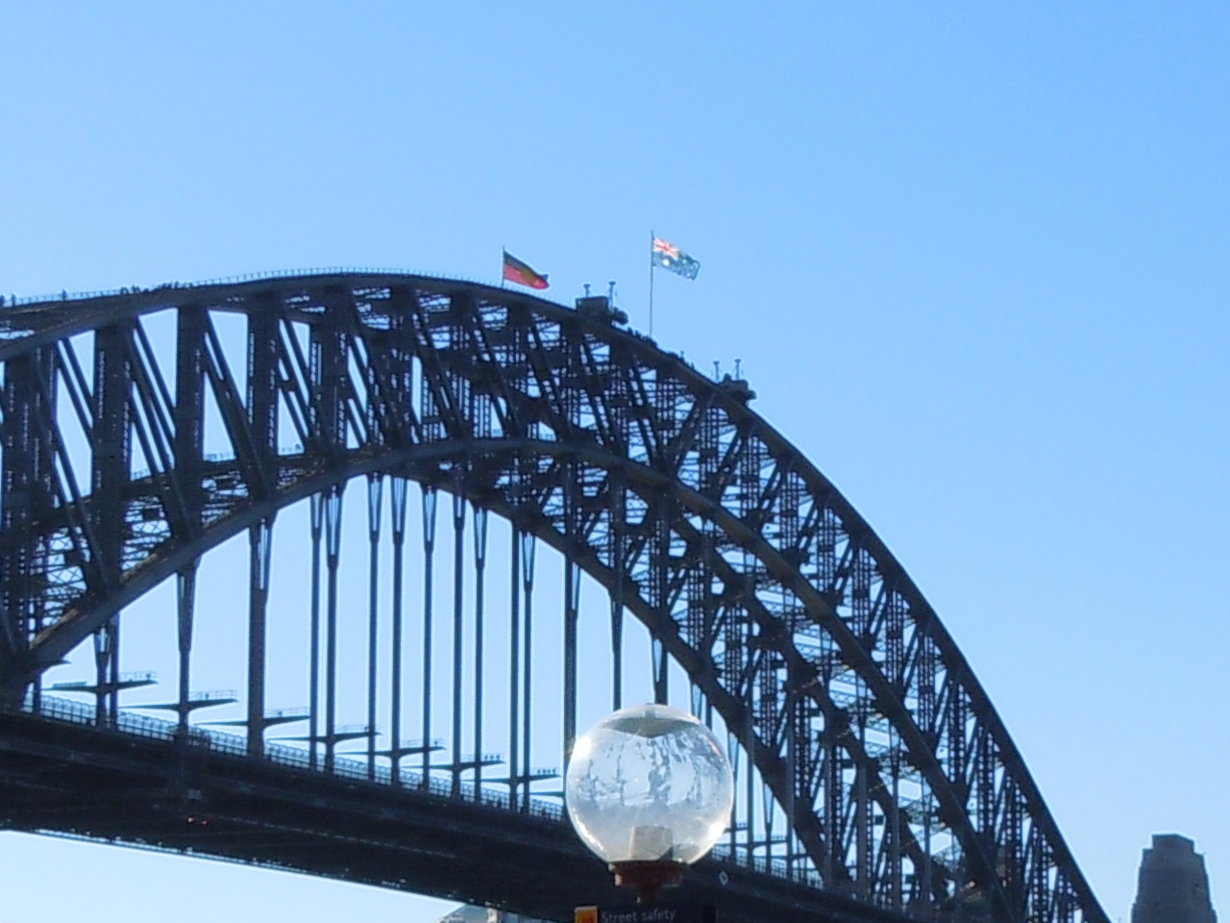
The Aboriginal flag and the Australian flag flying beside each other on the Sydney Harbour Bridge. A sign of respect for both cultures, different sets of values and diverse definitions of happiness.

About the author
Sy Wang Hin is a Year 3 English major who joined the ‘International Business: Australia and South East Asia summer program’, which was hosted by the University of New South Wales, and subsidized/supported by Chung Chi College. From late June to late July 2013, the sojourn included visits to several cities in Australia: Darwin, Canberra, Sydney and Cairns.

