Project Title
Group ID
Student name 1 | Student name 2 | Student name 3
Student id 2 | Student id 2 | Student id 3
Email 3 | Email 3 | Email 3

ABSTRACT
In this paper, we describe the formatting guidelines for project report…

Keywords
A, b, c..

- INTRODUCTION
In essence, we ask you to make your paper look exactly like this document. The easiest way to do this is simply to down-load a template from [2], and replaces the content with your own material.

- RELATED WORK
Show some related work on this section about your project. This section should include some references [3, 4].

- NAME OF SECTION 3
Replace the section name to your own.

- Subsection 1
This is a subsection.
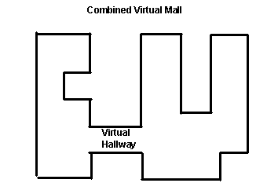
Figure 1. Insert caption to place caption below figure.

.

- Subsection 2
This is a subsection.
Table 1. Table captions should be placed above the table
Graphics | Top | In-between | Bottom
Tables | End | Last | First
Figures | Good | Similar | Very well

- Subsubsection 1
This is a subsubsection.

- Subsubsection 2
This is a subsubsection.

- NAME OF SECTION 4

- NAME OF SECTION 5

- CONCLUSION

- CONTRIBUTION
Put each team member’s contribution to the following table.
Table 2. Contribution of team members
Student Name | Contribution
Name 1 | Algorithm design..
Name 2 | Data collection..
Name 3 | Implementation of..

- REFERENCES
- Reasoning about naming systems. ACM Trans. Program. Lang. Syst. 15, 5 (Nov. 1993), 795-825. DOI= http://doi.acm.org/10.1145/161468.16147.
- Ding, W. and Marchionini, G. 1997. A Study on Video Browsing Strategies. Technical Report. University of Maryland at College Park.
- Fröhlich, B. and Plate, J. 2000. The cubic mouse: a new device for three-dimensional input. In Proceedings of the SIGCHI Conference on Human Factors in Computing Systems (The Hague, The Netherlands, April 01 - 06, 2000). CHI '00. ACM, New York, NY, 526-531. DOI= http://doi.acm.org/10.1145/332040.332491.
- Tavel, P. 2007. Modeling and Simulation Design. AK Peters Ltd., Natick, MA.
- Sannella, M. J. 1994. Constraint Satisfaction and Debugging for Interactive User Interfaces. Doctoral Thesis. UMI Order Number: UMI Order No. GAX95-09398., University of Washington.
- Forman, G. 2003. An extensive empirical study of feature selection metrics for text classification. J. Mach. Learn. Res. 3 (Mar. 2003), 1289-1305.

