This document is to guide NON-CSE students to login into the UNIX systems using SSH software to submit the programming homework.
- Open SSH, click the Quick Connect:
Host Name: gw.cse.cuhk.edu.hk (or gw2.cse.cuhk.edu.hk)
User Name: your unix user name (sent to you already)

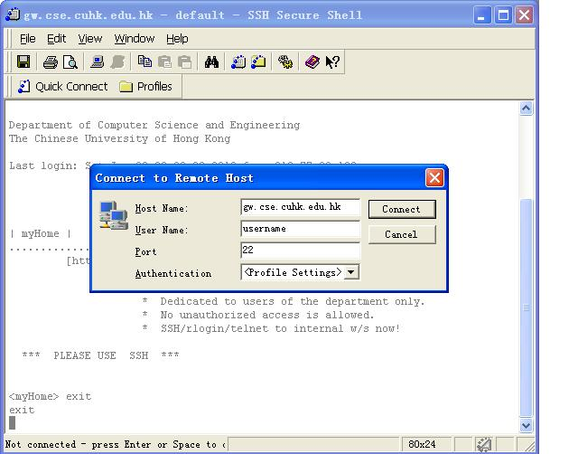

2, type in the unix password we have sent to you.

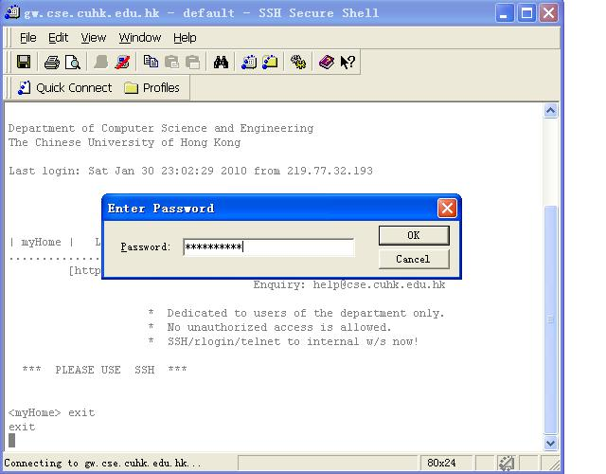

3, type in the command:
ssh linux2 (or linux3 or…)
refer to: https://www.cse.cuhk.edu.hk/corner/fac/computing.html#comp-fac
to login into a linux machine or sparc machine

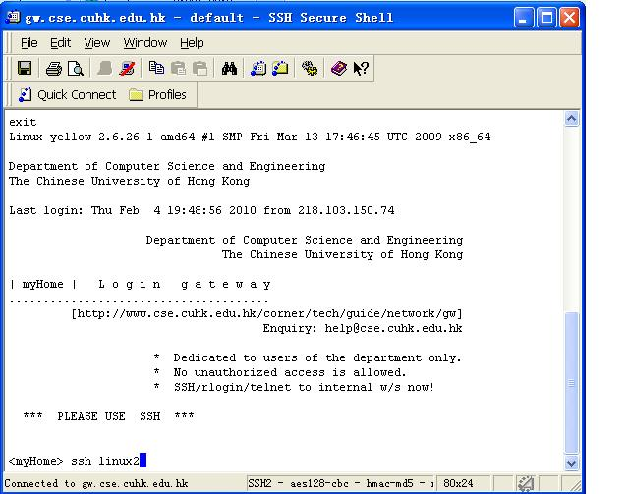

4, after you successfully login, you could click the button I circled on the left window below, and a new window would pop out. On the left side is you local machine, on your right side is the network driver in your unix account, you could write your programs on your local machine and upload it to the unix machine, and submit your program to the Online Jugement Server by typing the command:
mail csc2100@pc89072.cse.cuhk.edu.hk < myprogram.c
myprogram.c is your program name

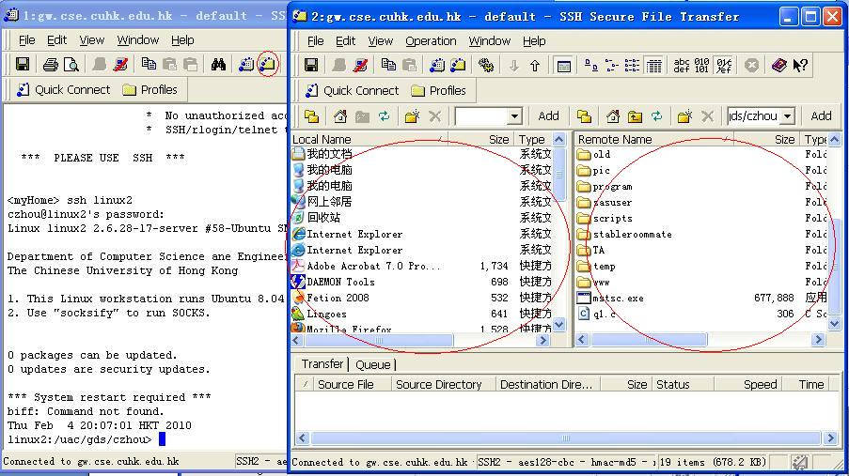

Tutor Tom Chao Zhou@CSC2100B

