ECLT5820 – Distributed and Mobile Systems

Topic 5: Time, Coordination and Agreement

- Lamport’s Timestamp
Write the Lamport’s Timestamp for the following operations.
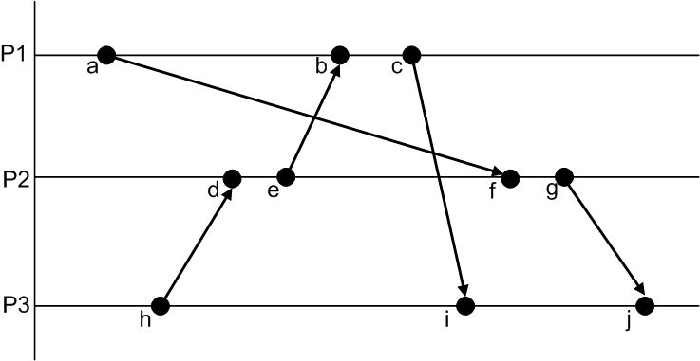

Answer: _______________________________________________________

- Vector Clock
Write the Vector Clock for the following operations.

Answer: _______________________________________________________________

