ECLT5820 – Distributed and Mobile Systems

Topic 11: Cloud Computing

This problem is to practice on using Cloud Computing to determine the frequency of each word in a large document collection.

We have 10 short documents (d1 - d10). All 10 documents are composed with 4 words (w1 – w4). For example the content of d1 is “w1w2w4”.

Use Map Reduce method to count the frequency of each word (w1 – w4) in 10 documents. We have 3 mappers and 2 reducers as shown in the figure.

Fill out the blanks and draw the missing arrays:

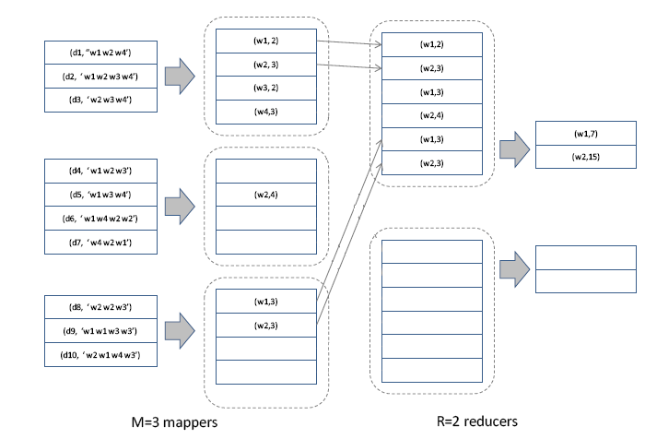
(w1,9)
(w1,4)
(w2,10)

ANS:
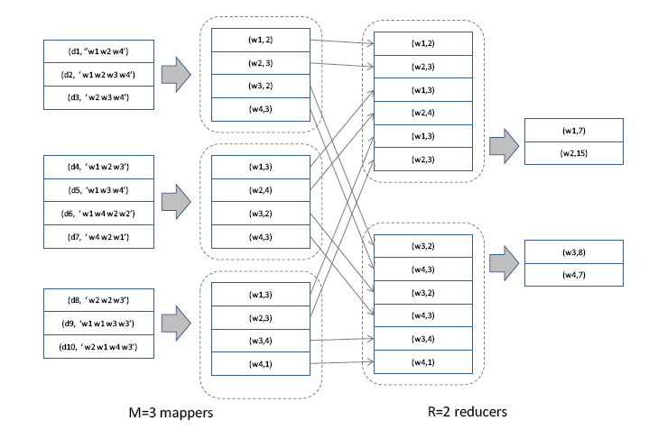
(w1,9)
(w1,4)
(w1,4)
(w2,10)

