
LYU0401 Location-Based Multimedia Mobile Service
2003/2004 Final Year Project
Second Term
Supervisor
Professor Michael R. Lyu
Fung Ka Kin
Ma Tilen
Abstract
This report is written to summarize all the work of our final year project entitled Location-Based Multimedia Mobile Service in the first semester. During the first semester, we mainly focus on the problem of localization. Therefore, in the second semester, base on our knowledge and developed tools in localization, we are able to further develop a location-based multimedia service system.

In the last semester, we have chosen the 1st floor of the Ho Sin-Hang Engineering Building, the Chinese University of Hong Kong to study the problem of localization. Our goal is to locate a person when he/she is walking around on the floor. To achieve the goal, we have encountered a lot of problems. For example, how to collect the signals from the Wireless LAN access points, how to process the data, how to choose and apply algorithms in order to use the collected signals and so on. Every problem mentioned will affect the accuracy in localization. Therefore, in this report, we are going to introduce how we can solve these problems.

In the second semester, we focus on the improvement of the localization system and the implementation of a location-based multimedia service system. We have introduced continuous space estimation in localization, point mapping and Dijsktra’s algorithm so as to improve the accuracy and functioning of our system. We have also implemented Multimedia Guidance System (MGS). This tool is mainly to assist developers to deploy Localization-Based Multimedia Service System.

We first give an introduction about the current issue of localization in recent years. Chapter 2 is Wireless LAN fundamentals will help you to understand some terms and standard in WLAN as well as our project. In the next section, we introduce different approaches and algorithms in localization, so that you have a brief idea on how to achieve localization. After that, we will give a detail description on how we apply the Area-Based Probability algorithm and solve the problems we face. We will also list out the result of the experiments that we have done on the accuracy of our system.

In chapter 6, we describe the advantages and the way of using continuous space estimation. We also include an experiment we have done to evaluate the performance of continuous space estimation. The next chapter, we will introduce point mapping and Dijsktra’s algorithm that used in our guide service application. Then, we will talk about the details in Multimedia Guidance System (MGS). This tool includes 3 parts. They are Wi-Fi Signal Scanner (WSS), Multimedia Guidance Processor (MGP) and Localization-Based Multimedia Service System (LBMSS).

At the end, we will give a brief summary and a listing of the problem that we have faced together with our solution. Then we will describe our contribution to the project. The last section is our project progress in the semester.

1. Introduction 7
2. Introduction to Wireless Network 9
2.1 Access Point (AP) 9
2.2 Wireless Terminology 9
2.3 Wireless Standard 10
2.4 Open System Interconnection (OSI) 7 Layer Model 12
3. Algorithms in Localization 15
3.1 Terms and Definitions 15
3.2 Generating a Training Set 17
3.3 Distance Mapping Algorithm 18
3.4 Point-Based Approach VS Area-Based Approach 19
3.5 Simple Point Matching Algorithm 20
3.6 Area Based Probability 22
4. Experiments and Implementation of Localization Algorithm 25
4.1 Our Choice of Algorithm 25
4.2 Applying the Area-Based Approach 27
4.3 Generating Training Set 28
4.4 Method in Getting the Testing Set 30
4.5 Finding Probabilities at Locations 31
4.5.1 Applying Bayles’ Rule 31
4.5.2 Finding the Probability P(s_{lj} | A_{i}) 32
4.5.3 Finding Integral of the Gaussian distribution function 34
4.5.4 Finding Probability P(S_{t} | A_{i}) 35
4.6 Experiment Result 37
5. Analysis of Experiment Results 50
5.1 Performance of Area-Based Probability Algorithm 50
5.2 Accuracy of our localization system 51
5.3 The effect of number of samples on accuracy 52
5.4 Other factors affecting the accuracy 53
5.4.1 Hardware failure 53
5.4.2 Change in environment 54
5.4.3 Orientation in collecting signal 54
6. Center-of-Mass technique in Continuous Space Estimation 56
6.1 Limitation of Discrete Space Estimation 56
6.2 Center-of-Mass in Continuous Space Estimation 56
6.3 Applying Center of Mass technique in the Guide Service 57
7. Evaluation of the Accuracy of Centre of Mass in Continuous Space Estimation 58
7.1 Methodology 58
7.2 Experiment Result 59
7.3 Analysis of Experiment Result 77
8. Point Mapping technique in the Guide Service 79
8.1 The Aim of Point Mapping Technique 79
8.2 Applying Point Mapping Technique 79
8.3 Evaluation of Point Mapping Technique in Continuous Space Estimation 82
8.3.1 Methodology 82
8.3.2 Experiment Result 83
8.3.3 Summary of the Experiment Statistics 92
8.3.4 Analysis of Experiment Result 92
9. Shortest Path Algorithm in the Guide Service 93
9.1 Introduction to Shortest Path Problem 93
9.2 Applying Dijkstra’s algorithm in the Guide Service 93
9.3 Pseudo code of Dijkstra's Algorithm 97
9.4 Example of Dijkstra’s Algorithm 97
10. Multimedia Guidance System 107
10.1 Introduction 107
10.2 Deploying Procedure 108
10.3 Features of Multimedia Guidance System (MGS): 109
10.4 Wi-Fi Signal Scanner (WSS) 111
10.4.1 Software Architecture 111
10.4.2 Network Driver Interface Specification (NDIS) 112
10.4.3 Feature of Wi-Fi Signal Scanner 114
10.4.4 Collecting Data Procedure using Wi-Fi Signal Scanner 116
10.4.5 Analysis the Data in Wi-Fi Signal Scanner 117
10.5 Multimedia Guidance Processor (MGP) 119
10.5.1 Overview of MGP 119
10.5.2 Data Processing Procedure in MGP 121
10.5.3 Feature of Multimedia Guidance Processor 129
10.6 Location-Based Multimedia Service System (LBMSS) 131
10.6.1 System architecture 131
10.6.2 Paint Server 132
10.6.3 Media Server 135
10.6.4 Chat and Management Server 138
10.6.5 Mobile client 141
10.6.6 Preparation Procedure 149
10.7 Summary of Multimedia Guidance System (MGS) 150
11. Summary 153
12. Problem and solution 155
13. Contribution of work 161
13.1 Introduction 161
13.2 Feasibility Study on project 161
13.3 Obtaining Wireless LAN Information in Windows CE 162
13.4 Algorithm Study 162
13.5 Design and Implementation of Wi-Fi Location System 163
13.6 Feasibility Study on Multimedia Service 163
13.7 Design and Implementation of Multimedia Guidance System 164
13.8 Conclusion 164
14. Schedule of Project 166
15. Acknowledgement 169
16. References 170
17. Appendix 174

1. Introduction
Localization is necessary for many higher level sensor network functions such as tracking, monitoring and geometric-based routing. There are many applications that provide services based on the location of the user, such as telephone follow me, which forwards phone calls to the user’s current location, everywhere printing, which chooses the nearest printer for mobile users, and intelligent tourist, which offers help information based on a tourist’s location.

Many positioning systems designed to determine or track a user’s location have been proposed in recent years. Those systems fall into three categories: global location systems, wide-area location systems based on cellular networks, and indoor location systems.

A typical global location system is the Global Positioning System (GPS), which receives signals from multiple satellites and employs a triangulation process to determine physical locations with an accuracy of approximately 10 m. However, GPS is inefficient for indoor use or in urban areas where high buildings shield the satellite signals.

Several cellular-network-based wide-area location systems have been proposed in recent years. The technological methods of location determination involve measuring the signal strength, the angle of signal arrival, and/or the time difference of signal arrival. However, the accuracy of wide-area location systems is highly limited by the cell size. Moreover, the effectiveness of systems for an indoor environment is also limited by the multiple reflections suffered by the radio frequency (RF) signal.

For an indoor environment, several systems based on various technologies such as infrared (IR), ultrasound, video surveillance, and radio signal are emerging. Among these systems, radio-signal-based approaches—more specifically, the wireless local-area network (WLAN) (IEEE 802.11b, also named Wi-Fi) radio-signal-based positioning system—have drawn great attention in recent years.

A WLAN-based positioning system has distinct advantages over all other systems. First, it is an economical solution because the WLAN network usually exists already as part of the communications infrastructure. For a notebook computer, personal digital assistant (PDA), or other mobile devices equipped with WLAN capability, the positioning system can be implemented simply in software—generally in middleware or at the application level. This software based location system significantly reduces cost with respect to dedicated architectures.

Second, the WLAN-based positioning system covers a large area compared with other types of indoor positioning systems. The WLAN-based positioning system may work in a large building or even across many buildings. Third, it is a stable system owing to its robust RF signal propagation. Video- or IR-based location systems are subject to restrictions, such as line-of-sight limitations or poor performance with fluorescent lighting or in direct sunlight.

In this innovative WLAN-based indoor positioning technology, the signal strength distribution of WLAN access points is collected to train a position-determination model. The training phase is followed by the working phase, during which the mobile device observes the WLAN signals and applies the position-determination model to calculate a position. To reduce the complexity of the training phase, the position-determination model is only trained from a limited amount of collected samples. To improve the accuracy of the location system, a localization algorithm is introduced in which the position determination relies on both collected signal strength and knowledge of space topology.

We have set up the WLAN-based positioning system on the first floor of the Ho Sin-Hang Engineering Building. The system is installed in Personal Digital Assistant (PDA) with Window CE as its platform. Based on the positioning technology, we further developed the Multimedia Guidance System (MGS). It not as simple as a multimedia application, but it is a tool to assist developers to deploy Localization-Based Multimedia Service System.

2. Introduction to Wireless Network

2.1 Access Point (AP)
It is a hardware device or a computer's software that acts as a communication link for user to access the wired Local Area Network (LAN). Each Access Point has a unique Network Interface Card (NIC). User can communicate the Access Point through this interface.

2.2 Wireless Terminology

Media Access Control address (MAC Address)
It is a unique hardware address that identifies each node in the network. Referencing to OSI 7 Layer Model, the Data Link Control (DLC) layer in the IEEE 802 network is divided into two sub layers: the Logical Link Control (LLC) layer and the Media Access Control (MAC) layer. And each different type of network medium requires a different MAC layer.
Those networks that do not confirm to IEEE 802 standards, the nodes in the network are called Data Link Control (DLC) address.

Service set identifier (SSID)
It is a 32 character. It adds to the header of packets that acts as a password when mobile device sends the packet through Wireless Local Area Network (WLAN). The SSID in one WLAN is different from another. All access points and mobile devices connecting to a specific WLAN must use the same SSID. They can be permitted to join the WLAN provided that they can provide the unique SSID. However, SSID can be sniffed in WLAN which easily get from a packet. It does not supply any security to WLAN.

Receive Signal Strength Indicator (RSSI)
It is the signal strength received by the mobile device in the WLAN. Its unit is in dBm. The smaller values of RSSI, the greater strength received by the mobile device. RSSI is a negative integer number.
Wireless Fidelity (Wi-Fi)
The Terms “Wireless Fidelity” is published by Wi-Fi Alliance. Formerly, the term “Wi-Fi” was only referring to IEEE 802.11b. Now, “Wi-Fi” generally means the all type of wireless network, including IEEE 802.11a, IEEE 802.11b, etc. Any networking products are tested by “Wi-Fi Alliance”. It is certificated as “Wi-Fi Certified”. This guarantee “Wi-Fi Certified” product can communicate with other “Wi-Fi Certified” product without problem.

Wired Equivalent Privacy (WEP)
It is a security protocol for wireless Local Area Network (WLAN). It aims to be protected from unauthorized access. It protects the WLAN by encrypting the data over the radio channel. However, it found that WEP can be cracked by advanced technique. WEP is used at the two lowest layers of the Open System Interconnection (OSI) model - the data link and physical layers; it therefore does not offer end-to-end security.

Wi-Fi Protected Access (WPA)
It is designed to improve upon the security features of WEP. It can work with existing Wi-Fi products that have been enabled with WEP. It improves data encryption through temporal key integrity protocol (TKIP). And it adds authentication through the extensible authentication protocol (EAP). EAP is a more secure encryption system ensuring only authorized users can access the WLAN.

2.3 Wireless Standard

IEEE 802.11
It is a family of wireless Local Area Network (WLAN) specifications developed by Institute of Electrical and Electronics Engineers (IEEE).

Currently, there are four specifications in IEEE 802.11 family:
- IEEE 802.11
- IEEE 802.11a
- IEEE 802.11b
- IEEE 802.11g

802.11e and 802.11i will be approved in 2004

IEEE 802.11
It operates on the 2.4 GHz band using either direct sequence spread spectrum (DSSS) or frequency hopping spread spectrum (FHSS). It provides up to 2 Mbps transmission rate.

IEEE 802.11a
It operates on 5 GHz band using orthogonal frequency division multiplexing encoding scheme (OFDM). It provides up to 54 Mbps transmission rate. It is not interoperable with IEEE 802.11b. Only eight channels are available.

IEEE 802.11b
It is often called “Wi-Fi”. It operates on 2.4 GHz using direct-sequence spread spectrum (DSSS) with complementary code keying (CCK). This allows high access to data at up to 300 feet from base station. It provides up to 11 Mbps transmission rate. Fourteen channels are available for this standard. Only eleven channels can be used in the United States due to Federal Communications Commission (FCC) regulations. Comparing to IEEE 802.11a, it requires fewer access points to cover large areas.

IEEE 802.11g
It operates on 2.4 GHz band. It provides up to 54 Mbps transmission rate. It uses orthogonal frequency division multiplexing encoding scheme (OFDM) when transmission rate is above 20 Mbps. Otherwise, it uses direct-sequence spread spectrum (DSSS) with complementary code keying (CCK). It improves security enhancements over 802.11. It is compatible with IEEE 802.11b. Fourteen channels are available in the 2.4 GHz band.

IEEE 802.11e
It is the first standard that targets on home and business environment. It has Quality-of-Service (QoS) in this standard. It adds multimedia support to the existing IEEE 802.11b and IEEE 802.11a wireless standards such that it has a full compatibility with previous standard. It can implement in following kinds of application, e.g. Video on demand, audio on demand, voice over IP (VoIP) and high-speed Internet access, etc.

IEEE 802.11i
It adds the Advanced Encryption Standard (AES) security protocol. This protocol is much stringer than the Wi-Fi Protected Access security standard (WFA) which implemented in the previous standard.

2.4 Open System Interconnection (OSI) 7 Layer Model
The model defines a networking framework in seven layers. It is divided into 7 Layer. The protocol is implemented according to each layer requirement in the model. Control in each layer is passed from one layer to next layer , starting at the top layer(application layer) to the bottom layer(physical layer) over the channel to the next station and back up the layer from the bottom layer to top layer.
The following is the OSI 7 Layer Model:
Application
Presentation
Session
Transport
Network
Data Link
Physical
Figure 2.1

Application Layer (Layer 7)
Layer 7 is the Application Layer. This layer defines the end-user and end-application protocols, such as telnet, http, and ftp. Everything is application-specific must be defined or implemented in this layer.
Presentation Layer (Layer 6)
Layer 6 is the Presentation Layer. This layer defines the data representation. It formats the data into specific format before transmit to the outside network. Protocol conversions, encryption/ decryption and graphics expansion are all implemented in this layer.

Session Layer (Layer 5)
Layer 5 is the Session Layer. It establishes, manages and terminates connections between applications in the station. This layer handling sets up, coordinates, and terminates conversations, exchanges, and dialogues between the applications at station.

Transport (Layer 4)
Layer4 is the Transport Layer. This layer handles the transferring data between end systems. It provides the end-to-end error recovery and flow control. It ensures the data can transfer correctly. Transmission Control
Protocol (TCP) and User Datagram Protocol (UDP) is the example that implement in this layer.

Network (Layer 3)
Layer3 is the Network Layer. This layer provides communication between the end system by switching and routing technologies. It also handles addressing, internetworking, error handling, congestion control and packet sequencing. Internet Protocol (IP) is the protocol implementing in this layer.

Data Link (Layer 2)
Layer2 is the Data Link Layer. It is divided into two sub layers: The Media Access Control (MAC) layer and the Logical Link Control (LLC) layer. The MAC layer controls how computer sending and receiving the data on the network. The LLC layer controls frame synchronization, flow control and error checking.

Physical (Layer 1)
Layer1 is the Physical Layer. It defines the physical and electrical signal of the network. The Network Interface Card (NIC) in the computer and the interfaces in the network equipments all run at this level.

3. Algorithms in Localization

3.1 Terms and Definitions
In order to understand the algorithm used in localization in a more systematic and formal way, we introduce some terms and definitions which are commonly used to describe Localization algorithm in wireless LAN.

A wireless LAN access point is represented by AP. Suppose there are n Access Points on the floor, they are represented by AP1, AP2, …, APn. Also, we assume that there are total m areas to be located, that is they can be represented by A₁, A₂, …, A_{k}. The offline measured signal strengths and locations an algorithm used is called the training set T₀. A training set (T₀) consists of a set of fingerprints (S_{i}) at m different areas A_{i}. More mathematically, T₀ can be represented by this equation, T₀ = {( A_{i}, S_{i} )}, i = 1 … m.

So, what is a fingerprint S? S_{i} is the set of expected average signal strengths measured from APs at a particular area A_{i}. As there are totally n APs, so a fingerprint S_{i} should have n elements and each of them is from one AP. More formally, S_{i} = (s_{i1}, …, s_{in}), where s_{ij} is the expected average signal strength from AP_{j}.

Training Set (To)
Fingerprint at A₁ (S₁)
Fingerprint at A₂ (S₂)
Fingerprint at A_{m} (S_{m})
Expected average signal strength of AP₂(S₂₂)
Expected average signal strength of AP_{n} (S_{2n})
Expected average signal strength of AP₁(S₂₁)
… …
… …
Figure 3.1 summarizes the structure of a training set

Received signal strength (RRS) refers to the signal strengths received from APs by the mobile device when a user uses it for localization. RRS is similar to a fingerprint. It contains the set of signal strengths measured from APs at the current position. The number of elements in RRS depends on how many access points the mobile device can detect at the current position.

Received signal strength (RRS)
Signal Strength received from AP₂
… …
Signal Strength received from AP₁
Signal Strength received from AP_{n}
Figure 3.2 summarizes the structure of a RRS

3.2 Generating a Training Set

As mentioned above, a Training Set is the offline measured signal strengths and locations an algorithm used in localization. A training set is essential for localization because it records the characteristics of different areas to be located. A training set is later used by an algorithm to distinguish different locations and find out the best fit location when a testing set is applied. A testing set is measured at real time when a person uses a mobile device to locate himself/herself. Therefore, it is important to prepare a training set for localization. The following will show a common way to generate a training set step by step.

In order to get the expected average signal strength from a particular AP_{j} at A_{i}, we need to read a series of signal strengths (s_{ijk} ) for this particular AP_{j} with a constant time between samples. After that, we calculate sij by averaging the series, {s_{ij1}, s_{ij2}…, s_{ijoij} }, where oij is the number of samples from AP_{j} at A_{i.}

Then, we can generate S_{i} by using the above method and measure n series of signal strengths (s_{ijk} ) for all the n APs. Finally, we use the same method to generate the fingerprints S at all m areas to be located and hence we will generate the training set.

3.3 Distance Mapping Algorithm

This algorithm is a simple algorithm which does not require a training set. So, it can be implemented more quickly. We first find out the locations of all the wireless LAN access points. During the localization, we create a testing set by measuring the signal strengths received locally from different access points. Then, we use the assumption that the distance between the current location and a particular access point is in direct proportion with the signal strengths measured from the access point.

Therefore, the possible locations that we can predict from the signal strengths from one particular AP are in a circular shape illustrated. In order to find the current location, we need to minimize the set of possible locations. It can be done easily by overlapping each of the circular set of possible locations predicted by different APs. Figure 3.3 shows how we can apply this algorithm and find out the current location. With stronger signal strengths received from an AP, the distance from it is smaller and so the circle illustrated in the figure is smaller. On the other hand, if the signal strengths received are weaker, the distance from it is longer and hence a larger circle.

X
X
X
Current Location
X: Location of an access point
Figure 3.3

3.4 Point-Based Approach VS Area-Based Approach
There are mainly two approaches used in localization, namely, the point-based approach and the area-based approach. Previous WLAN localization work often uses the traditional point-based approach to localization. In these approaches, the localization goal is to return a single point of possible location for the object to be located.

The above Distance Mapping algorithm is a simple algorithm using the point-based approach. However, in our case for a WLAN-enabled mobile device, we have used a novel area-based approach for WLAN localization systems based on the advantages of using this approach. The goal in an area-based localization system is to return a possible location of the mobile object as an area rather than a single location. So, in our case, we will return area of rooms, the areas of corridor corners or the area of corridor in front of certain rooms as the output result.

The advantages of area-based approaches arise from the fundamental uncertainty resulting from probabilistic approaches used by WLAN localization systems. Area-based systems are better able to utilize and describe this uncertainty in a meaningful manner as compared to point-based approaches.

One advantage is that area-based approaches can direct the user in his search for an object in a more systematic manner as compared to point-based approaches. For example, when looking for lost keys using an area-based approach, the user can begin his search for the keys in the most likely area maybe at room 101. Then he continually expands his search to the next most likely area maybe to room 102. The user thus searches in a systematic manner in relation to the likelihood of the object’s presence in the area.

A second advantage of area-based localization is that it presents the user an understanding of the system in a more natural and intuitive manner than a point-based approach. If our system returns Rm101 as the result, the user will have a better confidence for its location rather than returning a point with x and y coordinates.

The critical property that area-based systems exhibit in dealing with the uncertainty is their ability to trade accuracy for precision. Intuitively, localization accuracy is the error between the estimated position and the object’s true position. For area-based systems, we define accuracy as the distance the object is from the returned area. Precision describes the size of the area. A point is infinitely precise, but may not be very accurate. On the other hand, the area containing the entire scope of the localization system (e.g. the whole building) would have a high accuracy but poor precision. In order to achieve our goal to apply localization on 1st floor of the engineering building, we are not required to have a result as precise as a point; however, we apply the area-based approach to increase the accuracy for the WLAN-based system to localize objects.

3.5 Simple Point Matching Algorithm

The strategy behind Simple Point Matching (SPM) is to find a set of areas(Ai) that fall within a threshold of the RSS for each AP independently, and then return the area(s) that forms the intersection of each AP’s set. Figure 3.4 describes SPM in pseudo code.
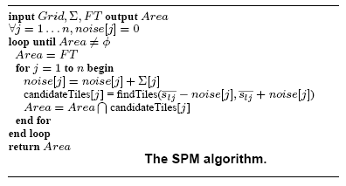
Figure 3.4

The Grid, Σ= (ε1, . . . , εn), FT , and Area, correspond to the a vector of the expected signals’ standard deviation received from each AP, a set of all the tiles on the floor, and the returned area, respectively.

More formally, SPM first finds n sets of areas, one for each AP_{j} , j = 1 . . . n, that “match” all fingerprints S_{l} = (s_{l1}, . . . , s_{ln}). The matching areas for each AP_{j} are found by adding an expected “noise” level, q to s_{lj}, and then by returning all the floor areas that fall within the expected threshold, s_{lj} ±q (we may substituted a value of -92 dBm for missing signals). SPM then returns the area formed by intersecting all matched areas from the different AP area sets.

For increasing the precision of the algorithm, i.e., to find the fewest high probability areas, it starts from a very low q. However, it then runs into the risk of returning no areas when one of the area sets returned from a particular AP is empty. Thus, on an empty intersection, the algorithm additively increases q, i.e., it first tries q, 2q, 3q,… , until a non-zero set of tiles results. Therefore, even in the worst case, a non-empty intersection will result when q is large enough.

An important issue is the how to pick the q for each AP_{j}. An intuitive way is to pick the expected standard deviation of the signals received from AP_{j}. For simplicity, you may pick 10 as the standard deviation for all APs as it is commonly used by localization. However, the standard deviation can vary from an access point to another, depending on the strength of the signal. Therefore, different standard deviation can be used as the threshold q for each AP to increase the accuracy in localization.

3.6 Area Based Probability
The strategy used by the Area-Based Probability (ABP) algorithm is to return a set of areas bounded by a probability that the object is within the returned set. We call the probability, α, the confidence, and it is an adjustable parameter.

To find a result area set, ABP computes the likelihood of received signal strength (RSS) that matches the fingerprints of each area in the training set (T0). Then it normalizes these likelihoods given the prior conditions: (1) the object must be on floor, and (2) all areas are a-priori equally likely to be visited. ABP then returns the top probability areas whose sum matches the desired confidence.

The confidence controls the accuracy-precision tradeoff. ABP thus stands on a more formal mathematical foundation than SPM. Figure 3.5 summarizes the ABP algorithm.
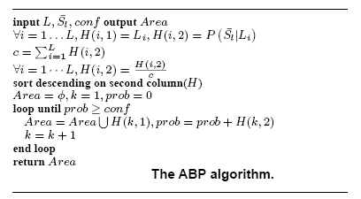
Figure 3.5

In ABP, signals received from different access points are assumed to be independent. For each AP_{j} , j = 1 . . . n, the sequence of received signal strengths s_{ijk}, k = 1 . . . o_{ij} , at each (x_{i}, y_{i}) in the original training set, T₀, is modeled as a Gaussian distribution. Although this assumption is not generally true, it significantly simplifies the computations with little performance degradation.

To apply the algorithm, we first generate a training set by the procedure mentioned in Section 3.2. Then, we compute the “mean” parameter of the distribution, s_{ij} for each fingerprint in the original training set T₀. For each AP_{j} , we assume that the standard deviation of the distribution at all the areas on the floor is constant, and equals to ε_{j}.

The algorithm use Bayes’ rule to compute the probability of being at each location, L_{i}, on the floor given the testing set S_{l}, i.e., the received signal strength of the object to be located. The Bayes’ rule is given below:
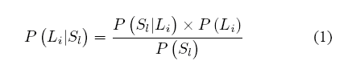
P(S_{l} | L_{i}) is the probability of having the testing set S_{l} when having known the current location is at L_{i}. P(S_{l}) is the probability of receiving this set of signal strengths S_{l} and P(L_{i}) is the probability at the location L_{i}.

However, P(S_{l}) is a constant c₁. Moreover, given we do not have prior knowledge about the exact object’s location. We assume that the object to be localized is equally likely to be at any location on the floor. So, P(L_{i}) = P(L_{j}), for all i and j and P(L_{i}) = c₂ for all i, where c₂ is another constant. Therefore, after we let c= c₂/ c₁, equation (1) is rewritten as equation (2) as follow:
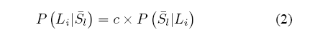
By using equation (2), we can derive the following:

Max{P(A_{i} |S_{t}) } = Max{c*P(S_{t} | A_{i}) } = Max{P(S_{t} | A_{i}) } (3)

Without having to know the value c, we can just return the location (area A_{i}) with maximum of P(S_{l} | A_{i}). In order to compute P(S_{l} | A_{i}) for all areas, we use the whole set S_{l} = (s_{l1}, . . . , s_{ln}) for computing the probability, i.e., signal strengths from all the access points. We also substitute a value of -92 dBm for missing signals, when the current location is not covered by the access point.

Let P(s_{lj} | A_{i}) be the probability of having a signal strength of s_{lj} from AP_{j} given the location is at A_{i}. P(s_{lj} | A_{i}) can be found by using our Gaussian distribution assumption. The follow is the equation of Gaussian distribution:
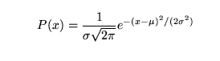 (4)
So, we compute P(S_{l} | A_{i}) by using the formula of independent event in probability:

P(S_{l} | A_{i}) = P(s_{l1} | A_{i}) X P(s_{l2} | A_{i}) X … X P(s_{ln} | A_{i}) (5)

Given that the object must be at exactly at one area, i.e., ΣP(A_{i} | S_{l}) =1 for all I,
ABP computes the actual probability density of the object for each area on the floor. Finally, ABP returns the top probability area(s) above its confidence, ε. This area(s) forms the result of localization.

4. Experiments and Implementation of Localization Algorithm

4.1 Our Choice of Algorithm
Distance Mapping Algorithm is simple and efficient in localization however it is not accurate and practical. It is because in real situation, the signal strength of an access point is not steady. It will fluctuate within a range. Therefore, the possible locations returned from one access point changes with time. By overlapping these area sets from all the access points, we can imagine that the resulting area is fluctuating. It indicates that the algorithm is very inaccurate.

Moreover, it is difficult to get a precise result from this algorithm. Sometimes, the overlapping area is an empty set (illustrated by Figure 4.1). And sometimes, a large area as the result set will be returned (illustrated by Figure
4.2).

X
X
X
Unknown Current
Location
X: Location of an access point
Figure 4.1
X
X
X
Current Location
X: Location of an access point
Figure 4.2

In comparing the Simple Point Matching and the Area-Based Probability algorithm, ABP is a more mathematically approach than SPM since it introduces a Gaussian distribution modal and the Bayles’ rule to find out the probability. More importantly, ABP is more robust and accurate than SPM. In SPM, sets of areas are returned from each AP and they are equally important. The resulting area is formed by intersecting these sets. However, in ABP, if the signal strengths received from a particular access point is closer to its mean value, then it will return a higher probability. In other words, more accurate signals received from one AP can compensate for other inaccurate measurements from other APs. As a result, we have chosen ABP in our project of localization.

4.2 Applying the Area-Based Approach
In order to apply the area-based approach, we divide the whole 1st floor of the Ho Sin-Hang Engineering building into different areas. We count each room as a single area and we further divide the corridor into several areas. Figure 4.3 is the floor plan of the 1st floor of the engineering building.
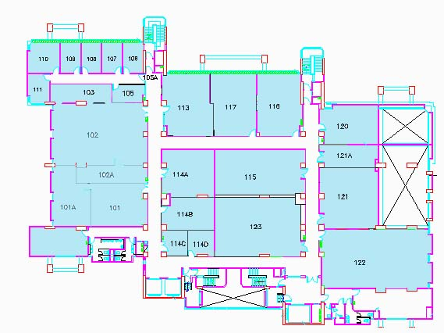

Figure 4.3

For simplicity, we only choose 12 different areas on the 1st floor to apply the localization. Area 1 is the one near the lifts, area 2 is the one near the toilet, area 3 is the one in front of Rm101, area 4 is at the North-West corner of the corridor, area 5 is near the North-West stairway on the first floor, area 6 is the one in front of Rm117, area 7 is at North-East corner of the corridor, area 8 is near the North-East stairway, area 9 is the one in front of Rm121, area 10 is at South-East corner of the corridor, area 11 is near the door of Rm123 and area 12 is at Rm101.

4.3 Generating Training Set
We have implemented a program called “Wi-Fi Location Detector”. It is a powerful tool to measure the signal received from the access points. The detail of this program is in section 6.7.

At each area chosen, we measure the signal strength from the access points for 1 minute. The access points detected depends on the location of measurement. Then, we average the samples so that we get the training set.

Figure 4.4 summarizes the fingerprints at the 12 areas. The missing data entry represent the access point is undetectable at the corresponding position.

Position | 1 | 2 | 3 | 4 | 5 | 6 | 7 | 8 | 9 | 10 | 11 | 12
AP MAC address | Signal Strength (dBm)
00:02:2d:28:be:9e | -70 | -62 | -58 | -67 | -73 | -78 | -83 | -86 | -84 | -81 | -78 | -55
00:02:2d:28:be:5d | -67 | -59 | -60 | -71 | -76 | -79 | -81 | -86 | -81 | -83 | -79 | -52
00:60:1d:1e:43:9b | -79 | -87 | -85 | -84 | -89 | -80 | -76 | -77 | -66 | -63 | -77 | -90
00:0f:34:f3:60:40 | -63 | -69 | -65 | -74 | -76 | -72 | -77 | -84 | -76 | -74 | -66 | -79
00:02:2d:21:39:1f |  |  | -82 | -78 | -82 | -59 | -78 | -73 | -83 | -85 | -82
00:11:93:3d:6f:c0 |  |  |  | -90 | -85 | -86 | -89 | -88
00:11:20:93:65:c0 |  |  |  |  | -89 | -89 |  |  |  |  |  | -90
00:0f:34:bb:df:20 |  |  |  | -89 | -90 | -82 | -88 | -88
00:0c:ce:21:1b:9d |  |  |  |  |  | -87
00:0c:85:35:33:d2 |  |  |  |  | -88 |  |  | -88
00:11:20:93:63:90 |  |  |  |  |  | -89 |  |  |  |  |  | -88
00:0c:85:35:33:d4 |  |  |  |  |  |  |  |  | -87
00:04:76:a7:ab:a3 |  |  |  |  |  |  |  |  |  |  |  | -90
Figure 4.4

After getting the samples, we find out the standard derivations of each access point. They are ranged from 7-10. There are totally 13 access points that can be detected on the floor, however, we do not use all of them for localization. Some of the Wireless LAN access points are located on another floor of outside the engineering building, so only very weak signals can be collected from them. We then ignore these access points because they have the least contribution to localization and also the computation time of the Area-Based Probability algorithm can be shortened. Finally, we have chosen 7 access points listed in Figure 4.5.

Name of Access Points | MAC Address
VIEWTECH AP1000 ONE A | 00:02:2d:28:be:9e
VIEWTECH AP1000 ONE B | 00:02:2d:28:be:5d
CSWaveLAN | 00:60:1d:1e:43:9b
ٱٱٱٱٱ | 00:0f:34:f3:60:40
CSWaveLAN | 00:02:2d:21:39:1f
ERGWAVE | 00:11:93:3d:6f:c0
ERGWAVE | 00:0f:34:bb:df:20
Figure 4.5

For missing signal strengths, we input -92 dBm as entry. We consider -92 dBm because it is slightly lower than the weakest signal strength we have recorded. Therefore, these values can also be used by localization algorithms in calculations. After the data-processing, the data are shown in Figure 4.6.

Position | 1 | 2 | 3 | 4 | 5 | 6 | 7 | 8 | 9 | 10 | 11 | 12
AP MAC address | Signal Strength (dBm)
00:02:2d:28:be:9e | -70 | -62 | -58 | -67 | -73 | -78 | -83 | -86 | -84 | -81 | -78 | -55
00:02:2d:28:be:5d | -67 | -59 | -60 | -71 | -76 | -79 | -81 | -86 | -81 | -83 | -79 | -52
00:60:1d:1e:43:9b | -79 | -87 | -85 | -84 | -89 | -80 | -76 | -77 | -66 | -63 | -77 | -90
00:0f:34:f3:60:40 | -63 | -69 | -65 | -74 | -76 | -72 | -77 | -84 | -76 | -74 | -66 | -79
00:02:2d:21:39:1f | -92 | -92 | -82 | -78 | -82 | -59 | -78 | -73 | -83 | -85 | -82 | -92
00:11:93:3d:6f:c0 | -92 | -92 | -92 | -90 | -85 | -86 | -89 | -88 | -92 | -92 | -92 | -92
00:0f:34:bb:df:20 | -92 | -92 | -92 | -89 | -90 | -82 | -88 | -88 | -92 | -92 | -92 | -92
Figure 4.6

4.4 Method in Getting the Testing Set

The above data is the training set. Then the remaining step is to apply the Area-Based Probability algorithm to use the training set. Originally, we have implemented Wi-Fi Signal Scanner to collect the signal strengths manually and generate the training set. We then modify it to collect the signal strengths and generate a testing set from time to time. The following table is an example of a set of received signal strength (RRS) we get from Point 1, i.e., at the lift.

AP MAC address | Signal Strength(dBm)
00:02:2d:28:be:9e | -71
00:02:2d:28:be:5d | -72
00:60:1d:1e:43:9b | -89
00:0f:34:f3:60:40 | -49
Figure 4.7

From Figure 4.7, we can see that only 4 wireless LAN access points are detected. In order to complete and generate a testing set, we need to substitute a value of -92dBm for missing data of the remaining 3 wireless LAN access points. Then the resulting testing set is shown in Figure 4.8.

AP MAC address | Signal Strength(dBm)
00:02:2d:28:be:9e | -71
00:02:2d:28:be:5d | -72
00:60:1d:1e:43:9b | -89
00:0f:34:f3:60:40 | -49
00:02:2d:21:39:1f | -92
00:11:93:3d:6f:c0 | -92
00:0f:34:bb:df:20 | -92
Figure 4.8

In order to get a more general set of testing set, we will first collect 4 sets of signals before we apply the localization. Then, we generate the testing set by averaging the values of the 4 samples. Therefore, the default sample size of the testing set is 4.

We have collected 100 testing sets for each of the 12 locations and applied the localization. Therefore, there are totally 1200 test cases for our localization system. We will then use the result of these test cases to estimate the accuracy of our system.

We would also like to find out how the number of samples in a testing set will affect on the accuracy, so we need to get the testing sets with different sample sizes. In order to do so, we have modified the program in Wi-Fi Location Detector so that when we invoke the collection of signals once, the generated testing set will contain the average value of new and current signal strengths. In other words, we are able to generate a testing set with larger number of samples which should be more accurate.

4.5 Finding Probabilities at Locations

4.5.1 Applying Bayles’ Rule
With the testing set S_{l}, we need to calculate the probability of being at each location, A_{i}, on the floor given the testing set, i.e., P( A_{i} | S_{l} ). By using the Bayles’ rule
and the equation derived in Section 3.6 talking about the Area-Based Probability Algorithm,
,we know that we only need to calculate the probability of having the testing set S_{l} when having known the current location is at L_{i}, i.e., P(S_{l} | L_{i}) in the above equation (2) for all locations.

4.5.2 Finding the Probability P(s_{lj} | A_{i})
P(s_{lj} | A_{i}) is the probability of having a signal strength of s_{lj} from AP_{j} given the location is at A_{i}. In order to find these probabilities, we need to use the assumption in Area-Based Probability algorithm. In ABP, signals received from different access points are assumed to be independent. For each wireless LAN access point, the sequence of received signal strengths s_{ijk}, k = 1 . . . o_{ij} , at each location in the original training set, T₀, is modeled as a Gaussian distribution (or Normal distribution) .

The equation of Gaussian distribution is
,where μ is the mean and σ is the standard derivation.

In our application, we can take μ as the expected average signal strengths for the access point to be calculated. And in order to simplify the computation, we take σ as 8.5. x is the signal strength received from the access point in the testing set. Figure 4.9 shows the graph of an example with mean signal strength = -60dBm and standard derivation of 8.5.

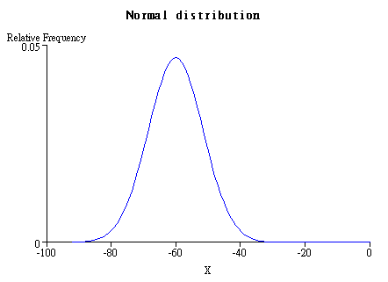
Figure 4.9

However, there is still a problem. The equation is a continuous function, but the signal strengths received are discrete values ranged from 0 to -92. Therefore, in order to use the equation, we need to define an interval. The most appropriate interval is 1 because each signal strength value should have an interval of 1 in the function of Gaussian distribution. Therefore, the probabilities can be found by the following equation:

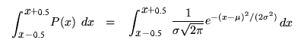

The probabilities found by integrating the Gaussian distribution equation can be illustrated by the Figure 4.10
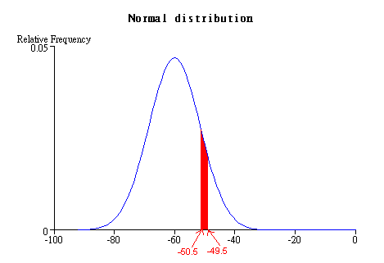
Figure 4.10

For example, when the signal strength in the testing set from a particular access point is -50dBm, the probability is represented by the red shaped area in Figure 4.10.

A standard normal distribution is a kind of normal distribution having μ=1 and σ=1. An arbitrary normal distribution can be converted to a standard normal distribution by changing variables. We let z = (x-μ) /σ and so we get the following equation.

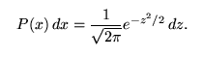

4.5.3 Finding Integral of the Gaussian distribution function

After that, we should introduce the error function erf(z) in probability. erf(z) is the "error function" encountered in integrating the normal distribution (which is a normalized form of the Gaussian function). It is an entire function defined by

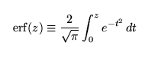

We need to introduce the error function because it can calculate the integration of normal distribution function in terms of finite additions, subtractions and multiplications. To achieve this, we need another expression of erf(z) which can be defined as a Maclaurin series.
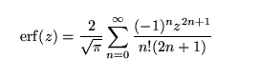
The relationship between the normal distribution function and the error function can be summarized by the following equations:

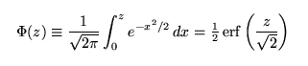

Hence, we can compute the value of this Maclaurin series and find out the probabilities P(s_{lj} | A_{i}) is the probability of having a signal strength of s_{lj} from AP_{j} given the location is at A_{i} for all i and j. We have found that if the value of signal strength is equal to the mean value of an access point, the probability calculated is approximately equal to 0.03.

4.5.4 Finding Probability P(S_{t} | A_{i})

P(S_{t} | A_{i}) is the probability of having the testing set S_{t} when having known the current location is at A_{i.} So, we compute P(S_{t} | A_{i}) for all 12 locations by using the formula of independent event in probability:
P(S_{t} | A_{i}) = P(s_{t1} | A_{i}) X P(s_{t2} | A_{i}) X … X P(s_{tn} | A_{i})

Then, we calculate the probability density based on the assumption that the mobile device must be at one of the 12 locations, i.e., ΣP(A_{i} | S_{t}) =1 for all locations i. We simply sum all the probabilities of the 12 locations and then divide all of them by the calculated sum.

With this formula derived in the algorithm,
Max{P(A_{i} |S_{t}) } = Max{c*P(S_{t} | A_{i}) } = Max{P(S_{t} | A_{i}) }
We return the area or location that is with the highest probability to indicate the mobile device is currently at this area.
Create a Training Set
Measure Signal Strength at Different Areas
Measure Signal Strength at Current Position
Create a Testing Set
Find out the Probabilities of Being at different Locations
Calculate Probability Density
Return the Area with Highest Probability
Data Processing
Data Processing
Using Wi-Fi Location Detector
Using Wi-Fi Signal Scanner
Using Normal Distribution Assumption and Error Function
Assume the Object must be on One Location
Finding the Highest Probability
Key Steps in Localization
Step 1
Step 2
Step 3
Step 4
Step 5
Step 6
Step 7
Figure 4.11 summarizes the key steps we use in localization

4.6 Experiment Result

The following 12 graphs show a general case that how the probabilities calculated by Area-Based Probability algorithm at the 12 areas change and achieve the goal of localization. Each of the graphs represents the Localization Graph at one area. There are totally 12 lines with different colors and each of them represent the probability of getting the testing set S_{t} given the location is at an area, i.e., P(S_{t} | A₁), P(S_{t} | A₂) … …P(S_{t} | A₁₂). The testing set is generated by averaging the signal strengths in the samples. The x-axis indicates the number of samples being used in the testing set. More samples are collected as time goes by so the x-axis can also be interpreted as a timeline. The y-axis indicates the value in terms of probability which is ranged from 0 to 1.

In ABP localization, the area with highest probability is returned, which indicates the mobile device is location at this area. In other words, within the same number of samples, the area with probability represented by a point in its line on the top is the returned area. Therefore, for example, for the Localization Graph at Area 1, the correct result should be the deep blue on the top. Otherwise, it means the result returned is incorrect.

Figure 4.12

Area 1 is the one near the lift. From the graph, we can see that the deep blue line represents the probability of being at area 1. It shows the probability first starts at about 0.4 and then drops to 0.25 and finally it gradually increases to 0.33. The line is always on the top of other lines as the number of samples increases. Therefore, our system always indicates the object is at area 1 which is the correct result.

Figure 4.13

Area 2 is the one near the toilet. From the graph, we can see that the purple line representing the probability of being at area 2 is always on the top of other lines as the number of samples increases. The probability is stable and always stays around 0.5. For other probabilities, they are quite stable and always stay below a value of 0.2. Therefore, our system always indicates the object is at area 2 which is the correct result.

Figure 4.14

Area 3 is the corridor in front of Rm101. From the graph, we can see that the green line representing the probability of being at area 3 is always on the top of other lines as the number of samples increases. The probability is quite stable and is always around 0.5. For other probabilities, most of them are quite stable and all of them always stay below a value of 0.3. Therefore, our system always indicates the object is at area 3 which is the correct result.

Figure 4.15

Area 4 is the North-West corner of the corridor. From the graph, we can see that the light blue line representing the probability of being at area 4 is always on the top of other lines as the number of samples increases. The probability is quite stable and is always over 0.4. The probability of being at area 5 remains at a comparatively high value around 0.3. For other probabilities, they are quite low, stable and always stay below a value of 0.1. Therefore, our system always indicates the object is at area 4 which is the correct result.

Figure 4.16

Area 5 is near the North-West stairway on the first floor. From the graph, we can see that the deep purple line representing the probability of being at area 5 is always on the top of other lines as the number of samples increases. The probability is quite high and is always around 0.6. For other probabilities, they are quite stable and always stay below a value of 0.2. Therefore, our system always indicates the object is at area 5 which is the correct result.

Figure 4.17

Area 6 is the one in front of Rm117. From the graph, we can see that the brown line representing the probability of being at area 6 is always on the top of other lines as the number of samples increases. The probability is very high and is usually around 0.9. For other probabilities, they are very low, stable and always have a value near 0. Therefore, our system always indicates the object is at area 6 which is the correct result.

Figure 4.18

Area 7 is the North-East corner of the corridor. From the graph, we can see that the deep green line representing the probability of being at area 7 is below the blue one when the number of samples equals to 1. As the number of samples increases, the probability of deep green line increases and remains at a value of 0.36 while the probability of blue line drops and lies below it. Therefore, our system first indicates the object is at area 8 which is an incorrect result and then indicates the object is at area 7 when the number of samples reaches 5.

Figure 4.19

Area 8 is near the North-East stairway on the first floor. From the graph, we can see that the blue line representing the probability of being at area 8 is always on the top of other lines as the number of samples increases. The probability is quite high and is always around 0.45. The probability of being at area 7 remains at a comparatively high value over 0.3. For other probabilities, they are quite low, stable and always stay below a value of 0.12. Therefore, our system always indicates the object is at area 8 which is the correct result.

Figure 4.20

Area 9 is the area in front of Rm121. From the graph, we can see that the light blue line representing the probability of being at area 9 is below the deep green one when the number of samples equals to 1. As the number of samples increases, the probability of the light blue line increase and remains at a value over 0.35 while the probability of deep green line drops and lies below it. Therefore, our system first indicates the object is at area 7 which is an incorrect result and then indicates the object is at area 9 when the number of samples reaches about 5.

Figure 4.21

Area 10 is South-East corner of the corridor. From the graph, we can see that the pale blue line representing the probability of being at area 10 is below the light blue one when the number of samples equals to 1. As the number of samples increases, the probability of the pale blue line increase and remains at a value around 0.4 while the probability of light blue line drops and lies below it. Therefore, our system first indicates the object is at area 4 which is an incorrect result and then indicates the object is at area 10 when the number of samples reaches about 5.

Figure 4.22

Area 11 is the one near the door of Rm123. From the graph, we can see that the yellow line representing the probability of being at area 11 is always on the top of other lines as the number of samples increases. The probability is quite high and is always over 0.5. For other probabilities, they are quite low, stable and always stay below a value of 0.15. Therefore, our system always indicates the object is at area 11 which is the correct result.

Figure 4.23

Area 12 is at Rm101. From the graph, we can see that the orange line representing the probability of being at area 12 is always on the top of other lines as the number of samples increases. The probability is quite high and remains over 0.8 as the number of samples reaches 13. For other probabilities, they are quite low, stable and always stay below a value of 0.15 as the number of samples increases. Therefore, our system always indicates the object is at area 12 which is the correct result.

5. Analysis of Experiment Results

5.1 Performance of Area-Based Probability Algorithm
The performance of ABP algorithm is good. It usually returns the correct location with a high probability over 0.3 and for most of other locations, it usually return a probability as low as 0.001. Therefore, it works well in distinguishing different locations.

However, when two areas are close together, the signal strengths collected from one area is similar to that of the other. In this case, the algorithm usually returns comparable probabilities for these two areas. Therefore, the algorithm may fail to give the correct location.

There is a tradeoff between time and accuracy in localization. A testing set is usually more accurate if its sample size is larger, but it requires a longer time to collect the signals. ABP algorithm has an acceptable accuracy even though the sample sizes of the testing sets are small. In other words, ABP algorithm can be applied to some location-based applications which require real-time localization.

5.2 Accuracy of our localization system
Figure 5.1
Figure 5.1 shows the accuracy of our system at different locations. The accuracy is in terms of the percentage of our system returning a correct location during localization. We have taken 80 testing sets for each of the 12 locations and test on the result of our system. The overall accuracy of our system is about 75.94%. That means on average, our system can indicate 76 correct locations when taking 100 trials.

We have found that the accuracy varies with different locations. It is because the localization algorithm will depends on the testing set generated at different locations. The accuracy at area 9 is particularly low because the distance between area 9 and area 10 is too close. Therefore, the signal strengths received from area 9 is very similar to those from area 10. Hence, our system may fail to distinguish between the two locations.

5.3 The effect of number of samples on accuracy
Figure 5.2
Figure 5.3

Figure 5.4

Figure 5.2, Figure 5.3 and Figure 5.4 show how the accuracy changes with the number of samples included in a testing set. Figure 5.2 and Figure 5.3 show the accuracy changes at different locations while Figure 5.4 represents the overall accuracy change of the system. We can conclude that the accuracy increases with the sample size. It first increases significantly and finally levels off when the sample number equals 21.

The accuracy will never reach 100% because there are some other factors affecting the accuracy. It will be discussed in the next section.

5.4 Other factors affecting the accuracy

5.4.1 Hardware failure
When any of the access points fails to give out signals or give out signals at unusual strength, the signals received from the mobile device will be different. Therefore, the accuracy of the system will decrease.

5.4.2 Change in environment
When there is one or more access points in the floor, its signals will cause the disturbance for those of original access points. Also, when someone opens the door or change the location of some large enough objects in the floor, it will affect the signals received. Because the signals may be originally weaken by the doors or these objects.

5.4.3 Orientation in collecting signal
Figure 5.5
Figure 5.6

Figure 5.5 and Figure 5.6 show the accuracy of localization when using different orientation in collecting the signals. The accuracy is measured at Rm101 and the North-East Corner of the 1st floor corridor respectively. We can see that there are slightly differences in the accuracies for different orientations. The orientation in collecting signals has some but not significant effect on localization.

6. Center-of-Mass technique in Continuous Space Estimation

6.1 Limitation of Discrete Space Estimation
In the last semester, we have used the area-based probability model to find out the current location. This model bases on firstly finding out the probability of being at each location in the training set and then returning the one with the highest probability. We find out the result in this way is one of the methods in discrete space estimation in which only a fixed number of output can be returned.

However, this method of discrete space estimation is not suitable for some location-based mobile application. Because when we move between two locations in the training set, the algorithm will never return an intermediate location where is the actually position. In order to due with this limitation in discrete space estimation, we introduce the Center-of-Mass technique in continuous space estimation.

6.2 Center-of-Mass in Continuous Space Estimation
We have chosen to implement the Center-of-Mass technique in continuous space estimation to solve the limitation of discrete space estimation. Using continuous space estimation has several advantages including the possibility of returning intermediate positions, higher accuracy and more suitable for mobile applications. Therefore, in order to improve our tour guide application, it is necessary for us to introduce this technique.

The Center of Mass technique is based on treating each location in the radio map as an object in the physical space whose weight is equal to the normalized probability assigned by the discrete-space estimation process. We then obtain the Center of Mass of the N objects with the largest mass, where N is a parameter to the system. More formally, let p(i) be the probability of a location x_{i}, i=1,2 …n, where n is the total number of locations in training set. Let Y be the set of locations in 2D space and Y(i) is the corresponding position of x_{i}
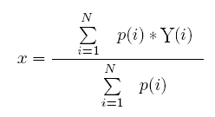
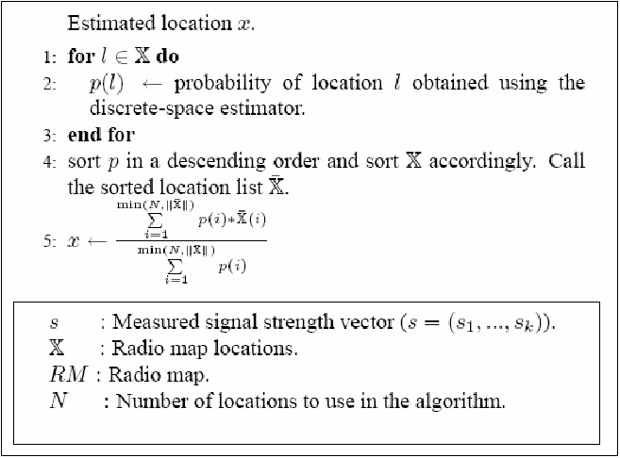

6.3 Applying Center of Mass technique in the Guide Service
In our Tour Guide Application, we have implemented the center of mass technique and we have found that it can really solve the limitation of the discrete space estimation. It can return an intermediate point, that is, points not in the training set. It also increases the overall accuracy and give a smooth change of position when we use a mobile device to move around the floor. The detailed evaluation of accuracy is given in later topics.

7. Evaluation of the Accuracy of Centre of Mass in Continuous Space Estimation

7.1 Methodology
As mentioned before, we have implemented the Center of Mass technique in our localization system. We are going to evaluate the performance of the new system and check if the accuracy is improved.

In order to find out the performance of our system and compared with the old one using Discrete Space Estimation, we carry out an experiment. Again, we have chosen 16 positions for the training set. They are shown in figure 7.1. In every location in the training set, we use our system to perform positioning for 100 times and we have implemented a simple program to record down the estimated positions. Our system estimates a new position at a interval of 4 second, therefore, totally, we need approximately 2 hours to get 1500 records.

After that, we calculate the distance error which is the distance between the actual position and the estimated positions. The value of the distance error is directly proportion to the actually distance. 1 distance error is about 10 centimeters. We also count the number of records that gives the same distance error for each location and it yields the frequency data.

Figure 7.1

7.2 Experiment Result
There are totally 15 positions for the training set. For each of them, there are two pairs of diagrams. One of them shows the distribution of the estimated points on the floor in which the blue dots on the floor plan represent the estimated point. The other shows the distribution of the distance error that is the distance between an estimated point and the actually position.
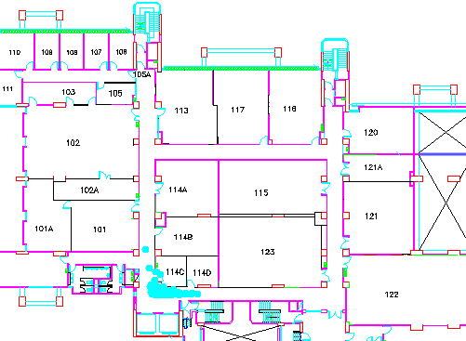

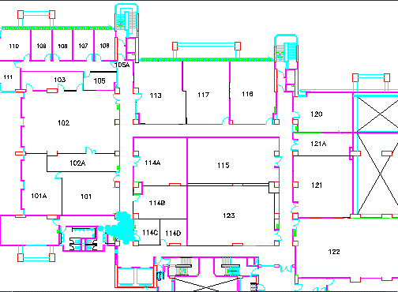

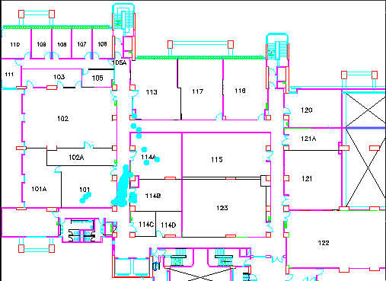

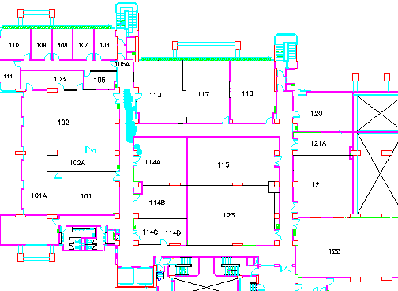

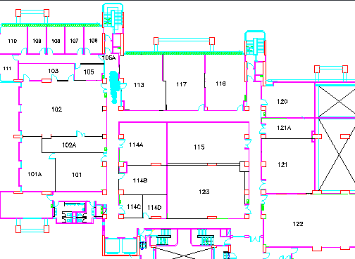

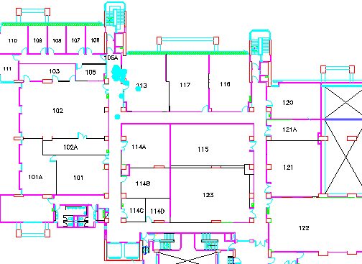

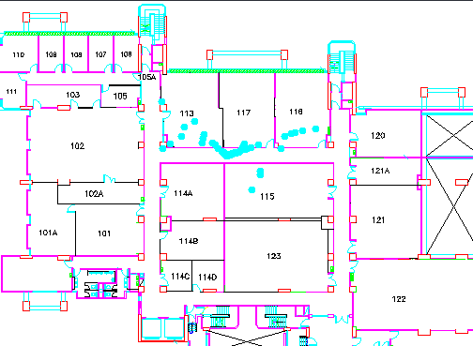

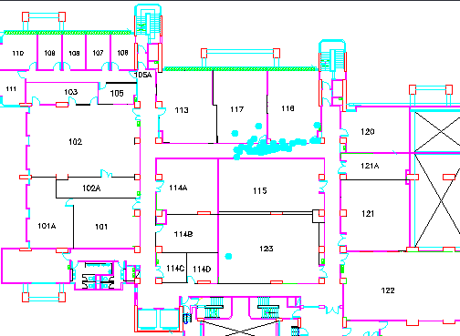

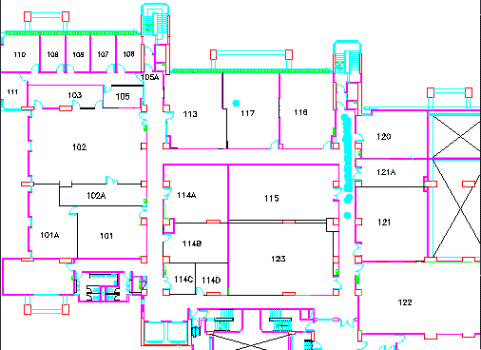

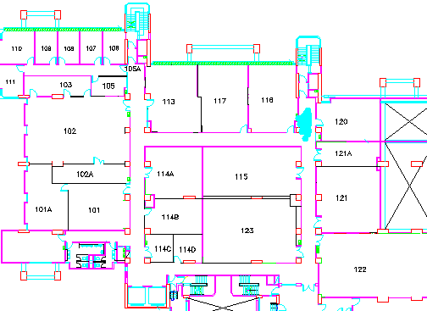

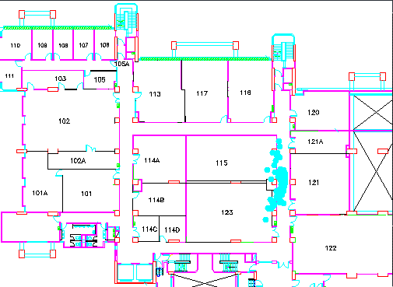

EMBED Excel.Chart.8 \s

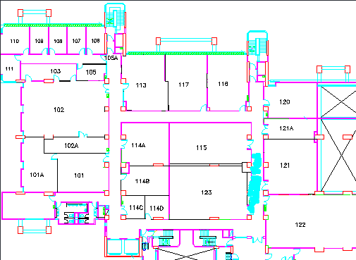

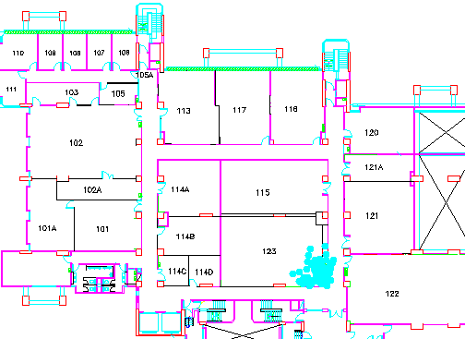

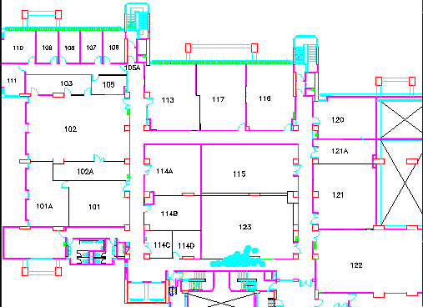

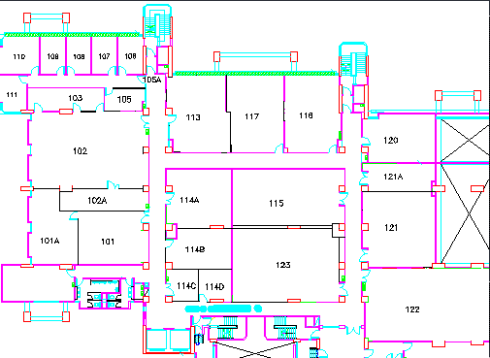

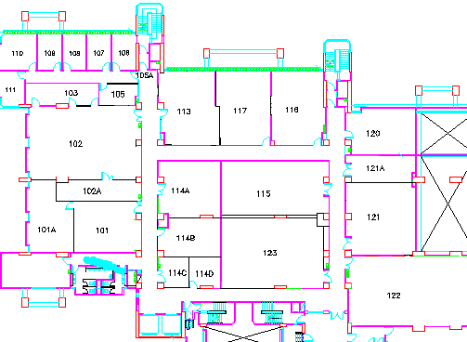

The following figures show a summary of statistics at all the positions:

7.3 Analysis of Experiment Result
- We have found that over 80% of the records are within 2 meters from the actually position and over 95% are within 3 meters. In other words, if the tolerance of error is 2 meters and 3 meters, the accuracy of our system is over 80% and 95% respectively.

- For most of the locations, especially at location 4,location 5 and location 10, the curve in its distance error graph shifts towards the right. It indicates that all the estimated points contain a certain amount of error as noise. It is may be due to the error in collecting the training set and collecting data for the experiment. More likely, it is due to the inaccuracy of continuous space estimation because the distance in real world may not be proportion to the probabilities among the training set positions.

Take the following as an example:
Suppose there are two positions A and B. The distance between A and B is 5 meters. When we are exactly at position A, we collect a set of received signal strength at it and carry out continuous space estimation. Because the A and B is close to each other, the signal strengths in the training set at A and B can be similar. Therefore, the probability calculated at B is non-zero and significantly affect the estimated position. Hence, the estimated point is not at A but shift a little bit towards B.

A
B
0.8
0.2
- For all the locations, we can find a few estimated points with a large distance error, for example, those between 3 meters to 5 meters. These points contribute to the inaccuracy of our system. Since our application trigger continuous space estimation in real time (4 per second), the scanner in our system may not collect enough signal strength. With this limited number of received signals, it is not accurate to carry out space estimation and hence, the result is not desirable.
- When we compare the continuous space estimation with the previously developed discrete space estimation, the result of former estimation at the training set locations is not precise enough. It is mainly due to the shifting effect in continuous space estimation. However, with an acceptable tolerance, the accuracy of the new system is still good. It has a better accuracy with tolerance of 2 meters.

- For intermediate points which are those lying between training set positions, the discrete space estimation is unable to locate them. It can only at most accuracy return the closest training set positions. Therefore, it is meaningless to talk about its accuracy at these points. For continuous space estimation, we find that our system has similar accuracy for the intermediate points comparing to training set positions. Therefore, continuous space estimation is more suitable for our system.

8. Point Mapping technique in the Guide Service

8.1 The Aim of Point Mapping Technique
Although the Center of Mass technique works very well and improves the positioning accuracy, we still find there are some aliasing due to the computation. For some times, when we walk around the corridor, we can see the positions returned is inside a room which is incorrect. In order to remove this aliasing and give a more fancy output, we can use the point mapping technique to solve it. The goal of the point mapping technique is to map the position returned from the continuous space estimator to a nearest point in the corridor. Of course, for simplicity, we have assumed all the possible locations of the mobile device are within the corridor.

8.2 Applying Point Mapping Technique
There are several methods that can achieve point mapping algorithm. The simplest one is to divide the whole corridor into a set of points. And then, we search for the closest point in the set. But, this method will introduce new error from quantization and require a heavy overhead of searching. Therefore, we have decided to use a line as a unit. First of all, we divide the whole corridor on the floor into several line segments shown figure 8.1.

Figure 8.1

In figure 8.1, there are totally 5 line segments and we denote them by L _{i} for i=1,2…5. Then, we need to define each line segment L _{i} by an equation:
P = P _{i1} + u _{i} (P _{i2} – P _{i1})
, where P_{i1} (x _{i1},y _{i1}) is the starting point of L _{i} ,P _{i} (x _{i2},y _{i2}) is the end point of L _{i} and u is a constant.

Suppose the point E(x _{e},y _{e}) be the estimated point returned from the continuous space estimator. Let I_{i} be the point of intersection between one of the lines L _{i} and the line at the tangent to L _{i} passing through E. Their relationship is illustrated by the following diagram:
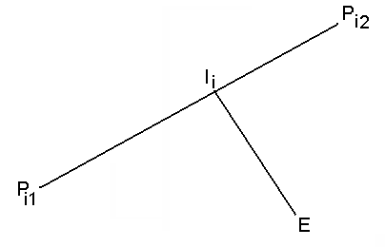
After that, in order to find the closest point on the set of lines, we have to calculate the distance D_{i} for all i, which is the distance between the estimated point E and L_{i}.

Since the tangent is perpendicular to L_{i}, we know that the dot product of the tangent and L_{i} is 0, thus we have:
(E - I_{i}) dot (P _{i2} – P _{i1}) = 0

After solving this equation and make constant u as subject, we have
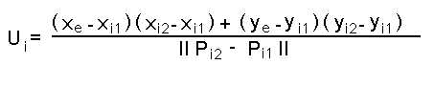
Moreover, we substituting u_{i} into the equation of L_{i} gives the point of intersection I_{i} as:
x = x_{i1} + u_{i} (x_{i2} – x_{i1})
y = y_{i1} + u_{i} (y_{i2} – y_{i1})

Having known the intersection, we calculate D_{i} for all i which is equal to the distance between I_{i} and E given by:
||I_{i} – E ||²
However, sometimes the intersecting point I_{i} does not line on the line segment L_{i}, so we need to check the value of constant u_{i}. I_{i} lies on the line segment L_{i} if and only if u_{i} lies between 0 and 1 inclusively. Finally, we return I_{i} with 0 ≤ u_{i} ≤ 1 and with smallest D_{i}.

1
2
Figure 8.2
In figure 8.2, the point mapping technique maps the point at position 1 to position 2. Therefore, the new mapped position is along the corridor.

8.3 Evaluation of Point Mapping Technique in Continuous Space Estimation
In order to give a more fancy interface and outlook of our tour guide application, we have implemented a point mapping function in our system. The goal is to map the estimated point output from our continuous space estimator to the nearest point in the corridor. However, we do not know if this technique has any side effect in our localization accuracy. As a result, we introduce experiments to find out the effect.

8.3.1 Methodology
Again, we have chosen the 16 positions for the training set which are used in the continuous space estimation. They are shown in figure 7.1. In every location in the training set, we use our system to perform positioning with refinement of point mapping for 100 times. We also use a simple program to record the estimated positions. Our system estimates a new position at an interval of 4 seconds; therefore, totally, we need approximately 2 hours to get 1500 records.

After that, we calculate the distance error which is the distance between the actual position and the estimated positions. The value of the distance error is directly proportion to the actually distance. 1 distance error is about 10 centimeters. We also count the number of records that gives the same distance error for each location and it yields the frequency data.

8.3.2 Experiment Result
There are totally 15 positions for the training set. For each of them, there is a diagram shows the distribution of the estimated points on the floor in which the blue dots on the floor plan represent the estimated point with refinement. Finally, there are a summary of distance error of estimated point at all positions.
Position 0
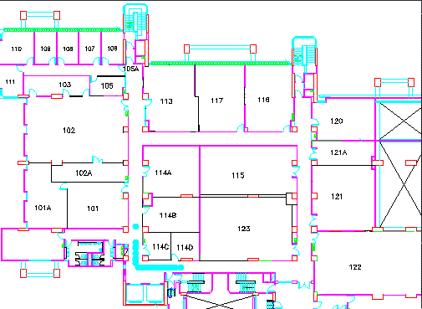

Position 1
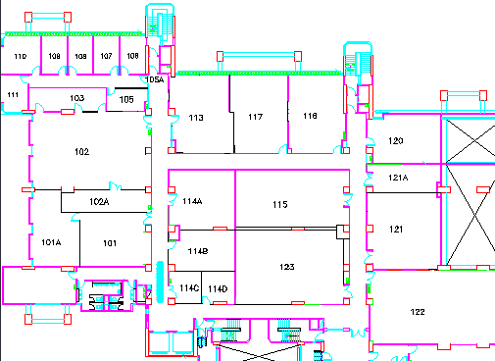
Position 2
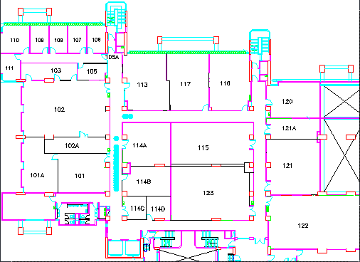

Position 3
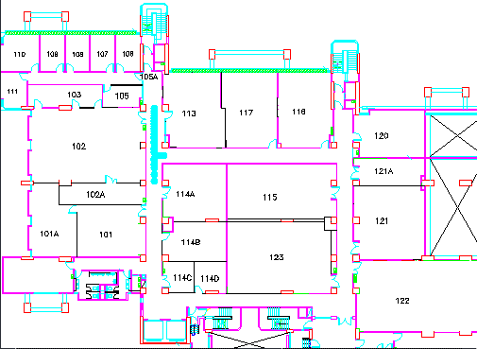
Position 4
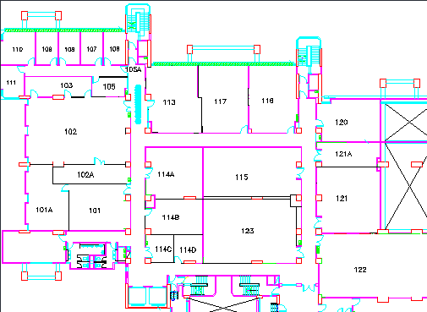

Position 5
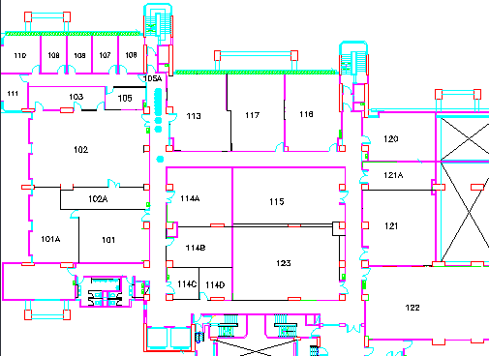
Position 6
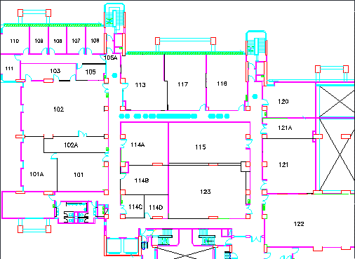

Position 7
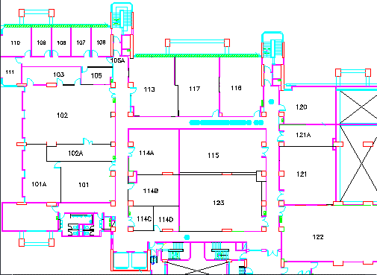
Position 8
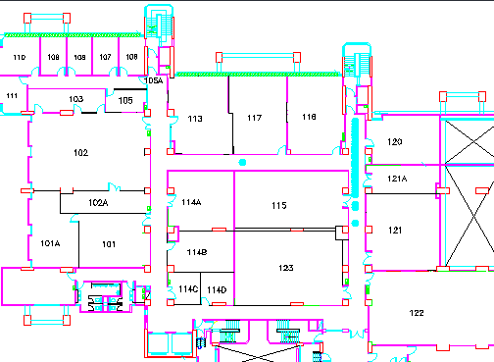

Position 9
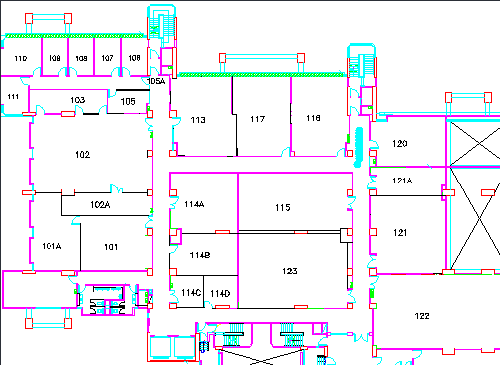
Position 10
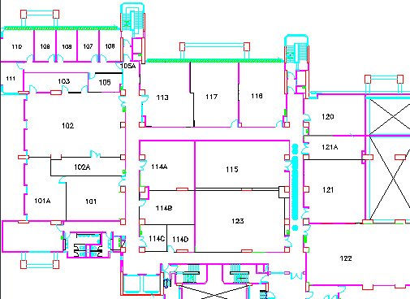

Position 11
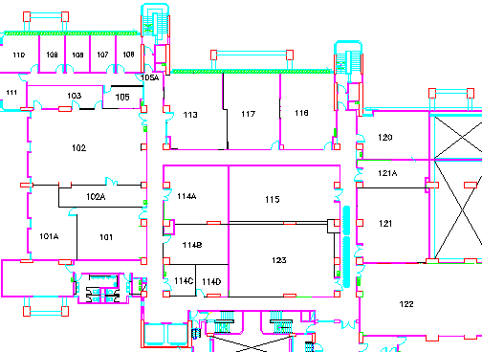
Position 12
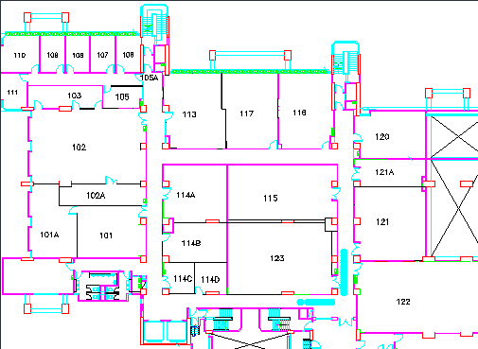

Position 13
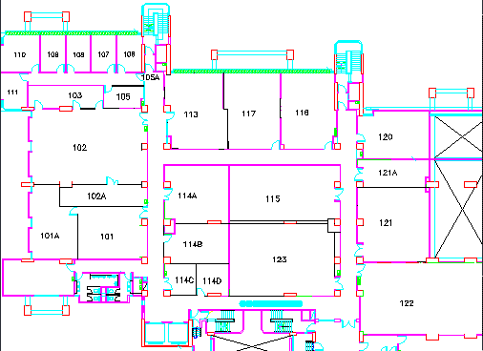
Position 14
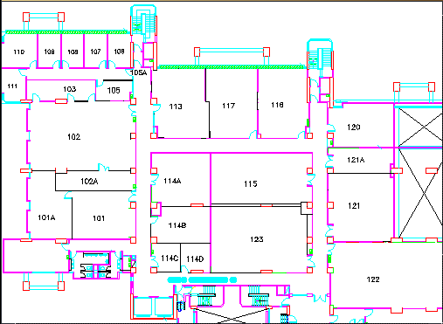

Position 15
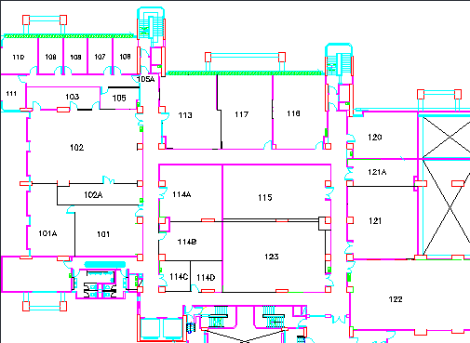

8.3.3 Summary of the Experiment Statistics

8.3.4 Analysis of Experiment Result
The performance of the Point Mapping algorithm is acceptable. It can achieve a better user interface for the Guide Service. In general, the estimated points with small distance error in continuous space estimation, the Point Mapping technique maps them to a point closer to the actual position. So, the overall distance error is reduced. On the other hand, for those with high distance error in continuous space estimation, the Point Mapping technique maps them to a point further away from the actual position. So, the overall distance error is increased. On average, the two effects cancel each other and hence the overall accuracy of our system is not affected by point mapping technique. To, conclude, it is feasible to use Point Mapping algorithm to give a fancy user interface.

9. Shortest Path Algorithm in the Guide Service

9.1 Introduction to Shortest Path Problem
Suppose the user want to go to a particular destination from the current location. The user may have more than one path to go through and we need to find a shortest path among all the possible paths.

For example, if the user is currently at Room101, and he/she wants to go to Room 117, it is very obvious that the user have 2 paths, one is through the upper red path in figure 9.1 and the other is through the blue path.

Figure 9.1

9.2 Applying Dijkstra’s algorithm in the Guide Service
Not all the people are able to read a map very clearly and some of them do know neither their current position nor their target destination even though given a map. Therefore, we have implemented an algorithm in our Tour Guide application in order to provide a shortest path for the user.

In order to teach the computer to find out the shortest path, we have used an algorithm called Dijkstra’s algorithm which is well-known to be a good algorithm to find a shortest path. However, we cannot apply the algorithm directly in our application. Firstly, we need to prepare a graph for computation. We define the nodes as the turning points or the ending of the corridors shown in figure 9.2. Then we add them to the graph. We also define edge between the nodes. If there is a path between two nodes, we add an edge connected between the two nodes. Also, we give a weight to each edge which is equal to the distance between the two connected nodes.

Figure 9.2
1
5
2
6
3
4
7
8
81
116
38
76
200
200
154
43
Figure 9.3

In figure 9.3, we have converted the floor plan into a graph with 8 nodes. The weights of the edges are in the ratio of their distances between their two connected nodes.

Given the pre-defined graph as well as the source and destination location, we should add two more nodes, one for the source and the other for the destination to the graph. The most difficult part is to find a way to add the edges between the source or the destination and other nodes. First of all, we use the technique similar to the point mapping algorithm. We consider every edge as a line segment. The segment is defined by two points and their coordinates equal to the positions of the two connected nodes. Then, we find out the lines that the current or the destination is the closest to. After that, we are able to add the new edges and calculate their weight. Taking the same example, we have a newly constructed graph as figure 9.4.

3
8
4
7
C
60
56
D
110
90
1
5
2
6
81
38
76
200
154
43
Figure 9.4

A shortest path problem is given a connected graph G=(V,E), a weight d:E->R+ and a fixed vertex s in V, find a shortest path from s to each vertex v in V. In our case, V= {1,2,3,4,5,6,7,8,C,D} and E= {(1,2), (2,C), (C,3), (3,8), (3,4), (2,D), (D,6), (5,6), (6,7), (4,7)} and their weight are shown in figure **. C is a vertex representing the current position and D represents the destination.

With this graph, we are able to find out the shortest path from C to D. In Dijkstra’s algorithm, there are totally |V|-1 times of relaxation. Initially, the shortest distances L(V) to all the vertexes are infinity and the set S contain the source C only. In each relaxation, the value L(V) is recalculated if V is not in S and connected some V in S. After each relaxation, a new vertex with minimum L(V) is put to a set S until all V are in S.

9.3 Pseudo code of Dijkstra's Algorithm
- Set i=0, S₀= {u₀=s}, L(u₀)=0, and L(v)=infinity for v <> u₀. If |V| = 1 then stop, otherwise go to step 2.
- For each v in V\S_{i}, replace L(v) by min{L(v), L(u_{i})+d_{v}^{u}_{i}}. If L(v) is replaced, put a label (L(v), u_{i}) on v.
- Find a vertex v which minimizes {L(v): v in V\S_{i}}, say u_{i+1}.
- Let S_{i+1} = S_{i} cup {u_{i+1}}.
- Replace i by i+1. If i=|V|-1 then stop, otherwise go to step 2.

9.4 Example of Dijkstra’s Algorithm
3
8
4
7
C
∞
D
∞
1
5
2
6
∞
∞
∞
∞
∞
∞
0
Relaxation 0
∞

3
8
4
7
C
60
D
∞
1
5
2
6
∞
∞
∞
∞
∞
56
0
Relaxation 1
∞

3
8
4
7
C
60
D
∞
1
5
2
6
∞
∞
∞
94
132
56
0
Relaxation 2
∞

3
8
4
7
C
60
D
∞
1
5
2
6
170
∞
∞

94
132
56
0
Relaxation 3
141

3
8
4
7
C
60
D
∞
1
5
2
6
170
∞
294
94
132
56
0
Relaxation 4
141

3
8
4
7
C
60
D
∞
1
5
2
6
170
∞
294
94
132
56
0
Relaxation 5
141
3
8
4
7
C
60
D
∞
1
5
2
6
170
∞
294
94
132
56
0
Relaxation 6
141

3
8
4
7
C
60
D
∞
1
5
2
6
170
260
294
94
132
56
0
Relaxation 7
141

3
8
4
7
C
60
D
303
1
5
2
6
170
260
294
94
132
56
0
Relaxation 8
141

3
8
4
7
C
60
D
303
1
5
2
6
170
260
294
94
132
56
0
Relaxation 9
141

10. Multimedia Guidance System

10.1 Introduction
Multimedia Guidance System (MGS) aims to develop Location-Based Multimedia System in a short time. With these tools, non-professionals can develop with little effort. With tradition development methods, it includes lots of steps such as design, analysis, etc. MGS simplifies steps and increases the efficiency and productivity in implementing system.

MGS consists of three components: Wi-Fi Signal Scanner (WSS), Multimedia Guidance Processor (MGP) and Location-Based Multimedia Service System (LBMSS).

Wi-Fi Signal Scanner
This is a tool installed in a mobile device to collect the data from access points at target place. It records the mean of signal strength received by the mobile device. After collecting the data from all the target position, the data is then being analyzed in the MGP.

Multimedia Guidance Processor
Multimedia Guidance Processor (MGP) is a tool to process signal strength data and set the client environment for LBMSS. MGP have to filter out some signal strength data because noise data are collected from WSS. This step can increase computation in LBMSS. For each target position, specific information is also set in MGP, e.g. name, picture, video, etc. Finally, LBSData file will be generated by MGP and passes to LBMSS for setting client environment.

Location-Based Multimedia Service System
Location-Based Multimedia Service System (LBMSS) is main part of MGS. This part composes of clients and servers. The client environment is controlled by LBSData file which is generated by MGP. The servers are mainly constructed by existing server architecture (e.g. HTTP, FTP). Some servers are tailored made for specific multimedia services. With client and servers, LBMSS provides interactive multimedia service for users. LBMSS provides chat, video, paint and guide services.

10.2 Deploying Procedure

Processing Data and generating LBSData
Collecting Signal strength data
Deploying System with clients and server application
Figure 10.1

Step 1 (Collecting Data):
First, the developer needs to collect the source data from the Wi-Fi network at target place. At each target position, it must collect mean strength signal data from Access Points. The data then are processed in the next step and used in localization algorithm.

Step 2 (Processing Data and generating LBSData):
Second, there are two things to do in this step:

1. The developer needs to process the source data and filter out some useless data (noise data). Normally, WSS collects some weak signal from outside target place or failed Access Point. This noise data affects the accuracy of localization algorithm. The data must be filtered out manually.

2. The actual position on map picture, name, video and picture of the position will be shown in LBMSS. All information should be set in this step.

At the end, LBSData file is generated by MGP.
Step 3 (Deploying System with clients and server application):
LBSData file generated in step2 would be used by LBMSS client. The client will set environment according to LBSData File. The client application estimates actual position by localization algorithm. The server application’s environment is also be set manually in this step. It includes setting up server, testing server and deploying server. After setting clients and servers, LBMSS can deploy multimedia service to users.

10.3 Features of Multimedia Guidance System (MGS):

a. Scalability:
The MGS can apply in any flexible environment. In case the change of environment, it can generate the System with perform the procedure once. The new System can be run in the new environment. MGS can be scaled at any time and anywhere.

b. Abstraction
The MGS would do all the prepared work for the developer. And most of prepared work is only the low level technology studying and research work. The developer only focuses on how to increase the accuracy of System rather than studying the prepared work. The prepared work is transparent for the developer.

c. Transparent
No matter what changes in the MGS, they can still deploying the system without any problem. Even though the core part of the MGS system is changed, it only affects core part, such as algorithm. The data source remains unchanged in the MGS.

d. User-friendly
The three components are made by using fancy user interface. They are very easy to use. The developer only needs to know how to use them correctly. It can be used by anyone with basic computer knowledge. They can handle the MGS well.

The MGS is a powerful and user friendly system. It can re-deploy system with applying three components once. The new system can deploy to users. MGS can develop Location-based Multimedia Service System within a short period of time.

10.4 Wi-Fi Signal Scanner (WSS)

Wi-Fi Signal Scanner is a tool to collect the signal strength received at the target position. The data then are used in the MGP. We will detail explain the WSS’s architecture, method of usage in the following section.

10.4.1 Software Architecture

Network Driver Interface Specification (NDIS)
Embedded Visual C++
Dynamic link library (DLL)
Visual Studio .NET 2003
Control Object (User Interface)
Build Library
Call DLL by DllImport
Control Architecture
View Architecture
Figure 10.2
The Software Architecture is divided into two main parts: Control Architecture and View Architecture.
Control Architecture (CA) controls the program flow in the WSS. Its main function is to get the Wi-Fi information for the program. CA is made by tools Embedded Visual C++. Embedded Visual C++ supports lots of libraries for programming Pocket PC. It is a desirable tool for CA. The CA gets the Wi-Fi information though Network Driver Interface Specification (NDIS) Application Programming Interface (API). NDIS is explained in the following section.

View Architecture (VA) is used to display the result for WSS. Since the Visual Studio .NET 2003 supports lots of user interface control, it is desirable for building a fancy interface for WSS. Many fancy user interface controls are supported, such as Data Grid, Label, Tree View and Scroll Bar.

The main bridge for VA and CA is the Dynamic link library (DLL). The CA information is passed by the DLL to VA such that it can display in the VA interface. The CA project is build by Dynamic link library (DLL) project in Embedded Visual C++. The main DLL role is to act as a bridge for CA and VA to communicate. This is an important part of Software Architecture.

10.4.2 Network Driver Interface Specification (NDIS)

The Network Driver Interface Specification (NDIS) is the interface by one or more network adapter drivers communicate with network adapters, protocol drivers, miniport drivers, and operating system. NDIS is abstracted all the lower level network adapter development for developer.

NDIS provides a pair of abstraction layers that connect network adapter drivers to an overlying protocol stack. Transmission Control Protocol/Internet Protocol (TCP/IP) and Infrared Data Association (IrDA) are the example for overlying protocol.

NDIS is supported in the Windows CE. NDIS provided a abstracted programming interface to write an target-specific programming/driver for the network adapter. All Kernel-mode functions required for development can be exported by NDIS Dynamic Link Library (Ndis.dll). NDIS also store the state information for the network adapter. That means all the information related to network adapter can be access by the user program through NDIS.
NDIS support these following functions:
a. A network adapter driver provided an abstracted layer for the upper-layer (Application Layer) to sending the data into the network.
b. A network adapter driver provided an abstracted layer for the upper-layer (Application Layer) to receive the data from the network.
c. It provides an interface for upper-layer (Application Layer) to configure a network adapter or a network adapter driver
d. It provides an interface for upper-layer (Application Layer) to queries a network adapter driver for specific configuration data from an underlying network adapter or from the network adapter driver

The following diagram shows the overall NDIS architecture for Windows based Architecture:
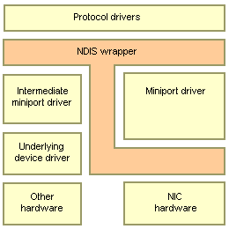
Figure 10.3
This diagram shows the NDIS acts as the bridge for the Protocol and the network adapter (Lower Layer). NDIS acts as midpoint role for the application to communicate with network driver. NDIS is interface for the application to get the lower layer information in the network adapter.

10.4.3 Feature of Wi-Fi Signal Scanner

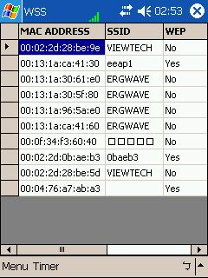
Figure 10.4
The above is the View of the WSS. They are made by the fancy user interface by Visual Studio .NET 2003. They are mainly made by Data Grid, Menu Item, etc. WSS is a highly user friendly software. The developer can learn the software in a short period of time.

There is much information shown in the WSS:
MAC Address:
It is the MAC Address of Access Point.
SSID:
It is the SSID of Access Point. Most of SSID is broadcast by the Access Point. SSID is not secured in WLAN.
WEP:
It is shown whether the WEP is enabled in the Access Point.
RSSI:
The signal is received by the mobile device for that particular Access Point
Num:
The number of times that signal received by the mobile device
Total:
The total number of signal strength received by mobile device.
Mean:
The mean of signal strength is received by the mobile device for that particular Access Point. The mean would used in localization algorithm.

There are several functions in the WSS:
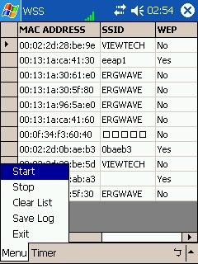
Figure 10.5
Start:
It is to start the timer of WSS. The time is enabled initially.
Stop:
It is to stop the timer of WSS.
Clear List:
It is to clear the current in the Data Grid.
Save Log:
It is to store the Wi-Fi information in the Data Grid. The Log file is stored the same path as the WSS program.
Exit:
It is to exit the WSS.

In the Timer Menu, there is setting option. It is to set timer value in WSS.

10.4.4 Collecting Data Procedure using Wi-Fi Signal Scanner
Open the Wi-Fi Signal Scanner
Analysis the collected data
Start to collect data
If too many noise data, collect again.
Finish collect data
Start / Stop timer (whenever needed.)
Clear List
The above flow diagram shows the common procedures of collecting the source data in one target position. They are divided into five main states. Two main states are important in collecting data. They include “Analysis the collected data” and “Start / Stop timer”.

Analysis the collected data:
In collecting the data in target place, some weak signals are received by device. They mainly come from other building, broken-down Access Point, etc. If there are too many weak signals in the collected data, it should be re-collected. The details would be explained in the following section.

Start / Stop timer:
WSS provides the flexibility for the developer to analysis data by stopping timer. It is convenient for them to analyze data in the middle of collecting process. If mean signal of target position tends to be static in short period of time, the developer should stop the timer and collect data in other target position.

10.4.5 Analysis the Data in Wi-Fi Signal Scanner

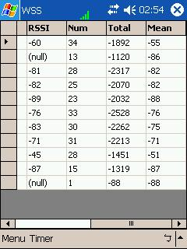
Figure 10.6
The above is the data got by the WSS at one target position. There is different meaning in each type of data. There are explanations in the following:

RSSI:
The signal is received by the mobile device. If RSSI shows a “null”, it means that no signal is received by the mobile device. Normally, RSSI shows the negative number. The value is the signal strength of that Access Point received by the device. The larger value (smaller in magnitude) means that signal strength is stronger for that Access Point. The value of RSSI is in terms of “dBm”.

Num:
It shows the number of signal received by device. If value of “Num” is too small, it means the connection between Access Point and device is very weak. We may ignore this data in localization algorithm. The data is labeled as “noise data”. This data is useless in locate the position. The data need to be filtered out in the MGP.

Mean:
This is an important data in the MGS. It is used in the localization algorithm. This mean data normally tends to be static after one to two minutes. If the mean data fluctuates for a long time, it means that signal received by device is not stable. This data should also be ignored because it would affect the accuracy of MGS. In localization algorithm, the stability of mean signal is very important. It should be very careful to analyze the data in WSS.

Total:
It is the same meaning as the “Mean”. It can be used to analysis the quality of signal strength with num. If num is very small and total is large, it means the quality is very poor. If num is very small and total is small, it means the quality is very good. The Total normally is used to calculate the “Mean”.

To conclude, it is important for us to analyze source data. It would affect the accuracy of localization algorithm. It should be careful when collecting the data in target position. There are different kinds of meaning for each field in the WSS. This would help the developer to filter out the noise data in the MGP.

10.5 Multimedia Guidance Processor (MGP)

Multimedia Guidance Processor (MGP) is a tool to process the signal strength data that are collected by WSS. After analyzing the data, we need to filter out some noise data if needed. The Location-Based Multimedia Service System (LBMSS) client environment is also set in the MGP. The developer need to process all the data and set client environment in MGP.

10.5.1 Overview of MGP
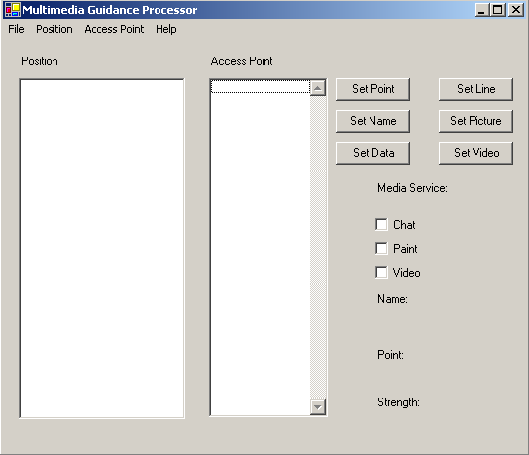
Position
Access Point
Setting and Information

Figure 10.7
MGP is mainly divided into 3 main regions: Position, Access Point, Setting and Information.

Position:
It shows the number of target position added in MGP. The default name of newly added position is positionX (where X is any integer). After setting data for particular position, there would be a list of Access Point under that particular position.
Access Point
It shows the total list of Access Point being used in the MGP. The list is the Media Access Control (MAC) Address of Access Point. And it can be delete the items in list whenever is needed. The change of Access Point is also updated in the Position region.

Setting and Information:
The name, data, video, picture and point of position are set in this region. If parameters are not set in MGP, they are set to default value. The “Set Line” button is to set lines for point mapping algorithm. The lines are used to map points in point mapping algorithm.
In the middle part, there are three services available in mobile client. Due to different requirement of system, it should be selected appropriate service for mobile client. If all service checkbox are clicked, all services are available in mobile client.
At the bottom of region, it shows the information of particular region. By clicking the list in the position region, the most updated information of selected position will be displayed here.

10.5.2 Data Processing Procedure in MGP
Open the MGP

Set the Project Name, Server Path and Map Picture Path in
Setting

Add/Delete the target Position
Set the name, data, video, picture, position in the Map Picture and Point of interest

Filter the noise data

Setting Lines
Generate Location-based Data

Select service for mobile client
Figure 10.8
There are eight steps to process data in MGP.

Step 1(Open MPG)
First, open the MGP program and process data step by step.

Step 2(Set the Project Name, Server Path and Map Picture Path in Setting)
First, we should click “File menu” and “Setting” option. The setting dialog will appear immediately.
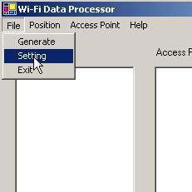
Figure 10.9
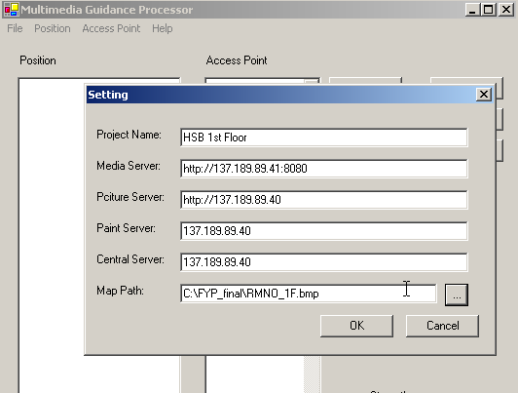
Figure 10.10
There are six fields in setting dialog. They are Project name, Media server, Picture Server, Paint Server, Central Server and Map Path. These fields control the client environment. If any fields set incorrectly, the client program cannot be run.
Step 3 (Setting Lines)
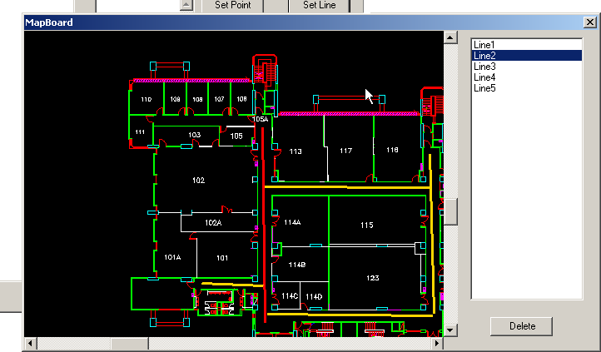
Figure 10.11
First, we load “Set Line Dialog” by click “Set Line” button. We can add line by click “start position” and “end position” on the map. Line will be shown on the map and a new item also is added in line list. By click item on the list, corresponding line will be shown in red colour. When we draw line wrongly, we can delete it by selecting on the list and click “Delete” button.

Step 4 (Add/Delete the target Position)

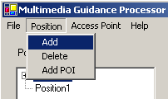
Figure 10.12

When adding or deleting the position, it should click the Position Menu in the Menu Bar. After adding the position, a new position is added in the list. The default name is “PositionX”. (where X is an integer)
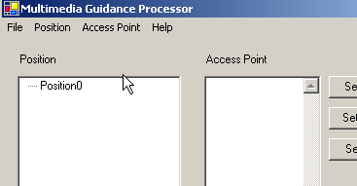
Figure 10.13

Step 5 (Set the name, data, video, picture and position in the Map Picture)
We should set the name, data, video, picture and position in the Map Picture for each position.

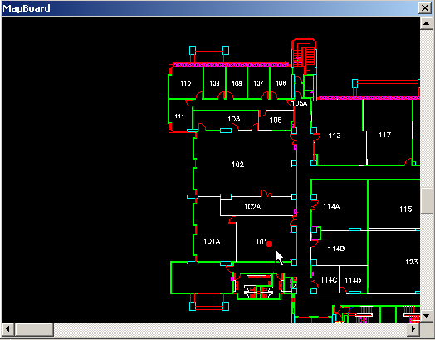
Figure 10.14
After clicking “Set Point”, MapBoard is shown immediately. We can set the point on the Map Picture by clicking on the Map.
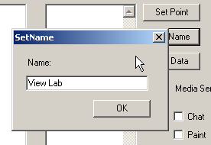
Figure 10.15
We set the name of a position by click the “Set Name” button. We should input the name in the Set Name dialog.

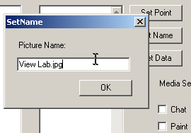
Figure 10.16
We set the picture of a position by click the “Set Picture” button. We should input the picture name which locates in “Media Server”.

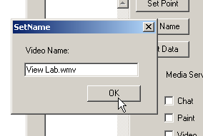
Figure 10.17
We set the video of a position by click the “Set Video” button. The Video will be played when user is at that position.

Finally, we should set source data (signal strength data) to each position. These data will be used by localization algorithm. Source data are import from WSS to MGP. After setting the Data, there would be a list of Access Point under the name of position in the “position region”.
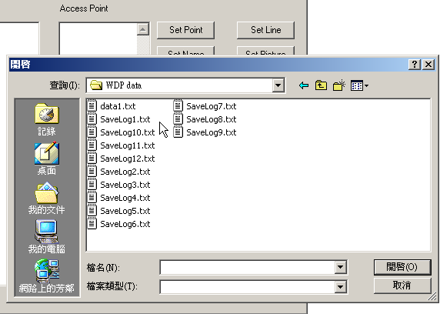
Figure 10.18

We also need to set Point of interest for Guide Service.
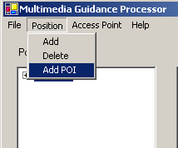
Figure 10.19
First, we have to click “Add POI” in Position Menu. The MapPOI Dialog will be shown immediately.
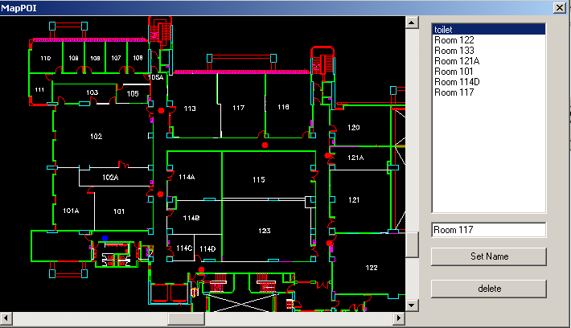
Figure 10.20

It can add Point of Interest (POI) by click on the map. The default name of POI is POI + <index number>. We can change the name by “Set Name” button with name inputted in textbox. If we want to delete POI, we can select POI in list box and click delete button.

After finishing adding POI, we have to go to next step.

Step 6 (Filter the noise data)
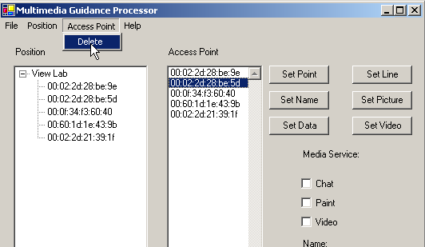
Figure 10.21
After analyzing the source data, we may need to filter out some noise data. It is done by deleting item in the Access Point List. The access point listed in the position would also be updated.

Step 7 (Select service for mobile client)
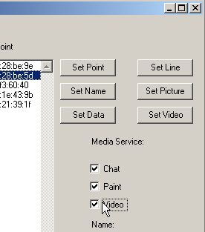
Figure 10.22

Then we select suitable services for client. We can select them by clicking checkboxes.

Step 8 (Generate Location-based Data)
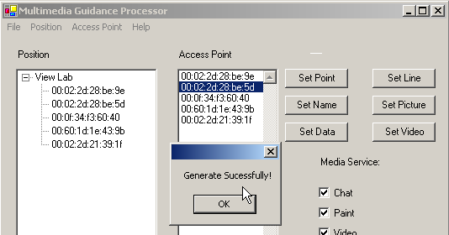
Figure 10.23
After processing the source data, we can generate the Location-Based Data (LBSData) File by clicking “Generate” in File Menu. If all settings are set correctly, “Generate successfully” message box will be shown. Otherwise, error message will be raise.

10.5.3 Feature of Multimedia Guidance Processor

Fancy User Interface:
The MGP is made Visual Studio .NET 2003. Graphics User Interface (GUI) simplifies the complexity of using MGP. The user can learn MGP in a short period of time. The user can set the Position parameters by just click the buttons or Map Picture in the interface. It is convenient for user to process the data in MGP.

Abstraction:
The MGP provides abstraction for the users to hidden the complex format of LBSData. They only to set the Data by GUI interface and MGP then generate LBSData for user. Whenever the format of LBSData changed, the MGP don’t change except the Generating part. MGP abstracts all the core part in MGS.

Robustness:
There is an error handling in MGP. Whenever error occurs, error message would be shown on the screen immediately. This is to prevent the System crash in MGP when generating LBSData. It is an important feature in MGP. This is to ensure the LBSData generating successfully.
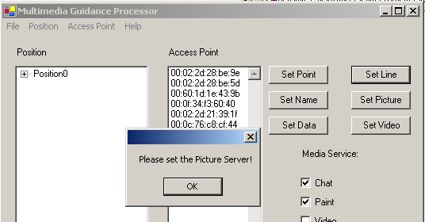
Figure 10.24
Flexible
MGP is a flexible system. The user can set the position parameter according to the user need. There is no restriction on setting the parameters. The user can set the parameter freely. The “Add/Delete Position” Option can let the user to add or delete position in the MGP. This option provides another flexible for user.

10.6 Location-Based Multimedia Service System (LBMSS)

Location-Based Multimedia Service System (LBMSS) is a system to provide multimedia service to clients based on location detected. The system provides chat, paint and video service. The clients use service through networking. The corresponding service output (e.g. picture) would show on the client device’s screen. The detail would be described in the followings.

10.6.1 System architecture

Figure 10.25

Location-Based Multimedia Service System (LBMSS) is consisting of Chat Server, Paint Server, Media Server and Mobile Clients. They are connected by Wireless Local Area Network (WLAN). Each Server provides different kinds of multimedia service for clients. The detail will be explained one by one as follow.

10.6.2 Paint Server
Paint server provides print server services for client. After clients draw their own picture, they can send it back to paint server. The server can print their artwork for clients whenever they needs.

The Paint Server divided into 3 modes: Signature, Points and Management.

Signature Modes

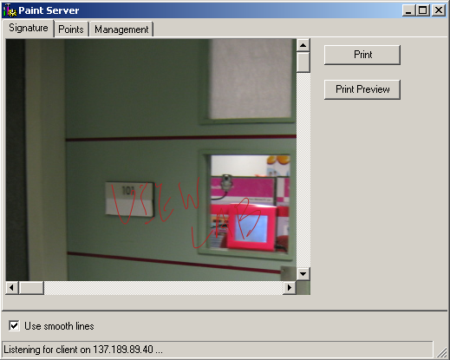
Figure 10.26

In the Signature mode, it show the latest artwork send by the client. The artwork includes two components. They are drawing lines and background picture. The client first captures drawing line and encode into byte stream. Then client sends encoded byte stream together with background picture path to server. After server receives message from client, it process message and draws the artwork on screen and save it on server storage immediately. The artwork can be printed by clicking print button if needed.

Points Mode

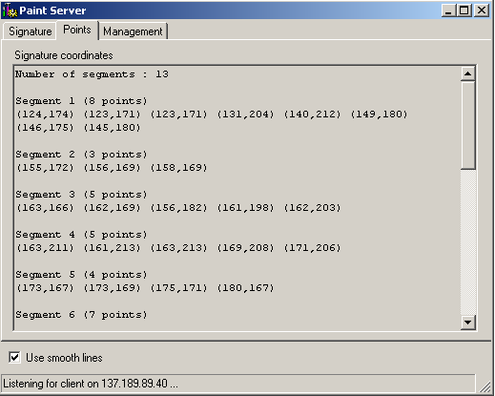
Figure 10.27

The Points mode shows line information. It mainly uses as debugging. In this mode, it shows number of drawing lines in the artwork and the point information in each line segment including point coordinates and number of points in each segment. This information is to check whether client program capture the correct line information. Also, it is used to verify the correctness of the message. If received message is corrupted, it shows strange code on the screen. This is to check the correctness of received message.

Management Mode

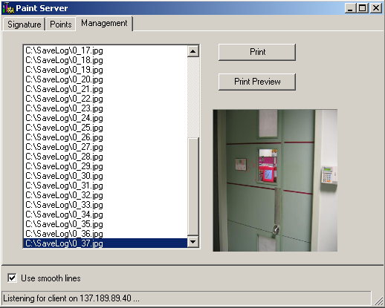
Figure 10.28

This mode is to manage all artworks received by server. Server sometimes may receive many artworks in a short time. The screen may refresh very fast and server cannot print the artwork one by one. However, server saves artwork in the storage whenever receives any incoming message. The saved artwork can be found in the Management mode. The server will save artwork in the following format:
<client id>+<picture id>.jpg

where picture id is incremented automatically by server.

The serve can preview any saved artwork by selecting artwork name in the list and previewed artwork will be show on the right hand side. If server needs to print the selected artwork, it is only just to click print button. This mode is to manage all artwork and print after server refreshing its screen in the Signature mode.

10.6.3 Media Server

Media Server is server to provide media files for client, e.g. video, picture, etc.
In our system, we provide different kinds of server architecture model in Media Server.
Media Server

Figure 10.29

Media Server is consisting of several server architectures, such as Hyper Text Transfer Protocol (HTTP) server, File Transfer Protocol (FTP) server, streaming server, etc. The Media server will provide media files through suitable architecture to the client. For example, the picture files are mainly provided by HTTP server which is well-know protocol in the Internet.

In the Location-Based Multimedia Service System, we mainly provide video and picture files for clients. The client can get media files through networking. We will brief describe deployment of these two types of media file.

Video
Video is a smoothly animating series of images. More complex than simple animated gifs, videos can add richness to content and enhance the user experience. Videos are often accompanied by sound tracks.

There are two types of video which system provides for clients. They pre-recorded video and real-time video.

Pre-recorded video
The video is recorded by video recorder and then encoded into specific video format, such as mpg, wma. After that, files will be published into HTTP server. The client can get video file through published server. However, there is a disadvantage. If bandwidth is too low, the client have to wait a long time before playing video. The problem can be solved by streaming video technology.
Real-time video
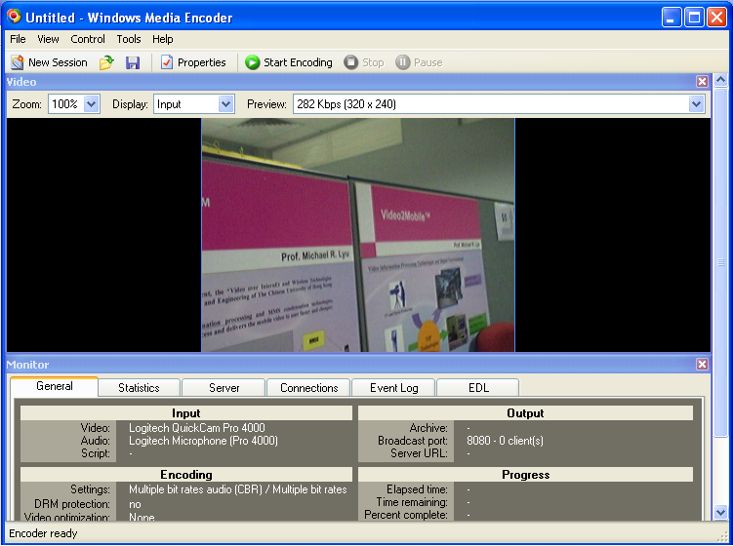
Figure 10.30
Real-time video is one kind of streaming video. It streams real time scene at that place. Since there is lots of free streaming software, we deploy real-time video by one of software product (Windows Media Encoder). We capture actual scene by camera and stream through software. The client can see scene environment through their device.

Picture

Picture can be images or computer graphics. It can be recorded by digit camera or created by graphics software. Picture is the most popular type of media nowadays. The most common way is to publish picture to HTTP server or FTP server.

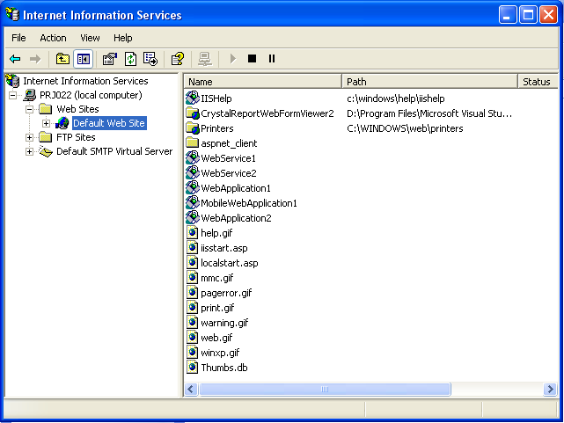
Figure 10.31

In conclusion, Media server is developed by existing server architectures. It is more convenient and save time. The media file can also be transferred in an efficient way. Also, Media Server has higher reliability because it is made by reliable server architecture. Media server can provide service all the time.

10.6.4 Chat and Management Server

Chat and Management Server not only provides chat service but also management service (monitor service). The main duty of server is to answer the enquiry from clients. The server controller (who controls Chat and Management Server) answers the enquiry based on chat and location information provided from server. The server is to support mobile client remotely.

The server is mainly divided into three parts: Chat, Map Monitor and Debug.

Chat

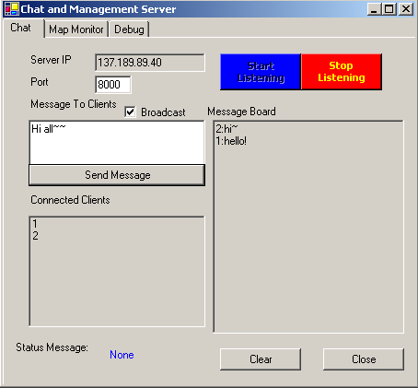
Figure 10.32

In the Chat part, it controls starting and ending of server. When server starts, it should first choose ip address and port number and click “Start Listening” button. Having server started, it listens the incoming connections from clients. When new client connects to server, the server will get a unique client id to that client. And new client id will be shown on “Connected Clients” list.
There are two types of message received by server. They are chat message and position message. The two messages are in the following format:

Chat message:
<0> <destination> <message content>

Note: <destination> is id for that machine. However, our system only supports sending to server. “<destination>” in our system is always set to “Sever”.

Position message
<1> <X-coordinate> <Y-coordinate>

The first field of message is the message id. With “message id”, it is more flexible to add other type of message in the future.

After server receives message, it will decode message and process it. If it receives chat message, the chat message content with client id will show on the “Message Board”. When server wants to reply client, it can reply message by broadcast mode or individual mode. In the broadcast mode, all clients can receive message sent by server. If server wants to send message to particular client, it should first select client id from “Connected Client” list and then send message to that client.

When server stops, it needs to click “Stop Listening” button. Then Server will stop listening connection from clients.

Map Monitor

In this mode, it shows the current position of all clients on the map. Each red dot on the map represents for one client and client id will be shown next to it. The client id is to distinguish each client on the map. The position will be real-time refresh when server receives position message from clients. This Map monitor mode is to trace client position. The diagram in the next page shows “Map Monitor” Mode in the Chat and Management Server.

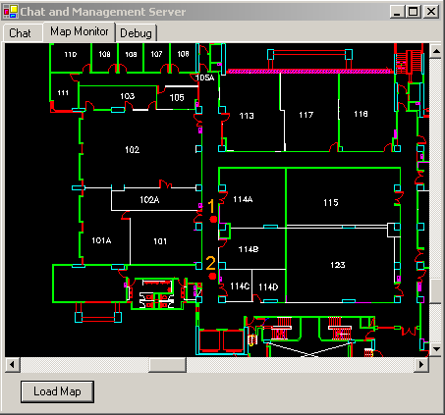
Figure 10.33
Debug
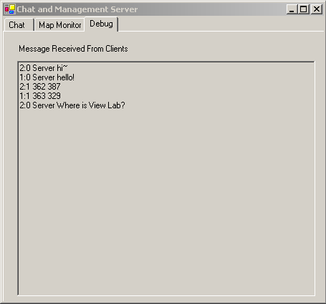
Figure 10.34
In the Debug mode, it shows actual message received by server. This is to check whether messages are correctly received by server. In the message board, it shows received message in the following format:

<client id> <actual message content>

This mode is mainly used as debugging client and server system.

Chat and Management Server provides two services for client (chat service and monitor service). With these two services, server controller can provide enquiry support for clients. He can answer enquiry through chat service in the server. The client can get reply as fast as possible. It provides a real-time enquiry service for clients.

10.6.5 Mobile client
Figure 10.35
The client provides lots of function, such as localization, chat, paint and video service. Since some of function is not needed for particular application, it should be blocked in the client program. The client’s setting is controlled by LBSData file.

When client starts program, it loads LBSData file to the program and set its environment according to the content in file. LBSData is set in the MGP procedure. Client will display according to settings in LBSData file.

There are seven tabs showed in client program provided that all functions are enabled. In each tab, it provides different kinds of functionality. We would describe their functions as follows.

Data
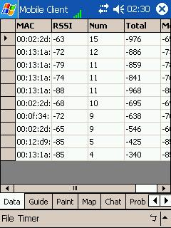
Figure 10.36

The Data Tab contains access point information received by Wi-Fi network card. This information will be used by localization algorithm to detect location in 2D plane. There are five fields in the Data Tab. It has its meaning.
MAC Address:
It is the MAC Address of Access Point.
RSSI:
The signal is received by the mobile device for that particular Access Point
Num:
The number of times that signal received by the mobile device
Total:
The total number of signal strength received by mobile device.
Mean:
The mean of signal strength is received by the mobile device for that particular Access Point. The mean would used in localization algorithm.

The Data Tab is used to verify the correctness of localization algorithm. There are factors affecting accuracy of algorithm. They are quality of signal strength (RSSI) and convergence of mean data (Mean field). If there is too much null value in RSSI field, it means no signal or weak signal received by device. The program does not have enough data to estimate position. Furthermore, if mean field fluctuates in large range, the signal strength received by device is not stable. The stability of data also affects the accuracy of localization algorithm.

Guide

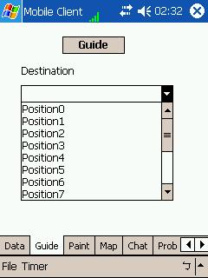
Figure 10.37

The Guide Tab provides guide service by drawing guide line on the map. The user can go to destination by following guide line on the map. The guide line would become shorter and shorter when user is nearing destination.
In order to use guide service, user must set destination and call service by click “Guide” button. The guide line then shown on the “Map Tab” screen.
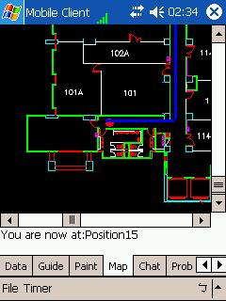
Figure 10.38

Map

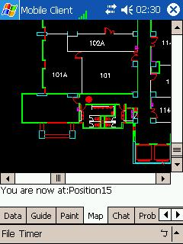
Figure 10.39

The Map Tab is to show the position in the Map Picture. A dot on the map shows the current user’s position. A guide line would show on the picture if users have called guide service before.

The Map Picture can be move by several modes:

Scroll Bar:
It can be move by directly click the scroll bar on the Map Mode. This is tradition method of moving the picture.

Key Pad:
It can move by press the Key Pad on the mobile device. This is most convenient way to move the Picture.

Drag:
It can move picture by directly drag on the screen. It can drag any position that the user wants. They can move picture freely

Chat

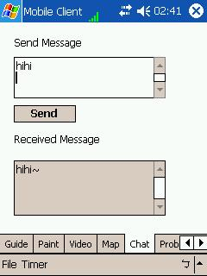
Figure 10.40

In Chat Tab, it provides interactive chat service for both client and server. “Client and Server” can send and receive message through chat service. Chat Tab mainly handles received message from server and sent message from client.
In our system, clients can only send message to server. They cannot send message to other peer clients. However, we have reserved flexibility for future enhancement. The message format in chat service contains “destination” field which can be used to enhance service. In the future, service can be modified into sending or receiving messages from anyone in the network.
The message format is shown as follows.
<0> <destination> <message content>

Paint

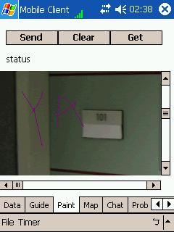
Figure 10.41

In the Paint Tab, user can draw anything they like on background picture. Background picture is loaded from Media Server. After loading picture, user can draw anything on it.

The program traces drawing lines and encodes into byte format. After that, user can send their artwork to Paint Server. The Paint Server then can save and print his work. The user can get back his hardcopy or softcopy from Paint Server.

There is a clear button in Paint Tab. Whenever user wants to change its drawing; it can clear whole drawing by clicking clear button.
Video
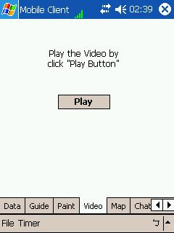
Figure 10.42

Client program would provide specific video based on location estimated. When user wants to see that location’s video, he just clicks play button. Video will be played by windows media player. Windows media player program will be pop-up on top of the client program. When user wants to return client program, it need to close windows media player program by himself.
Probability
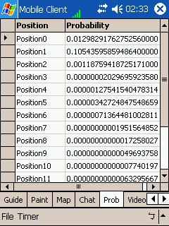
Figure 10.43
The Probability Tab shows the occurring probability in each position. The probability is calculated by the localization algorithm. For discrete estimation, the position with highest probability predict as the current user’s position. For continuous estimation, it is used as weight for estimating user’s position.
The developer can use it to test any error in the localization algorithm.

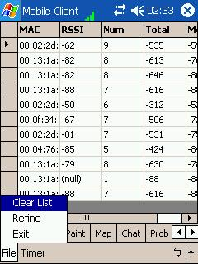
Figure 10.44

There several functions in the Menu Bar.
Clear List: To clear the sample data collected by device.
Start: To start the timer
Stop: To stop the timer
Exit: To exit the program

Server preparation Work and Environment

There are several servers in LBMSS. Before deploying system, the server environment must be set. The following table lists default server environment.

Server Name | Port Number
Paint Sever | 10200
Chat and Management Server | 8000
Media Server | 80(HTTP), Streaming Server(8080)
After setting server environment, we need to do some preparation work.

10.6.6 Preparation Procedure

Figure 10.45

The first thing to do is to prepare source photo and video. They can be taking by digit camera/video, drawing from graphics software or getting from internet. After that, we have to decide suitable server architecture for each server in LBMSS. For example, HTTP architecture is much suitable using in Media Server since HTTP is best multimedia transfer protocol nowadays. And then we have to set up server environment in LBMSS, e.g. binding server to specific port, setting map picture, etc. After finishing all preparation work, servers can start up and provide multimedia service for mobile client.

10.7 Summary of Multimedia Guidance System (MGS)

The advantages of MGS are in the followings.

User-friendly System
MGS is made by fancy user interface. User can learn MGS within short period of time. They can control the MGS by clicking the buttons or control in the system. MGS is a user-friendly System.

Hidden all the low-layer technique/technology
MGS have done all low-layer architecture for user. They can only to know how to process the data from the low-layer architecture. The user does not need to know the low-layer architecture before processing the data. The system has done all the things for users. The user can focus on the work rather than the technology using in the task.

Reusability
MGS is a highly reusable System. It can be used to implement any Location-Based Multimedia Service System (LBMSS). The user only needs to follow the procedures in implementing the System. MGS can generate any LBMSS in any area. MGS can be reused in deploying LBMSS in any area that user wants.

Flexibility
The LBMSS servers are made by existing server architectures. LBMSS can provide multimedia service based on current technology. The MGS do not fixed server using a specific technology. The developers can provides services with newly and suitable technology that they needed. MGS provide a flexibility environment for developers to implement their system.

Efficiency System
MGS saves lots of time in developing LBMSS since all the low-layer things are done by MGS. The users only need to collect the data at the target place. And then they process the data and deploying the system to the client. Using MGS, it is much faster than tradition methods to develop LBMSS. The following tables show period of time to implement the system.

Tradition Method
Task | Time
Studying the technology | 1-2 week
Software Design | 2-3 week
Architecture Design | 2-3 week
Algorithm design | 1-2 week

MGS Method
Task | Time
Wi-Fi Signal Scanner | 1/2 day
Multimedia Guidance Processor | 2-3 days
Location-Based Multimedia Service System | 4-5 days

The disadvantages of MGS are in the followings.

Fixed Technology
The MGS is only to support Wi-Fi (Wireless LAN) network. It cannot be using the GSM network or Bluetooth Network to deploy LBMSS. The technology is limited in MGS.

Fixed User Interface
Since all the user interface is done by MGS, the developers cannot change the interface that they want. The Interface is also fixed in MGS.

Well Training on Server preparation work.
Developers must be trained to control existing server architectures because servers are made by them (e.g. HTTP). The developer must have base knowledge on current server technology. Otherwise, it need time to train developers before using MGS.

In conclusion, MGS is a desirable tool for developing LBMSS. With MGS, it develops LBMSS in a short time. It saves much effort on studying technology. It increases the efficiency of implementing system. However, MGS is only fixed on deploying Wi-Fi Network. And also the client interface cannot be changed by developer. However, MGS is done the fancy user interface. It can fulfill the common requirement on most LBMSS. MGS can combine with existing server architecture to provide multimedia service. The MGS can provide any multimedia service that exists in the future by changing server architecture only. MGS is focus on 2D detection environment. The most suitable technology for 2D detection environment is Wireless LAN network. At this moment, it has little chance to develop 2D detection environment with other technology. MGS is a suitable tool for developing the LBMSS.

11. Summary
Our final year project is entitled Location-Based Multimedia Mobile Service. In the first semester, we mainly focus on the problem of localization. And in the second semester, base on our knowledge and developed tools in localization, we are able to further develop a location-based multimedia mobile service.

In this project, we have chosen the 1st floor of the Ho Sin-Hang Engineering Building in the Chinese University of Hong Kong to study the problem of localization. We succeed in achieving our goal which is to locate a person when he/she is walking around on the floor and we also implemented the Multimedia Guidance System (MGS).

There are a lot of problems in achieving the goal, for instance, how to collect the signals from the Wireless LAN access points, how to choose and apply algorithms to achieve localization and how to handle to communication within the client-server model. And we have solved every problem mentioned and achieve the goal to develop a location-based multimedia mobile service.

In the first section, we have given an introduction about the current issue of localization in recent years so you realize that localization is a heat topic recently. Then in Section 2, it talks about Wireless LAN fundamentals including Wireless LAN access points, Wireless LAN terminology, and Wireless LAN standard which help you to get basic idea on Wireless LAN and our project.

In Section 3, we have talked about the point-based approach and the area-based approach, so you know the advantages and disadvantages of different approach for localization. We have also introduced three localization algorithms, namely, the Distance Mapping algorithm, the Simple Point Matching algorithm and the Area-Based Probability, so you should have a brief idea on how to achieve localization.

In Section 4, we have discussed the advantages of using the Area-Based Probability algorithm for localization over other algorithms. Then, we have given a detail description on how we apply the Area-Based Probability algorithm and solve the problems we face. It includes the way we generate the training set and the testing set. We have also described how we apply some Mathematics assumptions, distribution models and some theories so that we are able to find out the probability used in localization. At the end of the section, we have also discussed the performance of the localization method.

In Section 5, we have performed some studies on the accuracy of our system and we have also given some analysis of them. In Section 6, we have introduced the Center of Mass technique in continuous space estimation. It allows us to solve the limitation of discrete space estimation. We also perform an experiment to evaluate the performance of our system with this technique. And the details of the experiment are provided in Section 7.

In both Chapter 8 and 9, we have given a clear explanation on the two techniques we have implemented in the Guide Service. The first one is the Point Mapping technique which is used to give a fancier user interface. The second one is the Dijsktra’s algorithm. It is a well-known algorithm using graph theory to solve the shortest path problem. We have also performed an experiment on the point mapping technique which is provided at the end of Chapter 8.

We have developed Multimedia Guidance System (MGS). It is a highly user-friendly system. MGS is made by fancy user interface. The developer can use our MGS to deploy system in a short period of time. MGS consists of three components: Wi-Fi Signal Scanner (WSS), Multimedia Guidance Processor (MGP) and Location-Based Multimedia Service System (LBMSS). WSS is tools to collect signal strength data. MGP is to process data and set LBMSS client environment. After setting server environment in LBMSS, LBMSS can be deployed to users.

In order to develop Location-Based Multimedia Service System, developer needs to use these tools one by one. Developer has to collect data by WSS. Then, developer has to process and filter out noise data by MGP. The last thing to do is set environment for client and servers. LBMSS can be released for public to use. The details of MGS have been discussed in Chapter 10.

12. Problem and solution

Problem 1
We can find any API to achieve the MAC Address of Access Point. We can get MAC address of Access Point.

Solution
We find API (NDIS) in Microsoft MSDN homepage that indirectly support to achieve MAC address of Access Point. NDIS is originally support to write the network adapter driver.

Problem 2
We don not how to using the API in NDIS since there is no sample code in MSDN. In the Internet, many people ask this question but no one knows how to solve it.

Solution
We ask this question in the MSDN homepage. However, the problem still does not be solved. We send the email to the Microsoft Researcher about the NDIS. The Researcher gives the sample code about the NDIS. We follow the code and carry on out project

Problem 3
The sample code seem do not work. We can only obtain one MAC address in Access Point List. We cannot get others MAC Address

Solution
There are is a bug in our program. We find the answer in the Microsoft MSDN homepage. We need follow structure defined in NDIS. We cannot move the pointer by the structure size. We should move the pointer by the length field in the structure.

Problem 4
We have differently in writing a GUI in Embedded Visual C++

Solution
Since there is lots if control don’t support in Embedded Visual C++, we move the Development Platform to Visual Studio .NET 2003. It supports more control and must easier in developing a beautiful GUI.

Problem 5
There is no NDIS support in .NET framework. We can get the MAC address in Visual Studio .NET 2003.

Solution
We make our Embedded Visual C++ to a DLL project. We import the DLL by Method “DllImport” in Visual Studio .NET 2003. We find this solution Microsoft MSDN homepage.

Problem 6
We have problem in write a Visual Studio .NET 2003 program. And we have not written any .NET program before.

Solution
We study the C# language on the NET. And we can find the samples codes in Microsoft MSDN homepage. Whenever we have problem, we solved by search in www.google.com.

Problem 7
We don’t know a good way to achieve the localization by using the signal strengths collected.

Solution
We read a lot of papers about the Localization Algorithm, so that we have learnt different approaches and different localization algorithms. We also find out the advantages and disadvantages of different algorithms, so that we are able to choose a suitable one to implement.

Problem 8
We do not know very clearly how to calculate the probability using the Gaussian distribution assumption in the Area-Based Probability algorithm.

Solution
We have found information on the Internet about the probability in mathematics. We have learnt the equation of the Gaussian distribution and how to find the probability by integrating the Gaussian distribution function.
Problem 9
We do not know how to write a program to perform integration.

Solution
We have found information on the Internet about the error function in mathematics. The Gaussian distribution function can be rewritten in terms of the error function. Then we can estimate the error function by a series and write a function in a program to calculate the value of the series.

Problem 10
We do not know how many iterations we need to calculate the series in problem 9. We need to minimize the number of iterations to reduce the overhead in calculating the probability.

Solution
We test on the accuracy of the series by increasing the number of iterations. We choose the number of iterations which is large enough so that the probability calculated will not be negative due to estimation error.

Problem 11
We do not know whether the orientation of collecting signal will affect the accuracy of our system.

Solution
We have performed a study on the orientation. We collect the signals in different orientation and compare their accuracy.

Problem 12
We do not know how large we should choose in the sample size of a testing set.

Solution
We have performed the studies on how the sample size of the testing set affects the accuracy of our localization system. With the study result, we can find a suitable sample size.

Problem 13
We do have a floor plan of the first floor of the Ho Sin-Hang Engineering Building.

Solution
We have asked for the help from the administrators of the engineering building. We have signed a special request form as a formal procedure. Finally, we get the floor plan from them.

Problem 14
We have not learnt socket programming in C# before.

Solution
I have to study tutorial in the Internet and find some examples in MSDN website.

Problem 15
I have implemented single client server which server can only accepts one client connection.

Solution
I have find solution in the Internet. The solution is to call function recursively on accept client function.

Problem 16
I found that all socket programming function is blocking function. It cannot accept data from more than one client.

Solution
I find the solution in MSDN and modify it with non-blocking function with AsyncCallback.

Problem 17
When client disconnects from server, server is loop forever.

Solution
This is due to bugs in the AsyncCallback function. When only handle it by length of received data. If data length equals to one, we break loop.
Problem 18
We do not know how to embedded windows media player in our program.

Solution
We have study windows media player documentation in MSDN and it can embed player by COM object.

Problem 19
COM object does not support in Windows CE .NET Platform.

Solution
We have found third party software (Odyssey Software CFCOM) to import COM object to .NET platform.

Problem 20
We have tried CFCOM but it still cannot import COM object successfully.

Solution
We solve it by control windows media player indirectly. We call windows media player by creating new process.

Problem 21
We do not know how to create process in C# and .NET does not support any API.

Solution
We can find API in embedded Visual C++ 4.0 API. We import API by DllImport function .NET. And we can create process successfully.

Problem 22
We have problem in sending object variable to server.

Solution
We have to write a function to encode object into specific format and send it to server.

Problem 23
We have problem in getting picture from HTTP server.
Solution
We have use .NET Web Service API to achieve picture from HTTP server and load it to picture box afterwards.

Problem 24
Discrete space estimation is not suitable for mobile application as it cannot return intermediate points that are not in the training set.

Solution
We introduce continuous space estimation to solve the limitation and we also find that its accuracy is good.

Problem 25
We want to carry out a function in guide service to direct the user to the destination he/she wants to go to.

Solution
Dijsktra’s algorithm is well-known to find shortest path, however, we cannot use it directly. We first convert to whole floor into a graph with nodes and edges before we can carry out the algorithm.

Problem 26
In our mobile application, it is not desirable to have an estimated point outside the area of the corridor. It is due to the inaccuracy of the continuous space estimator.

Solution
We introduce point mapping function to refine the estimated position. We map them into the closest point in the corridor. It is a trade-off between accuracy and fancy application interface. Luckily, we find that this technique does not worsen the accuracy of the system.

13. Contribution of work

13.1 Introduction
In this section, it is going to state our contribution on the project and what we have done during semester.

The section is divided into six main parts. They are “Feasibility Study”, “Algorithm Study”, “Obtaining Wireless LAN information” and “Design and Implementation of Wi-Fi Location System”, “Feasibility Study on Multimedia Service” and “Design and Implementation of Multimedia Guidance System”. My work mainly focuses on the design and implementation of Wi-Fi Location System (WLS) and Multimedia Guidance System (MGS). The detail of the six parts will be described one by one in the next paragraphs.

13.2 Feasibility Study on project
The first thing we do is to study the existing wireless technology, such as Bluetooth, GSM Network, Wireless LAN (WLAN), etc. We have spent several weeks on each technology. We have found that each technology has its own restrictions, for instance, coverage area, popularity, location information provided. Moreover, different technology has its own identifier to recognize the station, e.g. Cell ID in GSM Network, MAC address of Access Point in WLAN.

The other problem is that no mobile device support existing wireless technology. Most of them only support one technology. And each of them is built in different kinds of platforms, such as Symbian OS, Windows CE, and Palm OS. Programmable capability varies from one platform to another. We have studied on programmable capability on each platform for 3 weeks.

After we have considered all the characteristics on different platforms and technology, we decide our project using Wireless LAN technology with Windows CE Platform. Our project aims at developing a location-based multimedia service in 2D space. Wireless LAN supports the technology which provides enough information to estimate position in 2D space. Windows CE platform supports lots of Graphics controls, which is suitable to develop complicated multimedia software.

13.3 Obtaining Wireless LAN Information in Windows CE
When I develop the first program, it contains no wireless LAN API supported in Embedded Visual C++. After searching information on the Internet for about two weeks, we found that there is an indirect way to obtain the wireless LAN information. It is by Network Driver Interface Specification (NDIS) which include in the Windows CE Platform Builder 4.0. NDIS originally is an API for device driver programming. It supports different kinds of technology, such as IEEE 802.3 (Ethernet Network), Infrared Red, Wireless LAN, etc. There are lists of Network frame structures defined in NDIS such as the Ethernet frame WLAN frame. Hence, I am able to blind the Network interface Card (NIC) to NDIS and obtain the Network information through structure in NDIS.

The blinding process is not a directly step in NDIS which involves several steps. We needed to find out the suitable procedures on the Internet. However, there is neither any sample code in Microsoft MSDN nor there is no much website explaining NDIS. Finally, I have asked a researcher in Microsoft and he kindly gave us some useful advice on how to obtain information through NDIS. As a result, we are success in getting the wireless information that I want.

13.4 Algorithm Study
After obtaining the strength signal and MAC address from Access Points, we need to study algorithm to estimate the position at target place. We have studied two localization algorithms. They are Area-based probability and Simple Point Matching. Each of them applies different technique in localization.

We think that Area-based Probability is more suitable in our project. Area-based probability algorithm is based on statistical model. It estimates the position by calculating all occurring probabilities at all positions. The position with the highest probability is considered as the estimated position. We cannot ensure signal strength received by a mobile device at a particular position is always the same. With this algorithm, we can minimum error due to instability of signal strength.

13.5 Design and Implementation of Wi-Fi Location System
The development of the Location-based System can be logically divided into 3 main steps. We design a development tools to implement the Location-based System. The steps are collecting data, processing data, deploying and testing system. My main job in this section includes the coding and the design of program interfaces.

When I design the tools for each step, I have to consider the user-friendless. I decide to develop a Graphics User Interface (GUI) rather than Text Based only. There is a Microsoft Foundation Classes (MFC) library support in Embedded Visual C++ which is development tool for GUI. As I have not written windows programming before, I study reference book and websites in the Internet.

After I have familiar with MFC programming, I spend 2 weeks time to develop a draft programming to get Wireless LAN Information from Access Point. However, there is no much controls supported in MFC. I decide to change development platform from Embedded Visual C++ to Visual Studio .NET 2003. Visual Studio .NET 2003 support “Smart Device” project with C# only. I have to study new programming language C#.

By spending 2 week time, I learn the different classes and functions in C#, such as event handling, Timer class, etc. When I face any problem in implementing programming, I have solved problem by searching in Microsoft MSDN and books. I spend 1 month to develop Wi-Fi Location System.

13.6 Feasibility Study on Multimedia Service
In second semester, I have deigned a new system that supporting multimedia service. There are many multimedia services, e.g. chat, video streaming, slide show, etc. However, not all of them can be supported in Windows CE. I spent two weeks on studying capability on Windows CE Platform. I found that video, images and chat services can be implemented in CE Platform. I decide to implement these services in our new system.

13.7 Design and Implementation of Multimedia Guidance System
After studying multimedia capability of Windows CE, I design a new system that supports multimedia services. Later, this system is called “Multimedia Guidance System”.

Based on framework in Wi-Fi Location System, we design three tools in MGS. They are Wi-Fi Signal Scanner (WSS), Multimedia Guidance Processor (MGP) and Location-Based Multimedia Service System (LBMSS). Wi-Fi Signal Scanner is the same as WLS since the functionality of WSS in MGS is the same as in WLS.

Then I start to design Location-Based Multimedia Service System. I would like to implement Video, Chat and Paint service in client program. Since these multimedia services cannot be provided by client program only, some services need to be provided by servers. I spent 1 week to design server and client model for system and spent another 4 weeks time to implement LBMSS. When I implement LBMSS, I face technical problem, such as ActiveX/ COM interoperability, socket programming in .NET, etc. I have to find solution in the Internet. This is the most difficult part in LBMSS.

Next thing I do is to develop new Processor Application for MGS. LBSData File has been refined to fulfill the new changes in client program. Therefore, I develop MGP to generate refined LBSData File. MGP is mainly focus on processing signal strength data and setting environment for LBMSS. I spent about one month to implement MGP.

At Last, I test and debug whole system. There are some bugs in MGS, such as connecting problem. I have to debug it. After testing and debugging, I finish implement MGS.

13.8 Conclusion
In this semester, I have learnt more about wireless technology. It helps me to design the project related to wireless in the future. I have experience in programming on the mobile device. I have learnt the new development tools in the project, such as Visual Studio .NET 2003. This would help us to develop more complicated project in the future. I would also like to thank my partner, Tilen who help me a lot on the project. Although some parts are done by him, I may not have deep knowledge on his part. We always discuss our work to each other. I have a briefly idea about his work.

14. Schedule of Project
The following table is the Project schedule in this semester:

Date | Progress
June 2004 | -Plan the project aim and start to design project  -Study the wireless technology, such as Bluetooth, GSM network, Wireless LAN network
July 2004 | -Study the OS platform that can implement project. E.g. Symbian OS, Windows CE.  -Get familiar with Embedded Visual C++ and Symbian programming with Visual C++.
August 2004 | -Confirm the project using the Windows CE platform with Wireless LAN network  -Start to study the Application Program Interface (API) related to achieve MAC Address from Access Point
September 2004 | -Implement the draft version program to achieve the MAC address with Embedded Visual C++  -Study localization algorithm
October 2004 | -Modify the draft program to fully planned version(Wi-Fi signal Scanner) with Visual Studio .NET 2003  -Collect data using Wi-Fi signal Scanner  -Plan to implement first application using Location-based Technology  -Design appropriate algorithm in first application
November 2004 | -Test our first application(Wi-Fi Location Detector)  -Study the accuracy of Area-Based probability algorithm  -Plan and Develop the Wi-Fi Location System(WLS)  -Finish Develop the Wi-Fi Data Processor
December 2005 | - Study Continuous Localization Algorithm
January 2005 | -Study Socket Programming in C#  -Do experiment on Continuous Localization Algorithm  -Modify WLD to use Continuous Localization Algorithm
February 2005 | -Modify Server to support multi-client  -Plan and design mobile client for new system(Later we call it as Local-Based Multimedia Service System)  -Plan and develop Chat and Management Server  -Study accuracy of Continuous Localization Algorithm
March 2005 | -Develop Chat and Management Server  -Plan and Develop Paint Server  -Study Point Mapping Algorithm  -Plan and Develop Media Server  -Develop Mobile Client with chat service  -Study and test Dijkstra’s algorithm to find shortest path
April 2005 | -Test and Debug Local-Based Multimedia Service System  -Plan and Develop Multimedia Guidance Processor  -Develop mobile client with paint, guide and video service  -Study existing server architecture  -Implement Dijkstra’s algorithm in mobile client  -Test the correctness of Dijkstra’s algorithm  -Carry out experiments to evaluate accuracy of the system  -Do FYP report

15. Acknowledgement
We would like to thank Prof. Michael Lyu, our project supervisor, who has given us many useful suggestions and directions throughout this project.

We would also like to thank Edward Yau, Technical Manager of VIEW project. He has given us lots of background knowledge about Wireless Technology. He has also given us various innovative ideas on our project.

We would like to special thank John Krumm, Microsoft Researcher, who has given a technique support on using NDIS API.

16. References
- Moustafa Youssef, and Ashok K. Agrawala, "Continuous Space Estimation for WLAN Location Determination Systems," IEEE Thirteenth International Conference on Computer Communications and Networks, Chicago, IL USA, October 11-13, 2004.
- Moustafa Youssef, and Ashok K. Agrawala, "Handling Samples Correlation in the Horus System," IEEE Infocom, Hong Kong, March 2004.
- P. Krishnan, A.S. Krishnakumar, Wen-Hua Ju, Colin Mallows, and Sachin Ganu, "A System for LEASE: Location Estimation Assisted by Stationary Emitters for Indoor RF Wireless Networks," IEEE Infocom, Hong Kong, March 2004.
- Kamol Kaemarungsi, and Prashant Krishnamurthy, "Modeling of Indoor Positioning Systems Based on Location Fingerprinting ," IEEE Infocom, Hong Kong, March 2004.
- Youngjune Gwon, Ravi Jain, and Toshiro Kawahara, "Robust Indoor Location Estimation of Stationary and Mobile Users," IEEE Infocom, Hong Kong, March 2004.
- Moustafa Youssef and Ashok Agrawala, "On the Optimality of WLAN Location Determination Systems," Communication Networks and Distributed Systems Modeling and Simulation Conference, January 18-24 2004, San Diego, California.
- S. Ganu, A.S.Krishnakumar, P.Krishnan, "Infrastructure-based Location Estimation in WLAN Networks," IEEE Wireless Communications and Networking Conference (WCNC 2004).
- Moustafa Youssef, Ashok Agrawala, A. Udaya Shankar, "WLAN Location Determination via Clustering and Probability Distributions," IEEE International Conference on Pervasive Computing and Communications (PerCom) 2003, Fort Worth, Texas, March 23-26, 2003.
- Moustafa Youssef, Ashok Agrawala, "Small-Scale Compensation for WLAN Location Determination Systems," IEEE Wireless Communications and Networking Conference (WCNC) 2003 New Orleans, Louisiana, March 16-20, 2003.
- Moustafa Youssef, Ashok Agrawala, "On the Optimality of WLAN Location Determination Systems," CS-TR 4459, Department of Computer Science, University of Maryland, College Park, March 2003.
- Siddhartha Saha, Kamalika Chaudhuri, Dheeraj Sanghi, Pravin Bhagwat, "Location Determination of a Mobile Device Using IEEE 802.11b Access Point Signals," IEEE Wireless Communications and Networking Conference (WCNC) 2003 New Orleans, Louisiana, March 16-20, 2003.
- Saikat Ray, Rachanee Ungrangsi, Francesco de Pellegrini, Ari Trachtenberg and David Starobinski, "Robust Location Detection in Emergency Sensor Networks," IEEE Infocom 2003, San Francisco, pp. 1044-1053, March 2003.
- Saikat Ray, David Starobinski, Ari Trachtenberg and Rachanee Ungrangsi, "Robust Location Detection with Sensor Networks,'' IEEE JSAC (Special Issue on Fundamental Performance Limits of Wireless Sensor Networks), in press.
- Andrew Howard, Sajid Siddiqi, and Gaurav S Sukhatme, "An Experimental Study of Localization Using Wireless Ethernet", International Conference on Field and Service Robotics (FSR'03), Lake Yamanaka, Japan.
- Sajid Siddiqi, Gaurav S. Sukhatme, and Andrew Howard, "Experiments in Monte-Carlo Localization using WiFi Signal Strength," International Conference on Advanced Robotics (ICAR), Coimbra, Portugal, 2003.
- Ping Tao, Algis Rudys, Andrew M. Ladd, Dan S. Wallach, "Wireless LAN location-sensing for security applications", Wireless Security Workshop, San Diego, CA, 2003.
-  Ping Tao, Algis Rudys, Andrew M. Ladd, Dan S. Wallach, "Wireless LAN locationsensing for security applications", Wireless Security Workshop, San Diego, CA, 2003.
- T. He, C. Huang, B. M. Blum, J. A. Stankovic, and T. Abdelzaher. “Range-free localization schemes for large scale sensor networks. In Proceedings of the Ninth Annual Internationa Conference on Mobile Computing and Networking (MOBICOM)”, San Diego, CA, Sept. 2003
- Andrew M. Ladd, Kostas E. Bekris, Algis Rudys, Guillaume Marceau, Lydia E. Kavraki, and Dan S., "Robotics-Based Location Sensing using Wireless Ethernet," The Eighth ACM International Conference on Mobile Computing and Networking (MOBICOM) (Atlanta, GA), September 2002.
- P. Prasithsangaree, P. Krishnamurthy, and P. K. Chrysanthis, "On Indoor Position Location With Wireless LANs ," The 13th IEEE International Symposium on Personal, Indoor, and Mobile Radio Communications (PIMRC 2002), Lisbon, Portugal, September 2002.
- Arun Kishan, Michael Michael, Sahil Rihan, and Rahul Biswas, “Halibut: An Infrastructure for Wireless LAN Location-Based Services.”
- Michael Wallbaum, "Wheremops: An Indoor Geolocation System", The 13th IEEE International Symposium on Personal, Indoor, and Mobile Radio Communications, Pavilhão Atlântico, Lisbon, Portugal, September 15-18, 2002.
- T. Roos, P.Myllymäki, and H.Tirri, "A Statistical Modeling Approach to Location Estimation," IEEE Transactions on Mobile Computing, Vol. 1, No. 1, January-March 2002, pp. 59-69.
- K. Pahlavan, X. Li, and J. Makela, "Indoor Geolocation Science and Technology", IEEE Communications Magazine, Feb. 2002.
- Mauro Brunato, Csaba Kiss Kalló, "Transparent Location Fingerprinting for Wireless Services," in Proceedings of Med-Hoc-Net 2002.
- Roberto Battiti, Thang Lee Nhat, Alessandro Villani, " Location-aware computing: a neural network model for determining location in wireless LANs," Technical Report DIT-02-0083, 2002.
- Roberto Battiti, Mauro Brunato, Alessandro Villani, " Statistical Learning Theory for Location Fingerprinting in Wireless LANs," Technical Report DIT-02-0086, 2002.
- Paul Castro, Patrick Chiu, Ted Kremenek, and Richard Muntz, "A Probabilistic Location Service for Wireless Network Environments," In Proceedings of Ubicomp 2001, pp. 18--24. Springer Verlag, September 2001.
- Asim Smailagic, Daniel P. Siewiorek, Joshua Anhalt, David Kogan, and Yang Wang, “Location Sensing and Privacy in a Context Aware Computing Environment,“ Pervasive Computing, 2001.
- P. Myllymaki, T. Roos, H. Tirri, P. Misikangas, J. Sievanen, "A Probabilistic Approach to WLAN User Location Estimation," The Third IEEE Workshop on Wireless LANs, 2001.
- G. Shreve, D. Kell, "A Precision Location Network Using Ultra Wideband WLAN Radios," The Third IEEE Workshop on Wireless LANs, 2001.
- Personnel, T. Kochanski, "A Portable Wideband System for Monitoring and Locating Firefighters and Other Emergency," The Third IEEE Workshop on Wireless LANs, 2001.
- J. Hightower and G. Borriello. “Location systems for ubiquitous computing.” IEEE Computer, 34(8):57–66, Aug. 2001
- Paramvir Bahl and Venkata N. Padmanabhan, “RADAR: An In-Building RF-based User Location and Tracking System,” IEEE Infocom 2000, volume 2, pages 775-784, March 2000.
- P. Bahl, V. N. Padmanabhan, and A. Balachandran, “Enhancements to the RADAR User Location and Tracking System,” Microsoft Research Technical Report: MSR-TR-00-12 (February 2000)
- Asim Smailagic, Jason Small, and Daniel P. Siewiorek, “Determining User Location For Context Aware Computing Through the Use of a Wireless LAN infrastructure,” December 2000.
- Paul Castro and Richard Muntz, "Managing Context for Smart Spaces," IEEE Personal Communications, October 2000.
- Jay Werb, Colin Lanzl, "Designing a Positioning System for Finding People and Things Indoors," IEEE Spectrum, Vol. 35, No. 9., pp. 71-78, September 1998.
- S. Thrun, W. Burgard and D. Fox, “A probabilistic approach to concurrent mapping and localization for mobile robots”. Machine Learning, 31(1-3):29–53, 1998.
- Thomas Christ, Philip Godwin, "A Prison Guard Duress Alarm Location System," Proc. IEEE International Carnahan Conference on Security Technology, October 1993.

17. Appendix

17.1. Signal Strengths Collected by Wi-Fi Signal Scanner
AP MAC address | Position
AP MAC address | 1 | 2 | 3 | 4 | 5 | 6 | 7 | 8 | 9 | 10 | 11 | 12
00:02:2d:28:be:9e | -70 | -62 | -58 | -67 | -73 | -78 | -83 | -86 | -84 | -81 | -78 | -55
00:02:2d:28:be:5d | -67 | -59 | -60 | -71 | -76 | -79 | -81 | -86 | -81 | -83 | -79 | -52
00:60:1d:1e:43:9b | -79 | -87 | -85 | -84 | -89 | -80 | -76 | -77 | -66 | -63 | -77 | -90
00:0f:34:f3:60:40 | -63 | -69 | -65 | -74 | -76 | -72 | -77 | -84 | -76 | -74 | -66 | -79
00:02:2d:21:39:1f |  |  | -82 | -78 | -82 | -59 | -78 | -73 | -83 | -85 | -82
00:11:93:3d:6f:c0 |  |  |  | -90 | -85 | -86 | -89 | -88
00:11:20:93:65:c0 |  |  |  |  | -89 | -89 |  |  |  |  |  | -90
00:0f:34:bb:df:20 |  |  |  | -89 | -90 | -82 | -88 | -88
00:0c:ce:21:1b:9d |  |  |  |  |  | -87
00:0c:85:35:33:d2 |  |  |  |  | -88 |  |  | -88
00:11:20:93:63:90 |  |  |  |  |  | -89 |  |  |  |  |  | -88
00:0c:85:35:33:d4 |  |  |  |  |  |  |  |  | -87
00:04:76:a7:ab:a3 |  |  |  |  |  |  |  |  |  |  |  | -90

17.2 Probability Changes at Different Locations

17.2.1 Probability Changes at Area 1
Probability at Locations | Sample Number
Probability at Locations | 1 | 5 | 9 | 13 | 17 | 21 | 25 | 29 | 33 | 37 | 41
Probability at A₁ | 0.386747 | 0.393857 | 0.238336 | 0.265182 | 0.272068 | 0.290128 | 0.308682 | 0.292967 | 0.307465 | 0.316625 | 0.329145
Probability at A₂ | 0.327626 | 0.343003 | 0.231836 | 0.237417 | 0.218078 | 0.214042 | 0.177562 | 0.168522 | 0.141765 | 0.130703 | 0.13968
Probability at A₃ | 0.104723 | 0.114281 | 0.230239 | 0.232544 | 0.216576 | 0.224654 | 0.173917 | 0.162797 | 0.142748 | 0.124529 | 0.148646
Probability at A₄ | 0.084524 | 0.069957 | 0.188417 | 0.163456 | 0.177236 | 0.162337 | 0.19027 | 0.204509 | 0.211683 | 0.209133 | 0.19464
Probability at A₅ | 0.047294 | 0.035533 | 0.057381 | 0.049096 | 0.057045 | 0.050825 | 0.066537 | 0.082119 | 0.085 | 0.091239 | 0.076025
Probability at A₆ | 1.42E-05 | 1.08E-05 | 0.000214 | 0.000199 | 0.000241 | 0.000227 | 0.000355 | 0.000404 | 0.000493 | 0.000567 | 0.000466
Probability at A₇ | 0.0019 | 0.001314 | 0.003083 | 0.002787 | 0.003471 | 0.00305 | 0.005961 | 0.006587 | 0.008745 | 0.010778 | 0.007714
Probability at A₈ | 2.84E-05 | 1.66E-05 | 6.34E-05 | 5.06E-05 | 6.75E-05 | 5.38E-05 | 0.000128 | 0.000153 | 0.000215 | 0.000276 | 0.000172
Probability at A₉ | 0.000665 | 0.000466 | 0.000629 | 0.000584 | 0.000728 | 0.000648 | 0.001455 | 0.0014 | 0.002135 | 0.002668 | 0.001909
Probability at A₁₀ | 0.00047 | 0.00033 | 0.000347 | 0.000309 | 0.000396 | 0.000363 | 0.000814 | 0.000773 | 0.001262 | 0.001513 | 0.001161
Probability at A₁₁ | 0.028162 | 0.023308 | 0.03611 | 0.036472 | 0.044171 | 0.04519 | 0.067931 | 0.074031 | 0.094286 | 0.10845 | 0.096834
Probability at A₁₂ | 0.017845 | 0.017924 | 0.013346 | 0.011902 | 0.009924 | 0.008483 | 0.006388 | 0.005737 | 0.004203 | 0.003517 | 0.003606

17.2.2 Probability Changes at Area 2
Probability at Locations | Sample Number
Probability at Locations | 1 | 5 | 9 | 13 | 17 | 21 | 25 | 29 | 33 | 37 | 41
Probability at A₁ | 0.068129 | 0.107231 | 0.123569 | 0.147312 | 0.191963 | 0.158606 | 0.176342 | 0.147312 | 0.147312 | 0.133969 | 0.133969
Probability at A₂ | 0.512777 | 0.490644 | 0.520394 | 0.525546 | 0.505246 | 0.520797 | 0.518411 | 0.525546 | 0.525546 | 0.51928 | 0.51928
Probability at A₃ | 0.21611 | 0.201143 | 0.183242 | 0.192893 | 0.188023 | 0.202018 | 0.190274 | 0.192893 | 0.192893 | 0.193246 | 0.193246
Probability at A₄ | 0.018576 | 0.055224 | 0.040887 | 0.032643 | 0.037045 | 0.030188 | 0.0322 | 0.032643 | 0.032643 | 0.038074 | 0.038074
Probability at A₅ | 0.003345 | 0.015913 | 0.011946 | 0.00915 | 0.01176 | 0.008231 | 0.009539 | 0.00915 | 0.00915 | 0.010821 | 0.010821
Probability at A₆ | 2.86E-07 | 1.56E-06 | 1.35E-06 | 1.19E-06 | 1.8E-06 | 1.13E-06 | 1.4E-06 | 1.19E-06 | 1.19E-06 | 1.29E-06 | 1.29E-06
Probability at A₇ | 1.58E-05 | 0.000117 | 0.000106 | 8.49E-05 | 0.000132 | 7.53E-05 | 0.0001 | 8.49E-05 | 8.49E-05 | 9.5E-05 | 9.5E-05
Probability at A₈ | 1.06E-07 | 1.44E-06 | 1.1E-06 | 7.01E-07 | 1.11E-06 | 5.64E-07 | 7.83E-07 | 7.01E-07 | 7.01E-07 | 8.88E-07 | 8.88E-07
Probability at A₉ | 3.64E-06 | 2.62E-05 | 2.53E-05 | 2.1E-05 | 3.37E-05 | 1.89E-05 | 2.55E-05 | 2.1E-05 | 2.1E-05 | 2.29E-05 | 2.29E-05
Probability at A₁₀ | 2.69E-06 | 2.16E-05 | 1.74E-05 | 1.43E-05 | 2.32E-05 | 1.32E-05 | 1.71E-05 | 1.43E-05 | 1.43E-05 | 1.62E-05 | 1.62E-05
Probability at A₁₁ | 0.00048 | 0.002219 | 0.002078 | 0.002158 | 0.003557 | 0.002229 | 0.002768 | 0.002158 | 0.002158 | 0.002162 | 0.002162
Probability at A₁₂ | 0.18056 | 0.127459 | 0.117732 | 0.090176 | 0.062214 | 0.077823 | 0.070321 | 0.090176 | 0.090176 | 0.102311 | 0.102311

17.2.3 Probability Changes at Area 3
Probability at Locations | Sample Number
Probability at Locations | 1 | 5 | 9 | 13 | 17 | 21 | 25 | 29 | 33 | 37 | 41
Probability at A₁ | 0.005386 | 0.007436 | 0.007618 | 0.007618 | 0.008573 | 0.009604 | 0.012213 | 0.011177 | 0.012972 | 0.015014 | 0.016391
Probability at A₂ | 0.170708 | 0.188935 | 0.18828 | 0.18828 | 0.189694 | 0.19026 | 0.199357 | 0.198225 | 0.205982 | 0.213446 | 0.214464
Probability at A₃ | 0.498389 | 0.493851 | 0.472144 | 0.472144 | 0.482312 | 0.490487 | 0.513938 | 0.483526 | 0.475417 | 0.466141 | 0.494995
Probability at A₄ | 0.033402 | 0.04245 | 0.05351 | 0.05351 | 0.06364 | 0.075349 | 0.078951 | 0.084121 | 0.093669 | 0.10401 | 0.097527
Probability at A₅ | 0.00137 | 0.002113 | 0.002935 | 0.002935 | 0.00374 | 0.004745 | 0.005255 | 0.005756 | 0.006964 | 0.008401 | 0.007663
Probability at A₆ | 1.64E-06 | 2E-06 | 2.74E-06 | 2.74E-06 | 3.65E-06 | 4.82E-06 | 6.05E-06 | 6.27E-06 | 8.13E-06 | 1.05E-05 | 1.01E-05
Probability at A₇ | 3.28E-06 | 5.5E-06 | 8.3E-06 | 8.3E-06 | 1.13E-05 | 1.54E-05 | 1.93E-05 | 2.15E-05 | 2.98E-05 | 4.13E-05 | 3.71E-05
Probability at A₈ | 4.33E-08 | 7.78E-08 | 1.39E-07 | 1.39E-07 | 2.03E-07 | 2.95E-07 | 3.51E-07 | 4.29E-07 | 6.21E-07 | 8.97E-07 | 7.32E-07
Probability at A₉ | 3.31E-07 | 5.94E-07 | 8.83E-07 | 8.83E-07 | 1.21E-06 | 1.64E-06 | 2.11E-06 | 2.32E-06 | 3.26E-06 | 4.58E-06 | 4.18E-06
Probability at A₁₀ | 2.65E-07 | 5.17E-07 | 7.69E-07 | 7.69E-07 | 1.08E-06 | 1.51E-06 | 1.92E-06 | 2.05E-06 | 2.76E-06 | 3.72E-06 | 3.49E-06
Probability at A₁₁ | 6.24E-05 | 0.000104 | 0.000132 | 0.000132 | 0.000175 | 0.000231 | 0.000315 | 0.000301 | 0.00039 | 0.000504 | 0.000528
Probability at A₁₂ | 0.290677 | 0.265102 | 0.275369 | 0.275369 | 0.251847 | 0.2293 | 0.189941 | 0.216862 | 0.204563 | 0.192423 | 0.168377

17.2.4 Probability Changes at Area 4
Probability at Locations | Sample Number
Probability at Locations | 1 | 5 | 9 | 13 | 17 | 21 | 25 | 29 | 33 | 37 | 41
Probability at A₁ | 0.074468 | 0.081733 | 0.053506 | 0.05051 | 0.05019 | 0.037372 | 0.037372 | 0.032369 | 0.030088 | 0.035229 | 0.043938
Probability at A₂ | 0.076556 | 0.06735 | 0.058134 | 0.043988 | 0.048821 | 0.039497 | 0.039497 | 0.03821 | 0.02847 | 0.033334 | 0.04274
Probability at A₃ | 0.079248 | 0.067817 | 0.0636 | 0.046169 | 0.054155 | 0.047601 | 0.047601 | 0.044795 | 0.03202 | 0.03265 | 0.043636
Probability at A₄ | 0.413499 | 0.40632 | 0.456074 | 0.43653 | 0.452128 | 0.475657 | 0.475657 | 0.479652 | 0.452058 | 0.436158 | 0.442102
Probability at A₅ | 0.273119 | 0.272113 | 0.281121 | 0.313268 | 0.298634 | 0.305607 | 0.305607 | 0.321224 | 0.352469 | 0.359407 | 0.330702
Probability at A₆ | 0.00187 | 0.002261 | 0.002682 | 0.003339 | 0.00297 | 0.003953 | 0.003953 | 0.004577 | 0.005609 | 0.004162 | 0.003883
Probability at A₇ | 0.018053 | 0.02472 | 0.024164 | 0.033133 | 0.027507 | 0.030164 | 0.030164 | 0.027996 | 0.037798 | 0.036468 | 0.030884
Probability at A₈ | 0.001288 | 0.001812 | 0.00221 | 0.003385 | 0.002696 | 0.00349 | 0.00349 | 0.003284 | 0.004953 | 0.00446 | 0.003199
Probability at A₉ | 0.00187 | 0.002981 | 0.002609 | 0.003627 | 0.00297 | 0.002998 | 0.002998 | 0.002169 | 0.00297 | 0.00307 | 0.002636
Probability at A₁₀ | 0.000816 | 0.001301 | 0.001092 | 0.001497 | 0.001278 | 0.00122 | 0.00122 | 0.000847 | 0.001144 | 0.001216 | 0.001044
Probability at A₁₁ | 0.053073 | 0.066886 | 0.048908 | 0.060874 | 0.054155 | 0.048264 | 0.048264 | 0.040663 | 0.049836 | 0.050817 | 0.05151
Probability at A₁₂ | 0.006141 | 0.004705 | 0.005899 | 0.003678 | 0.004497 | 0.004177 | 0.004177 | 0.004212 | 0.002586 | 0.003028 | 0.003725

17.2.5 Probability Changes at Area 5
Probability at Locations | Sample Number
Probability at Locations | 1 | 5 | 9 | 13 | 17 | 21 | 25 | 29 | 33 | 37 | 41
Probability at A₁ | 0.001478 | 0.000877 | 0.00082 | 0.000974 | 0.001267 | 0.001718 | 0.002183 | 0.002183 | 0.002509 | 0.002595 | 0.002358
Probability at A₂ | 0.000517 | 0.00029 | 0.000217 | 0.000258 | 0.000309 | 0.000523 | 0.000743 | 0.000743 | 0.000953 | 0.000986 | 0.001001
Probability at A₃ | 0.000363 | 0.000164 | 0.000102 | 0.000106 | 0.000134 | 0.000236 | 0.000309 | 0.000309 | 0.000391 | 0.000404 | 0.000498
Probability at A₄ | 0.108889 | 0.080614 | 0.062955 | 0.06164 | 0.066979 | 0.087156 | 0.095102 | 0.095102 | 0.10341 | 0.102631 | 0.117956
Probability at A₅ | 0.630232 | 0.582096 | 0.559332 | 0.578789 | 0.570915 | 0.595471 | 0.632046 | 0.632046 | 0.641353 | 0.645387 | 0.64598
Probability at A₆ | 0.015185 | 0.014418 | 0.01126 | 0.008478 | 0.008961 | 0.008484 | 0.006115 | 0.006115 | 0.005953 | 0.005363 | 0.006885
Probability at A₇ | 0.1259 | 0.15762 | 0.176332 | 0.172649 | 0.177512 | 0.159027 | 0.139092 | 0.139092 | 0.131714 | 0.128928 | 0.118774
Probability at A₈ | 0.07978 | 0.131691 | 0.153564 | 0.140315 | 0.129162 | 0.102174 | 0.080009 | 0.080009 | 0.070705 | 0.069209 | 0.065546
Probability at A₉ | 0.003707 | 0.004641 | 0.00564 | 0.005918 | 0.006431 | 0.005922 | 0.005475 | 0.005475 | 0.005184 | 0.005363 | 0.004547
Probability at A₁₀ | 0.000997 | 0.001087 | 0.001339 | 0.001445 | 0.001614 | 0.001507 | 0.001493 | 0.001493 | 0.001375 | 0.001422 | 0.001223
Probability at A₁₁ | 0.032933 | 0.02649 | 0.028431 | 0.02942 | 0.036708 | 0.037761 | 0.037404 | 0.037404 | 0.036413 | 0.037669 | 0.035185
Probability at A₁₂ | 1.94E-05 | 1.18E-05 | 7.3E-06 | 8.67E-06 | 9.04E-06 | 1.86E-05 | 2.9E-05 | 2.9E-05 | 4.1E-05 | 4.25E-05 | 4.75E-05

17.2.6 Probability Changes at Area 6
Probability at Locations | Sample Number
Probability at Locations | 1 | 5 | 9 | 13 | 17 | 21 | 25 | 29 | 33 | 37 | 41
Probability at A₁ | 9.59E-07 | 1.62E-06 | 1.13E-05 | 1.2E-05 | 1.07E-05 | 1.67E-05 | 1.35E-05 | 2.1E-05 | 1.18E-05 | 1.84E-05 | 1.84E-05
Probability at A₂ | 2.29E-08 | 2.23E-08 | 1.38E-06 | 8.24E-07 | 6.04E-07 | 9.41E-07 | 8.29E-07 | 1.29E-06 | 7.26E-07 | 1.13E-06 | 1.13E-06
Probability at A₃ | 3.02E-07 | 1.34E-06 | 4.22E-05 | 3.15E-05 | 2.31E-05 | 3.13E-05 | 2.61E-05 | 3.53E-05 | 2.29E-05 | 3.09E-05 | 3.09E-05
Probability at A₄ | 0.00182 | 0.002032 | 0.014919 | 0.010539 | 0.008051 | 0.010336 | 0.010033 | 0.01283 | 0.009155 | 0.011724 | 0.011724
Probability at A₅ | 0.006142 | 0.001697 | 0.007578 | 0.00528 | 0.004204 | 0.005704 | 0.006099 | 0.008243 | 0.005489 | 0.007429 | 0.007429
Probability at A₆ | 0.814285 | 0.947613 | 0.937498 | 0.948696 | 0.955517 | 0.943374 | 0.941373 | 0.925737 | 0.946306 | 0.931926 | 0.931926
Probability at A₇ | 0.03836 | 0.015611 | 0.01678 | 0.015414 | 0.014289 | 0.018345 | 0.01882 | 0.024067 | 0.017412 | 0.022299 | 0.022299
Probability at A₈ | 0.134973 | 0.028288 | 0.019536 | 0.015202 | 0.013335 | 0.015977 | 0.018306 | 0.021847 | 0.016937 | 0.020242 | 0.020242
Probability at A₉ | 0.000325 | 0.000486 | 0.000345 | 0.000379 | 0.000342 | 0.00047 | 0.000457 | 0.000626 | 0.0004 | 0.000549 | 0.000549
Probability at A₁₀ | 6.37E-05 | 0.000243 | 9.53E-05 | 0.000125 | 0.000112 | 0.000158 | 0.000149 | 0.00021 | 0.00013 | 0.000184 | 0.000184
Probability at A₁₁ | 0.004029 | 0.004027 | 0.003194 | 0.004321 | 0.004117 | 0.005587 | 0.004723 | 0.006383 | 0.004135 | 0.005596 | 0.005596
Probability at A₁₂ | 5.2E-11 | 4.65E-11 | 2.28E-08 | 7.14E-09 | 4.14E-09 | 6.44E-09 | 6.52E-09 | 1.01E-08 | 5.71E-09 | 8.87E-09 | 8.87E-09

17.2.7 Probability Changes at Area 7
Probability at Locations | Sample Number
Probability at Locations | 1 | 5 | 9 | 13 | 17 | 21 | 25 | 29 | 33 | 37 | 41
Probability at A₁ | 0.000117 | 0.000456 | 0.000434 | 0.000371 | 0.000371 | 0.000304 | 0.000304 | 0.000304 | 0.000304 | 0.000304 | 0.000304
Probability at A₂ | 4.85E-06 | 1E-05 | 8.56E-06 | 9.64E-06 | 9.64E-06 | 7.69E-06 | 7.69E-06 | 7.69E-06 | 7.69E-06 | 7.69E-06 | 7.69E-06
Probability at A₃ | 1.45E-05 | 3.71E-05 | 3.25E-05 | 2.97E-05 | 2.97E-05 | 1.98E-05 | 1.98E-05 | 1.98E-05 | 1.98E-05 | 1.98E-05 | 1.98E-05
Probability at A₄ | 0.015988 | 0.018525 | 0.016462 | 0.018544 | 0.018544 | 0.015427 | 0.015427 | 0.015427 | 0.015427 | 0.015427 | 0.015427
Probability at A₅ | 0.019672 | 0.015912 | 0.013195 | 0.017546 | 0.017546 | 0.016994 | 0.016994 | 0.016994 | 0.016994 | 0.016994 | 0.016994
Probability at A₆ | 0.105522 | 0.114104 | 0.10716 | 0.079731 | 0.079731 | 0.055417 | 0.055417 | 0.055417 | 0.055417 | 0.055417 | 0.055417
Probability at A₇ | 0.318911 | 0.364453 | 0.361736 | 0.364817 | 0.364817 | 0.363245 | 0.363245 | 0.363245 | 0.363245 | 0.363245 | 0.363245
Probability at A₈ | 0.438292 | 0.257953 | 0.252514 | 0.30062 | 0.30062 | 0.329739 | 0.329739 | 0.329739 | 0.329739 | 0.329739 | 0.329739
Probability at A₉ | 0.054344 | 0.107965 | 0.123048 | 0.111103 | 0.111103 | 0.116914 | 0.116914 | 0.116914 | 0.116914 | 0.116914 | 0.116914
Probability at A₁₀ | 0.013638 | 0.035233 | 0.041856 | 0.037793 | 0.037793 | 0.040884 | 0.040884 | 0.040884 | 0.040884 | 0.040884 | 0.040884
Probability at A₁₁ | 0.033497 | 0.085352 | 0.083553 | 0.069436 | 0.069436 | 0.061048 | 0.061048 | 0.061048 | 0.061048 | 0.061048 | 0.061048
Probability at A₁₂ | 6.53E-08 | 6.59E-08 | 5.39E-08 | 8.35E-08 | 8.35E-08 | 6.94E-08 | 6.94E-08 | 6.94E-08 | 6.94E-08 | 6.94E-08 | 6.94E-08

17.2.8 Probability Changes at Area 8
Probability at Locations | Sample Number
Probability at Locations | 1 | 5 | 9 | 13 | 17 | 21 | 25 | 29 | 33 | 37 | 41
Probability at A₁ | 0.000128 | 7.75E-05 | 6.88E-05 | 9.4E-05 | 5.04E-05 | 5.3E-05 | 4.19E-05 | 6.28E-05 | 5.25E-05 | 5.22E-05 | 8.2E-05
Probability at A₂ | 3.83E-06 | 3.05E-06 | 2.11E-06 | 2.66E-06 | 9.14E-07 | 1.07E-06 | 9.23E-07 | 1.14E-06 | 1.16E-06 | 1.15E-06 | 1.66E-06
Probability at A₃ | 1.2E-05 | 8.31E-06 | 5.15E-06 | 5.49E-06 | 1.74E-06 | 1.99E-06 | 1.62E-06 | 1.89E-06 | 1.76E-06 | 1.75E-06 | 2.33E-06
Probability at A₄ | 0.01265 | 0.011877 | 0.008218 | 0.008176 | 0.00438 | 0.00494 | 0.004548 | 0.004499 | 0.004694 | 0.004734 | 0.005262
Probability at A₅ | 0.013744 | 0.015445 | 0.009436 | 0.011237 | 0.007828 | 0.00946 | 0.008955 | 0.008497 | 0.009766 | 0.009067 | 0.01036
Probability at A₆ | 0.10416 | 0.101943 | 0.062281 | 0.053964 | 0.03274 | 0.034937 | 0.031292 | 0.025858 | 0.024831 | 0.026108 | 0.02294
Probability at A₇ | 0.337322 | 0.316731 | 0.318299 | 0.339351 | 0.311703 | 0.314723 | 0.302065 | 0.320134 | 0.311703 | 0.314418 | 0.335262
Probability at A₈ | 0.387334 | 0.453729 | 0.449715 | 0.429257 | 0.478484 | 0.489844 | 0.517916 | 0.458603 | 0.498745 | 0.496183 | 0.448198
Probability at A₉ | 0.088237 | 0.063712 | 0.102448 | 0.104786 | 0.107505 | 0.094531 | 0.089484 | 0.118315 | 0.098947 | 0.098439 | 0.114043
Probability at A₁₀ | 0.0284 | 0.018615 | 0.033898 | 0.033726 | 0.039732 | 0.033517 | 0.030862 | 0.044952 | 0.035083 | 0.034903 | 0.042734
Probability at A₁₁ | 0.02801 | 0.017858 | 0.01563 | 0.0194 | 0.017575 | 0.017992 | 0.014832 | 0.019077 | 0.016176 | 0.016093 | 0.021114
Probability at A₁₂ | 5.1E-08 | 5.57E-08 | 3.91E-08 | 4.05E-08 | 9.48E-09 | 1.16E-08 | 1.15E-08 | 1.18E-08 | 1.43E-08 | 1.43E-08 | 1.8E-08

17.2.9 Probability Changes at Area 9
Probability at Locations | Sample Number
Probability at Locations | 1 | 5 | 9 | 13 | 17 | 21 | 25 | 29 | 33 | 37 | 41
Probability at A₁ | 0.001285 | 0.001834 | 0.001344 | 0.001547 | 0.001062 | 0.000923 | 0.000923 | 0.001099 | 0.000949 | 0.00092 | 0.00092
Probability at A₂ | 1.2E-05 | 1.01E-05 | 7.23E-06 | 9.29E-06 | 6.2E-06 | 4.83E-06 | 4.83E-06 | 6.42E-06 | 4.96E-06 | 4.81E-06 | 4.81E-06
Probability at A₃ | 1.28E-05 | 6.84E-06 | 4.74E-06 | 5.93E-06 | 3.8E-06 | 3.04E-06 | 3.04E-06 | 4.27E-06 | 3.39E-06 | 3.52E-06 | 3.52E-06
Probability at A₄ | 0.007438 | 0.002894 | 0.002305 | 0.002842 | 0.002401 | 0.001948 | 0.001948 | 0.002416 | 0.001947 | 0.002079 | 0.002079
Probability at A₅ | 0.013856 | 0.005032 | 0.003845 | 0.005079 | 0.004727 | 0.003578 | 0.003578 | 0.004085 | 0.003073 | 0.003236 | 0.003236
Probability at A₆ | 0.009344 | 0.0017 | 0.001392 | 0.001623 | 0.00149 | 0.001278 | 0.001278 | 0.001361 | 0.00116 | 0.001188 | 0.001188
Probability at A₇ | 0.349612 | 0.220717 | 0.204653 | 0.225878 | 0.228394 | 0.206964 | 0.206964 | 0.205778 | 0.185259 | 0.182063 | 0.182063
Probability at A₈ | 0.134681 | 0.053879 | 0.054278 | 0.060742 | 0.072501 | 0.064797 | 0.064797 | 0.061808 | 0.054881 | 0.055446 | 0.055446
Probability at A₉ | 0.237396 | 0.353162 | 0.370845 | 0.356458 | 0.355479 | 0.369884 | 0.369884 | 0.362714 | 0.374961 | 0.363435 | 0.363435
Probability at A₁₀ | 0.148366 | 0.279193 | 0.297254 | 0.274114 | 0.273361 | 0.296483 | 0.296483 | 0.303048 | 0.326547 | 0.339161 | 0.339161
Probability at A₁₁ | 0.097997 | 0.081572 | 0.064073 | 0.071703 | 0.060575 | 0.054138 | 0.054138 | 0.05768 | 0.051215 | 0.052463 | 0.052463
Probability at A₁₂ | 4.35E-08 | 2.71E-08 | 2.13E-08 | 2.85E-08 | 1.99E-08 | 1.48E-08 | 1.48E-08 | 2.17E-08 | 1.61E-08 | 1.56E-08 | 1.56E-08

17.2.10 Probability Changes at Area 10
Probability at Locations | Sample Number
Probability at Locations | 1 | 5 | 9 | 13 | 17 | 21 | 25 | 29 | 33 | 37 | 41
Probability at A₁ | 0.003394 | 0.007267 | 0.008551 | 0.005951 | 0.009531 | 0.008155 | 0.008155 | 0.008155 | 0.011054 | 0.011054 | 0.009073
Probability at A₂ | 5.08E-05 | 0.000106 | 9.43E-05 | 5.26E-05 | 9.68E-05 | 7.41E-05 | 7.41E-05 | 7.41E-05 | 0.000103 | 0.000103 | 7.59E-05
Probability at A₃ | 3.98E-05 | 9.93E-05 | 0.000111 | 5.92E-05 | 0.000118 | 9.31E-05 | 9.31E-05 | 9.31E-05 | 0.000133 | 0.000133 | 9.94E-05
Probability at A₄ | 0.00615 | 0.010556 | 0.008318 | 0.005869 | 0.009018 | 0.007201 | 0.007201 | 0.007201 | 0.008983 | 0.008983 | 0.007793
Probability at A₅ | 0.003637 | 0.006506 | 0.003888 | 0.003195 | 0.004709 | 0.003509 | 0.003509 | 0.003509 | 0.004563 | 0.004563 | 0.004241
Probability at A₆ | 0.000514 | 0.000824 | 0.000658 | 0.000604 | 0.000775 | 0.000654 | 0.000654 | 0.000654 | 0.000794 | 0.000794 | 0.000769
Probability at A₇ | 0.117685 | 0.131592 | 0.095438 | 0.096477 | 0.10205 | 0.091017 | 0.091017 | 0.091017 | 0.097532 | 0.097532 | 0.097148
Probability at A₈ | 0.024002 | 0.021217 | 0.011833 | 0.013361 | 0.012479 | 0.010977 | 0.010977 | 0.010977 | 0.010827 | 0.010827 | 0.011556
Probability at A₉ | 0.402795 | 0.351171 | 0.340484 | 0.348981 | 0.321478 | 0.329233 | 0.329233 | 0.329233 | 0.311522 | 0.311522 | 0.310295
Probability at A₁₀ | 0.381125 | 0.356059 | 0.413193 | 0.41769 | 0.39556 | 0.422256 | 0.422256 | 0.422256 | 0.394056 | 0.394056 | 0.403507
Probability at A₁₁ | 0.060607 | 0.114601 | 0.117431 | 0.10776 | 0.144184 | 0.12683 | 0.12683 | 0.12683 | 0.160433 | 0.160433 | 0.155443
Probability at A₁₂ | 4.98E-07 | 7.44E-07 | 5.11E-07 | 2.35E-07 | 4.32E-07 | 3.17E-07 | 3.17E-07 | 3.17E-07 | 4.01E-07 | 4.01E-07 | 2.68E-07

17.2.11 Probability Changes at Area 11
Probability at Locations | Sample Number
Probability at Locations | 1 | 5 | 9 | 13 | 17 | 21 | 25 | 29 | 33 | 37 | 41
Probability at A₁ | 0.141613 | 0.143711 | 0.128264 | 0.0978 | 0.108039 | 0.089499 | 0.078352 | 0.085776 | 0.099869 | 0.099869 | 0.095873
Probability at A₂ | 0.004468 | 0.003345 | 0.002393 | 0.002095 | 0.003137 | 0.002083 | 0.001824 | 0.001838 | 0.00239 | 0.00239 | 0.002054
Probability at A₃ | 0.006356 | 0.003921 | 0.002344 | 0.001787 | 0.002429 | 0.001681 | 0.00169 | 0.0018 | 0.002308 | 0.002308 | 0.00204
Probability at A₄ | 0.073945 | 0.048885 | 0.036453 | 0.040934 | 0.053379 | 0.043612 | 0.046334 | 0.043568 | 0.047997 | 0.047997 | 0.042999
Probability at A₅ | 0.055313 | 0.044376 | 0.040716 | 0.046357 | 0.062147 | 0.050775 | 0.051042 | 0.046686 | 0.047997 | 0.047997 | 0.040127
Probability at A₆ | 0.002449 | 0.001735 | 0.001293 | 0.001413 | 0.001518 | 0.001464 | 0.002023 | 0.001955 | 0.001929 | 0.001929 | 0.001826
Probability at A₇ | 0.072428 | 0.071497 | 0.076375 | 0.108485 | 0.114974 | 0.120478 | 0.127996 | 0.115466 | 0.11078 | 0.11078 | 0.110851
Probability at A₈ | 0.003459 | 0.003143 | 0.0035 | 0.006555 | 0.007241 | 0.008019 | 0.009129 | 0.007476 | 0.006693 | 0.006693 | 0.006606
Probability at A₉ | 0.042242 | 0.046576 | 0.054057 | 0.084585 | 0.076998 | 0.092647 | 0.091854 | 0.084015 | 0.080606 | 0.080606 | 0.092616
Probability at A₁₀ | 0.0373 | 0.040005 | 0.047077 | 0.070671 | 0.058398 | 0.075295 | 0.072615 | 0.068281 | 0.063723 | 0.063723 | 0.076318
Probability at A₁₁ | 0.560412 | 0.592799 | 0.607523 | 0.539312 | 0.511727 | 0.514439 | 0.517137 | 0.543135 | 0.535702 | 0.535702 | 0.528685
Probability at A₁₂ | 1.45E-05 | 7.79E-06 | 4.59E-06 | 5.84E-06 | 1.15E-05 | 6.67E-06 | 5.84E-06 | 5.12E-06 | 7.34E-06 | 7.34E-06 | 6.05E-06

17.2.12 Probability Changes at Area 12
Probability at Locations | Sample Number
Probability at Locations | 1 | 5 | 9 | 13 | 17 | 21 | 25 | 29 | 33 | 37 | 41
Probability at A₁ | 0.00459 | 0.001554 | 0.000872 | 0.000275 | 0.000124 | 0.000184 | 0.000274 | 0.000333 | 0.000406 | 0.000494 | 0.0006
Probability at A₂ | 0.252903 | 0.161699 | 0.133611 | 0.079721 | 0.0543 | 0.064525 | 0.077184 | 0.083991 | 0.091568 | 0.099744 | 0.10855
Probability at A₃ | 0.081964 | 0.056938 | 0.074245 | 0.041916 | 0.027772 | 0.036355 | 0.036333 | 0.040088 | 0.041354 | 0.042622 | 0.04389
Probability at A₄ | 0.007243 | 0.002894 | 0.001624 | 0.000499 | 0.000244 | 0.000445 | 0.000555 | 0.000713 | 0.000832 | 0.000972 | 0.001133
Probability at A₅ | 0.001304 | 0.000364 | 0.000126 | 2.77E-05 | 1.12E-05 | 2.31E-05 | 3.45E-05 | 4.74E-05 | 6.02E-05 | 7.63E-05 | 9.67E-05
Probability at A₆ | 2.44E-08 | 4.82E-09 | 1.28E-09 | 2.11E-10 | 6.91E-11 | 1.51E-10 | 2.66E-10 | 3.82E-10 | 5.19E-10 | 7.05E-10 | 9.58E-10
Probability at A₇ | 1.14E-06 | 1.85E-07 | 2.91E-08 | 4.3E-09 | 1.33E-09 | 2.95E-09 | 6.22E-09 | 9.17E-09 | 1.34E-08 | 1.95E-08 | 2.83E-08
Probability at A₈ | 1.29E-08 | 1.78E-09 | 1.93E-10 | 2.28E-11 | 6.5E-12 | 1.69E-11 | 3.79E-11 | 5.98E-11 | 9.09E-11 | 1.38E-10 | 2.09E-10
Probability at A₉ | 1.09E-07 | 1.67E-08 | 2.49E-09 | 3.57E-10 | 1.08E-10 | 2.35E-10 | 5.16E-10 | 7.62E-10 | 1.13E-09 | 1.66E-09 | 2.45E-09
Probability at A₁₀ | 6.51E-08 | 1.04E-08 | 2.17E-09 | 2.82E-10 | 8.16E-11 | 2.02E-10 | 3.81E-10 | 5.78E-10 | 8.19E-10 | 1.16E-09 | 1.64E-09
Probability at A₁₁ | 1.71E-05 | 3.11E-06 | 9.76E-07 | 1.48E-07 | 4.46E-08 | 9.74E-08 | 1.72E-07 | 2.46E-07 | 3.35E-07 | 4.55E-07 | 6.18E-07
Probability at A₁₂ | 0.651978 | 0.776549 | 0.789522 | 0.877561 | 0.91755 | 0.898469 | 0.885619 | 0.874828 | 0.865779 | 0.856091 | 0.84573

17.3 The Number of Samples Required to Give Correct Localization Result at Different Locations
Area\ Sample Number | 1 | 5 | 9 | 13 | 17 | 21 | 25 | >=25 | Total
1 | 68 | 4 | 2 | 1 | 1 | 2 | 2 | 0 | 80
2 | 64 | 12 | 3 | 1 | 0 | 0 | 0 | 0 | 80
3 | 60 | 16 | 3 | 1 | 0 | 0 | 0 | 0 | 80
4 | 59 | 11 | 7 | 3 | 0 | 0 | 0 | 0 | 80
5 | 68 | 7 | 3 | 1 | 1 | 0 | 0 | 0 | 80
6 | 60 | 12 | 4 | 2 | 1 | 1 | 0 | 0 | 80
7 | 57 | 8 | 5 | 5 | 3 | 1 | 0 | 1 | 80
8 | 70 | 5 | 3 | 1 | 0 | 1 | 0 | 0 | 80
9 | 42 | 13 | 11 | 5 | 4 | 2 | 1 | 2 | 80
10 | 56 | 8 | 4 | 7 | 3 | 1 | 0 | 1 | 80
11 | 70 | 4 | 2 | 2 | 1 | 1 | 0 | 0 | 80
12 | 55 | 12 | 5 | 2 | 2 | 1 | 2 | 1 | 80

17.3 Estimated Points by Center of Mass Algorithm
The following are the estimated points by center of mass algorithm in continuous space estimation. We collect 100 estimated points at totally 16 positions from 0 to 15 on the 1st floor of the Engineering building.
100 Estimated Position at Position 0 (360,422)
X-Coordinate | Y-Coordinate | Error | X-Coordinate | Y-Coordinate | Error | X-Coordinate | Y-Coordinate | Error
394 | 422 | 24.08318916 | 372 | 420 | 2 | 379 | 422 | 9.219544457
386 | 422 | 16.1245155 | 383 | 422 | 13.15294644 | 376 | 422 | 6.32455532
367 | 420 | 3 | 371 | 421 | 1.414213562 | 383 | 422 | 13.15294644
395 | 420 | 25 | 381 | 421 | 11.04536102 | 374 | 422 | 4.472135955
386 | 420 | 16 | 382 | 420 | 12 | 368 | 422 | 2.828427125
377 | 420 | 7 | 373 | 420 | 3 | 380 | 420 | 10
380 | 420 | 10 | 380 | 420 | 10 | 380 | 420 | 10
369 | 397 | 23.02172887 | 371 | 419 | 1.414213562 | 390 | 421 | 20.02498439
374 | 400 | 20.39607805 | 369 | 420 | 1 | 375 | 418 | 5.385164807
362 | 393 | 28.16025568 | 365 | 417 | 5.830951895 | 399 | 421 | 29.01723626
358 | 373 | 48.50773134 | 385 | 420 | 15 | 372 | 419 | 2.236067977
374 | 418 | 4.472135955 | 388 | 416 | 18.43908891 | 371 | 420 | 1
401 | 420 | 31 | 378 | 420 | 8 | 372 | 420 | 2
402 | 421 | 32.01562119 | 369 | 412 | 8.062257748 | 380 | 418 | 10.19803903
392 | 421 | 22.02271555 | 376 | 419 | 6.08276253 | 382 | 419 | 12.04159458
392 | 420 | 22 | 372 | 421 | 2.236067977 | 374 | 416 | 5.656854249
402 | 421 | 32.01562119 | 364 | 412 | 10 | 368 | 406 | 14.14213562
388 | 419 | 18.02775638 | 376 | 421 | 6.08276253 | 378 | 419 | 8.062257748
400 | 421 | 30.01666204 | 373 | 419 | 3.16227766 | 380 | 419 | 10.04987562
364 | 419 | 6.08276253 | 374 | 421 | 4.123105626 | 372 | 418 | 2.828427125
366 | 412 | 8.94427191 | 392 | 421 | 22.02271555 | 375 | 419 | 5.099019514
369 | 414 | 6.08276253 | 374 | 421 | 4.123105626 | 373 | 422 | 3.605551275
371 | 413 | 7.071067812 | 377 | 421 | 7.071067812 | 393 | 419 | 23.02172887
363 | 413 | 9.899494937 | 376 | 419 | 6.08276253 | 407 | 421 | 37.01351105
380 | 418 | 10.19803903 | 378 | 422 | 8.246211251 | 414 | 421 | 44.01136217
367 | 414 | 6.708203932 | 371 | 422 | 2.236067977 | 408 | 420 | 38
364 | 411 | 10.81665383 | 379 | 421 | 9.055385138 | 377 | 413 | 9.899494937
368 | 418 | 2.828427125 | 372 | 421 | 2.236067977 | 385 | 418 | 15.13274595
381 | 419 | 11.04536102 | 378 | 421 | 8.062257748 | 379 | 416 | 9.848857802
371 | 416 | 4.123105626 | 367 | 415 | 5.830951895 | 388 | 420 | 18
380 | 419 | 10.04987562 | 371 | 420 | 1
372 | 417 | 3.605551275 | 365 | 421 | 5.099019514
376 | 419 | 6.08276253 | 368 | 422 | 2.828427125
376 | 421 | 6.08276253 | 365 | 418 | 5.385164807
382 | 421 | 12.04159458 | 386 | 421 | 16.03121954

100 Estimated Position at Position 1 (360,387)
X-Coordinate | Y-Coordinate | Error | X-Coordinate | Y-Coordinate | Error | X-Coordinate | Y-Coordinate | Error
365 | 385 | 5.385164807 | 358 | 386 | 2.236067977 | 364 | 392 | 6.403124237
360 | 408 | 21 | 358 | 385 | 2.828427125 | 361 | 400 | 13.03840481
359 | 409 | 22.02271555 | 354 | 380 | 9.219544457 | 355 | 387 | 5
355 | 402 | 15.8113883 | 358 | 385 | 2.828427125 | 358 | 385 | 2.828427125
357 | 404 | 17.2626765 | 359 | 396 | 9.055385138 | 362 | 395 | 8.246211251
358 | 392 | 5.385164807 | 358 | 391 | 4.472135955 | 359 | 395 | 8.062257748
354 | 393 | 8.485281374 | 365 | 399 | 13 | 364 | 396 | 9.848857802
358 | 390 | 3.605551275 | 357 | 394 | 7.615773106 | 364 | 398 | 11.70469991
360 | 390 | 3 | 361 | 399 | 12.04159458 | 358 | 403 | 16.1245155
359 | 387 | 1 | 360 | 387 | 0 | 363 | 397 | 10.44030651
361 | 391 | 4.123105626 | 354 | 378 | 10.81665383 | 364 | 402 | 15.5241747
351 | 391 | 9.848857802 | 357 | 384 | 4.242640687 | 357 | 383 | 5
362 | 390 | 3.605551275 | 365 | 383 | 6.403124237 | 361 | 392 | 5.099019514
359 | 392 | 5.099019514 | 359 | 387 | 1 | 361 | 386 | 1.414213562
362 | 394 | 7.280109889 | 357 | 385 | 3.605551275 | 345 | 395 | 17
345 | 396 | 17.49285568 | 358 | 385 | 2.828427125 | 336 | 391 | 24.33105012
360 | 384 | 3 | 357 | 381 | 6.708203932 | 352 | 394 | 10.63014581
344 | 391 | 16.4924225 | 362 | 396 | 9.219544457 | 349 | 393 | 12.52996409
357 | 393 | 6.708203932 | 360 | 385 | 2 | 354 | 396 | 10.81665383
350 | 374 | 16.40121947 | 353 | 390 | 7.615773106 | 359 | 391 | 4.123105626
356 | 393 | 7.211102551 | 367 | 405 | 19.31320792 | 360 | 390 | 3
354 | 396 | 10.81665383 | 363 | 400 | 13.34166406 | 352 | 393 | 10
342 | 398 | 21.09502311 | 353 | 403 | 17.4642492 | 342 | 394 | 19.31320792
360 | 399 | 12 | 357 | 374 | 13.34166406 | 359 | 379 | 8.062257748
353 | 397 | 12.20655562 | 359 | 390 | 3.16227766 | 356 | 395 | 8.94427191
358 | 397 | 10.19803903 | 352 | 387 | 8 | 361 | 395 | 8.062257748
338 | 396 | 23.76972865 | 356 | 386 | 4.123105626 | 365 | 400 | 13.92838828
347 | 400 | 18.38477631 | 358 | 402 | 15.13274595 | 366 | 398 | 12.52996409
327 | 392 | 33.37663854 | 361 | 394 | 7.071067812 | 364 | 398 | 11.70469991
352 | 403 | 17.88854382 | 351 | 393 | 10.81665383 | 364 | 399 | 12.64911064
339 | 397 | 23.2594067 | 362 | 395 | 8.246211251
354 | 399 | 13.41640786 | 361 | 377 | 10.04987562
342 | 396 | 20.1246118 | 362 | 386 | 2.236067977
362 | 397 | 10.19803903 | 363 | 401 | 14.31782106
350 | 379 | 12.80624847 | 366 | 390 | 6.708203932

100 Estimated Position at Position 2 (360,329)
X-Coordinate | Y-Coordinate |  | Error |  | X-Coordinate |  | Y-Coordinate |  | Error | X-Coordinate |  | Y-Coordinate |  | Error
359 | 347 |  | 18 |  | 363 |  | 331 |  | 4 | 362 |  | 347 |  | 18
360 | 353 |  | 24 |  | 362 |  | 332 |  | 4 | 362 |  | 338 |  | 9
363 | 330 |  | 3 |  | 356 |  | 344 |  | 16 | 358 |  | 364 |  | 35
363 | 331 |  | 4 |  | 363 |  | 331 |  | 4 | 361 |  | 348 |  | 19
361 | 355 |  | 26 |  | 356 |  | 353 |  | 24 | 363 |  | 324 |  | 6
361 | 340 |  | 11 |  | 360 |  | 340 |  | 11 | 363 |  | 322 |  | 8
363 | 341 |  | 12 |  | 358 |  | 340 |  | 11 | 363 |  | 323 |  | 7
360 | 343 |  | 14 |  | 358 |  | 352 |  | 23 | 361 |  | 349 |  | 20
358 | 352 |  | 23 |  | 356 |  | 346 |  | 17 | 362 |  | 340 |  | 11
362 | 336 |  | 7 |  | 363 |  | 341 |  | 12 | 380 |  | 281 |  | 52
361 | 340 |  | 11 |  | 356 |  | 348 |  | 19 | 363 |  | 330 |  | 3
363 | 330 |  | 3 |  | 363 |  | 330 |  | 3 | 363 |  | 330 |  | 3
363 | 341 |  | 12 |  | 351 |  | 365 |  | 37 | 361 |  | 334 |  | 5
357 | 359 |  | 30 |  | 358 |  | 353 |  | 24 | 369 |  | 332 |  | 9
363 | 333 |  | 5 |  | 356 |  | 348 |  | 19 | 371 |  | 358 |  | 31
363 | 341 |  | 12 |  | 355 |  | 352 |  | 24 | 356 |  | 363 |  | 34
364 | 334 |  | 6 |  | 349 |  | 369 |  | 41 | 362 |  | 338 |  | 9
363 | 331 |  | 4 |  | 359 |  | 360 |  | 31 | 390 |  | 316 |  | 33
355 | 358 |  | 29 |  | 363 |  | 330 |  | 3 | 363 |  | 330 |  | 3
363 | 331 |  | 4 |  | 359 |  | 354 |  | 25 | 387 |  | 299 |  | 40
356 | 356 |  | 27 |  | 359 |  | 346 |  | 17 | 363 |  | 330 |  | 3
359 | 349 |  | 20 |  | 354 |  | 356 |  | 28 | 374 |  | 360 |  | 34
363 | 333 |  | 5 |  | 361 |  | 334 |  | 5 | 361 |  | 334 |  | 5
364 | 329 |  | 4 |  | 359 |  | 337 |  | 8 | 363 |  | 339 |  | 10
362 | 343 |  | 14 |  | 359 |  | 347 |  | 18 | 355 |  | 363 |  | 34
358 | 355 |  | 26 |  | 358 |  | 344 |  | 15 | 361 |  | 359 |  | 30
363 | 341 |  | 12 |  | 361 |  | 334 |  | 5 | 361 |  | 355 |  | 26
359 | 354 |  | 25 |  | 359 |  | 337 |  | 8 | 363 |  | 333 |  | 5
362 | 339 |  | 10 |  | 359 |  | 347 |  | 18 | 359 |  | 365 |  | 36
363 | 333 |  | 5 |  | 358 |  | 354 |  | 25 | 360 |  | 352 |  | 23
363 |  | 341 |  | 12 |  | 361 |  | 334 |  |  | 5
364 |  | 334 |  | 6 |  | 362 |  | 335 |  |  | 6
363 |  | 331 |  | 4 |  | 362 |  | 347 |  |  | 18
363 |  | 328 |  | 3 |  | 362 |  | 338 |  |  | 9
363 |  | 328 |  | 3 |  | 362 |  | 335 |  |  | 6

100 Estimated Position at Position 3 (360,268)
X-Coordinate | Y-Coordinate |  | Error |  | X-Coordinate |  | Y-Coordinate |  | Error | X-Coordinate |  | Y-Coordinate |  | Error
363 | 249 |  | 19 |  | 362 |  | 231 |  | 37 | 363 |  | 273 |  | 6
361 | 227 |  | 41 |  | 363 |  | 228 |  | 40 | 362 |  | 260 |  | 8
362 | 235 |  | 33 |  | 365 |  | 271 |  | 6 | 363 |  | 268 |  | 3
362 | 237 |  | 31 |  | 363 |  | 236 |  | 32 | 362 |  | 260 |  | 8
363 | 247 |  | 21 |  | 364 |  | 266 |  | 4 | 363 |  | 269 |  | 3
362 | 239 |  | 29 |  | 363 |  | 267 |  | 3 | 363 |  | 255 |  | 13
361 | 240 |  | 28 |  | 364 |  | 270 |  | 4 | 364 |  | 274 |  | 7
370 | 241 |  | 29 |  | 373 |  | 289 |  | 25 | 363 |  | 272 |  | 5
361 | 237 |  | 31 |  | 363 |  | 246 |  | 22 | 364 |  | 274 |  | 7
363 | 265 |  | 4 |  | 363 |  | 268 |  | 3 | 361 |  | 238 |  | 30
363 | 268 |  | 3 |  | 360 |  | 219 |  | 49 | 364 |  | 277 |  | 10
361 | 232 |  | 36 |  | 363 |  | 263 |  | 6 | 361 |  | 239 |  | 29
363 | 251 |  | 17 |  | 363 |  | 263 |  | 6 | 366 |  | 268 |  | 6
360 | 233 |  | 35 |  | 361 |  | 232 |  | 36 | 364 |  | 253 |  | 16
365 | 281 |  | 14 |  | 362 |  | 224 |  | 44 | 360 |  | 222 |  | 46
363 | 279 |  | 11 |  | 370 |  | 266 |  | 10 | 361 |  | 229 |  | 39
368 | 270 |  | 8 |  | 361 |  | 236 |  | 32 | 363 |  | 270 |  | 4
365 | 229 |  | 39 |  | 363 |  | 274 |  | 7 | 364 |  | 271 |  | 5
362 | 249 |  | 19 |  | 360 |  | 226 |  | 42 | 363 |  | 272 |  | 5
364 | 260 |  | 9 |  | 365 |  | 242 |  | 26 | 361 |  | 227 |  | 41
363 | 247 |  | 21 |  | 364 |  | 248 |  | 20 | 363 |  | 264 |  | 5
360 | 229 |  | 39 |  | 363 |  | 248 |  | 20 | 364 |  | 277 |  | 10
364 | 268 |  | 4 |  | 364 |  | 270 |  | 4 | 364 |  | 274 |  | 7
361 | 231 |  | 37 |  | 364 |  | 272 |  | 6 | 363 |  | 267 |  | 3
362 | 254 |  | 14 |  | 363 |  | 253 |  | 15 | 363 |  | 266 |  | 4
361 | 222 |  | 46 |  | 364 |  | 268 |  | 4 | 363 |  | 268 |  | 3
367 | 260 |  | 11 |  | 364 |  | 271 |  | 5 | 368 |  | 272 |  | 9
365 | 264 |  | 6 |  | 364 |  | 279 |  | 12 | 364 |  | 273 |  | 6
365 | 271 |  | 6 |  | 363 |  | 267 |  | 3 | 365 |  | 263 |  | 7
365 | 270 |  | 5 |  | 363 |  | 268 |  | 3 | 369 |  | 268 |  | 9
364 |  | 268 |  | 4 |  | 363 |  | 262 |  |  | 7
366 |  | 273 |  | 8 |  | 364 |  | 270 |  |  | 4
361 |  | 226 |  | 42 |  | 376 |  | 296 |  |  | 32
364 |  | 270 |  | 4 |  | 364 |  | 271 |  |  | 5
364 |  | 267 |  | 4 |  | 363 |  | 268 |  |  | 3

100 Estimated Position at Position 4 (360,226)
X-Coordinate | Y-Coordinate |  | Error |  | X-Coordinate |  | Y-Coordinate |  | Error | X-Coordinate |  | Y-Coordinate |  | Error
360 | 216 |  | 10 |  | 359 |  | 216 |  | 10 | 360 |  | 230 |  | 4
360 | 222 |  | 4 |  | 359 |  | 215 |  | 11 | 361 |  | 224 |  | 2
360 | 214 |  | 12 |  | 361 |  | 221 |  | 5 | 362 |  | 213 |  | 13
361 | 212 |  | 14 |  | 363 |  | 220 |  | 7 | 363 |  | 210 |  | 16
364 | 215 |  | 12 |  | 360 |  | 226 |  | 0 | 361 |  | 216 |  | 10
362 | 247 |  | 21 |  | 359 |  | 215 |  | 11 | 360 |  | 219 |  | 7
360 | 215 |  | 11 |  | 360 |  | 215 |  | 11 | 363 |  | 212 |  | 14
360 | 225 |  | 1 |  | 360 |  | 215 |  | 11 | 360 |  | 210 |  | 16
360 | 221 |  | 5 |  | 360 |  | 214 |  | 12 | 359 |  | 216 |  | 10
364 | 210 |  | 16 |  | 360 |  | 213 |  | 13 | 360 |  | 214 |  | 12
361 | 208 |  | 18 |  | 360 |  | 215 |  | 11 | 359 |  | 213 |  | 13
361 | 207 |  | 19 |  | 361 |  | 215 |  | 11 | 360 |  | 221 |  | 5
360 | 220 |  | 6 |  | 360 |  | 216 |  | 10 | 360 |  | 214 |  | 12
360 | 226 |  | 0 |  | 360 |  | 215 |  | 11 | 359 |  | 208 |  | 18
360 | 225 |  | 1 |  | 360 |  | 218 |  | 8 | 359 |  | 218 |  | 8
360 | 221 |  | 5 |  | 366 |  | 229 |  | 7 | 362 |  | 215 |  | 11
359 | 218 |  | 8 |  | 360 |  | 224 |  | 2 | 360 |  | 209 |  | 17
361 | 214 |  | 12 |  | 362 |  | 219 |  | 7 | 362 |  | 240 |  | 14
359 | 212 |  | 14 |  | 360 |  | 227 |  | 1 | 360 |  | 214 |  | 12
360 | 219 |  | 7 |  | 360 |  | 215 |  | 11 | 367 |  | 227 |  | 7
361 | 217 |  | 9 |  | 360 |  | 211 |  | 15 | 360 |  | 235 |  | 9
363 | 225 |  | 3 |  | 360 |  | 223 |  | 3 | 359 |  | 218 |  | 8
359 | 211 |  | 15 |  | 360 |  | 218 |  | 8 | 361 |  | 227 |  | 1
363 | 209 |  | 17 |  | 362 |  | 217 |  | 9 | 360 |  | 213 |  | 13
362 | 213 |  | 13 |  | 360 |  | 226 |  | 0 | 360 |  | 222 |  | 4
360 | 216 |  | 10 |  | 360 |  | 217 |  | 9 | 362 |  | 229 |  | 4
360 | 211 |  | 15 |  | 360 |  | 226 |  | 0 | 360 |  | 211 |  | 15
360 | 217 |  | 9 |  | 359 |  | 216 |  | 10 | 361 |  | 216 |  | 10
361 | 210 |  | 16 |  | 359 |  | 212 |  | 14 | 360 |  | 214 |  | 12
359 | 217 |  | 9 |  | 367 |  | 221 |  | 9 | 360 |  | 211 |  | 15
360 |  | 213 |  | 13 |  | 360 |  | 215 |  |  | 11
360 |  | 212 |  | 14 |  | 362 |  | 236 |  |  | 10
359 |  | 211 |  | 15 |  | 360 |  | 219 |  |  | 7
359 |  | 207 |  | 19 |  | 362 |  | 214 |  |  | 12
360 |  | 213 |  | 13 |  | 361 |  | 214 |  |  | 12

100 Estimated Position at Position 5 (360,187)
X-Coordinate | Y-Coordinate |  | Error |  | X-Coordinate |  | Y-Coordinate |  | Error | X-Coordinate |  | Y-Coordinate |  | Error
361 | 214 |  | 27 |  | 363 |  | 203 |  | 16 | 362 |  | 201 |  | 14
362 | 207 |  | 20 |  | 361 |  | 206 |  | 19 | 361 |  | 201 |  | 14
367 | 206 |  | 20 |  | 364 |  | 202 |  | 16 | 361 |  | 203 |  | 16
366 | 204 |  | 18 |  | 361 |  | 202 |  | 15 | 362 |  | 202 |  | 15
362 | 204 |  | 17 |  | 361 |  | 201 |  | 14 | 362 |  | 201 |  | 14
360 | 203 |  | 16 |  | 360 |  | 202 |  | 15 | 369 |  | 204 |  | 19
362 | 204 |  | 17 |  | 362 |  | 202 |  | 15 | 360 |  | 205 |  | 18
360 | 203 |  | 16 |  | 360 |  | 201 |  | 14 | 363 |  | 203 |  | 16
361 | 204 |  | 17 |  | 361 |  | 201 |  | 14 | 376 |  | 220 |  | 37
359 | 203 |  | 16 |  | 361 |  | 200 |  | 13 | 373 |  | 204 |  | 21
361 | 202 |  | 15 |  | 364 |  | 203 |  | 16 | 364 |  | 209 |  | 22
361 | 203 |  | 16 |  | 367 |  | 204 |  | 18 | 370 |  | 216 |  | 31
361 | 206 |  | 19 |  | 360 |  | 203 |  | 16 | 365 |  | 208 |  | 22
359 | 205 |  | 18 |  | 361 |  | 205 |  | 18 | 392 |  | 228 |  | 52
363 | 205 |  | 18 |  | 361 |  | 203 |  | 16 | 363 |  | 203 |  | 16
361 | 204 |  | 17 |  | 362 |  | 200 |  | 13 | 371 |  | 210 |  | 25
363 | 204 |  | 17 |  | 362 |  | 200 |  | 13 | 359 |  | 211 |  | 24
361 | 203 |  | 16 |  | 362 |  | 199 |  | 12 | 363 |  | 211 |  | 24
362 | 204 |  | 17 |  | 360 |  | 200 |  | 13 | 360 |  | 212 |  | 25
361 | 205 |  | 18 |  | 364 |  | 201 |  | 15 | 363 |  | 213 |  | 26
361 | 204 |  | 17 |  | 361 |  | 198 |  | 11 | 362 |  | 209 |  | 22
359 | 204 |  | 17 |  | 361 |  | 201 |  | 14 | 360 |  | 209 |  | 22
363 | 205 |  | 18 |  | 361 |  | 202 |  | 15 | 360 |  | 209 |  | 22
360 | 204 |  | 17 |  | 364 |  | 201 |  | 15 | 369 |  | 238 |  | 52
361 | 201 |  | 14 |  | 363 |  | 202 |  | 15 | 363 |  | 201 |  | 14
361 | 203 |  | 16 |  | 363 |  | 204 |  | 17 | 362 |  | 201 |  | 14
359 | 203 |  | 16 |  | 362 |  | 202 |  | 15 | 361 |  | 201 |  | 14
361 | 202 |  | 15 |  | 361 |  | 201 |  | 14 | 361 |  | 203 |  | 16
360 | 203 |  | 16 |  | 361 |  | 205 |  | 18 | 362 |  | 202 |  | 15
362 | 202 |  | 15 |  | 363 |  | 203 |  | 16 | 362 |  | 201 |  | 14
360 |  | 205 |  | 18 |  | 362 |  | 202 |  |  | 15
360 |  | 205 |  | 18 |  | 360 |  | 202 |  |  | 15
363 |  | 200 |  | 13 |  | 361 |  | 204 |  |  | 17
362 |  | 199 |  | 12 |  | 361 |  | 203 |  |  | 16
363 |  | 201 |  | 14 |  | 363 |  | 201 |  |  | 14

100 Estimated Position at Position 6 (439,269)
X-Coordinate | Y-Coordinate |  | Error |  | X-Coordinate |  | Y-Coordinate |  | Error | X-Coordinate |  | Y-Coordinate |  | Error
495 | 254 |  | 58 |  | 400 |  | 283 |  | 41 | 472 |  | 251 |  | 38
493 | 261 |  | 55 |  | 504 |  | 260 |  | 66 | 443 |  | 242 |  | 27
511 | 260 |  | 73 |  | 467 |  | 257 |  | 30 | 491 |  | 258 |  | 53
513 | 259 |  | 75 |  | 428 |  | 285 |  | 19 | 491 |  | 256 |  | 54
430 | 283 |  | 17 |  | 459 |  | 259 |  | 22 | 510 |  | 261 |  | 71
386 | 215 |  | 76 |  | 460 |  | 258 |  | 24 | 415 |  | 235 |  | 42
438 | 281 |  | 12 |  | 405 |  | 277 |  | 35 | 473 |  | 254 |  | 37
439 | 273 |  | 4 |  | 375 |  | 343 |  | 98 | 445 |  | 248 |  | 22
447 | 278 |  | 12 |  | 413 |  | 278 |  | 28 | 477 |  | 261 |  | 39
440 | 272 |  | 3 |  | 382 |  | 298 |  | 64 | 491 |  | 260 |  | 53
507 | 262 |  | 68 |  | 465 |  | 254 |  | 30 | 448 |  | 247 |  | 24
484 | 261 |  | 46 |  | 365 |  | 356 |  | 114 | 522 |  | 262 |  | 83
440 | 279 |  | 10 |  | 419 |  | 275 |  | 21 | 432 |  | 254 |  | 17
422 | 280 |  | 20 |  | 518 |  | 258 |  | 80 | 490 |  | 262 |  | 51
431 | 269 |  | 8 |  | 478 |  | 253 |  | 42 | 397 |  | 270 |  | 42
505 | 255 |  | 67 |  | 552 |  | 264 |  | 113 | 375 |  | 211 |  | 86
426 | 279 |  | 16 |  | 546 |  | 260 |  | 107 | 439 |  | 249 |  | 20
460 | 251 |  | 28 |  | 550 |  | 262 |  | 111 | 426 |  | 271 |  | 13
435 | 266 |  | 5 |  | 549 |  | 263 |  | 110 | 394 |  | 273 |  | 45
484 | 252 |  | 48 |  | 499 |  | 264 |  | 60 | 397 |  | 278 |  | 43
418 | 279 |  | 23 |  | 511 |  | 264 |  | 72 | 437 |  | 240 |  | 29
507 | 256 |  | 69 |  | 502 |  | 278 |  | 64 | 472 |  | 254 |  | 36
505 | 256 |  | 67 |  | 528 |  | 262 |  | 89 | 457 |  | 254 |  | 23
491 | 253 |  | 54 |  | 450 |  | 266 |  | 11 | 538 |  | 257 |  | 100
497 | 254 |  | 60 |  | 441 |  | 286 |  | 17 | 420 |  | 282 |  | 23
513 | 255 |  | 75 |  | 436 |  | 244 |  | 25 | 389 |  | 216 |  | 73
423 | 275 |  | 17 |  | 465 |  | 251 |  | 32 | 414 |  | 268 |  | 25
433 | 236 |  | 34 |  | 407 |  | 231 |  | 50 | 403 |  | 304 |  | 50
394 | 254 |  | 47 |  | 443 |  | 245 |  | 24 | 412 |  | 231 |  | 47
438 | 274 |  | 5 |  | 433 |  | 239 |  | 31 | 496 |  | 259 |  | 58
430 |  | 233 |  | 37 |  | 422 |  | 296 |  |  | 32
428 |  | 273 |  | 12 |  | 396 |  | 345 |  |  | 87
373 |  | 269 |  | 66 |  | 447 |  | 247 |  |  | 23
402 |  | 280 |  | 39 |  | 490 |  | 253 |  |  | 53
374 |  | 293 |  | 69 |  | 411 |  | 314 |  |  | 53

100 Estimated Position at Position 7 (489,269)
X-Coordinate | Y-Coordinate |  | Error |  | X-Coordinate |  | Y-Coordinate |  | Error | X-Coordinate |  | Y-Coordinate |  | Error
479 | 269 |  | 10 |  | 500 |  | 266 |  | 11 | 457 |  | 267 |  | 32
484 | 270 |  | 5 |  | 475 |  | 268 |  | 14 | 477 |  | 268 |  | 12
483 | 268 |  | 6 |  | 475 |  | 268 |  | 14 | 502 |  | 265 |  | 14
479 | 269 |  | 10 |  | 470 |  | 267 |  | 19 | 481 |  | 268 |  | 8
460 | 269 |  | 29 |  | 473 |  | 268 |  | 16 | 500 |  | 266 |  | 11
485 | 268 |  | 4 |  | 486 |  | 264 |  | 6 | 484 |  | 268 |  | 5
486 | 268 |  | 3 |  | 508 |  | 264 |  | 20 | 487 |  | 269 |  | 2
524 | 258 |  | 37 |  | 479 |  | 268 |  | 10 | 488 |  | 269 |  | 1
487 | 269 |  | 2 |  | 479 |  | 268 |  | 10 | 488 |  | 269 |  | 1
510 | 263 |  | 22 |  | 468 |  | 265 |  | 21 | 493 |  | 267 |  | 4
492 | 268 |  | 3 |  | 480 |  | 268 |  | 9 | 488 |  | 269 |  | 1
481 | 241 |  | 29 |  | 472 |  | 259 |  | 20 | 486 |  | 269 |  | 3
541 | 257 |  | 53 |  | 488 |  | 264 |  | 5 | 480 |  | 268 |  | 9
518 | 260 |  | 30 |  | 473 |  | 268 |  | 16 | 477 |  | 268 |  | 12
474 | 269 |  | 15 |  | 507 |  | 258 |  | 21 | 485 |  | 268 |  | 4
484 | 267 |  | 5 |  | 518 |  | 260 |  | 30 | 483 |  | 268 |  | 6
481 | 268 |  | 8 |  | 518 |  | 260 |  | 30 | 483 |  | 268 |  | 6
476 | 269 |  | 13 |  | 501 |  | 264 |  | 13 | 488 |  | 267 |  | 2
455 | 249 |  | 39 |  | 490 |  | 266 |  | 3 | 487 |  | 269 |  | 2
476 | 269 |  | 13 |  | 482 |  | 264 |  | 9 | 476 |  | 255 |  | 19
479 | 269 |  | 10 |  | 493 |  | 266 |  | 5 | 484 |  | 269 |  | 5
469 | 265 |  | 20 |  | 481 |  | 268 |  | 8 | 484 |  | 269 |  | 5
491 | 266 |  | 4 |  | 491 |  | 267 |  | 3 | 486 |  | 269 |  | 3
471 | 268 |  | 18 |  | 470 |  | 265 |  | 19 | 491 |  | 266 |  | 4
486 | 268 |  | 3 |  | 484 |  | 268 |  | 5 | 486 |  | 269 |  | 3
484 | 268 |  | 5 |  | 471 |  | 269 |  | 18 | 478 |  | 269 |  | 11
491 | 265 |  | 4 |  | 487 |  | 267 |  | 3 | 514 |  | 266 |  | 25
496 | 265 |  | 8 |  | 498 |  | 265 |  | 10 | 502 |  | 265 |  | 14
508 | 265 |  | 19 |  | 462 |  | 264 |  | 27 | 487 |  | 269 |  | 2
509 | 265 |  | 20 |  | 478 |  | 267 |  | 11 | 497 |  | 267 |  | 8
499 |  | 264 |  | 11 |  | 482 |  | 269 |  |  | 7
457 |  | 275 |  | 33 |  | 483 |  | 270 |  |  | 6
486 |  | 259 |  | 10 |  | 491 |  | 268 |  |  | 2
497 |  | 260 |  | 12 |  | 489 |  | 268 |  |  | 1
480 |  | 269 |  | 9 |  | 530 |  | 259 |  |  | 42

100 Estimated Position at Position 8 (563,269)
X-Coordinate | Y-Coordinate |  | Error |  | X-Coordinate |  | Y-Coordinate |  | Error | X-Coordinate |  | Y-Coordinate |  | Error
560 | 291 |  | 22 |  | 553 |  | 265 |  | 11 | 560 |  | 329 |  | 60
561 | 264 |  | 5 |  | 550 |  | 342 |  | 74 | 564 |  | 320 |  | 51
559 | 268 |  | 4 |  | 548 |  | 345 |  | 77 | 557 |  | 343 |  | 74
560 | 299 |  | 30 |  | 557 |  | 313 |  | 44 | 558 |  | 318 |  | 49
560 | 280 |  | 11 |  | 542 |  | 320 |  | 55 | 559 |  | 317 |  | 48
561 | 288 |  | 19 |  | 520 |  | 383 |  | 122 | 544 |  | 354 |  | 87
537 | 322 |  | 59 |  | 532 |  | 335 |  | 73 | 551 |  | 358 |  | 90
544 | 307 |  | 42 |  | 557 |  | 301 |  | 33 | 548 |  | 361 |  | 93
546 | 302 |  | 37 |  | 542 |  | 330 |  | 65 | 563 |  | 325 |  | 56
542 | 299 |  | 37 |  | 525 |  | 363 |  | 101 | 553 |  | 322 |  | 54
548 | 302 |  | 36 |  | 533 |  | 352 |  | 88 | 563 |  | 300 |  | 31
560 | 278 |  | 9 |  | 512 |  | 352 |  | 97 | 545 |  | 366 |  | 99
558 | 273 |  | 6 |  | 547 |  | 307 |  | 41 | 561 |  | 332 |  | 63
561 | 294 |  | 25 |  | 492 |  | 349 |  | 107 | 560 |  | 336 |  | 67
551 | 314 |  | 47 |  | 507 |  | 411 |  | 153 | 563 |  | 301 |  | 32
556 | 278 |  | 11 |  | 548 |  | 287 |  | 23 | 561 |  | 332 |  | 63
552 | 284 |  | 19 |  | 552 |  | 329 |  | 61 | 549 |  | 355 |  | 87
561 | 309 |  | 40 |  | 514 |  | 325 |  | 74 | 558 |  | 331 |  | 62
560 | 270 |  | 3 |  | 541 |  | 285 |  | 27 | 537 |  | 335 |  | 71
562 | 264 |  | 5 |  | 517 |  | 323 |  | 71 | 562 |  | 284 |  | 15
562 | 282 |  | 13 |  | 501 |  | 328 |  | 86 | 509 |  | 336 |  | 86
556 | 263 |  | 9 |  | 516 |  | 316 |  | 66 | 559 |  | 271 |  | 4
561 | 295 |  | 26 |  | 482 |  | 361 |  | 123 | 561 |  | 281 |  | 12
555 | 295 |  | 27 |  | 502 |  | 337 |  | 91 | 554 |  | 296 |  | 28
538 | 348 |  | 83 |  | 549 |  | 319 |  | 52 | 554 |  | 305 |  | 37
549 | 353 |  | 85 |  | 550 |  | 310 |  | 43 | 538 |  | 333 |  | 69
559 | 301 |  | 32 |  | 546 |  | 296 |  | 32 | 558 |  | 277 |  | 9
561 | 281 |  | 12 |  | 561 |  | 308 |  | 39 | 551 |  | 295 |  | 29
562 | 282 |  | 13 |  | 561 |  | 303 |  | 34 | 539 |  | 291 |  | 33
551 | 318 |  | 50 |  | 561 |  | 311 |  | 42 | 557 |  | 298 |  | 30
550 |  | 319 |  | 52 |  | 553 |  | 388 |  |  | 119
545 |  | 306 |  | 41 |  | 543 |  | 344 |  |  | 78
561 |  | 271 |  | 3 |  | 553 |  | 326 |  |  | 58
552 |  | 262 |  | 13 |  | 550 |  | 294 |  |  | 28
555 |  | 260 |  | 12 |  | 555 |  | 356 |  |  | 87

100 Estimated Position at Position 9 (563,260)
X-Coordinate | Y-Coordinate |  | Error |  | X-Coordinate |  | Y-Coordinate |  | Error | X-Coordinate |  | Y-Coordinate |  | Error
560 | 262 |  | 22 |  | 555 |  | 242 |  | 8 | 561 |  | 254 |  | 14
561 | 248 |  | 8 |  | 556 |  | 241 |  | 7 | 558 |  | 254 |  | 15
561 | 260 |  | 20 |  | 555 |  | 242 |  | 8 | 559 |  | 242 |  | 4
562 | 246 |  | 6 |  | 558 |  | 246 |  | 8 | 561 |  | 250 |  | 10
562 | 250 |  | 10 |  | 558 |  | 243 |  | 6 | 561 |  | 242 |  | 3
560 | 241 |  | 3 |  | 554 |  | 244 |  | 10 | 561 |  | 244 |  | 4
561 | 251 |  | 11 |  | 557 |  | 244 |  | 7 | 561 |  | 242 |  | 3
562 | 239 |  | 1 |  | 554 |  | 244 |  | 10 | 555 |  | 256 |  | 18
561 | 237 |  | 4 |  | 555 |  | 247 |  | 11 | 559 |  | 240 |  | 4
562 | 239 |  | 1 |  | 550 |  | 243 |  | 13 | 562 |  | 249 |  | 9
560 | 238 |  | 4 |  | 553 |  | 247 |  | 12 | 561 |  | 254 |  | 14
561 | 237 |  | 4 |  | 552 |  | 250 |  | 15 | 558 |  | 251 |  | 12
561 | 235 |  | 5 |  | 555 |  | 248 |  | 11 | 560 |  | 248 |  | 9
561 | 235 |  | 5 |  | 558 |  | 249 |  | 10 | 558 |  | 251 |  | 12
561 | 240 |  | 2 |  | 558 |  | 252 |  | 13 | 560 |  | 255 |  | 15
561 | 239 |  | 2 |  | 559 |  | 237 |  | 5 | 559 |  | 245 |  | 6
560 | 238 |  | 4 |  | 560 |  | 236 |  | 5 | 561 |  | 243 |  | 4
561 | 234 |  | 6 |  | 560 |  | 240 |  | 3 | 560 |  | 243 |  | 4
561 | 251 |  | 11 |  | 561 |  | 249 |  | 9 | 561 |  | 242 |  | 3
561 | 262 |  | 22 |  | 561 |  | 247 |  | 7 | 561 |  | 242 |  | 3
560 | 239 |  | 3 |  | 561 |  | 245 |  | 5 | 561 |  | 251 |  | 11
561 | 243 |  | 4 |  | 554 |  | 259 |  | 21 | 561 |  | 240 |  | 2
561 | 257 |  | 17 |  | 561 |  | 244 |  | 4 | 562 |  | 243 |  | 3
557 | 244 |  | 7 |  | 561 |  | 241 |  | 2 | 561 |  | 243 |  | 4
560 | 241 |  | 3 |  | 560 |  | 240 |  | 3 | 559 |  | 258 |  | 18
561 | 250 |  | 10 |  | 560 |  | 258 |  | 18 | 558 |  | 251 |  | 12
560 | 247 |  | 8 |  | 560 |  | 247 |  | 8 | 558 |  | 246 |  | 8
560 | 241 |  | 3 |  | 560 |  | 246 |  | 7 | 560 |  | 249 |  | 9
560 | 240 |  | 3 |  | 560 |  | 244 |  | 5 | 560 |  | 243 |  | 4
562 | 258 |  | 18 |  | 557 |  | 255 |  | 16 | 561 |  | 243 |  | 4
561 |  | 246 |  | 6 |  | 558 |  | 267 |  |  | 27
561 |  | 243 |  | 4 |  | 556 |  | 255 |  |  | 17
561 |  | 243 |  | 4 |  | 557 |  | 250 |  |  | 12
562 |  | 244 |  | 4 |  | 558 |  | 255 |  |  | 16
562 |  | 249 |  | 9 |  | 560 |  | 252 |  |  | 12

100 Estimated Position at Position 10 (555,320)
X-Coordinate | Y-Coordinate |  | Error |  | X-Coordinate |  | Y-Coordinate |  | Error | X-Coordinate |  | Y-Coordinate |  | Error
563 | 329 |  | 12 |  | 562 |  | 334 |  | 16 | 560 |  | 332 |  | 13
550 | 315 |  | 7 |  | 562 |  | 345 |  | 26 | 559 |  | 340 |  | 20
552 | 309 |  | 11 |  | 561 |  | 344 |  | 25 | 557 |  | 352 |  | 32
557 | 305 |  | 15 |  | 561 |  | 335 |  | 16 | 562 |  | 342 |  | 23
563 | 329 |  | 12 |  | 563 |  | 327 |  | 11 | 561 |  | 347 |  | 28
550 | 315 |  | 7 |  | 563 |  | 324 |  | 9 | 562 |  | 337 |  | 18
552 | 309 |  | 11 |  | 563 |  | 331 |  | 14 | 549 |  | 364 |  | 44
557 | 305 |  | 15 |  | 562 |  | 332 |  | 14 | 558 |  | 347 |  | 27
557 | 347 |  | 27 |  | 559 |  | 347 |  | 27 | 550 |  | 315 |  | 7
558 | 331 |  | 11 |  | 562 |  | 348 |  | 29 | 552 |  | 309 |  | 11
557 | 291 |  | 29 |  | 562 |  | 332 |  | 14 | 557 |  | 305 |  | 15
548 | 299 |  | 22 |  | 563 |  | 334 |  | 16 | 562 |  | 334 |  | 16
556 | 284 |  | 36 |  | 564 |  | 332 |  | 15 | 553 |  | 349 |  | 29
553 | 302 |  | 18 |  | 564 |  | 331 |  | 14 | 561 |  | 341 |  | 22
541 | 321 |  | 14 |  | 563 |  | 329 |  | 12 | 562 |  | 321 |  | 7
546 | 333 |  | 16 |  | 564 |  | 330 |  | 13 | 553 |  | 355 |  | 35
551 | 324 |  | 6 |  | 564 |  | 328 |  | 12 | 550 |  | 315 |  | 7
555 | 303 |  | 17 |  | 564 |  | 326 |  | 11 | 552 |  | 309 |  | 11
554 | 302 |  | 18 |  | 564 |  | 330 |  | 13 | 557 |  | 305 |  | 15
554 | 299 |  | 21 |  | 564 |  | 326 |  | 11 | 562 |  | 334 |  | 16
555 | 330 |  | 10 |  | 561 |  | 327 |  | 9 | 550 |  | 366 |  | 46
556 | 324 |  | 4 |  | 560 |  | 342 |  | 23 | 557 |  | 346 |  | 26
563 | 332 |  | 14 |  | 563 |  | 342 |  | 23 | 560 |  | 333 |  | 14
563 | 335 |  | 17 |  | 562 |  | 364 |  | 45 | 561 |  | 333 |  | 14
563 | 335 |  | 17 |  | 562 |  | 324 |  | 8 | 560 |  | 327 |  | 9
564 | 338 |  | 20 |  | 564 |  | 328 |  | 12 | 563 |  | 336 |  | 18
557 | 355 |  | 35 |  | 560 |  | 332 |  | 13 | 561 |  | 326 |  | 8
558 | 320 |  | 3 |  | 563 |  | 324 |  | 9 | 563 |  | 337 |  | 19
562 | 337 |  | 18 |  | 564 |  | 333 |  | 16 | 563 |  | 329 |  | 12
557 | 305 |  | 15 |  | 562 |  | 329 |  | 11 | 561 |  | 340 |  | 21
563 |  | 329 |  | 12 |  | 562 |  | 327 |  |  | 10
550 |  | 315 |  | 7 |  | 560 |  | 333 |  |  | 14
552 |  | 309 |  | 11 |  | 561 |  | 334 |  |  | 15
557 |  | 305 |  | 15 |  | 559 |  | 331 |  |  | 12
558 |  | 334 |  | 14 |  | 561 |  | 336 |  |  | 17

100 Estimated Position at Position 11 (563,336)
X-Coordinate | Y-Coordinate |  | Error |  | X-Coordinate |  | Y-Coordinate |  | Error | X-Coordinate |  | Y-Coordinate |  | Error
563 | 328 |  | 8 |  | 563 |  | 332 |  | 4 | 563 |  | 325 |  | 11
561 | 339 |  | 4 |  | 563 |  | 325 |  | 11 | 564 |  | 332 |  | 4
563 | 346 |  | 10 |  | 564 |  | 332 |  | 4 | 563 |  | 334 |  | 2
561 | 336 |  | 2 |  | 563 |  | 334 |  | 2 | 564 |  | 335 |  | 1
563 | 331 |  | 5 |  | 564 |  | 335 |  | 1 | 563 |  | 336 |  | 0
561 | 333 |  | 4 |  | 563 |  | 336 |  | 0 | 563 |  | 335 |  | 1
562 | 331 |  | 5 |  | 563 |  | 335 |  | 1 | 561 |  | 388 |  | 52
562 | 331 |  | 5 |  | 563 |  | 333 |  | 3 | 561 |  | 379 |  | 43
559 | 335 |  | 4 |  | 563 |  | 332 |  | 4 | 557 |  | 389 |  | 53
562 | 323 |  | 13 |  | 564 |  | 334 |  | 2 | 561 |  | 381 |  | 45
562 | 323 |  | 13 |  | 563 |  | 336 |  | 0 | 561 |  | 382 |  | 46
561 | 326 |  | 10 |  | 563 |  | 334 |  | 2 | 560 |  | 374 |  | 38
561 | 330 |  | 6 |  | 564 |  | 333 |  | 3 | 563 |  | 357 |  | 21
561 | 334 |  | 3 |  | 564 |  | 334 |  | 2 | 563 |  | 329 |  | 7
556 | 355 |  | 20 |  | 562 |  | 333 |  | 3 | 564 |  | 329 |  | 7
563 | 331 |  | 5 |  | 564 |  | 336 |  | 1 | 564 |  | 333 |  | 3
561 | 333 |  | 4 |  | 563 |  | 324 |  | 12 | 563 |  | 333 |  | 3
562 | 331 |  | 5 |  | 563 |  | 327 |  | 9 | 563 |  | 333 |  | 3
562 | 331 |  | 5 |  | 563 |  | 323 |  | 13 | 564 |  | 333 |  | 3
559 | 335 |  | 4 |  | 555 |  | 342 |  | 10 | 563 |  | 332 |  | 4
562 | 323 |  | 13 |  | 559 |  | 368 |  | 32 | 563 |  | 325 |  | 11
562 | 323 |  | 13 |  | 558 |  | 365 |  | 29 | 564 |  | 332 |  | 4
561 | 326 |  | 10 |  | 563 |  | 363 |  | 27 | 563 |  | 334 |  | 2
561 | 330 |  | 6 |  | 564 |  | 358 |  | 22 | 564 |  | 335 |  | 1
561 | 334 |  | 3 |  | 561 |  | 368 |  | 32 | 563 |  | 336 |  | 0
556 | 355 |  | 20 |  | 564 |  | 356 |  | 20 | 563 |  | 335 |  | 1
556 | 355 |  | 20 |  | 560 |  | 376 |  | 40 | 560 |  | 379 |  | 43
564 | 330 |  | 6 |  | 561 |  | 355 |  | 19 | 561 |  | 369 |  | 33
563 | 329 |  | 7 |  | 563 |  | 329 |  | 7 | 562 |  | 371 |  | 35
563 | 329 |  | 7 |  | 564 |  | 329 |  | 7 | 559 |  | 382 |  | 46
564 |  | 329 |  | 7 |  | 564 |  | 333 |  |  | 3
564 |  | 333 |  | 3 |  | 563 |  | 333 |  |  | 3
563 |  | 333 |  | 3 |  | 563 |  | 333 |  |  | 3
563 |  | 333 |  | 3 |  | 564 |  | 333 |  |  | 3
564 |  | 333 |  | 3 |  | 563 |  | 332 |  |  | 4

100 Estimated Position at Position 12 (545,400)
X-Coordinate | Y-Coordinate |  | Error |  | X-Coordinate |  | Y-Coordinate |  | Error | X-Coordinate |  | Y-Coordinate |  | Error
551 | 395 |  | 8 |  | 522 |  | 408 |  | 24 | 555 |  | 399 |  | 10
551 | 379 |  | 22 |  | 528 |  | 408 |  | 19 | 550 |  | 397 |  | 6
551 | 385 |  | 16 |  | 541 |  | 407 |  | 8 | 553 |  | 398 |  | 8
542 | 399 |  | 3 |  | 540 |  | 407 |  | 9 | 555 |  | 399 |  | 10
545 | 399 |  | 1 |  | 540 |  | 405 |  | 7 | 553 |  | 397 |  | 9
545 | 395 |  | 5 |  | 545 |  | 399 |  | 1 | 547 |  | 400 |  | 2
540 | 404 |  | 6 |  | 540 |  | 406 |  | 8 | 550 |  | 396 |  | 6
538 | 391 |  | 11 |  | 546 |  | 392 |  | 8 | 552 |  | 394 |  | 9
556 | 407 |  | 13 |  | 530 |  | 395 |  | 16 | 555 |  | 391 |  | 13
544 | 404 |  | 4 |  | 533 |  | 409 |  | 15 | 545 |  | 407 |  | 7
546 | 403 |  | 3 |  | 539 |  | 397 |  | 7 | 550 |  | 405 |  | 7
541 | 401 |  | 4 |  | 556 |  | 394 |  | 13 | 542 |  | 406 |  | 7
546 | 391 |  | 9 |  | 527 |  | 404 |  | 18 | 552 |  | 413 |  | 15
522 | 398 |  | 23 |  | 544 |  | 384 |  | 16 | 547 |  | 409 |  | 9
531 | 387 |  | 19 |  | 523 |  | 409 |  | 24 | 559 |  | 385 |  | 21
534 | 373 |  | 29 |  | 526 |  | 411 |  | 22 | 558 |  | 388 |  | 18
515 | 400 |  | 30 |  | 542 |  | 407 |  | 8 | 544 |  | 406 |  | 6
532 | 380 |  | 24 |  | 546 |  | 411 |  | 11 | 546 |  | 408 |  | 8
541 | 387 |  | 14 |  | 549 |  | 406 |  | 7 | 546 |  | 407 |  | 7
538 | 393 |  | 10 |  | 547 |  | 403 |  | 4 | 546 |  | 408 |  | 8
545 | 386 |  | 14 |  | 537 |  | 388 |  | 14 | 535 |  | 411 |  | 15
546 | 411 |  | 11 |  | 538 |  | 389 |  | 13 | 534 |  | 407 |  | 13
539 | 390 |  | 12 |  | 549 |  | 406 |  | 7 | 533 |  | 413 |  | 18
550 | 370 |  | 30 |  | 543 |  | 401 |  | 2 | 535 |  | 408 |  | 13
535 | 389 |  | 15 |  | 546 |  | 405 |  | 5 | 543 |  | 406 |  | 6
542 | 408 |  | 9 |  | 547 |  | 392 |  | 8 | 552 |  | 394 |  | 9
549 | 397 |  | 5 |  | 545 |  | 407 |  | 7 | 548 |  | 399 |  | 3
541 | 400 |  | 4 |  | 553 |  | 404 |  | 9 | 540 |  | 407 |  | 9
547 | 408 |  | 8 |  | 552 |  | 400 |  | 7 | 537 |  | 408 |  | 11
550 | 409 |  | 10 |  | 542 |  | 393 |  | 8 | 536 |  | 407 |  | 11
539 |  | 385 |  | 16 |  | 539 |  | 396 |  |  | 7
531 |  | 404 |  | 15 |  | 550 |  | 398 |  |  | 5
528 |  | 406 |  | 18 |  | 536 |  | 409 |  |  | 13
549 |  | 410 |  | 11 |  | 554 |  | 396 |  |  | 10
544 |  | 409 |  | 9 |  | 551 |  | 397 |  |  | 7

100 Estimated Position at Position 13 (501,421)
X-Coordinate | Y-Coordinate |  | Error |  | X-Coordinate |  | Y-Coordinate |  | Error | X-Coordinate |  | Y-Coordinate |  | Error
460 | 419 |  | 41 |  | 460 |  | 417 |  | 41 | 481 |  | 411 |  | 22
467 | 416 |  | 34 |  | 460 |  | 416 |  | 41 | 485 |  | 411 |  | 19
491 | 404 |  | 20 |  | 461 |  | 418 |  | 40 | 485 |  | 409 |  | 20
454 | 418 |  | 47 |  | 458 |  | 417 |  | 43 | 484 |  | 414 |  | 18
460 | 411 |  | 42 |  | 467 |  | 414 |  | 35 | 496 |  | 409 |  | 13
451 | 415 |  | 50 |  | 449 |  | 418 |  | 52 | 463 |  | 415 |  | 38
454 | 420 |  | 47 |  | 484 |  | 414 |  | 18 | 478 |  | 404 |  | 29
461 | 415 |  | 40 |  | 466 |  | 416 |  | 35 | 455 |  | 420 |  | 46
448 | 414 |  | 53 |  | 465 |  | 415 |  | 36 | 458 |  | 419 |  | 43
449 | 411 |  | 53 |  | 468 |  | 416 |  | 33 | 447 |  | 419 |  | 54
447 | 417 |  | 54 |  | 458 |  | 415 |  | 43 | 448 |  | 419 |  | 53
457 | 413 |  | 45 |  | 471 |  | 404 |  | 34 | 466 |  | 419 |  | 35
458 | 415 |  | 43 |  | 470 |  | 416 |  | 31 | 456 |  | 419 |  | 45
440 | 413 |  | 62 |  | 461 |  | 411 |  | 41 | 444 |  | 419 |  | 57
448 | 417 |  | 53 |  | 471 |  | 406 |  | 34 | 443 |  | 419 |  | 58
462 | 418 |  | 39 |  | 471 |  | 405 |  | 34 | 444 |  | 415 |  | 57
448 | 416 |  | 53 |  | 460 |  | 411 |  | 42 | 461 |  | 409 |  | 42
452 | 417 |  | 49 |  | 478 |  | 412 |  | 25 | 449 |  | 414 |  | 52
473 | 396 |  | 38 |  | 468 |  | 413 |  | 34 | 456 |  | 413 |  | 46
484 | 412 |  | 19 |  | 463 |  | 414 |  | 39 | 463 |  | 419 |  | 38
486 | 411 |  | 18 |  | 459 |  | 417 |  | 42 | 466 |  | 418 |  | 35
475 | 411 |  | 28 |  | 453 |  | 416 |  | 48 | 477 |  | 417 |  | 24
475 | 417 |  | 26 |  | 465 |  | 411 |  | 37 | 481 |  | 418 |  | 20
468 | 418 |  | 33 |  | 460 |  | 417 |  | 41 | 463 |  | 419 |  | 38
474 | 418 |  | 27 |  | 469 |  | 414 |  | 33 | 446 |  | 416 |  | 55
474 | 415 |  | 28 |  | 480 |  | 414 |  | 22 | 466 |  | 418 |  | 35
480 | 416 |  | 22 |  | 472 |  | 415 |  | 30 | 453 |  | 409 |  | 49
466 | 417 |  | 35 |  | 468 |  | 416 |  | 33 | 448 |  | 406 |  | 55
459 | 417 |  | 42 |  | 475 |  | 414 |  | 27 | 440 |  | 417 |  | 61
469 | 416 |  | 32 |  | 470 |  | 416 |  | 31 | 450 |  | 419 |  | 51
458 |  | 410 |  | 44 |  | 472 |  | 413 |  |  | 30
478 |  | 415 |  | 24 |  | 478 |  | 411 |  |  | 25
465 |  | 417 |  | 36 |  | 504 |  | 402 |  |  | 19
472 |  | 415 |  | 30 |  | 471 |  | 412 |  |  | 31
473 |  | 418 |  | 28 |  | 484 |  | 410 |  |  | 20

100 Estimated Position at Position 14 (424,421)
X-Coordinate | Y-Coordinate |  | Error |  | X-Coordinate |  | Y-Coordinate |  | Error | X-Coordinate |  | Y-Coordinate |  | Error
373 | 414 |  | 51 |  | 410 |  | 418 |  | 14 | 371 |  | 410 |  | 54
396 | 421 |  | 28 |  | 391 |  | 415 |  | 34 | 376 |  | 412 |  | 49
396 | 417 |  | 28 |  | 394 |  | 418 |  | 30 | 376 |  | 410 |  | 49
382 | 418 |  | 42 |  | 397 |  | 419 |  | 27 | 396 |  | 410 |  | 30
404 | 418 |  | 20 |  | 401 |  | 414 |  | 24 | 374 |  | 412 |  | 51
395 | 419 |  | 29 |  | 422 |  | 417 |  | 4 | 379 |  | 411 |  | 46
399 | 419 |  | 25 |  | 401 |  | 416 |  | 24 | 380 |  | 414 |  | 45
397 | 418 |  | 27 |  | 386 |  | 414 |  | 39 | 413 |  | 408 |  | 17
402 | 420 |  | 22 |  | 405 |  | 418 |  | 19 | 413 |  | 418 |  | 11
391 | 420 |  | 33 |  | 405 |  | 418 |  | 19 | 425 |  | 417 |  | 4
389 | 415 |  | 36 |  | 397 |  | 417 |  | 27 | 416 |  | 418 |  | 9
381 | 414 |  | 44 |  | 396 |  | 417 |  | 28 | 434 |  | 418 |  | 10
378 | 414 |  | 47 |  | 407 |  | 419 |  | 17 | 417 |  | 419 |  | 7
384 | 418 |  | 40 |  | 404 |  | 418 |  | 20 | 389 |  | 414 |  | 36
385 | 415 |  | 39 |  | 408 |  | 419 |  | 16 | 380 |  | 415 |  | 44
385 | 416 |  | 39 |  | 416 |  | 418 |  | 9 | 410 |  | 417 |  | 15
377 | 415 |  | 47 |  | 411 |  | 418 |  | 13 | 412 |  | 416 |  | 13
384 | 417 |  | 40 |  | 407 |  | 419 |  | 17 | 418 |  | 416 |  | 8
380 | 414 |  | 45 |  | 419 |  | 420 |  | 5 | 440 |  | 416 |  | 17
393 | 417 |  | 31 |  | 414 |  | 418 |  | 10 | 432 |  | 414 |  | 11
397 | 418 |  | 27 |  | 416 |  | 419 |  | 8 | 421 |  | 408 |  | 13
382 | 416 |  | 42 |  | 399 |  | 417 |  | 25 | 436 |  | 417 |  | 13
381 | 415 |  | 43 |  | 382 |  | 418 |  | 42 | 404 |  | 416 |  | 21
387 | 417 |  | 37 |  | 374 |  | 415 |  | 50 | 428 |  | 416 |  | 6
385 | 415 |  | 39 |  | 371 |  | 412 |  | 54 | 389 |  | 415 |  | 36
389 | 416 |  | 35 |  | 366 |  | 411 |  | 59 | 403 |  | 418 |  | 21
392 | 418 |  | 32 |  | 370 |  | 414 |  | 54 | 430 |  | 417 |  | 7
410 | 419 |  | 14 |  | 371 |  | 414 |  | 53 | 404 |  | 418 |  | 20
391 | 416 |  | 33 |  | 363 |  | 412 |  | 62 | 410 |  | 417 |  | 15
398 | 418 |  | 26 |  | 379 |  | 415 |  | 45 | 409 |  | 417 |  | 16
397 |  | 417 |  | 27 |  | 365 |  | 405 |  |  | 61
390 |  | 418 |  | 34 |  | 385 |  | 408 |  |  | 41
390 |  | 417 |  | 34 |  | 370 |  | 411 |  |  | 55
389 |  | 414 |  | 36 |  | 374 |  | 406 |  |  | 52
393 |  | 417 |  | 31 |  | 375 |  | 411 |  |  | 50

100 Estimated Position at Position 15 (296,385)
X-Coordinate | Y-Coordinate |  | Error |  | X-Coordinate |  | Y-Coordinate |  | Error | X-Coordinate |  | Y-Coordinate |  | Error
298 | 385 |  | 2 |  | 303 |  | 385 |  | 7 | 321 |  | 391 |  | 26
307 | 386 |  | 11 |  | 303 |  | 386 |  | 7 | 306 |  | 386 |  | 10
293 | 384 |  | 3 |  | 302 |  | 385 |  | 6 | 304 |  | 386 |  | 8
294 | 384 |  | 2 |  | 304 |  | 386 |  | 8 | 297 |  | 384 |  | 1
294 | 384 |  | 2 |  | 302 |  | 385 |  | 6 | 302 |  | 386 |  | 6
293 | 384 |  | 3 |  | 305 |  | 386 |  | 9 | 302 |  | 385 |  | 6
298 | 384 |  | 2 |  | 305 |  | 386 |  | 9 | 306 |  | 386 |  | 10
295 | 384 |  | 1 |  | 313 |  | 388 |  | 17 | 304 |  | 386 |  | 8
295 | 384 |  | 1 |  | 301 |  | 385 |  | 5 | 312 |  | 388 |  | 16
299 | 383 |  | 4 |  | 304 |  | 385 |  | 8 | 306 |  | 386 |  | 10
297 | 384 |  | 1 |  | 295 |  | 384 |  | 1 | 315 |  | 389 |  | 19
292 | 383 |  | 4 |  | 299 |  | 385 |  | 3 | 311 |  | 387 |  | 15
297 | 384 |  | 1 |  | 299 |  | 385 |  | 3 | 303 |  | 386 |  | 7
295 | 384 |  | 1 |  | 303 |  | 386 |  | 7 | 312 |  | 387 |  | 16
297 | 384 |  | 1 |  | 305 |  | 386 |  | 9 | 312 |  | 389 |  | 16
297 | 384 |  | 1 |  | 298 |  | 385 |  | 2 | 313 |  | 388 |  | 17
296 | 384 |  | 1 |  | 297 |  | 384 |  | 1 | 329 |  | 395 |  | 34
297 | 384 |  | 1 |  | 299 |  | 385 |  | 3 | 306 |  | 386 |  | 10
303 | 385 |  | 7 |  | 301 |  | 385 |  | 5 | 308 |  | 388 |  | 12
296 | 384 |  | 1 |  | 303 |  | 386 |  | 7 | 306 |  | 387 |  | 10
298 | 384 |  | 2 |  | 298 |  | 385 |  | 2 | 305 |  | 387 |  | 9
294 | 384 |  | 2 |  | 298 |  | 384 |  | 2 | 307 |  | 387 |  | 11
298 | 384 |  | 2 |  | 302 |  | 385 |  | 6 | 312 |  | 389 |  | 16
304 | 386 |  | 8 |  | 316 |  | 388 |  | 20 | 303 |  | 386 |  | 7
300 | 385 |  | 4 |  | 309 |  | 387 |  | 13 | 310 |  | 388 |  | 14
304 | 386 |  | 8 |  | 308 |  | 387 |  | 12 | 302 |  | 386 |  | 6
301 | 385 |  | 5 |  | 302 |  | 386 |  | 6 | 305 |  | 387 |  | 9
311 | 388 |  | 15 |  | 312 |  | 388 |  | 16 | 305 |  | 387 |  | 9
301 | 385 |  | 5 |  | 307 |  | 386 |  | 11 | 325 |  | 394 |  | 30
300 | 385 |  | 4 |  | 313 |  | 389 |  | 17 | 299 |  | 385 |  | 3
297 |  | 384 |  | 1 |  | 308 |  | 387 |  |  | 12
302 |  | 385 |  | 6 |  | 305 |  | 386 |  |  | 9
305 |  | 386 |  | 9 |  | 303 |  | 385 |  |  | 7
301 |  | 385 |  | 5 |  | 312 |  | 388 |  |  | 16
300 |  | 385 |  | 4 |  | 310 |  | 387 |  |  | 14

