Department of Computer Science and Engineering
The Chinese University of Hong Kong

Final Year Project Report
2002~2003

LYU 0203

Smart Traveller with Visual Translator
for OCR and Face Recognition

Supervisor
Prof. Michael Lyu

Wong Chi Hang
Tsang Siu Fung

Table of Content
Table of Content I
Abstract 1
1 Introduction 2
1.1 Motivations 2
1.2 Objective 2
1.3 Real Life Examples 3
1.4 Contribution 4
2 Related Technique Studies 5
2.1 Pattern Recognition Model 6
2.2 Color Models 7
2.3 Image Enhancing Methods 8
2.3.1 Sobel filter 8
2.3.2 Histogram equalization 8
2.3.3 Blur 9
2.4 Image Segmentation 11
2.4.1 Labeling of Connected Component 11
2.4.2 Color Segmentation 12
2.4.3 Watershed segmentation 13
2.5 Similarity and Distance Measurements 15
2.6 Feature Extraction Methods 16
2.6.1 Gabor Wavelet Feature 16
2.6.2 Proposed Feature 17
2.7 Classification Method 19
2.8 Recognition 21
2.8.1 Minimum Euclidean Distance 21
2.8.2 Exact Matching 21
2.9 Korean Characters 22
2.10 Face Detection 23
2.10.1 Template Matching 23
2.10.2 Elastic Graph Matching 23
2.10.3 Hough Transform 24
2.10.4 Deformable Template 24
3 System Design 25
3.1 Overall Design 25
3.2 Component Design 26
3.2.1 Korean OCR 26
3.2.2 Face Recognizer 31
3.2.3 Training Korean OCR Database 35
3.2.4 Decision Tree Learning Procedure 37
3.3 Hardware Requirements 38
4 Implementation 39
4.1 Korean Optical Character Recognizer 39
4.1.1 Stroke Extraction Module 39
4.1.2 Stroke Feature Extraction Module 40
4.1.3 Korean Pattern Identification 41
4.1.4 Learning Decision Tree 42
4.1.5 Stroke Recognition 43
4.1.6 Photo Captured 44
4.2 Face Detection 44
4.2.1 Segmentation Module 44
4.2.2 Template Matching Module 46
5 Development Tools & API 48
5.1 Microsoft Visual C++ 48
5.2 Embedded Visual C++ 49
5.3 FlyCAM-CF SDK 49
6 Project Progress 51
6.1 Progress 51
6.2 Difficulties 52
6.2.1 Solved Problems 52
6.2.2 Unsolved Problems 54
6.3 Summary 55
7 Future Work 56
7.1 Combination of Strokes 56
7.2 Dictionary 56
7.3 Porting the modules to mobile device 56
7.4 Symbian OS 57
7.5 Face Recognition 57
8 Bibliography 58

Abstract
Nowadays, mobile devices become more and more important because of light, simple and convenience. Therefore, the needs for the applications on mobile device are increasing. There are many applications available in the market. However, the types of applications are limited, e.g. personal schedule, personal financial calculator and e-books. Therefore, this project is to enhance the usage of mobile device and make life easier. Then we proposed our project – Smart Traveller with Visual Translator for OCR and Face Recognition
This report is divided into 7 parts, which includes: introduction of this final year project, related technique studies (Image Processing Technique and Data Mining Technique), system design, implementation (Korean Character Recognition and Face Detection), development tools & API (Visual C++ and Embedded Visual C++), project progress and future work.
First, we will discuss the related techniques which include basic image processing techniques, segmentation, feature extraction and recognition. Therefore, we can apply these techniques into this project.
Second, we will discuss the overall design which contains Korean character recognition and face recognition while these two parts are our main modules in this project. Also, we will discuss how we can train the database for Korean character in order to use this database for Korean Character Recognition Module used.
Then, this report shows what we have implemented in the system such as the Stroke Extraction, Recognition and Skin Color Segmentation.
Finally, we will report about our progress and the difficulty when we implement the system. After that, we will move on to the future work to discuss what we want to achieve in the next semester.

- Introduction
  - Motivations
There are more and more people who have trips to foreign country recently in Hong Kong. While the quality of life improves, there are many people who go to other foreign country for sight viewing. In addition, since the rapid development of technology, mobile devices become more common today. Many people would own a mobile device at least.
Nowadays, mobile devices become smaller and more powerful. Mobile devices such as pocket pc, palm and mobile phone can be used to be a personal assistant, send and receive e-mail and surf the internet. They are also easy to be carried so more people will have mobile devices.
Very often, travellers encounter many problems about unfamiliar foreign language. Although there are dictionary for mobile devices, they are not easy to be used. Sometimes, users do not know how to input the foreign character even they have an electronic dictionary.
Therefore, the demand of an application for travellers is large. Unfortunately, such an application is insufficient in the market. Here we try to implement a system which can solve this problem.

  - Objective
In this project, we aim to solve common travellers’ problems. However, we only concentrate on two parts. They are visual translator and face recognition. We will combine digital camera, Personal Data Assistant (PDA), Optical Character Recognition (OCR), and face recognition techniques to form a visual translator for travellers (VTT). With the help of PDA, travellers can understand the foreign character on the signs and guideposts. Also VTT can remind the traveller a known person whose name is not remembered by the traveller. In our system, we expect the users are Hong Kong people.
For the visual translator, we would attempt to translate Korean character first. For our first attempt to OCR, we choose Korean because it is simple and well-structured (2.9). And also, we have asked some people who travel to Korea. They really have a difficulty with on Korean Character when traveling on the street. For Chinese and Japanese, we do not consider because it is more complicated.
For the face recognition, we would implement two main parts, face detection and recognition. We will implement a module for face detection first and then recognition module. Since we expect the users are Hong Kong people, we only consider Chinese face. In other words, the face recognition for Chinese has a higher accuracy.
VTT is a powerful and useful application for travellers. It helps travellers to solve many problems when travelling. It includes character translator and face recognition.

  - Real Life Examples
Very often, if travellers have a trip to a foreign country which they do not familiar with, then they will not understand some information on the signs and guideposts. Therefore, they will lose this information and fun. Then the travellers will lose much fun in this trip.
The other situation the traveller would probably have is that the traveller lost a way in the street. Not only does he/she cannot communicate with the foreigner because he/she can not speak the foreign language and the foreigner cannot understand what he/she says, but also he/she cannot know his/her location by the street name on the guideposts. In this time, the traveller will be frustrated and worried.
In these situations, the traveller can use VTT to solve these problems. With the help of powerful VTT, the traveller will know his/her location and have more fun during the trip.
For another example, sometimes somebody would say “Hi, Henry” with us. However, we forget what the name of that person is because we seldom meet him/her, e.g. attending conference every year. It is an embarrass situation. In this case, VTT can help you to solve this problem. We can capture his/her face and save his/her name when we meet him/her at the first time. Therefore, by VTT, we can recognize this face when this embarrass situation happens. Fig 1 shows the idea of the Face Recognition.
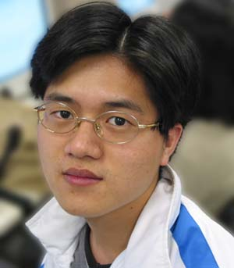
Vincent
Fig 1 the Recognition of Face to Name

  - Contribution
This part, we would describe the contribution of work and knowledge gained through the first semester. The following is our contribution:
- Study Image Processing Technique, Data Mining Technique
- Implemented Korean Stroke Extraction
- Implemented Korean Stroke Recognition
- Partially Built the Database
- Implemented Face Region Detection
- Implemented Location of the iris

- Related Technique Studies
This Chapter, we will discuss about some technique that closely related with our project. Due to the goal of this project, recognize characters and face, there are some common basic techniques which are useful for our project.
For Pattern Recognition Model, it is a generic model for both parts of this project. We can follow the flow of the model to achieve the recognition goal.
And also, we need to study about some image fundamental concept such as neighbors, connectivity and color models.
Furthermore, in this project, we would capture images from camera. So the captured images sometimes may have some noise. Then we need to study some basic techniques to enhance the quality of the image before recognition such as blurring, sharpening, histogram equalization and edge detection.
For the model of pattern recognition, we need to segment objects out from the image. Therefore, image segmentation is also a technique we studied such as labeling of connected component, color segmentation and watershed segmentation.
Feature Extraction is also a necessary technique for pattern recognition such as Gabor features. And also, we would introduce our proposed feature extraction method for this project.
For recognition part, we need some methods to compare features. Then we studied some methods such as Minimum Euclidean Distance, Exact Matching and Decision Tree.
In this project, we would deal with the Korean Characters. Therefore, we also studied some information about this such as the pattern, coding and strokes. And also, specifically, we would introduce some common techniques about the face detection to localize a face in the image.

  - Pattern Recognition Model
Due to our project, we need to recognize characters and face. Therefore, we need to study about a generic pattern recognition model [] in order to implement it into our application. Fig 2 shows the generic pattern recognition model.

Image
Segmentation
Feature Extraction
Classification
Input Image
Object Image
Feature Vector
Object Type
Find Each Object from the Image
Quantify the object by some characteristics
Assign Label for each object
Fig 2 Pattern Recognition Model
The input image is raw input. In the image segmentation module, the objects are extracted from this image e.g. extracting different characters and detecting the face.
In the feature extraction module, the input objects are quantified by some characteristics e.g. number of corners, number of functions, shape descriptors and some statistical analysis. This quantified values/vector is feature.
After that, each feature vector is assigned with a label to classify/identify it. Therefore, all feature vectors are classified and stored in the database.
For recognition process, we need to recognize an image. This input image is needed to pass through the first two modules (image segmentation and feature extraction). Therefore, some feature vectors are obtained. Then these feature vectors are compared with the vectors in the database. The comparison methods are by means of similarity/distance methods. Therefore, the most similar one is the recognized result.

  - Color Models
Color model [] is a model that can represent the color. Color usually describes much information about an object. Therefore, color model is a quite popular technique for detecting an object. Since human being have only three types of color photoreceptor, we only need 3D space to represent color space. There are several common color models such as RGB (red, green and blue), HSB (hue, saturation and brightness) and YUV (luminance-chrominance). Unfortunately, not all color models can be used to detect an object. Usually, HSB and YUV color model are much popular. In this project, we choose YUV to detect face in face recognition part. Although some color models are suitable for detecting object, they also have their limitations such as the range it can represent.

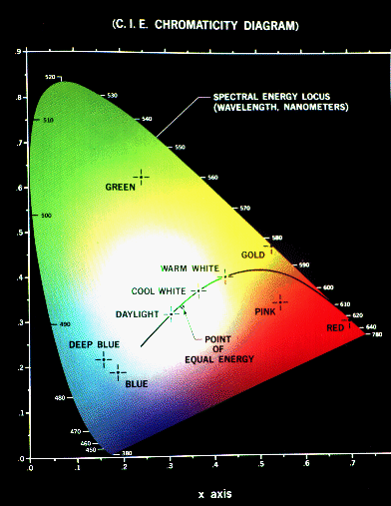
Fig 3 C.I.E. Chromaticity Diagram
  - Image Enhancing Methods
Image enhancing methods include edge detection, blur, contrast, histogram equalization and etc. They are quite common enhancing method.

    - Sobel filter
For edge detection we use Sobel filter []. There are two filters for line detection.
121000 -1-2-1 Horizontal filter
-101-202-101vertical filter

Fig 4 the Horizontal and Vertical Sobel Filter
These two filters are used to find the edge in horizontal and vertical direction (G_{x} and G_{y}) respectively. Once, they are found. We can obtain the gradient vector (G_{x}i+G_{y}j). We can calculate the direction of the edge by analysis the gradient vector. The direction and magnitude of edge are important because they can be used in the edge linking.

    - Histogram equalization
For the histogram equalization [], it just makes the intensity of an image more even. Usually, it applies on gray-level images.
Histogram equalization provides a sophisticated method for modifying the dynamic range and contrast of an image by altering that image. Histogram equalization employs a monotonic, non-linear mapping which re-assigns the intensity values of pixels in the input image such that the output image contains a uniform distribution of intensities (i.e. a flat histogram). This technique is used in image comparison processes (because it is effective in detail enhancement) and in the correction of non-linear effects introduced by, say, a digitizer or display system.

    - Blur
Usually, we apply a filter to make the image blurring []. The filter of blur can be simplified to:
1 | 1 | 1
1 | 1 | 1
1 | 1 | 1
Simple blur filter

Fig 5 the Average Filter
This simply averages the pixel within 3x3-pixel region and the resultant image becomes blurring. We also can use Gaussian blur.
For example, 9x9 Gaussian blur filter [] is.

$$\left[\begin{matrix}0 & 0 & 1 & 1 & 1 & 1 & 1 & 0 & 0 \\ 0 & 1 & 2 & 3 & 3 & 3 & 2 & 1 & 0 \\ 1 & 2 & 3 & 6 & 7 & 6 & 3 & 2 & 1 \\ 1 & 3 & 6 & 9 & \text{11} & 9 & 6 & 3 & 1 \\ 1 & 3 & 7 & \text{11} & \text{12} & \text{11} & 7 & 3 & 1 \\ 1 & 3 & 6 & 9 & \text{11} & 9 & 6 & 3 & 1 \\ 1 & 2 & 3 & 6 & 7 & 6 & 3 & 2 & 1 \\ 0 & 1 & 2 & 3 & 3 & 3 & 2 & 1 & 0 \\ 0 & 0 & 1 & 1 & 1 & 1 & 1 & 0 & 0\end{matrix}\right]$$
Fig 6 Gaussian Blur Filter
Fig 6 shows the Gaussian Blur Filter. Fig 7 shows the 3D view of it.
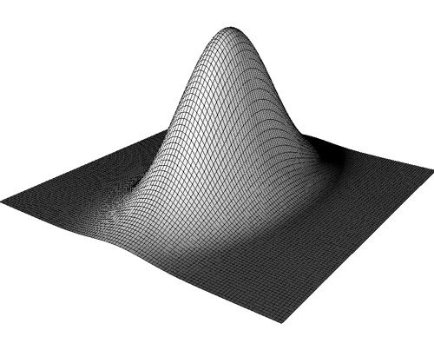
Fig 7 3D View of 2D Gaussian Blur Filter
The 2d Gaussian blur filter can be obtained by the formula:
$$f(x,y)={\text{ke}}^{−\frac{1}{2}\frac{x^{2}}{s_{x}^{2}}}e^{−\frac{1}{2}\frac{y^{2}}{s_{y}^{2}}}$$
where k is a constant, sx and sy are the standard deviation for x and y axis respectively.
  - Image Segmentation
    - Labeling of Connected Component
By definition, “if p and q are pixels of an image subset S, then p is connected to q in S if there is a path from p to q consisting entirely of pixels in S” [] and “for any pixel p in S, the set of pixels in S that are connected to p is called a connected component of S”, Therefore, in labeling of connected component algorithm, we need to find all the connected components(sets) and label them with different labels for distinguishing them. And also, the connectivity using is 8-connectivity.

(a)$\left[\begin{matrix}0 & 0 & 1 & 1 & 0 & 0 & 1 & 0 & 1 & 1 \\ 0 & 1 & 1 & 1 & 1 & 0 & 0 & 1 & 1 & 1 \\ 0 & 1 & 1 & 0 & 0 & 0 & 0 & 0 & 1 & 1 \\ 0 & 1 & 1 & 0 & 0 & 0 & 0 & 0 & 0 & 1 \\ 0 & 1 & 0 & 0 & 0 & 0 & 1 & 0 & 0 & 1 \\ 0 & 0 & 0 & 0 & 0 & 1 & 1 & 1 & 0 & 0 \\ 1 & 1 & 1 & 0 & 0 & 1 & 1 & 1 & 1 & 0 \\ 1 & 1 & 0 & 0 & 1 & 0 & 0 & 1 & 1 & 1 \\ 0 & 1 & 1 & 0 & 0 & 1 & 1 & 1 & 0 & 0 \\ 0 & 0 & 0 & 1 & 0 & 1 & 0 & 0 & 0 & 0\end{matrix}\right]$ (b)$\left[\begin{matrix}0 & 0 & 1 & 1 & 0 & 0 & 2 & 0 & 2 & 2 \\ 0 & 1 & 1 & 1 & 1 & 0 & 0 & 2 & 2 & 2 \\ 0 & 1 & 1 & 0 & 0 & 0 & 0 & 0 & 2 & 2 \\ 0 & 1 & 1 & 0 & 0 & 0 & 0 & 0 & 0 & 2 \\ 0 & 1 & 0 & 0 & 0 & 0 & 3 & 0 & 0 & 1 \\ 0 & 0 & 0 & 0 & 0 & 3 & 3 & 3 & 0 & 0 \\ 4 & 4 & 4 & 0 & 0 & 3 & 3 & 3 & 3 & 0 \\ 4 & 4 & 0 & 0 & 3 & 0 & 0 & 3 & 3 & 3 \\ 0 & 4 & 4 & 0 & 0 & 3 & 3 & 3 & 0 & 0 \\ 0 & 0 & 0 & 4 & 0 & 3 & 0 & 0 & 0 & 0\end{matrix}\right]$
Fig 8 (a) The input image, (b) The resultant labeling of connected component
For examples, Fig 8(a), we consider about the “1” entries. We found that there are 4 connected components. And the result of this labeling algorithm is as Fig 8(b).
The algorithm is to transverse the input matrix from left to right and top to bottom for each entry. And the mask $\left[\begin{matrix}a & b & c \\ d & p & − \\ − & − & −\end{matrix}\right]$ can help us to describe the algorithm more convenience. The point p is the testing entry point.
Fig 9 shows the pseudo code of the algorithm.

If p=0, move on to the next position.
Else If p=1 and a=b=c=d=0,
assign a new label to p.
Else If p=1 and either one of a=1,b=1,c=1 and d=1,
assign the same label to p.
Else If p=1 and [(a=1 or b=1 or c=1 or d=1) but with different labels],
assign a new label to p, make them equivalent to this new label.
Else // p=1 and [(a=1 or b=1 or c=1 or d=1) but with same label]
assign the same label to p
Fig 9 the Algorithm of Labeling of Connected Component
Therefore, the labeling of connected component algorithm can help us to distinguish different connected component. It is important for extracting the strokes of the character in order to recognize the strokes.

    - Color Segmentation
Actually, we can use color model to segment the object in the image. Color is a very good descriptor in usual case. We can construct a color histogram [] and locate the pitch. Then we can find different color range in the histogram. Hence, different color object is identified.
For example, Fig 10 shows an example of color histogram.
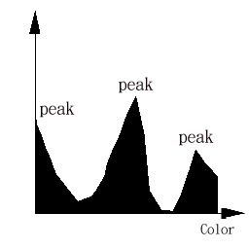
Fig 10 the Color Histogram
From this color histogram, we can segment three regions by three different range of color.

    - Watershed segmentation
Watershed segmentation [] is a method for separating essentially convex and relatively smooth features that touch slightly. Any gray scale image can be considered as a topographic surface. If we flood this surface from its minima and, if we prevent the merging of the waters coming from different sources, we partition the image into two different sets: the catchments basins and the watershed lines. The watershed lines will outline the region. Hence, we can segment regions by using watershed segmentation.
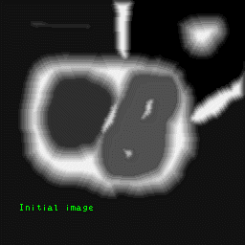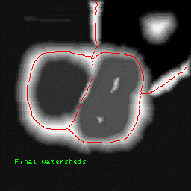
Fig 11 (a) The Initial Image, (b) The Resultant Image of Watershed Segmentation
Fig 11(a) is the initial image and Fig 11(b) is the final watershed image.

  - Similarity and Distance Measurements
In the part of Pattern Recognition Model (2.1), it is important that we need to find the similarity [] of two objects in order to recognize the object belongs to which class. Therefore, we need to study about some common similarity functions for the project used.
The most common similarity functions are defined by distance measurements. The smaller distance within two feature vectors, these two feature vectors are more similar. There are three common distance measurements:
Euclidean Distance:
((x_{i}-x_{j})^{T}(x_{i}-x_{j}))^{1/2} or (x_{i}-x_{j})^{T}(x_{i}-x_{j})
City Block/Manhattan Distance:
$\sum_{m−1}^{p}{|x_{\text{im}}−x_{\text{jm}}|}$
Chessboard Distance:
${\text{max}}_{m−1}^{p}(|x_{\text{im}}−x_{\text{jm}}|)$
where x_{i}, x_{j} are two vectors
We can apply these distance measurements due to the applications. The importance of these measurements is help us to identify the classification in the pattern recognition model (2.1)
  - Feature Extraction Methods
As mentions before (2.1), we need to quantify an object to some values or a feature vector. Therefore, we need to study some common feature extraction methods to deal with our project.

    - Gabor Wavelet Feature
Gabor wavelet [] is a feature extraction technique.
Simple cells in the primary visual cortex have receptive fields (RFs) which are restricted to small regions of space and highly structured.

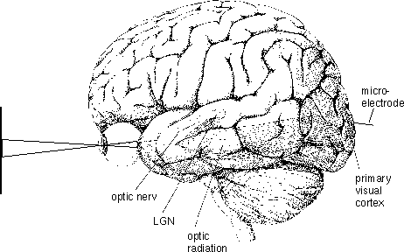
Fig 12 the Principle of Stimulation of Light
The RF of a certain cell was measured location for location by projecting a dot-like stimulus on a homogeneous screen the corresponding eye looks to.
The results of Jones´ and Palmer´s experiments [] suggest modeling the shapes of the RFs by two-dimensional Gabor filters, a plane wave restricted by a Gaussian. In other words, Gabor wavelet filter is used to model the RFs of simple cells
The response a of such a cell can be written as a correlation of the input data, i.e. an image I(x), with the modeled RF p(x):
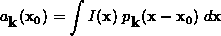
where
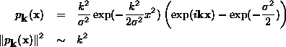

The response a is the feature extracted by Gabor filter.

    - Proposed Feature

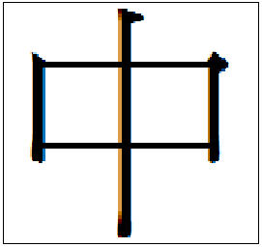
Fig 13 the Basic Idea of our Proposed Feature
Fig 13 shows the basic idea of our proposed feature. This idea is inspired from []. There are n rays transverse from left and stop at the first hit at the stroke position. Therefore, the length of this n rays is marked as d_{i} where 0<=i<n.
Then we compare d_{j} and d_{j+1}. If d_{j}<d_{j+1}, a_{j}=1; If d_{j}>d_{j+1}, a_{j}=-1; If d_{j}=d_{j+1}, a_{j}=0. Therefore, we can obtain all a_{j} where 0<=j<n-1.
Besides the rays from left to right, we can transverse rays from right-left, top-down and bottom-up similarly. Finally, there are 4(n-1) values (b₀, b₁, b₂, …, b_{4n-5}) obtained all together.
For addition, we count the number of holes (b_{4n-4}) in the character/stroke. Therefore, the feature vector b is obtained with 4n-3 dimensions.
  - Classification Method
For the pattern recognition model (2.1), we need to classify all the objects with labels. We can use the methods described in the next section (2.8) or we can learn a decision tree [] which is described in this section for recognizing the object.
The advantages of decision tree are faster for recognition and have ability to predict/recognize some unseen/untrained cases.
For the decision tree, each internal node represents an attribute which is used for determining which path would transverse. Each branch represents the possible value of that attribute node. Each leaf node provides a classification. Therefore, for a testing vector, we can transverse from the root to the leaf by testing the attribute (entry) in the vector. Then we can get the classification of this testing vector.
For learning a decision tree, we need a training set which contains all training vectors. And we need to set the target attribute (classification). For training, we need to choose the best attribute (entry) to extend tree by adding branch with this best attribute. After that, we sort the training vectors to leaf nodes. If all/most training vectors are being classified, then stop; else repeat choosing and extending steps for leaf nodes. Therefore, a decision tree is obtained.
So, the important question is how to choose the best attribute. Then we introduce three measurements:
Entropy: I(T) = -(p₁log(p₁) + p₂log(p₂)+…+p_{n}log(p_{n}))
Misclassification cost: I(T) = 1 – max_{i} p_{i}
Gini: I(T) = $\sum_{i≠j}{p_{i}p_{j}=1−\sum_{j}{p_{j^{2}}}}$
Where T is the vector set
p is the goal attribute
p_{i} is the density/probability of i^{th} value of p
Then we introduce another measurement which is to measure the information after choosing an attribute(X):
I(X, T) = $\sum_{i=1}^{n}{\frac{|T_{i}|}{|T|}I(T_{i})}$
where T_{i} is the set which partitioned by X with i^{th} value
T is the vector set
Therefore, we can calculate how much information gain for choosing an attribute(X). The formula is Gain(X, T) = I(T) – I(X, T). Therefore, we choose the attribute that gain maximum information (max_{i}(X_{i}, T)) to be the best attribute for extending the tree.
From the above, the decision tree can be built automatically from the training set when identify which attribute is goal attribute. However, the decision tree we built is just for the value of attributes is discrete. For continuous case, the above method is not workable.
  - Recognition
    - Minimum Euclidean Distance
Once, we extract the feature. We must compare the feature extracted with feature of each class in order to find the most probable class. There are several methods to solve this problem. We can use minimum Euclidean distance []. It is very simply and straightforward method.
We can use this formula
$d^{2}=\sum_{i=1}^{n}{(x_{i}−c_{i})^{2}}$. (2.5)
where x is the feature vector of target object, c is the feature vector of the class.
Hence, the most probable class is c such that d is minimized.

    - Exact Matching
This recognition method is just to compare the extracted feature with all the features in the database. If the extracted feature is exactly equal to one of the features in the database, that feature is the result.

  - Korean Characters
The Pattern of the Korean Characters is limited. There are six combinations of block pattern []:

: Initial consonants
: Vowels
: Final consonants
Fig 14 the 6 Patterns of Korean Character
To represent a Korean character, the Johab standard which is 16-bit code is used. The following is Johab standard coding:
1st bit : denotes it is a Johab encoding
2nd-6th bits : Initial consonants
7th-11th bits : Vowels
12th-16th bits : Final consonants
Fig 15, 16 and 17 show the coding of each Korean stroke.

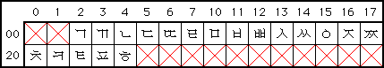
Fig 15 Initial Consonants
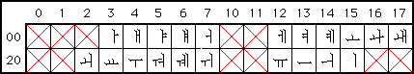
Fig 16 Vowels
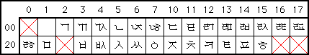
Fig 17 Final Consonants

  - Face Detection
    - Template Matching
In face detection, we can use a simple template matching [13]. It bases on normalized cross-correlation.
Let I₁, I₂ be images of the same size.
I₁(p_{i}) = a_{i ,} I₂(p_{i}) = b_{i}
$$\text{NCC}(I_{1},I_{2})=\frac{\sum_{i}{((a_{i}−\overline{a})(b_{i}−\overline{b}))}}{\sqrt{\sum_{i}{(a_{i}−\overline{a})^{2}\sum_{i}{(b_{i}−\overline{b})^{2}}}}}$$
NCC(I₁, I₂) lies on the range [-1, 1]
Actually, it is used to measure the similarity of the patterns of two images. However, it has its weakness. If the intensity of an image is the same, the NCC is undefined. Fortunately, this situation is never occurs in practice. This technique can be used to detection the eyes and mouth.

    - Elastic Graph Matching
In some case, such a simple template matching is not good enough to recognize an object. There is more sophisticated technique which is Elastic Graph Matching []. The graph matching algorithm tries to find a position for each node of the graph which maximizes the feature similarity and minimizes the topography costs at the same time. We can determine the cost function for the topography costs.
Usually, elastic graph matching algorithm consists of two steps. The first step is to approximate the best matching position by not allowing distortion of graph. That means that all nodes are moved at the same time. The second step is allowed each node to move individually. This technique is used in the feature extraction.

    - Hough Transform
The Hough Transform []-[] is known to be robust to imperfect data and noise. In the case that the edge information is not complete, Hough Transform can find the complete shape of the edge according to small portion of edge information. Hough Transform works with a parametric representation of the object we are looking for. Hence, we should determine a parametric representation for the object. Then, we have the searching space for the parametric representation. The searching space usually consists of position and the parameter used in the representation. For example, if the parametric representation is a circle, then searching space is [x, y, r], where x ,y is the coordinate and r is the radius.
Finally, for each pixel p = (a,b) in which the edge magnitude is nonzero, we increment the corresponding accumulator.
A(x,y,r) = A(x,y,r) + 1 if | (x-a)²+(y-b)²-r²| < e where e is the width of the circle.
Therefore, we can choose the accumulator which has the highest value and hence determine the parametric representation.

    - Deformable Template
Deformable template [] is a kind of template matching. It is also similar to Hough transform. It works with a parameter representation. However, it has a more complicated similarity function. Therefore, its time complexity is quite large.
- System Design
  - Overall Design
The overall design of our application is shown as Fig 18.

GUI
Camera API
Camera
Korean OCR
Face Recognizer

Face Database
Stroke Database
&
Dictionary
Request
Request
Data
Data
Request
Output
User
Query
Result
Query
Update
Result
Request Response
Request Response
Request Response
Fig 18 the Overall Design
The Graphical User Interface (GUI) provides an interface for the user. It coordinates the different components and displays the corresponding result.
The Camera API is an interface which is provided by the camera hardware company to operate the camera. Therefore, it provides some functions for capturing the image data. After that, the data is passed to the recognition engine. Then the user can request the system to translate the characters or recognize the face.
For the Korean OCR module, it needs to recognize the Korean characters and translate it into English.
For the Face Recognizer, it helps user to recognize the face or add “new face” into the database for future used.

  - Component Design
    - Korean OCR
Image Segmentation
Stroke Feature Extraction
Stroke Recognition
Translator
Stroke Database & Dictionary
Stroke Combination
Text Area Detection
Character Extraction
Binarization

Stroke Extraction
Input Image
Strokes
Strokes’ Feature Vectors
Recognized Results
Korean
Chars
Query
Result
Query Result
English
Binary Character Image
Fig 19 the Basic Idea of Korean OCR Module
Fig 19 shows the basic idea of the Korean OCR Module.
The input image is captured from the camera through the Camera API which is provided by the Camera Manufacturer. Then this image is passed into our Korean OCR module for translating the Korean characters into English. By the model of pattern recognition (2.1), it is necessary to segment the image first. Therefore, the image is the input of the first component – Image Segmentation.

      - Image Segmentation
In the Image Segmentation Module, we need four other sub-modules to complete its task. They are Text Area Detection, Binarization, Character Extraction and Stroke Extraction Components.

        - Text Area Detection
We proposed edge detection method (2.3) to do this task. After doing the Sobel mask on the image, we take the horizontal projection and vertical projection.
If there are characters in an area, the density of edge detected is high. Therefore, there is/are peak(s) in the horizontal projection and vertical projection. If the value is higher than a threshold, it is potentially a text area. Fig 20 shows the idea graphically.
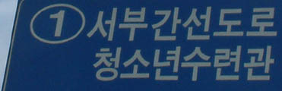
Horizontal Projection
Threshold
Vertical Projection
Fig 20 the idea of Horizontal Project and Vertical Project
Therefore, we can loosely detect the text area. Then the system can ask the user to help us to fine tune the boundary of the text area to achieve the goal. So the output is the text area image.

        - Character Extraction
After detecting the text area, the next step is to extract the character by character. The method to be used is also the edge vertical projection of the row of characters. The method can be used because there is a little gap between characters. Therefore, the vertical projection of edge should be low relatively. So we can use the same method to segment the characters and pass the character images to the next module.

        - Binarization
Binarization means that we separate the image into two colors only. Typically, they are black and white. It is necessary to do the binarization because several steps afterward (including stroke extraction and stroke feature extraction) just can process the binary image.
Typically, the sign and guidepost are contrast in color (following figure) for the background color and text color. Therefore, we can make use of the color segmentation (2.4.2) to segment the image into two colors. Then the output image becomes a binary character image.
Fig 21 a Sample of Korean Street Guidepost

        - Stroke Extraction
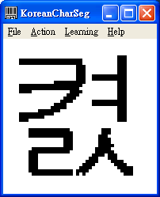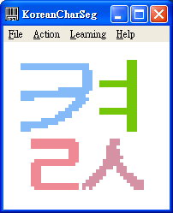
Fig 22 the idea of Stroke Extraction
For the Korean Character, the strokes are separated typically. It means that the strokes are different connected components for a binary character image. Therefore, the labeling connected component algorithm (2.4.1) can be used.
Then all connected components can be extracted. However, sometimes, the two strokes connected with 8-connectivity []. Therefore, some improvements need to be done.
We count the area (number of pixels) of a connected component which is 4-connectivity. After that, if two large size of area which connected with 8-connectivity, they are different strokes.
Therefore, all different strokes can be extracted and pass into the next module.

      - Stroke Feature Extraction
The feature we used is our proposed feature (2.6.2). Five rays are used in each side. Therefore, the dimension of the feature vector is 17. However, we simplify the entry that represents number of holes. The simplified entry is just for determining whether have hole. And also, one more entry is added. This entry is to represent the ratio of width and height (width/height). If the ratio is greater than 1.2, the entry is 1; if it is less than 1/1.2, then the entry is -1, else the entry is 0. It is added because some simple strokes have the same proposed feature vector (2.6.2). Fig 23 shows an example pair of strokes:

Fig 23 the Example of confused strokes
Therefore, the dimension of the feature vector is 18.

      - Stroke Recognition
For stroke recognition, we propose two methods. One is the exact/template matching (2.8) to recognize the input feature vectors from the stroke database. It is an easy way to recognize a pre-learned stroke (3.2.3) in the database. Another method is using the decision tree (2.7) which is learned when training (3.2.4). Therefore, the stroke codes can be got from this module.

      - Stroke Combination
For this module, it is used to combine the different strokes into one Korean character representation. Each stroke is the sub-part of initial consonant, vowel and final consonant (2.9). Therefore, we need to determine that the stroke is belonging to which part.
Before determining the stroke belonging, we need to identify whether the Korean character contains the final consonant. Therefore, it is necessary to identify which one of the 6-pattern (2.9) the character belongs to. After that, we can determine the stroke belonging by the relative position in the character.
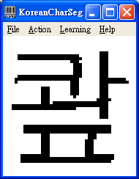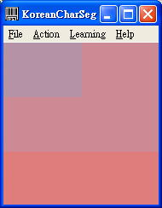
Fig 24 the Idea of 6 Korean Patterns Identification
Therefore, we can get the initial consonant, vowel and final consonant (optional). Then we can represent the character with the Johab standard coding (2.9).

      - Translator
This module is to translate the Korean Characters into English. Therefore, we need to maintain a database that stores this translation. Fig 25 shows some examples of Korean-English Dictionary.
가다 go; proceed; travel; attend (some place)
가게 a shop; a store
가까 be close, near
가끔 sometimes; now and then; occasionally
Fig 25 examples of Korean-English Dictionary

    - Face Recognizer
Face Recognizer consists of two parts. They are face detection and face recognition. Face detection will be started at first term. And the face recognition will be started at second term. Face detection will be discussed in this report, but the face recognition will be discussed in future work.

      - Face Detection
Design for face detection
Color Segmentation
Locating the face
Finding the facial feature
Histogram equalization
Input Image
Facial feature images
Threshold
Hough transform and deformable template
Segmentation images
Region containing face region
Images which are located the eyes and mouth
Fig 26 the six steps of face detection
Fig 26 shows the six steps in the face detection. First, an image of a person will be captured by a camera. This is the input image. And then, the system will perform color segmentation. It will find the potential face regions from the background. After that, it will find the position of eyes and mouth by several techniques. Finally, it will locate the irises and the mouths very precisely. The six steps will be discussed in follows.

        - Skin Color Segmentation
Before color segmentation [], we must choose an appropriate color mode. We choose YCbCr because of its simplicity and robustness. Y component is used to represent the intensity of the image. Cb and Cr are used to represent the blue and red component respectively. We only use this color model to represent the skin color. We found that if the skin color is transformed to CbCr histogram, region that represents the skin color is very small.
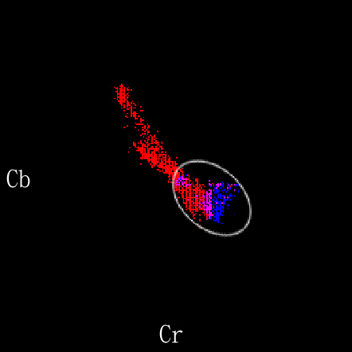
Fig 27 the CbCr Histogram
Fig 27 shows the CbCr Historgram. The blue region represents the skin color and the red region represents the other color in the image.
We can use a simple ellipse in the CbCr histogram to represent skin color. With this result, we can transform it into CbCr histogram and check each pixel to see whether it is in the ellipse region. Hence, we can find the skin-color region very quickly.
We use this formula to represent the ellipse:
$$\frac{X^{2}}{L^{2}}+\frac{Y^{2}}{S^{2}}=1$$
where L is the length of the long axis and S is the length of the short axis.
$$\begin{aligned}X=\text{Cb}\text{cos}θ+\text{Cr}\text{sin}θ \\ Y=−\text{Cb}\text{sin}θ+\text{Cr}\text{cos}θ\end{aligned}$$
We choose L = 35.42, S = 20.615, θ = -0.726 (radius)

        - Locating the Face
After finding the skin-color regions, we believe these regions may contain faces. Then we use pseudo-convex hull to outline each regions. The image may contain more than one person’s face. Therefore, these regions will be analyzed one by one.

        - Finding the Facial Features
After the segmentation of face region, we have some parts which are not regarded as skin color within the potential face regions. They are probably the regions of eyes and mouth. Then we only consider the red component of these regions because it usually includes the most information about faces.

        - Histogram Equalization
Once we found the regions containing the eyes, we perform histogram equalization. Sometimes, the input image is not good enough. They may be too dark or too bright. Histogram equalization (2.3.2) remedies this problem. Therefore, less error is introduced in following steps.

        - Threshold
We check each pixel in the regions containing eyes to see whether it has a low value. Since iris and eyelids are dark usually, we can reduce the searching space for eyes greatly by threshold.

        - Hough Transform and Deformable Template
After finding the searching space for eyes, we can use Hough transform (2.10.3) to find the location of iris precisely. The details of Hough transform is discussed in above (2.10.3).
For the mouth, we apply deformable template to find the location of mouth. We define the deformable template model (2.10.4) and cost function. We then try to minimize the cost function.
Finally, we have found the location of eyes and mouth, the face detection is finished.

    - Training Korean OCR Database
GUI
Trainer
Request & Assign Stroke Code
Response
Korean TTF File
TTF2BMP
Stroke Extraction
Stroke Feature Extraction
Feature & Stroke Code Storage
Assign Code
Character Bitmap
Stroke Bitmap
Stroke Database
Fig 28 the procedure of training the Korean OCR Database
The procedure is to train the stroke database for stroke recognition (3.2.1.3). The Korean Character Stroke Bitmap is loaded from a Korean TTF File. When the trainer watches the stroke bitmap, he/she can assign a stroke code. Therefore, the stroke database can be prepared.

      - Korean TTF File
TTF means True-Type Font. TTF File [] is a file type that contains the graphic representation of characters (language). Therefore, we can make use of this TTF file to avoid collecting necessary training set. And also, the characters in sign and guidepost are printed characters, so using the TTF File is a simple way to find the standard fonts.

      - TTF2BMP
This module [] is to extract the character bitmaps from the TTF file. Therefore, we need to have a rough idea about the TTF file. First, the module needs to read the header of the TTF and get the information such as the beginning position of each character. Then we extract the character by character.

      - Stroke Extraction
This module has been discussed in Section 3.2.1.1.4.

      - Stroke Feature Extraction
This module has been discussed in Section 3.2.1.2.

      - Feature & Stroke Code Storage
The trainer need to assign stroke codes to stroke types with the stroke features. Then we need to store the feature paired with its stroke code. Then the stroke database can be obtained.

    - Decision Tree Learning Procedure
Stroke Database
Decision Tree Learning
Stroke Database in Tree Form
Fig 29 the Procedure of Decision Tree Learning
The Decision Tree Learning Method has been described in Section 2.7. We make use of the algorithm to learn the decision tree. We load all features and codes (target attribute) from the stroke database which is prepared in the previous section (3.2.3). And then, the decision tree is learned by all the information. After that, we store the decision into the database.

  - Hardware Requirements
The hardware requirements are mobile device with camera. At the market, there are several devices available:
Pocket PC | Lifeview FlyCAM-CF | Nokia 7650
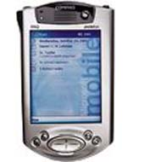 | 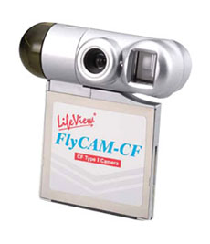 | 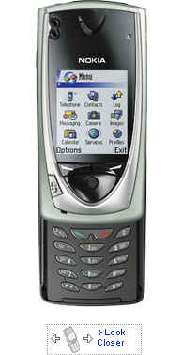
We will implement the system on the Pocket PC with Lifeview FlyCAM-CF first. If the time is available, Nokia 7650 is also a good choice too.

- Implementation
For our implementation, we will concentrate on the workable algorithm for Korean OCR, face detection and recognition first. Therefore, we will implement all algorithms on desktop at the first stage.
At the second stage, we will port the coding from desktop to the actual mobile device say Pocket PC. Therefore, it is necessary to optimize our coding such that the coding is small and efficient.

  - Korean Optical Character Recognizer
    - Stroke Extraction Module
As mentioned before, the labeling of connected component algorithm is used. In the implementation, we make use of this algorithm to extract the stroke. We pass the integer array into the blob_count function. This integer array contains 1s and 0s. 1s represent the strokes and 0s represent the background. This function returns how many different connected components and labels all the connected components in different labels.
The prototype of this function is: int blob_count(int *A, int height, int width) where height and width is the dimension of this matrix A.
The first part of this function is the same as the description at Section 2.4.1. However, the extracted strokes are not as perfect as we expected. Two or more strokes would be connected together.
Therefore, as section 3.2.1.1.4 mentioned, we need to do an enhancement for the algorithm. Area of 4-connectivity connected components should be measured. After measuring the area, we would try to split two large areas which are 8-connected together.

Large Area
8-connected
Fig 30 two 8-connected large area
For choosing the area, the area is larger than 5 pixels consider as large area for a 48x48 character. Therefore, the returned array is all the labeled 8-connected components width 4-connected within components.
However, practically, the two strokes (large area) may be 4-connected together.


Large Area
4-connected
Fig 31 two 4-connected large area
But in this case, we cannot introduce a new idea to tackle the problems.

    - Stroke Feature Extraction Module
As mentioned in Section 2.6.2 and 3.2.1.2, the feature vector is 18-dimension. And also, there are three types of features. Therefore, the feature extraction function is divided into three parts.
We propose this feature because we have tried to use the Gabor feature filter. However, it is not workable on our stroke pattern recognition by testing. And also, we have tried some simple testing such that our proposed feature is workable.
The first part is to find the first hit stroke features by submitting five rays from each side. And measure the difference of them to extract the features. The second part is to determine the dimension ratio. We just do a division on width and height to extract this feature.
Then last part is to determine whether has hole in the stroke. First, we try to find a pixel which is potentially a hole. And then, we use flood-fill algorithm on this pixel. If the filling hits the strokes (black color), it is a hole. Therefore, we can identify whether the extracted stroke has a hole.

    - Korean Pattern Identification
For identifying which Korean Pattern the character belongs to, we divided the character into 2x3 sub-regions. Then for each sub-region, label it with its major stroke (connected component) labeling. It means that more pixels of stroke in the sub-region, the labeling of this sub-region is that stroke labeling.
0 1 2 3 4 5
Fig 32 the identification of each Korean Pattern
Then we can pass this sub-region labeling into another function to analyze Korean Pattern, we simply use if-then-else statement to check the 2x3 sub-regions labeling. The following function is to analyze the result. The coding of pattern 0 – 5 is shown as Fig 32. And also, the input sub-region labeling is upside down because of bitmap format is upside down. Fig 33 shows the algorithm we implemented.

int analystKoreanPattern(int flag[2][3])
{
if(flag[0][2]==flag[1][2]) // Pattern 0,3
{
int i,j,pixel,count;
pixel=-1;
for(i=0;i<2&&pixel==-1;i++)
for(j=0;j<3&&pixel==-1;j++)
if(flag[i][j]!=-1)
pixel=flag[i][j];

count = 0;
for(i=0;i<2;i++)
for(j=0;j<3;j++)
if(flag[i][j]==pixel)
count++;
if(count>=5)
return -1;

// Pattern 3
if( ( flag[0][2]!=flag[0][1] && flag[0][1] != flag[0][0] && flag[0][2] != flag[0][0] ) ||
( flag[1][2]!=flag[1][1] && flag[1][1] != flag[1][0] && flag[1][2] != flag[1][0] ) )
return 3;
else
return 0;
}
else // Pattern 1,2,4,5
{
// Pattern 1,2
if( (flag[0][2]==flag[0][1] && flag[1][2]==flag[1][1] && flag[1][1]==flag[1][0]) ||
(flag[0][1]==flag[0][0] && flag[1][2]==flag[1][1] && flag[1][1]==flag[1][0]) )
{
if(flag[0][1]==flag[0][0]||flag[0][0]==-1)
return 1;
else
return 2;
}
else // Pattern 4,5
{
if(flag[0][2]==flag[0][1])
return 4;
else
return 5;
}
}
}
Fig 33 the implementation of Korean Pattern Identification

    - Learning Decision Tree
The algorithm to learn the decision tree has been discussed in Section 2.7. Fig 34 shows the pseudo-code of decision tree learning algorithm. Our implementation is totally followed this algorithm.
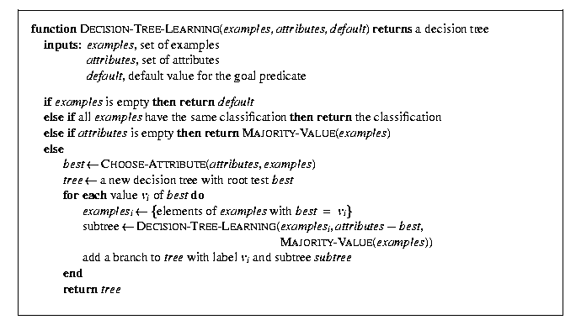
Fig 34 the pseudo code of algorithm of Decision Tree Learn
For choosing the attribute for extending the tree, we would use the entropy. We plan to implement it in the future.

    - Stroke Recognition
In Section 3.2.1.3, we proposed to use exact/template matching and decision to recognize the strokes. Therefore, we implement these two methods and prepare to compare these two methods in the future.
We use the exact/template matching function. We have the stroke database and the testing stroke’s feature. The function just compares the input feature and the database linearly. If there is an exact match on the database, this match is the recognized result.
For decision tree, we simply transverse the tree node by node with the attributes such that the tree is learned from the implementation of previous section. Then the leaf node is the result. Therefore, the recognition speed is much faster than the exact matching method.

    - Photo Captured
For using the FlyCAM-CF API (5.3), we have tried to follow the actual C++ coding which provided by the API [].
However, we found that it is workable. Before capturing a frame, we need to call StartPreview and StopPreview functions which provided with the API first. Otherwise, the captured frame buffer is destructed. And also, the captured frame buffer is not the correct orientation of the frame. Therefore, we need to rotate the buffer also.

  - Face Detection
    - Segmentation Module
In the color segmentation, we can simply search the whole image and check whether each pixel is in the ellipse of the CbCr histogram. However, we use another algorithm for searching the face regions more efficiently.
We distribute some agents in the image uniformly say 10x10. Each agent will check whether the pixel is a skin-like pixel and the pixel is not visited by the other agent. If yes, it will produce 4 more agents at its four neighboring points. If no, it will move to one of four neighboring points randomly and decrease its lifespan by 1. When its lifespan becomes zero, it will be removed from the image.
If the pixel the agent located is skin color, it will produce four more agents
This agent produces 4 more agents
Fig 35 the idea of agent segmentation
If the pixel the agent located is not skin color, it will move to one of four neighboring points randomly and decrease its lifespan by 1

This agent move to one of four neighboring point
Fig 36 the idea of moving agent
After this process, we can find the many regions which are searched by the agents. Therefore, we should combine them. In general, we only search 20% of the whole image. This algorithm is quite efficient.
Although this algorithm is quite good, we modified a little bit. Since some pixels are wrongly regarded as skin color, we use a Gaussian model to represent the distribution of YCbCr value of skin color.
At first n testing of skin color in each father agent, we check whether the pixel is in the simple ellipse as usual. In the same time, we calculate the mean and the variance of Y, Cb and Cr for each region searched by the corresponding agent. After n testing of skin color, the agents are no longer to test the skin color by the simple ellipse equation. Each agent will check whether the pixel is skin color by following formula.
$$|Y−\overline{Y}|<k_{Y}σ_{Y}$$
$$\frac{(\text{Cb}−\overline{\text{Cb}})^{2}}{k_{\text{Cb}}σ_{\text{Cb}}^{2}}+\frac{(\text{Cr}−\overline{\text{Cr}})^{2}}{k_{\text{Cr}}σ_{\text{Cr}}^{2}}≤1$$
where the k_{Y}, k_{Cb} and k_{Cr} are constant determined by experience. σ_{Y}, σ_{Cb} and σ_{Cr} are the standard deviation of Y, Cb and Cr respectively.
If the Y, Cb and Cr value of a pixel satisfy the formula above, then it is regarded as skin color.

    - Template Matching Module
For the detection of eyes, we use Hough transform with 2D circle parametric representation. After the histogram equalization and threshold, the searching space of eyes is greatly reduced. In this stage, we can speed up the process of Hough transform. We use a simple circle equation for the detection of eyes.
$$(x−x_{c})^{2}+(y−y_{c})^{2}=r^{2}$$
where x_{c}, y_{c} and r are the coordinate of center and radius respectively.
In this equation, we should find the value of x_{c}, y_{c} and r. Therefore, we construct a 3D searching space for these unknown. The details of Hough transform is discussed in Section 2.10.3. After Hough transform, we can locate the position of iris.
For the detection of mouth [], we can find the regions which contains redder component. Usually, mouth is redder other facial region. We can only consider such regions. In this task, we apply a deformable template. We only minimize the cost function

Fig 37 the template of mouth
Fig 37 shows the template of mouth. It consists of three parabolas. In the detection of mouth, we should minimize the cost function and determine the parameters for the three parabolas.

- Development Tools & API
In this Section, we introduce some development tools and Application Programming Interface (API) that help us to implement our system,

  - Microsoft Visual C++

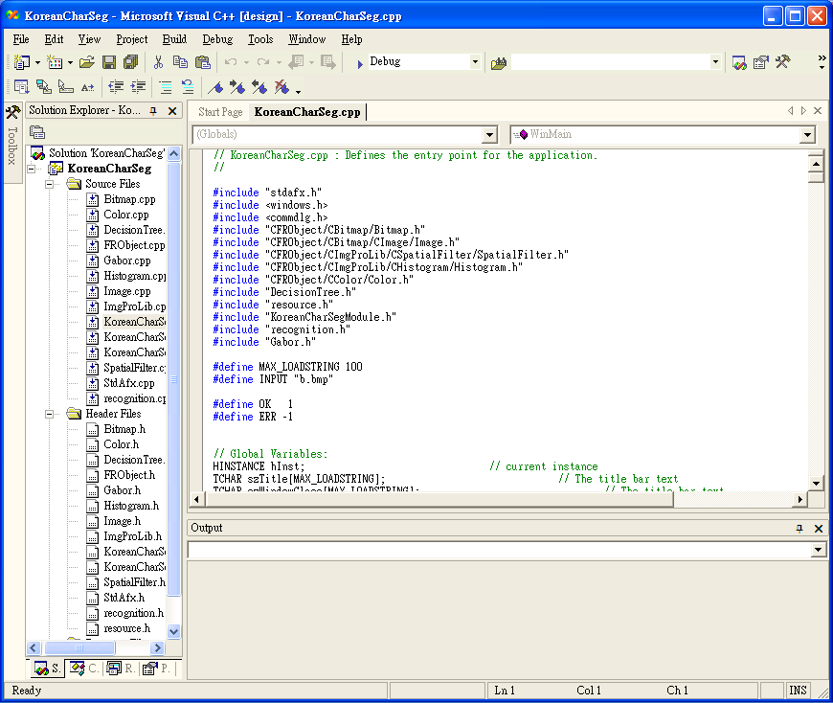
Fig 38 the snapshot of Microsoft Visual C++ Environment
Microsoft Visual C++ is a generic C++ development environment which dedicates for Microsoft Windows Series Application Development. It provides an easy and interactive interface for developing an application. And also, it provides large amount of libraries such as Traditional Win32 Programming and Microsoft Fundamental Class (MFC). And also, it supports all the features in C++ such as Object-Oriented Programming and Standard IO Stream Class.

  - Embedded Visual C++

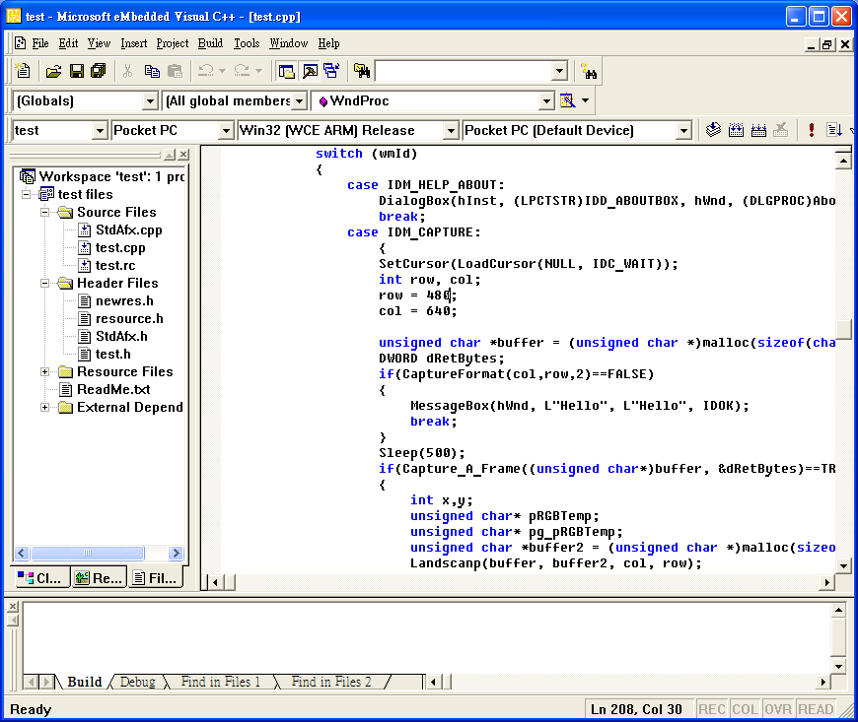
Fig 39 the snapshot of Embedded Visual C++ Environment
Embedded Visual C++ is a dedicated development environment for Windows CE and Pocket PC. The functionality is similar to the Microsoft Visual C++. However, it is not support for standard IO Stream Class. Therefore, we need to use back the IO functions in Standard C.

  - FlyCAM-CF SDK
The FlyCAM-CF SDK (Software Development Kit) [] includes all necessary driver, Application Programming Interface (API), and documentation enabling fast and efficient Pocket PC software compatibility with the FlyCAM-CF CompactFlash™ camera card.
The API was programmed by C++. Therefore, it can be worked with the Embedded Visual C++ tightly. It provides several functions such as video previewing and photo capturing.
The official user’s guide [] provides a rough idea how to preview the video and capture a frame. Fig 40 and 41 show the official recommended flow of using the API.
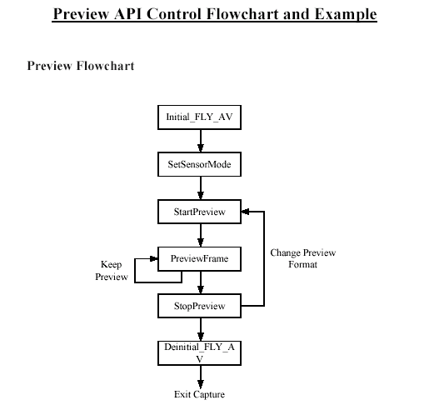
Fig 40 Preview API Control Flowchart
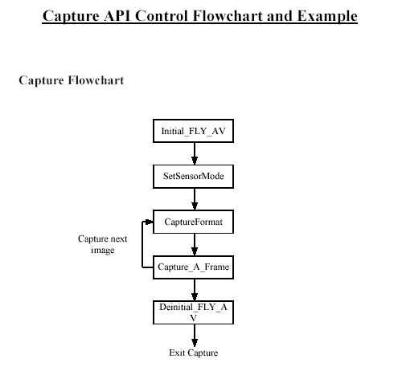
Fig 41 Capture API Control Flowchart

- Project Progress
  - Progress
Month | Progress
June 2002 | Study on Windows Programming  - Windows Function, Message Loop  - Event Handling  Study Text Area Detection  - Gray Scale  - Edge Detection: Sobel Filter, Derivative, Second-Derivative  - Horizontal and Vertical Edge Projection with threshold  Study on some Image Processing Technique  - Sharpen  - Contrast  - Edge-Enhancing  Study on OCR technique  - Feed-Forward Neural Network  - Associative Memory  - Gabor Features
July-August 2002 | Start to study on face detection and recognition  Start to build a library for future use  - Bitmap, Image  - Color Transformation  - Matrix, Vector  - Image Processing Library  Study the face recognition
September 2002 | Plan the schedule  Study on Korean Character Pattern  Implement Labeling Connected Component Algorithm  Study on face detection
October 2002 | Design and implement Stroke Feature Module  Design and Implement Korean Pattern Identification Module  Implement Decision Tree  Implement the linear exact matching OCR module  Study and correct the ttf2bmp.c  Design and implement Face Detection Module
November 2002 | Test and Improve the stroke feature  Train the stroke database (about 3400 characters)  Test the FlyCAM-CF API  Write the first term report  Improve the face detection
Table 1 the progress of this project

  - Difficulties
    - Solved Problems
Problem 1
It is difficult to design the stroke feature which is suitable for our usage. The stroke feature should have a little bit fault-tolerance.
Solution
We try to study papers/references which are about the feature extraction. Then we try to improve some of it. After that, we try to test and improve by implementing it.

Problem 2
For Korean Pattern Identification, there is no world known algorithm to identify the patterns.
Solution
We just try to implement an if-then-else algorithm to tackle the problem. We used divide-conquer technique to reduce the pattern problem.

Problem 3
TTF file format is a very complicated format file. It needs much time to study the TTF File specification.
Solution
We found a ttf2bmp.c source file to get the bitmap from a typical Chinese (Big 5) TTF file. Therefore, we can study on it and try to make it workable on a Korean File. However, there are many formats in TTF file. Therefore, we used much time on it.

Problem 4
It needs so much time on training the stroke database. The rate for training is 100 characters per hour. Then we need 34 hours to train a complete set of one TTF File.
Solution
Actually, no other solutions, we just spend the time honestly and trained the database.

Problem 5
There was an obstacle on testing the FlyCAM-CF API. We could not capture a frame correctly even though we followed the FlyCAM-CF API Guide exactly. And also, the manufacturer does not provide the sample code officially.
Solution
We asked the manufacturer to get help. But they just gave a very complicated sample code for us to study. However, we found that the flow of program is not much different. Luckily, we found that it should be run two functions first before capturing. They are StartPreview and StopPreview functions.

Problem 6
The captured frame from the FlyCAM-CF API is not in correct orientation.
Solution
We implement a function to rotate the frame.

Problem 7
There are so much Korean Coding such as Wutang, Johab and UNICODEs. However, the common coding is Wutang which is not sensible for human to code the Korean character while Johab is sensible.
Solution
We found the mappings file from different types of coding.

    - Unsolved Problems
Unsolved Problem 1
The TTF File is so complicated that we just can extract one type of Korean TTF file. And also, this type of format is not very common so that many fonts cannot be loaded.

Unsolved Problem 2
The combination of stroke is not very obvious. It needs time and wisdom to analyze the trained stroke database.

Unsolved Problem 3
If the color of background contains large amount of skin color, color segmentation will contains many errors. Therefore, the face detection would not be accurate.

  - Summary
For this project, we need to so much time on training and testing some parameters such that make the application is workable. And also, there are so many unexpected situations happen even though some technique problems such as the FlyCAM-CF API []. But we would try our best to tackle the problems
- Future Work
  - Combination of Strokes
In Korean Recognizer (3.2.1) of the System Design (3.1), combination of strokes is a necessary step because it can enhance the correctness of recognition part. However, in learning stroke process, the strokes may not be extracted perfectly (two or more strokes stick together). Therefore we will analyze the stroke database so that we can map them into the initial consonant, vowel, final consonant of the Johab Coding (2.9). Therefore, we can combine them into a Johab Coding Character. Then we can pass it to translate.

  - Dictionary
We will implement the dictionary function. Our approach is to translate the Korean to English but not Chinese because English is an international language. Therefore, we need to find and input the Korean-English dictionary database. Then we can make use of this dictionary to finalize the translator function.

  - Porting the modules to mobile device
Our goal is to implement the system in mobile device. Therefore, we need to port the modules such as Korean Recognizer and Face Detection into the mobile device.
Besides, we will implement the system into Pocket PC first because we have the knowledge about Windows Programming and the camera API is ready for us. Therefore, Pocket PC is our first mobile device we expected to port.
If time is available, we will try to implement the system on Nokia 7650 because it is a mobile phone which it is very popular and the camera is built in device. However, its Operation System is Symbian. Therefore, we need to study about the programming technique on Symbian OS.

  - Symbian OS
Symbian OS is the advanced, open operating system licensed by the world's leading mobile phone manufacturers. It is designed for the specific requirements of advanced 2G, 2.5G and 3G mobile phones. Symbian OS includes a robust multi-tasking kernel, integrated telephony support, communications protocols, data management, advanced graphics support, a low-level graphical user interface framework and a variety of application engines.

  - Face Recognition
For face recognition, our first goal is to recognize the face within 20 faces of Chinese. And also, the captured image is a frontal and normal luminance source. Then the objective is the correctness should be higher than 90%.
We would study the neuron network, probability model, principle component analysis and fuzzy logic. Therefore, we can compare with different algorithm and choose a better one for our project.
Therefore, we will try to implement and do some experiments on it. Actually, we spend much time on testing and improving the face recognition during the implementation.

- Bibliography
[] “Rafael C. Gonzalez and Richard E. Woods “, Digital Image Processing, 2nd Edition, , Prentice Hall, 2002.
[] “Data Mining”, Course CSC5180 Web Site , The Chinese University of Hong Kong – The Department of Computer Science and Engineering : http://www.cse.cuhk.edu.hk/~lwchan/teaching/csc5180.html
[] Korean standard: http://www.cwi.nl/~dik/english/codes/stand.html#ksc
[] “TrueType 1.0 Font Files (Technical Specification Revision 1.66 August 1995)”, Microsoft Corporation, ©1990-1995.
[] “ttf2bmp.c”, written by Lin YawJen (LYJ) 1994, edited by Wu LiangSheng (LSN) 1994
[] “FlyCAM-CF SDK Software Development Kit”: http://www.lifeview.com.tw/eng/pro_ia_cam_cf_sdk.html
[] “FlyCAM-CF API User’s Guide 2002”, Animation Technologies Inc.
[] “An evaluation of the two-dimensional gabor filter model of simple receptive fields in cat striate cortex.”, J.P. Jones and L.A. Palmer. , J. Neurophysiol., 58(6):1233-1258, 1987.
[] “Estimation of mouth Features Using Deformable Templates”, Liang Zhang, Institut fur Theoretische Nachrichtentechnik and Informationsverarbeitung, University Hannover.
[] “A Comparative Study On Color Edge Detection”, Andreas Koschan, Proceedings 2nd Asian Conference on Computer Vision ACCV´95, Singapore, 5-8 December 1995, Vol. III, pp. 574-578.
[] “Improved Techniques for Automatic Image Segmentation”, Hai Gao, Wan-Chi Siu, and Chao-Huan Hou, IEEE TRANSACTIONS ON CIRCUITS AND SYSTEMS FOR VIDEO TECHNOLOGY, VOL. 11, NO. 12, DECEMBER 2001
[] “Chinese Optical Character Recognition for Information Extraction from Video Images”, Wing Hang Cheung, Ka Fai Pang, Michael R. Lyu, Kam Wing Ng, Irwin King , Department of Computer Science and Engineering, The Chinese University of Hong Kong, Shatin, N.T., Hong Kong
[] “Fast Normalized Cross-Correlation”, J. P. Lewis, Industrial Light & Magic
[] “Face recognition using fisherface algorithm and elastic graph matching”, Hyuyng-Ji Lee, Wan-Su Lee, and Jae-Ho Chung, Dept. of Electronic Engr., Inha Univ., Inchon 402-751, Korea
[] “Locating facial features with color information”, ZHANG Xin, XU Yanjun, DU Limin, The institute of Acoustics, Chinese Academy of Sciences.
[] Robert Mariani, “Subpixellic Eyes Detection”, RWCP, KRDL Multi-Modal Function Laboratory, Kent Ridge Digital Laboratory.
[] “Gray-Scale Character Recognition by Gabor Jets Projection”, Hiroshi Yoshimura, Minoru Etoh, Kenji Kondo and Naokazu Yokoya, Graduate School of Information Science, Nara Institute of Science and Technology Multimedia Laboratories, NTT DoCoMo, Inc
[] “Face Detection in Color Images”, Rein-Lien Hsu, Student Member, IEEE, Mohamed Abdel-Mottaleb, Member, IEEE, and Anil K. Jain, Fellow, IEEE.
[] “An Efficient Approach For Facial Feature Extraction”, Kin-Man Lam and Yan-Lin Li, Department of Electronic and Information Engineering, The Hong Kong Polytechnic University, Hong Kong.
[] “Probabilistic Modeling of Local Appearance and Spatial Relationships for Object Recognition”, Henry Schneiderman and Takeo Kanade, Robotics Institute, Carnegie Mellon University, Pittsburgh.
[] “Estimation of eye and mouth corner point positions in a knowledge-based coding system”, Liang Zhang, Institut fur Theoretische Nachrichtentechnik und Inforationsverarbeitung, Universitat Hannover, Appelstrabe.
[] “Estimation of eye, eyebrow and nose features in videophone sequences”, Markus Kampmann and Liang Zhang, Institut fur Theoretische Nachrichtentechnik und Inforationsverarbeitung, Universitat Hannover, Appelstrabe.
[] “Stroke Extract from Gray-Scale Character Image”, Jang Won Suh and Jin H. Kim, Computer Science Department, KAIST.
[] Active Shape Models - Modeling Shape Variations and Gray Level Information and an Application to Image Search and Classification, Ghassan Hamarneh, The Imaging and Image Analysis Group, Department of Signals and Systems, Chalmers University of Technology, Gothenburg, Sweden.
[] “Probabilistic Modeling of Local Appearance and Spatial Relationships for Object Recognition”, Henry Schneiderman and Takeo Kanade, Robotics Institute, Carnegie Mellon University
[] “Face Detection in Still Gray”, Images, Bernd Heisele, Tomaso Poggio, Massimiliano Pontil, MASSACHUSETTS INSTITUTE OF TECHNOLOGY, ARTIFICIAL INTELLIGENCE LABORATORY and CENTER FOR BIOLOGICAL AND COMPUTATIONAL LEARNING DEPARTMENT OF BRAIN AND COGNITIVE SCIENCES, May, 2000.
[] “Neural Network Classifiers for Optical Chinese Character Recognition”, Richard Romero, Robert Berger, Robert Thibadeau and David Touretzky, Imaging Systems Lab, Robotics Institute, Carnegie Mellon University.
[] Symbian OS Official Homepage: http://www.symbian.com/

