Department of Computer Science and Engineering
The Chinese University of Hong Kong

2002-2003 Final Year Project
LYU 0202
Advanced Audio Information Retrieval System

Supervised by Prof. Michael Lyu
Group Member: Fok Ka Ling(00593524)
Ng Lai Sze (00571413)
Abstract
While current approaches for audiovisual data are mostly focused on visual cues, audio signal may actually play a more important role in content for many application. Audio signal from TV can be segmented and classified into various types; speaker tracking can be done by clustering the segment.
In this project, we focused on the building of AdvAIR system using various algorithms for component implementation, which provide a platform for all rounded speech recognition and analysis usage.
AdvAIR, Advance Audio Information Retrieval System, is designed for the various speech analysis usages. It provides the functions such as Video Scene Change, Speaker Clustering, Language system recognition, Speaker Identification for the ease of audio mining. The use of robust GMM model, BIC criterion ensures the accuracy and reliability of the system.
In the future, the more accurate open-set speaker identification determination function will be provided as well as music pattern matching and gender identification.

Acknowledge
We would like to express our faithful gratitude to Professor Michael R. Lyu for his useful suggestion and kindly guidance towards our project.
We would also like to express our thanks to Jackie Chun Keung CHAU, who have helped us to plan for the project and give us lots of help on both theory and programmin
Table of contents
Chapter 1 | Introduction
1.1 | Project Background……………………………………………... | 6
1.2 | Audio Mining…………………………………………………… | 6
 | 1.2.1 Introduction to audio mining……………………………… | 6
 | 1.2.2 Application of audio mining………………………………. | 7
1.3 | Implementation of audio mining………………………………... | 8
 | 1.3.1 The need of audio mining system………………………… | 8
 | 1.3.2 Automatic video scene change…………………………… | 9
 | 1.3.3 The need of other component……………………………... | 9
 | 1.3.4 AdvAIR platform………………………………………….. | 9
1.4 | System block diagram of AdvAIR system……………………… | 10
1.5 | How AdvAIR works…………………………………………….. | 10
 | 1.5.1 Feature extraction…………………………………………. | 10
 | 1.5.2 Segmentation……………………………………………… | 11
 | 1.5.3 Speaker clustering………………………………………… | 11
 | 1.5.4 Speaker identification……………………………………... | 11
 | 1.5.5 Continuous speaker independent speech recognition……... | 11
1.6 | Importance of audio segmentation……………………………… | 12
1.7 | Implementation using BIC likelihood…………………………... | 13
1.8 | Importance of Audiovisual data analysis and summary………… | 14
Chapter 2 | Feature Extraction
2.1 | Introduction to speech…………………………………………... | 15
2.2 | Nature of sound features………………………………………… | 15
2.3 | Feature Encoding and processing……………………………….. | 16
2.4 | MFCC model……………………………………………………. | 18
 | 2.4.1 Model Introduction………………………………………... | 18
 | 2.4.2 Data rate compression…………………………………….. | 19
Chapter 3 | Audio Scene Change
3.1 | Model Selection Criteria………………………………………... | 21
3.2 | Segmentation techniques, Change Point Detection through BIC.. | 23
 | 3.2.1 Single Acoustic Change Point Detection………………….. | 23
 | 3.2.2 Multiple Acoustic Change Point Detection……………….. | 27
3.3 | Enhanced Implementation Algorithm…………………………... | 29
3.4 | Hierarchical Clustering through BIC…………………………… | 31
Chapter 4 | Speaker Identification/Classification
4.1 | Introduction to speaker Identification (SI) ……………………... | 34
4.2 | Background knowledge about Gaussian Mixture Model (GMM) | 35
4.3 | Training and Testing for Gaussian Mixture Model……………... | 40
4.4 | Why speaker identification is more accurate than gender identification…………………………………………………….. | 44
Chapter 5 | Experimental Result
5.1 | BIC audio segmentation………………………………………… | 45
 | 5.1.1 Parameters setting…………………………………………. | 45
 | 5.1.2 Overall Result……………………………………………... | 45
 | 5.1.3 Comparison with old proposed system………………… | 46
5.2 | GMM speaker identification……………………………………. | 46
 | 5.2.1 Training stage……………………………………………... | 46
 | 5.2.2 Testing stage………………………………………………. | 47
 | 5.2.3 Result for open-set experiment…………………………… | 47
5.3 | Conclusion………………………………………………………. | 48
 | 5.3.1 BIC audio segment system………………………………... | 48
 | 5.3.2 GMM speaker identification system……………………… | 48
Chapter 6 | AdvAIR Advanced Audio Information Retrieval System
6.1 | Segmentation system……………………………………………. | 50
6.2 | Speaker Recognition System……………………………………. | 54
Chapter 7 | AdvAIR platform based application
7.1 | Embedded Application for video segmentation………………… | 58
7.2 | Audio database and file system…………………………………. | 60
7.3 | Automatic message routing based on caller identification……… | 60
Chapter 8 | Conclusion and Future Work
8.1 | Conclusion………………………………………………………. | 61
8.2 | Future Work……………………………………………………... | 61
 | Contribution of Work | 62
 | Reference | 64
Chapter 1 Introduction
  - Project Background
With the honor of supervision by Professor Michael R. Lyu, whom is the Principal Investigator of VIEW lab, our project can be done in supportable and smooth fashion.
VIEW, Video over InternEt and Wireless, is a project to develop a multilingual digital video content hub for culture exchange and commercial deployment. The project tries to delivers:
1. Multilingual video segmentation, categorization, indexing, searching, cashing, delivery, and presentation techniques.
2. Software enabling schemes for content creation, information summarization and dissemination, security authentication, and wireless access.
3. A multimedia content hub for distant learning, financial news, virtual Hong Kong tour, telemedicine, and culture exchange.
Our project is following the mother project of VIEW, and tries to find out the possibility of using audio information as a potential source of data mining. With bringing the concept from professor Lyu, a speech process platform AdvAIR have been developed in order to facilitates the multipurpose audio data extraction and analysis.

  - Audio Mining
    - Introduction
Audio mining is a way to turns information hidden in sound resource into archives that can be browsed, searched and mined. It is also an essential in the decade of Internet, which made the access of unlimited data storage capacity possible with the ease of clicking a mouse. As the result of blooming technology, even greater volume of data in the form of speech from television, radio, telephone calls can be captured and used for data mining and perform various analysis.

1.2.2 Application of audio Mining
Application using audio Mining includes
1. Technical support centers. A technical support manager responsible for providing feedback to a product development team can search a database of recorded technical support calls to determine the issues end users are contending with.
2. Call centers. A stockbroker or call center operator can gain access to specific recorded conversations to verify transaction information. Marketing executives can access customer requests and feedback from a company database to fine-tune marketing campaigns.
3. Broadcast media. A news editor at a TV or radio station can search archives of recorded broadcasts to retrieve information relevant to breaking news almost immediately. The technology can also be used to index live broadcasts.
4. Corporate communications and public relations departments. Communications and PR managers can index and search both live video feeds and archived broadcasts to track how their company or a competitor is being covered in the news.
5. Conference managers. A conference management organization can use audio mining to create index of key topics to help in preparing tapes of sessions. Such an index would allow material on CD-ROM to be directly accessible.
6. Law enforcement and security operations. Security personnel can obtain critical information from hours of recorded phone calls or radio transmissions much more rapidly than before. The technology also allows the indexing and searching of live broadcasts in order to monitor breaking events.

  - Implementation of audio mining
1.3.1 The need of implementation audio mining system
Intuitive access to information in everyday environments is becoming a central concern of new information society technologies. An important question is how established and well functioning everyday environments can be enhanced rather than replaced by virtual environments. Augmented or enhanced reality technologies address this issue but have concentrated so far on the visual sense and have mainly been used in applications. [1]. Auditory augmentation of visually dominated everyday environments is a new and very promising approach in creating user-friendly information systems, which are accessible to everybody. The complementarily between the visual and auditory sense is the basis for a new type of multi-sensory content, which will become feasible thanks to anticipated advances in auditory rendering.
1.3.2 Automatic video scene change
Automatic video scene change detection is a fundamental but challenging task of audio mining by combing the visual and audio for information grapping. Using visual information alone often cannot provide a satisfactory solution. With the combination of audio and visual features, the checking of boundary and classification of video can be done with pleasing result.

1.3.3 The need of other components
Audio segmentation is also inadequate in case where the output of a speech recognizer is to serve as input for further processing based units. This includes natural language parser or translation system. For such system, the fragmented recognition output would have to put back together and unrelated material would need to resegment into linguistic units. Automatic detection of linguistic segment could improve the user interface of much speech system. A spoken language could use the knowledge incorporated in an automatic segmenter to help end-point a user’s speech input.

1.3.4 AdvAIR platform
In a view of this, a platform that performs various speech functions such as front-end features extraction, segmentation, back end process such as language identification should be developed. AdvAIR, ADVance Audio Information Retrieval system is a platform for such usage. When designing such a system, one often faces two problems: first, devising a procedure efficient enough to be able to identify languages in a short period of time; second, collecting the data needed. In principle, models for language, gender is often computed offline for the task of best fitting model determination.

1.4 System block diagram of proposed AdvAIR system
Audio Signal
Feature Extraction
Audio Scene Change
Clustering
Speaker Modeling and Identification

Speech Recognition

From News, Audio Channel
By MFCC
BIC Segmentation
By 256 GMM
By Via-voice technology
Gender Identification
Language Mode Identification

Fig 1.4(a)

1.5 How AdvAIR works
The required technology to produce accurate results in a processing operation that incorporates speech and language should contain at least six elements.
1.5.1 Feature extraction
For which to enhance speech back-end process and provide the fundamental part of a speech recognition system. It also provides the data compression for which to reduce the data processing size. Chapter 2 will fully explain the feature extraction concept of computer processing.
1.5.2 Segmentation
Story segmentation is the process of turning continuous stream of source into units, each of which contains a coherent set of topic. The main difficulty of segmentation process is to locate the story boundaries and the definition of story segments. Speaker segmentation is the same as the story segmentation, which differs only by means of, locates the boundaries between speakers in the stream. The use of mathematical model provides a good means to identify and transcribe them; it often is the core of most of audio recognition system. The segmentation process will be described in chapter 3.

1.5.3 Speaker clustering
The process of grouping together the audio segment according to the unique features of speaker, environment and channel condition is the responsibility of speaker clustering modules. The challenges come from the background noise, music and variable condition.

1.5.4 Speaker identification
To recognize the speakers who voices known prior, which often produce great interest to the field of data mining. The training process and the open set speaker identification often contribute the greatest challenge. Various methods of speaker identification and clustering will discuss in chapter 4.

1.5.5 Continuous speaker independent speech recognition.
It is important to note that extracting terms from speech is more difficult than doing so from written text. The need of real-time speech recognition needs mathematical model to identify and transcribe the continuous voice. None ness to say, to capability to extract word in audio stream provides a good means of data analysis. This part will be developed in the future.

1.6 Importance of Audio Segmentation
In many speech recognition and speaker identification applications, it is often assumed that the speech from a particular individual is available for processing. When this isn’t the case, and the speech from the desired speaker is intermixed with the speech from other speakers. The speech must be segmented into speech from the individuals before the recognition or identification process can commence.
As mentioned before, the segmentation is also the main core of most speech recognition and audio mining system, it is important to know what the reason is. As the clustering, speaker modeling and identification is all relies on the part of audio segmentation, in order to provide the reliability and the robustness of the overall system, audio segmentation should be performed accurately. Moreover, as the rapid expansion of audio information, audio segmentation provides a good means of divide and conquer strategy towards the homogenous speaker, environment and channel condition. An AUTOMATIC segmentation system is intended to replace hang-segmentation system, which by commitment, will facilities the retrieve of information and interest of user. As the volume of the available material becomes huge, manual segmentation and indexing through computer processing based on content analysis is clearly the trend.
In our proposed AdvAIR system, BIC algorithm, a well-known model in statistic, is applied in an improved fashion, which provides a dramatically increase in performance without decrease in accuracy.

1.7 Implementing using BIC likelihood.
BIC, Bayesian Information Criterion, is a model selection criterion well known in the statistic literature. The BIC criterion can also be applied as a termination criterion in hierarchical method for clustering of audio segments: two nodes can be merged only if the merging increases the BIC value. [2].
By experiments, it shows that BIC maximum likelihood approach for acoustic change detection can achieve a high success rate; the overtraining and some other problem can also be avoided. Let’s take a look on Figure 1.7(a), it shows a block diagram of typical segmentation system
Speech Input
Speech Segmentation Criteria

Threshold
Optimality
Accept

Reject

Speaker Change
Fig 1.7(a)
As we can see, the attribute Threshold, Optimality is the criteria for deciding a change point is whether exists or not. By measurement, BIC provides robust, threshold-free and optimal converging features, so the choice of BIC is a crystal clear selection.

1.8 Importance of Audiovisual Data Analysis and summary
While current approaches for audiovisual data are mostly focused on visual cues, audio signal may actually play a more important role in content for much application. Audio signal from TV can be segmented and classified into various types; clustering the segment can do speaker tracking. Moreover, simple audio features including energy function, average zero-crossing rate, and spectral peak tracks are extracted to ensure the feasibility of real time processing [3].
In this project, we focused on the building of AdvAIR system using various algorithms for component implementation, understanding of the speech recognition system and its application, the following chapters that guide you through the road for building up the AdvAIR platform. Here you will enjoy the journey of speech recognition and analysis.
Chapter 2 Feature Extraction
2.1 Introduction to speech
Speech sounds are created by vibration of human vocal tract. Speech is transmitted through media like air, liquid and solid where take on the form of radiating waves.
Figure 2.1(a) shows a sample waveform of human speech
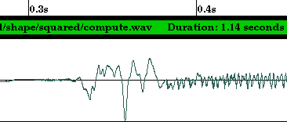
Fig. 2.1 (a)
As we see the wave is in an analog format, it should be digitized into the form where computer readable. The need of transforming a speech waveform into a sequence of parameters vectors is now be highlighted.

2.2 Nature of sound features
Speech exhibits significant variation from instance to instance the same speaker and text. From the point of view of text-independent speaker identification, a speaker produces a stream of speech features (features will be discussed in greater detail below). These features characterize both the speech as well as the speaker. For a reasonable period of speech (i.e. several seconds), we expect the features to fill features space in a way that depends primarily on the speaker.
An important step in speaker identification process is to extract sufficient information for good discrimination, at the same time, to capture the information in a form and size that is efficiency to be modeled.
The generic features of sound include loudness, pitch period and bandwidth of an audio signal, different object have different signature, which produces a particular sound. For example, musical instrument has its own “impulse response” when struck. Storing these signatures and analyzing can identify particular object, which made the sound. [4]. In general, when classifying an audio sequence, one can first find some low-level acoustic characteristics associated with each short audio clip, and then compare it with those pre-calculated for different class of audio.

2.3 Features Encoding and processing
The overall process of feature extraction is to convert the waveform into a sequence of parameter blocks, which we call it vectors. Continuous waveform is first discrete into bits representation (i.e. 16 bit, 32 bit) with higher bits represent higher quality and then the bits vector is encoded into parameter vectors; the number of sample collected in one second is called a sampling rate.
A frame is a collection of sample vectors with a constant frame window size. Frame is overlapping with another frame; clip-level features are computed based on frame-level features.
Window Size
Fig 2.3 (a)
There is lots of features model to use to characterize audio signals. Volume Contour which use the root mean square (RMS) of the signal magnitude within each frame to approximate the volume of the frame, to detect frame that are silent, the comparison of volume and zero crossing rate of each frame to some preset thresholds. [3].
Harmonicity distinguishes between harmonic spectra (such as musical sounds and vowels), inharmonic spectra (such as metallic sounds) and noise. It is computed by measuring the deviation of the sound’s line spectrum for a perfectly harmonic spectrum. [5].
Pitch is the period of an audio waveform, and also it is important parameter for analysis and synthesis of speech signals. AMDF, average magnitude difference function is one of the common models to determine the pitch of each frame.
Spectral Centroid is the “balancing point” of the spectral power distribution. Many kinds of music involve percussive sounds, which, by including high-frequency noise, push the spectral mean higher. [3]. In addition, excitation energies can be higher for music than for speech, where pitch stays in a low range. This feature can give different results for voiced and unvoiced speech.
Zero-Crossing Rate is the number of time-domain zero crossing with a speech frame. This can determinate the silent point.
With so many important features can be derived in sound, a systemic way to modeling the sound should be introduced for elegant, efficiency audio system to be built on it.

2.4 MFCC model
2.4.1 Model Introduction
Mel-frequency cepstral coefficients (MFCC) is a model of homomorphic type processing which allows us to separate the broad spectral characteristic of sound form pitch and voicing information. [6].
MFCC is computed by re-sampling a conventional magnitude spectrogram to match critical bands as measured by auditory perception experiments. The representation is inverted to generate a smooth spectrogram for the sound. As MFCC is an industrial standard of performing feature extraction, we choose it as well as other system as our base-line extraction mechanism. Figure 2.4.1(a) shows a MFCC conceptual graph.
Frequency
Energy in each band
Fig 2.4.1(a)

2.4.2 Data rate compression
We have mentioned use of features vector can reduce the number of data process. Here we can show that use of MFCC can reduce the data rate at a scale of half.
Let’s the sampling rate of 16 bits 22050 Hz
That is 22050 samples are taken by each second.
So, for each second, the computer should handle
16 * 22050 = 352800 bits, which is 44100 bytes = 43 Kbytes
If MFCC feature extraction is used with window size 400 and 24 features vector dimension and stepping size 128 (each feature uses 16 bits for representation)
Then for each second there is only
22050/128 *24 *16 bits = 66150 bits, that is 8268.75 byes needed to handle.

Chapter 3 Audio Scene Change
Nowadays, there are a lot of models available for detecting audio scene change. For examples, decoder-guided segmentation, model-based segmentation, metric-based segmentation, BIC segmentation techniques. Some segmentation techniques such as decoder-guided segmentation only segmented the audio stream at the silence locations and regard it as the change point. However, the segmented result will be a set of segmented sentences which don’t have useful meaning always. The data is not useful and meaningful when divided into too small and discrete pieces. Since most of the time, only data long enough to give some statistics or information is needed. For instances, in a news TV program or in a recorded conference, there are a lot of people speaking interleavingly. We believe that paragraphs of speech speaked by speakers are more useful than a huge set of single sentences from the audio streams. While for the model-based segmentation, metric-based segmentation, a threshold is needed for segmentation. As compare to the above three techniques, no threshold is needed for the BIC segmentation and BIC segmentation can divided audio streams into output streams that is long enough to provide useful information.

BIC segmentation is robust, threshold free and generalizes well to unseen acoustic conditions. The input audio stream can be modeled as Gaussian process. A maximum likelihood approach is used to detect turns in Gaussian process. BIC which is a model selection criterion is used to determine whether there is a change point. Besides using for segmentation, BIC can also be used as termination criterion in hiearchical clustering. Two nodes can be merged if the merging increases the BIC value. In other words, if BIC value increased after merging two nodes, then both nodes are belong to the same speaker. BIC clustering algorithm can produce clusters with high purity. BIC is good for both segmentation and clustering, so we have choosen the BIC for segmentation of our input audio stream, and clustering to form more meaingful information in our AdvAIR Advanced Audio Information Retrievel System Engine.

Segmentation is an important part because segmentation is needed before speaker identification or classification can be done. It can be also used to extract parts needed from an input stream.

3.1 Model Selection Criteria
A given data set can be described using a suitable model. Nowadays, there are many different kinds of model available. However we need to choose the model carefully so that it really can represent our data set. Different models are associated with different number of parameters. Increase in the number of parameters leads to increase in the likelihood of the training data. If the number of parameters is more than needed, the problem of overtraining may occur. In order words, models with too many parameters are not general and result in over-fitting, while those with too few parameters are not accurate and result in under-fitting. Plenty of method can be used for model selection. For examples, nonparametric methods such as cross-validation, parametric methods such as the Bayesian Information Criterion (BIC) [7, 14].

BIC is a likelihood criterion which is penalized by the large number of parameters in the model. There is a trade-off in the number of parameter and the accuracy of the model estimation.
X = {x_{i} : i = 1,2,….,N} is the data set we are modeling.
M = {m_{i}: i = 1,2,….,K} is the candidates of desired parametric models.
Let L(X, m) be the likelihood function for model M. We want to maximize the likelihood function.
Let Num(m) be the number of parameters in the model M.
BIC criterion is defined as:
BIC (m) = log L(X,m) - $\frac{1}{2}$*λ*Num(m) *log(N) ……………………… (1)
Where penalty weight λ = 1
The BIC procedure is to choose the model such that BIC criterion is maximized. This procedure can be derived as a large-sample version of Bayes procedures for the case of independent, identically distributed observations and linear models [7].
BIC criterion is widely used for model identification in statistical modeling such as time series [8], linear regression [9]. It is also used in the engineering literature such as for speaker adaptation [10]. λ in equation (1) can be assigned different value, but only λ = 1 represents BIC.

3.2 Segmentation techniques, Change Point Detection through BIC
As mentioned in this report, BIC can be used for both audio stream change point detection and hiearchical clustering. Next we are going to give the alogrithm used for single change point detection. After that, we will give the alogrithm for multiple change point detection.

Let us find define some notations for detection of acoustic change in audio stream using BIC criterion:
d is the number of feature used to model the audio stream.
N is the number of frame in the audio stream.
X = {x_{i} Є R^{d} , i = 1,2,…,N} is the set of feature vectors representing the entire audio stream. (x₁ is the first feature vector, x_{i} is the i-th feature vector)
Assume X is drawn from an independent multivariate Gaussian process:
x_{i} ~ N( μ_{i} , Σ_{i} ) where the μ_{i} is the mean vector and Σ_{i} is the full covariance matrix.

3.2.1 Single Acoustic Change Point Detection
Let’s look into the algorithm for detecting single change point first. Assume that the change point occur at time i. We can view H₀ and H₁ as two different models. H₀ models the data as one Gaussian. H₁ models the data as two Gaussians.
H₀: X₁ … X_{N} ~ N( μ , Σ )
H₁: X₁ … X_{i} ~ N( μ₁ , Σ₁ ) ;
X_{i+1} …X_{N} ~ N( μ₂ , Σ₂ ) …………………………… (2)

The maximum likelihood ratio statistics is:
R(i) = N log | Σ | - N₁ log | Σ₁ | - N₂ log | Σ₂ |
where Σ, Σ_{1,} Σ₂ are the sample covariance matrices from all the data { X₁ … X_{N} }, { X₁ … X_{i} } and from { X_{i+1} …X_{N} } respectively.
The maximum likelihood estimate of the changing point is:
t = arg(max_{i} R(i))

BIC values can be expressed as:
BIC(i) = R(i) -λ* P …………………………… (3)
where P is the penalty, λ is the penalty weight
λ= 1
P = $\frac{1}{2}$(d +$\frac{1}{2}$d(d+1)) log N where d is the dimension of the space or the number of feature use to model the audio stream
If BIC(i) is positive, then the model of two Gaussians(H₁) is better than the model of one Gaussian(H₀). That is {max_{i} BIC(i)} > 0
Therefore maximum likelihood estimate of the changing point can be expressed as:
t = arg(max_{i} BIC(i))

BIC segmentation method has the following advantage comparing to the metric-based segmentation methods, there are experiment done on single point detection by some expert to show these.
- BIC is more robust because it use all the samples on either the left hand side of change point i and the samples on right hand side of change point i. In contrast, the metric-based segmentation methods use only a pre-defined number of samples on the left hand side and right hand side of the chagne point. The distance between the first sample and last sample used can be log likelihood ratio distance [11] or the Kullback-Liebler distances (KL distance). Probably only a few samples are used (for examples only two seconds samples). As a result, the measurement is not robust and is noise. The result of a speech signal of 77 seconds which contain two speakers measured using log likelihood ratio distance(i.e. the Gish distance), KL distance.

Figure 3.2.1(a) below shows how the sound wave look like, it is clear that the change point is between 40 and 50 seconds. Figure 3.2.1(b) show the log likelihood ratio distance. It is clear that at the change point a local maximum occur, but there are other maxima which does not correspond to any change point. Figure 3.2.1(c) show the KL distance. It also obtain a local maximum at the change point and there exist some other maxima which does not correspond to any change point. Figure 3.2.1(d) show that BIC criterion can accurately locate the change point and it is clearly show that only one change point is detected.

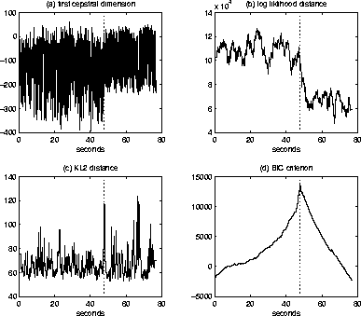

Fig 3.2.1(a) Fig 3.2.1(b)

Fig 3.2.1(c) Fig 3.2.1(d)

- BIC is threshold free. Both log likelihood ratio distance and KL distance rely on the threshold to detect the change point, while BIC doesn’t need a threshold. Finding a suitable threshold is really a difficult problem. If a wrong threshold is used, then change point may not be able to locate accurately.
- BIC has optimality. Change point can be located accurately as the sample size increases.

3.2.2 Multiple Acoustic Change Point Detection
Algorithm for detecting multiple acoustic change point is similar to that for detecting single change point. That’s the extension of the algorithm for detecting single acoustic change point.
Step 1: Initialize the interval [a,b] as a = 1, b = 2
Step 2: detect if there is a changing point in the interval [a,b] through BIC single change point detection algorithm
Step 3: If there is no change point in interval [a,b],
then set b = b+1
else let t be the changing point detected,
set a = t+1, b = t+2
Step 4: Stop when all samples are processed. Otherwise go to Step (2)

For example,

Start Pos. Frame 0
Change point
Frame 2000
Change point
Frame 1000
End Pos.
Frame 3000
Fig 3.2.2(a)
Figure 3.2.2(a) shows an audio stream which has two change points (at frame 1000, frame 2000), Step to compute the change point is:

- First set a=1, b=2
- Use single point detection algorithm to detect change point between [1,2]. Detect the interval [1,3], [1,4], [1,5], … ,[1,1000], [1,1001], …
As there is no change point between frame 1 and frame 1000, so we increase b until we detect a change point, probably b is increased until a value between 1000 and 3000 which allow us to detect the change point at frame 1000, let’s assume we detect the change point when b = b’
- Then we set a = 1001, b = 1002 and repeat step (2) to step (4)
We investigate the interval [1001,1002], [1001,1003], [1001,1004], … ,[1001,2000], …
Similarly, we stop when b equal to a value between frame 2000 and 3000 which allow us to detect the change point at frame 2000, let’s assume we detect the change point when b = b’’
- Then we set a = 2001, b = 2002 and repeat step (2) to step (4)
We investigate the interval [2001,2002], [2001,2003], [2001,2004], … , [2001,3000] and then we can stop. As there is no change point between frame 2001 and 3000, we only repeat to increase b until b reach the end (frame 3000). Then our detection of multiple change point will be ended.

3.3 Enhanced Implementation Algorithm
The multiple change point detection algorithm mentioned in section 3.2.2 starts by detecting change point within 2 frames. Next the investigation interval is increased by 1 through increasing b by 1 when no change point is detected within the interval. However, it is very slow if we process also the small interval such as 2 frames because there are a lot of frame in an audio stream. We have implemented our engine using this implementation but it run very slowly, we need to wait for around 30 minutes for detecting change point for a 15 seconds mpeg file. We need to wait a long time for segmenting such a short mpeg, so if we use it for a long mpeg, we may need to wait for a long time. A system that needs unreasonable time for running is not so useful in the real world.
As a result, in order to achieve a higher speed, our engine use implementation that based on the multiple change point detection algorithm but a larger processing interval is used. The minimum processing interval used in our engine is 100 frames. In one second, they’re around 170 frames. So frame i and frame i+100 is only difference by less than one second and error in detecting the change point is acceptable and is not very large when we use interval of 100 frames rather than 2 frames. We start the processing by setting a = 1, b = 100, then we will increase the interval by 100 frames every time we can’t find the change point. The new implementation is faster then the old implementation for around than 100 times. For a 15 seconds mpeg file, we can detect the change point at around 15 seconds. However, the trade-off is that the change point we detect is not so accurate. To compensate this, we have a recalculation after detecting a change point. After we have detecting a change point using the 100 frame interval implementation, we investigate on the frames before that change point and the frame after that change point with interval incremented by 1 every time to locate a more accurate change point.

3.4 Hierarchical Clustering through BIC
Clustering is also a useful technique, because sometimes the segmentation algorithm is not so accurate, it may cut two consecutive speeches, which belong to two people into two different parts. So after clustering we can group them together. Another case is that we have a lot of segments in which there are different speakers, each speaker has several segment in the data set, in order to provide more organized and meaningful information, we can do clustering to group all the segment belong to the same speaker together. For example, in a recorded conference, we may want to get all the segments that belong to the president of the company so as to follow the instruction he given.
As mentioned in the beginning of Chapter 3, BIC can also be used for clustering besides segmentation. Now we are going to give the algorithm for clustering.
Let’s define some notations first:
S = {s₁,…,s_{k}} is a set of node
Suppose s₁,s₂ are belong to the same speaker, let s be the new node if we merge s₁ and s₂.
Let S’ = {s,…,s_{k}}
We model each node s_{i} as a multivariate Gaussian distribution N( μ_{i} , Σ_{i} ).

Then we compare S and S’ to see which has a higher BIC value.

Modeling s2
Modeling s1
Modeling s
Fig 3.4 (a)

In figure 3.4(a), one Gaussian distribution is the modeling s and the other two Gaussian distributions model s1 and s2. We compare the modeling of S and S’ as a Gaussian distribution to see which is more likely to represent the data set. We check if one Gaussian distribution modeling s as a node of combining s1 and s2 is better or two Gaussian models which model s1, s2 separately is better. The idea is shown on the above diagram.

The equation we used is the same as that for segmentation:
BIC = N log | Σ | - N₁ log | Σ₁ | - N₂ log | Σ₂ | - λ*P ………………………… (4)
where P is the penalty,
P = $\frac{1}{2}$(d +$\frac{1}{2}$d(d+1)) log N where d is the dimension of the space or the number of feature use to model the audio stream
λ= 1 is the penalty weight,
N = N1+N2 is the sample size of the merged node s,
Σ is the sample covariance matrix of the merged node.
Two nodes should be merged if equation (4) is negative. If equation (4) gives a positive value, by segmentation algorithm described in Section 3.2.1, there is a change point, which means that the two nodes are belong to different speaker. Therefore, when equation (4) gives a negative value that means those two nodes are belong to the same speaker.
Chapter 4 Speaker Identification/Classification
Speaker identification is an important part in real world. It is use to identify a speaker given an input stream. Doing segmentation and clustering is a support for doing speaker identification. We need to segment a long input stream into a list of stream that belongs to different speakers. And then we can choose to cluster the speech belong to the same person. However, we only have different group of segments by doing segmentation and clustering. The most useful information someone may want to know is who is the speaker of a speech or a set of segments. In addition, you may ask is this speech spoken by person X. That’s why speaker identification is important. For examples, in security lock system using voice lock, the main idea is to verify is the speaker the authorized person to open the lock. In voice mail system, you may want to know who have leave you message too, this is speaker identification.

4.1 Introduction to speaker Identification (SI)
A speaker recognition system is a system, which can identify the speaker given an input audio stream. In order to be able to identify speaker, the recognition system must have some knowledge about whom the system want to identify first. Before the recognition system can work, it must do pre-processing -- training. Training is a process in which sound clips of a group of speaker need to be collected. It uses some model to train the group of speakers which the system want to identify and then store it in some understandable form to allow the system to use it afterwards.

Recognition system can be divided into two types: close set or open set
1. Close-set recognition system
  - The system can only recognize the speaker inside the set of speaker used for training.
  - The input speech is assumed to be spoken by one of the speaker inside the training set.
  - The system only need to check which speaker is the input speech belongs to within the training set.
  - If speech not belong to the training set is input, the system will just identify the speaker as the most similar speaker inside the training set.
2. Open-set recognition system
  - The system can recognize the speaker as outsider among the training set.
  - When a speech belongs to speaker inside the training set, it can recognize it. Otherwise, it can identify the speaker as unknown.
  - The outsider can then be trained and put into the training set.
  - It is more complicated then close-set system.

Our speech recognition engine is an open-set recognition system. When the input speaker is not inside the set of speaker we have trained, we can identify that he/she is an unknown speaker.

4.2 Background knowledge about Gaussian Mixture Model (GMM)
As different speakers and different languages have their own statistical density, so we can identify speakers by the statistical density. A Gaussian distribution is a normal distribution, which uses mean and variance to represent it. Gaussian Mixture Model is a type of density model that use to represent the speaker model. It strictly follows the probabilistic rules. Advantage is that Gaussian mixture model is text independent, robust, computationally efficient and easy to implement.
GMM[12] is commonly used for language identification, gender identification and speaker identification. It is more accurate for identifying speaker than gender. We will explain the reason after we have talk about GMM.

Figure 4.2 (a) represent one Gaussian distribution. A Gaussian distribution is represented by a mean and variance
mean
Fig 4.2(a)

The speaker model is a Gaussian mixture model instead of a Gaussian distribution. A Gaussian mixture model is modeled by many different Gaussian distributions. Each of the Gaussian distribution has its mean; variance and weighting in the Gaussian mixture model it modeling [13]. This is shown in figure 4.2 (b). Figure 4.2 (c) shows how a Gaussian mixture model is being model by the Gaussian distribution.
Model for Speaker i
……………………
Fig 4.2 (b)

Fig 4.2 (c)

You may wonder why we need to use many Gaussian mixture models to represent the speaker model. Why don’t we use one Gaussian mixture model to represent the speaker model?
This is because Gaussian distribution, which is a normal distribution, is symmetric. However, in real world, the distribution, which uses to represent a speaker model, is not always symmetric. It may look like the following figure 4.2(d). In which a symmetric Gaussian distribution cannot represent the model. A Gaussian mixture model will represent each model and each Gaussian distribution is model by many small Gaussian distribution... So the result score is the A Gaussian mixture model is represented by the sum of the small Gaussian distribution multiple by the weight for it. So that all the small Gaussian distribution contributes a point in the Gaussian mixture model model it.

Fig 4.2(d)

Assume M is the number of small Gaussian distribution used to model the Gaussian mixture model
Let us consider the simple case first, when there is only one-dimensional random vector:
The equation used to calculate the Gaussian Mixture Density is:
$p(x)=\sum_{i=1}^{M}{p_{i}b_{i}}(x)$
where i = 1, …. , M
$b_{i}(x)=\frac{1}{(2π)^{1/2}{\left|Σ_{i}\right|}^{1/2}}\text{exp}\left\{\left.−\frac{1}{2}(x−μ_{i})'Σ_{i}^{−1}(x−μ_{i})\right\}\right.$
x is the input
$b_{i}$ is the score for Gaussian distribution i
$μ_{i}$is the mean for Gaussian distribution i
$Σ_{i}$is the covariance matrices for Gaussian distribution i
$p_{i}$is the weighting of the score for the Gaussian distribution i
We need $\sum_{i=1}^{M}{}$because we need to sum up all the score contributed by the M different Gaussian distribution.
The following equation is used to calculate the Gaussian Mixture Density for D-dimensional random vector:
$p(\vec{x})=\sum_{i=1}^{M}{p_{i}b_{i}}(\vec{x})$
where $\vec{x}$ D-dimensional random vector
i = 1, … , M
$b_{i}(\vec{x})=\frac{1}{(2π)^{D/2}{\left|Σ_{i}\right|}^{1/2}}\text{exp}\left\{\left.−\frac{1}{2}(\vec{x}−{\vec{μ}}_{i})'Σ_{i}^{−1}(\vec{x}−{\vec{μ}}_{i})\right\}\right.$ ……. (5)
4.3 Training and Testing for Gaussian Mixture Model (GMM)
$λ=\left\{\left.p_{i},{\vec{μ}}_{i},Σ_{i}\right\}\right.$Before you can identify a speaker, an important step must be done. That is training for speaker models. For every speaker you need to identify, you need to collect clips that is long enough for training. After training, a set of parameters are obtained. They are the mean, variance and the weighting for the small Gaussian distribution (mixture weights). They are represented by in which $p_{i}$ represents the Gaussian mixture weights.${\vec{μ}}_{i}$ Represents the mean and $Σ_{i}$ represents the variance. A possible approach to do training is the Maximum Likelihood parameter estimation. The aim of training is to obtain the mean, variance, and weighting of each Gaussian distribution ($λ$).

Steps for training:
1. First collect a set of sound clips that is long enough for each speaker you want to identified
2. Begin with an initial model λ
Then we calculate the new mean, variance, weighting for the model by using $\bar{λ}$the following formula.
Gaussian mixture weights:
${\bar{p}}_{i}=\frac{1}{T}\sum_{t=1}^{T}{p(i|{\vec{x}}_{t},λ)}$

Means:
${\bar{\vec{μ}}}_{i}=\frac{\sum{p(i|{\vec{x}}_{t},λ){\vec{x}}_{t}}}{\sum{p(i|{\vec{x}}_{t},λ)}}$

Variances:
${\bar{σ}}_{i}^{2}=\frac{\sum{p(i|{\vec{x}}_{t},λ)x_{t}^{2}}}{\sum{p(i|{\vec{x}}_{t},λ)}}−{\bar{μ}}_{i}^{2}$

3. Check if the newly calculated parameter is more suitable to model the speaker by using the following formula.
$p(i|{\vec{x}}_{t},λ)=\frac{p_{i}b_{i}({\vec{x}}_{t})}{\sum{p_{k}b_{k}({\vec{x}}_{t})}}$

We use part of the training data to test the parameter$\bar{λ}$. If the score $p(X|\bar{λ})$ is larger than the score$p(X|λ)$, then we will use the newly calculated parameter $\bar{λ}$ to do the training again.
We use the new parameter $\bar{λ}$ when the following equation is satisfied.
$p(X|\bar{λ})≥p(X|λ)$

4. Continuous to do the training by repeating step (3) and step (4).
It has been proven by some paper that this method is a convergent approach. In order words, when we repeat to train the parameter$\bar{λ}$, we will get the parameter which is more close to the actual parameter for modeling the speaker. The error between the actual parameter for the model and $λ$ become smaller and smaller through training. With more training data, the error will be smaller.

For both close set and open set model, every speaker has its own GMM model. In addition, open set speech recognition system has an extra GMM overall speaker model to decide whether to reject the input stream as outsider.

How to do speaker identification:
- Calculate the scores for each of the GMM against the incoming audio streams using the following equation and the means and variances calculated during training. This is to compare the input feature vectors against the speaker model for the trained identity.
The following equation is derived from equation (5)
$\text{ln}p(\vec{x})=\text{ln}\sum_{i=1}^{M}{p_{i}b_{i}}(\vec{x})$

However, we will take logarithm. You may wonder why do we take logarithm. This is because the value b_{i}$(\vec{x})$ is always too small. If we do not take logarithm, then final result value may underflow.

- Select the speaker GMM with maximum score as the result
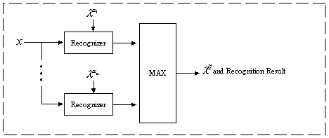 Fig 4.3(a)
In figure 4.3(a), X is the input audio stream, and each of the recognizer is to check the score of the audio stream against one of the GMM, which represent one speaker. Then we can identify that the speaker of the incoming audio stream is the same as the speaker for the GMM with the highest score.
Our speech recognition engine is implemented using the GMM. As GMM is quite common and it is very tedious to implement all the things in GMM, so we have used some library to aid us to implement the engine.
The above diagram shows the speech recognition for close set. For open set speech recognition, we need to do one more steps. The result of the above algorithm is that we will know that which speaker in our training set is most likely to be the speaker of the input stream. Then we calculate the score for the GMM overall speaker model. Compare this score with the maximum score from the result of close-set algorithm. If the score of for the GMM overall speaker model is more close to 1 than the maximum score from the close set algorithm, then the incoming stream is identified as an unknown speaker. Otherwise, the incoming stream is identified as the speaker recognized in the close-set algorithm.
4.4 Why speaker identification is more accurate than gender identification
We have mentioned that identification for gender is not as accurate as speaker identification if both are close set recognition. The Gaussian mixture model for speaker will probably have little variance, but those for male or female will have a large variance, so the situation is look like figure 4.4(a). The variance for gender is quite large; as a result, the region of error for gender is larger than the region of error for the speaker identification. It is easier to overlap with each other when the variance is large. This is the situation in figure 4.4 (b).

Fig 4.4 (a)

Region of error
Fig 4.4 (b)
Chapter 5 Experimental Result
This chapter is included the experimental result of some stage, i.e. audio segmentation, language identification, gender identification and speaker classification of the AdvAIR platform. The measurement is just a rough determination, and more accurate experiment and result would be provided in the next semester.

5.1 BIC audio segmentation
5.1.1 Parameters setting
- Dimension: 24
The number of features vector used in the MFCC standard.
- Sampling rate: 22050 Hz
- Number of Channel: 1
- Number of Filter Bank: 60
- Frame windows size: 400
- Frame stepping rate: 128
The overlapping area of neighbor frame is 400-128 = 272 samples.

5.1.2 Overall Result
Table 5.1.2(a) show the overall result of the experiment.

Test | Wave length | Actual Turing Point | False Alarm | Missed Point | Time used
1 | 9 seconds | 2 | 0 | 0 | 2 seconds
2 | 12 seconds | 4 | 0 | 0 | 4 seconds
3 | 25 seconds | 3 | 0 | 0 | 8 seconds
4 | 120 seconds | 8 | 1 | 0 | 134 seconds
5 | 540 seconds | 12 | 8 | 0 | 1200 seconds
Table 5.1.2(a)

5.1.3 Comparison with old proposed system
Table 5.1.2(b) shows the comparison of the old system performance with the new system performance.
Test | Method | Wave length | Actual Turning Point | False Alarm | Missed Point | Time used
1 | Old | 9 seconds | 2 | 0 | 0 | 10 seconds
1 | New | 9 seconds | 2 | 0 | 0 | 2 seconds
2 | Old | 12 seconds | 4 | 0 | 0 | 40 seconds
2 | New | 12 seconds | 4 | 0 | 0 | 4 seconds
3 | Old | 25 seconds | 3 | 1 | 0 | 1300 seconds
3 | New | 25 seconds | 3 | 2 | 0 | 8 seconds
4 | Old | 540 seconds | 12 | 7 | 2 | Over 1 days
4 | New | 540 seconds | 12 | 8 | 2 | 1200 seconds
Table 5.1.2(b)

5.2 GMM Speaker Identification
5.2.1 Training Stage
For close-set experiment, we used five males and five females from TVB news for the training stage. Each speaker has about 20 minutes sound clips to train his own GMM.
For open-set experiment, we used same configuration of open-set experiment with the generic speech GMM. The generic human speech GMM is trained by using both male and female voices in the close-set experiment.

5.2.2 Testing Stage
We used five males and five females to test our system. Each speaker has five sound clips having about 5 second’s duration. Thus, there are 50 sound clips in total for testing.

5.2.3 Results for close-set experiment
We select the speaker having maximum score within the group as the result. There are 48 sound clips correct. Thus, the recognition accuracy: = 48/50 =96%

5.2.4 Results for open-set experiment
With the close-set experiment result, we decide accept or reject the speaker by the generic speech GMM. We used 1 as our threshold. The result is shown below:
Correct = 45/50 = 90%
False alarm = 7/ (9*50) = 1.5%
False reject = 3/50 = 6%

5.3 Conclusion
5.3.1 BIC audio segment system
The maximum likelihood approach to detect changing points in an independent Gaussian process; the decision is based on the BIC criterion. The change detection can successfully detect the acoustic change with reasonable duration of scene (> 2 s). The accuracy is above 80% with a satisfactory speed performance with compare to the traditional approach.

5.3.2 GMM speaker and language identification system
The approach of using 256 GMM model to identify close-set speaker and language is quite a little bit success. According to the result, the accuracy is about 90% in both of the test. With larger number of speaker, the training time is much higher without the accuracy satisfied.
Chapter 6 AdvAIR Advanced Audio Information Retrieval System
Our Engine is called AdvAIR; it is stand for Advanced Audio Information Retrieval System. The pronunciation of AdvAIR is similar with at air. What we mainly process is the audio stream or the audio channel in the video stream. In our world, air is the main channel for transmitting the sound wave signal, the speech of a person. Therefore, we use AdvAIR as the name of our system to let people have the idea that our system is related to air, and related to audio when they hear the name AdvAIR.
Audio Signal
Feature Extraction
Audio Scene Change
Clustering
Speaker Modeling and Identification

Speech Recognition

From News, Audio Channel
By MFCC
BIC Segmentation
By 256 GMM
By Via-voice technology
Gender Identification
Language Mode Identification

Fig. 6.0(a)

In our AdvAIR Advanced Audio Information Retrieval System which the flow-chart shown in the Fig. 6.0(a). We have two main engines. One is for segmentation, another is for recognition. We write two separate engines because we think that both the segmentation or recognition techniques are useful. Also they can be used separately. Segmentation can be used to give a general idea about the input stream. It can also be used for building up a database of audio or video stream. We have a speaker recognition system beside the segmentation system. The speaker recognition system is used to recognize the speaker of the input stream. The input of both Engines is an mpeg video in .mpeg format.

6.1 Segmentation System
Segmentation Engine takes an mpeg video in .mpeg format as input. A player section is used to show the mpeg video. When we want to do the segmentation, the engine first converts the mpeg into a wave file to extract the audio channel information from the video stream. Next, the feature in every frame in the wave file is extracted and stored in feature vectors. BIC segmentation algorithm is used to calculate where in the audio stream we should segment. After segmentation, all the segments belong to the same speaker is grouped together.
Figure 6.1(a) shows the Graphical User Interface of our Segmentation System.
Figure 6.1(b) shows the top part of the Graphical User Interface shows in figure 6.1(a). Before you can do segmentation, you need to select an mpeg file for processing. You can select an mpeg file by clicking the open button below. After that, the absolute path of the mpeg file is shown on the text box in the left hand side.

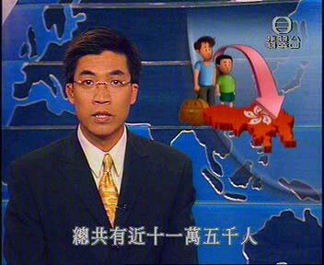
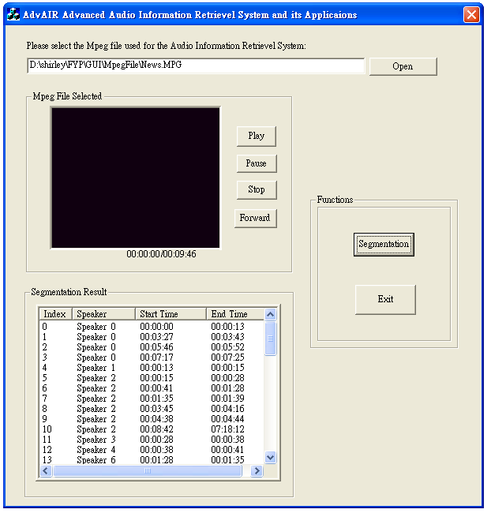 Fig 6.1(a)

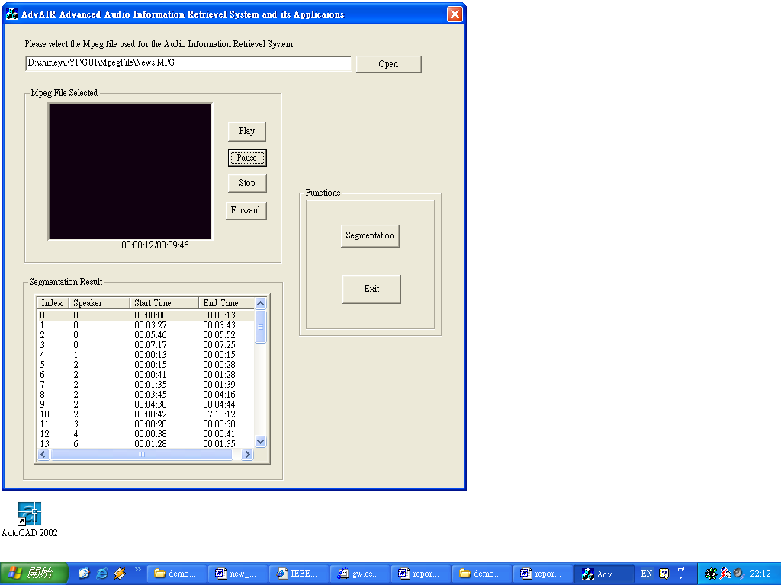
Fig 6.1(b)

The mpeg file selected will be shown in the left upper part of the System Interface. This part is shown in figure 6.1(c). It is a small mpeg player. You can watch the video selected by using play, pause, and stop, forward button provided next to the screen for mpeg file. The duration and current position of the mpeg file playing can be shown just below the screen for the mpeg file.
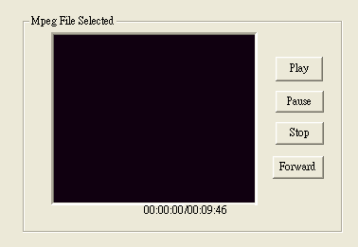
Fig 6.1(c)

When you want to do segmentation, you can press the segmentation button in the right part of the Graphic User Interface. This is shown in figure 6.1(d).
Fig 6.1(d)

After you have pressed the segmentation button, you will need to wait for some time for processing. For a 15 seconds input mpeg video, you need to wait for around 15 seconds for the processing. After finished processing, the result will be shown in the left bottom part of the system interface. The sample result is shown in figure 6.1(e). The column Speaker shows the speaker number. The column starts time and end time show the start time and end time of the segment belong to a speaker.
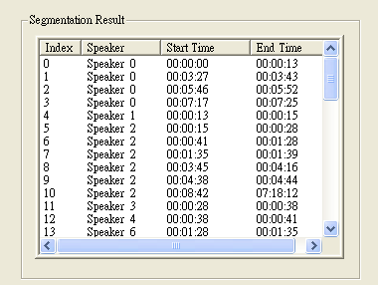
Fig 6.1(e)
6.2 Speaker Recognition Systems
The speaker recognition system is a system, which can recognize speaker using Gaussian Mixture Models. The Training has been done in prior before we can use this system. This system with the segmentation system in which we need to first convert the mpeg file into wave file for processing of the audio channel. Then features are extracted from every frames of the audio stream. Figure 6.2(a) shows the Graphical User Interface of the Speaker Recognition System.
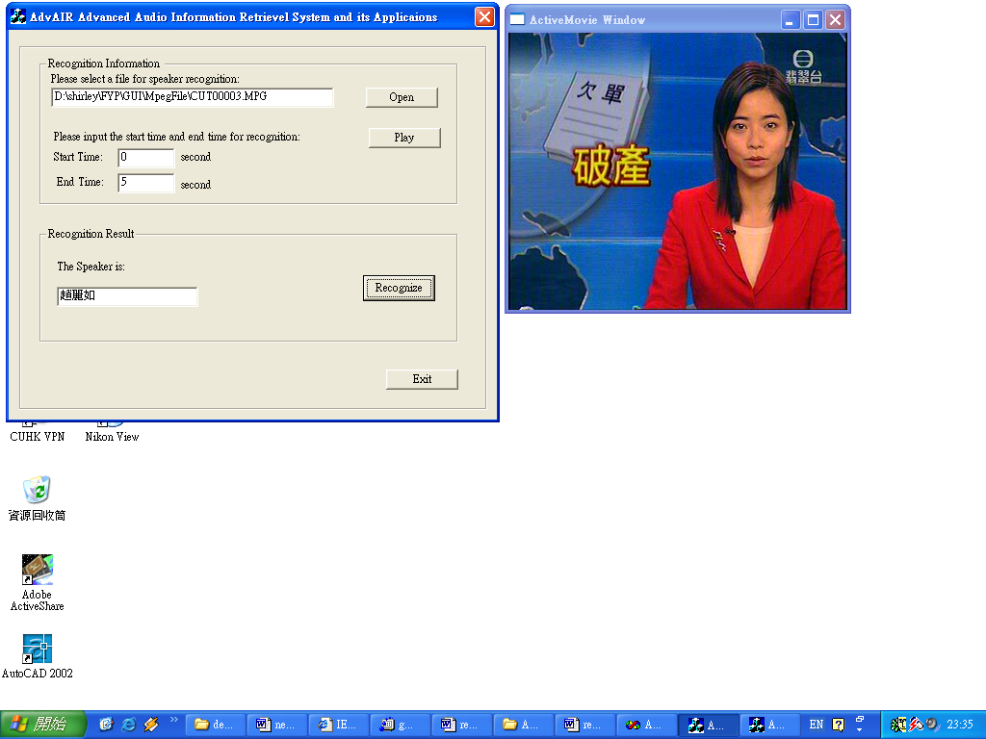
Fig 6.2(a)

Figure 6.2(b) shows the top part of the system interface. First you can select an mpeg file by clicking the open button shown in figure 6.2(b). And then the absolute path of the mpeg file selected will be shown in the text box in figure 6.2(b). The mpeg video will be opened too. The mpeg video will be in a new screen such as figure 6.2(c)
.

Fig 6.2(b)
Fig 6.2(c)
When we want to recognize the speaker, we need to first set the start time and end time of the mpeg file we want to recognize. This is because a selected video mpeg can be as long as 30 minutes and it can involve many speakers. User may only interest in only part of the input mpeg file. You can set the start and end investigation time in the middle part of the system interface. This part is shown in figure 6.3(d). The above is the start time, and the below one is the end time.
Fig 6.3(d)

After setting the start time and end time, you can then click the button Recognize in the lower part of the system interface which shown in figure 6.3(e). After that, the recognition process will start. The result will then show in the text box in figure 6.3(e).
For examples, when the speaker is “趙麗如”, it will show ”趙麗如” in the result text box as in figure 6.3(e). If the speaker is not inside our training set of speaker, then Unknown will be shown in the result text box as in figure 6.2(f).
Fig 6.3(e)

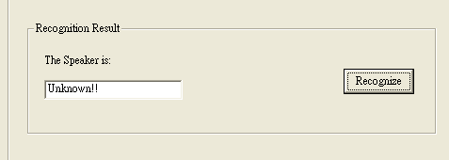
Fig 6.2(f)
Chapter 7 AdvAIR platform based application
7.1 Embedded Application for video segmentation
A video clip is rich of multimodal information source; it contains lots of information such as speech, audio, color patterns, motion and text. For human, semantic content recognition can be done with ease, while for computer; it is still in a quite primitive stage. Base on the AdvAIR system, application can now distinguish the speaker identity, classify and group of the speaker track. Important speech, the sensitive content, can be track down by means of speech recognition and pattern matching, the field of data mining can be done with ease.

Video Clip

Multimedia Player

AdvAIR platform
Speaker Tracking Indexing

Data base storage
Fig 7.1(a)

The input of the system is the mpeg 1 video clip, after the process done by AdvAIR platform; the result with index about the speaker, time, and content will be then given to the multimedia player with the visual presentation

7.2 Audio database and file system
Audio database system, which is a file system, designed to work with a large number of audio files, would be benefit by using the AdvAIR platform. With the new sound add to the database, the sound is processed under AdvAIR system, and an object is formed with the indexing information and statistical information. The ability of grouping and identifying the speaker helps the job of indexing, by using the platform of identification, query can be formed by using a combination of constraints and a set of sound that form a training set.

7.3 Automatic message routing based on called identification
Automatic message routing based on called identification is a system that routing message. An incoming call could be identified as from a desired group or non-desired group. Desired group’s message leaving will be handled by speech recognition engine and capture the key word to form a SMS or E-mail to the user.
Fig 7.3(a)
Caller call
User rejects the phone due to various reasons
Caller leave message

Speaker Identity is checked by AdvAIR based system
Desired speaker group
Non-desired speaker group
System tries to analysis the message content
Send e-mail or SMS to user with key word of the message

The basic idea according to Fig 7.3(a) is, first a caller will be phone to user of the system whom can’t listen the call due to various reason. The caller will then leave a message to user, which may contain the important content. The AdvAIR based application will then classify caller into two groups by the prior training. The content of the desired group caller will be captured and an e-mail or short message will be sent to user with the speaker identity as title to notify the user the important message.

Chapter 8 Conclusion and Future Work
8.1 Conclusion
AdvAIR platform have provide the essential element for the use of speech recognition, speaker identification, gender and language system classification. We have developed and approach for segmentation of speech from different speakers that requires no prior information about the speaker using own designed BIC enhanced algorithm with speed performance ensured. We have also introduced the use of Gaussian mixture speaker models for robust text-independent speaker identification. The primary focus on this work was on a task for real applications, such as voice mail labeling and retrieval. The Gaussian mixture speaker model was specifically evaluated for identification tasks using short duration utterance from unconstrained conversational speech. Moreover, Gender and Language system identification has also been developed to provide a full range of speech services.

8.2 Future work
In the future, we plan to improver our system in the way of accuracy, and speed performance. More features will be added to the platform, the additional function proposed will be speech, non-speech recognition, music pattern matching, open-set speaker identification with a better determination function, content extraction and recognition to make AdvAIR to be an all-rounded platform
Contribution of Work
Our project is divided into 2 main parts
- Training and algorithm analysis
- GUI implementation and Code developing

Overall we do the following
- Prepare of work, that is learning of fundamental knowledge
- Scene change algorithm analysis
- New algorithm development and analysis
- Preliminary code implement
- Code improvement
- GUI implementation of video scene change
- Prepare the knowledge about GMM
- Use of GMM training
- Developed the GMM speaker identification program
- Develop the GMM gender identification program
- GUI presentation for both identification programs
- Report

The work where Alex contributes
  - Scene Change algorithm analysis
  - New algorithm development and analysis
  - Code improvement
  - Training of data
  - Report

The work where Shirley contributes
    - Design of all GUI presentation
    - Preliminary audio scene change code development
    - Study and analysis of GMM model
    - Speaker Identification code development
    - Report
Reference
[1] Eckel, G., Immersive audio-augmented environments: the LISTEN project, Information Visualization, Processing, Fifth International Conference, pp. 571 -573, 2001

[2] Scott Shaobing Chen, and P.S. Gopalakrishnan, Speaker, Environment and Channel Change Detection and Clustering via the Bayesian Information Criterion, DARPA Broadcast News Transcription and Understanding Workshop, pp. 127-132, 1998.

[3] Hao Jiang, Tong Lin, Hong-Jiang Zhang, Video segmentation with the assistance of audio content analysis, Multimedia and Expo, IEEE International Conference Volume: 3, pp. 1507-1510, 2000

[4] Zhu Liu, Jincheng Huang, Yao Wang, Tsuhan Chen, Audio feature extraction and analysis for scene classification, Multimedia Signal Processing, IEEE First Workshop, pp. 343-348, 1997

[5] Wold, E., Blum, T., Keislar, D., Wheaten, J., Content-based classification, search, and retrieval of audio, IEEE Multimedia, Issue 3, Volume 3, pp. 27-36, Fall 1996

[6] Steve Young, Julian Odell, Dave Ollason, Valtcho Valtchev, Phil Woodland, The HKT Book, Entropic Cambridge Research Laboratory, Version 2.1, pp.72, 1994

[7] G. Schwarz, Estimating the dimension of a model, The Annals of Statistics, vol. 6, pp 461-464, 1978.

[8] W.S. Wei, Time Series Analysis, Addison-Wesley, 1993.

[9] D. Foster and E. George, `The risk inflation factor in multiple linear regression, Technical Report, Univ. of Texas, 1993.

[10] K. Shinoda et al., Speaker adaptation with autonomous model complexity control by MDL principle, Proceedings of ICASSP, pp 717-720, 1996.

[11] H. Gish and N. Schmidt, Text-independent speaker identification, IEEE Signal Processing Magazine, pp 18-21, Oct. 1994.

[12] D. A. Renold, and R. C. Rose, Robust text-independent speaker identification using gaussian mixture speaker model, IEEE Trans. Speech and Audio Processing, Vol. 3, pp. 72-83, 1995.

[13] J. Picone, Signal modeling techniques in speech recognition, Proceedings of the
IEEE, Vol. 79, No. 4, April 1991.

[14] S.S.Chen and P.S. Gopalakrishnan , Speaker, Environment and Channel Change Detection and Clustering via the Bayesian Information Criterion, DARPA Broadcast
News Transcription and Understanding Workshop, 127-132, 1998.

[15] D. A. Reynolds and R. C. Rose, Robust Text-Independent Speaker Identification Using Gaussian Mixture Speaker Models, IEEE Trans. on Speech and Audio Processing, vol.3, No.1, pp.72-83,January 1995.

[16] B. Atal, Automatic recognition of speakers from their voices, Proc. IEEE, vol. 64, pp. 460-475, April 1976.

