**The Youth of Hong Kong: Methodical Magic**

**By**

**Rohan SHETTY**

Here’s a thought that came up in my Chinese Culture & Heritage Class last week: Human genes are 98.4 percent identical to those of pygmy chimps. Think about that for a second. Close your eyes and picture yourself. Now imagine that there’s a chimp right next to you. That chimp—that furry, lanky, amusing little creature—is almost a perfect biological replica of you, and yet there is so much that separates your existence. Small margins make a big difference.

***

I really like the Learning Garden. The chairs, especially the blue ones, remind me of home—of Texas’ open blue skies—and the fluid, flat layout brings back memories of Dallas’ rolling pastures, the beige cattle replaced with bright computer screens and slick black hair. The University Library is the perfect place to people watch—to observe the subtleties that make Hong Kongers a different, and special, breed. Slender students, both arms oppressively filled with textbooks, rush here and there, as if being chased. Professors, looking for a quiet respite from noisy classrooms, lean back in chairs and twiddle their bushy beards, adjusting the rims of their staid glasses every few seconds. Visitors, fascinated by impeccable exhibits on Chinese lore, cautiously whisper to each other, afraid of disturbing the peace around them. Libraries are, to be sure, places of reflection and unashamed enterprise, but they are also havens of unperturbed sincerity, pockets where we can’t help but be ourselves. For in solitude, there is little to hide.

I’ve always thought that the best way to learn about a culture is to adopt a bottom-up approach. This means that looking at individuals and discovering the narratives that bind them together is much more revealing than tracing the ways in which a system—political, economic, or otherwise—trickles down to social structures. After all, individuals create culture, not the other way around. And it’s from the everyday, mundane activities that culture sprouts: passing hellos in the hallway, small talk by the water fountain, half-smiles to someone across the classroom. These are the tiny gestures that craft an atmosphere—one may even say home—in which we seek some sort of belonging. These are how relationships begin—a coy nudge to your neighbor, a brave question in tutorial—and they are ultimately what underpin local cultures.

In the elevator of Kuo Mou Hall, and scattered elsewhere in my hostel, is a black-and-white poster that best encapsulates how I began to think about the youth of Hong Kong: “People should not be afraid of their governments. Governments should be afraid of their people.” These two sentences are, for me, what set the Hong Kongers of my generation apart. Let me explain.

“Governments should be afraid of their people.” Hong Kong natives are a peaceful bunch. They don’t intimidate. They don’t incite fear. In fact, one of the first things I noticed was just how calm they always seemed. In control, composed, collected. You can imagine my slight amusement, then, when I read those words in the elevator. Amused not because I thought Hong Kongers couldn’t stand up for themselves, but amused that they would even have to. Things on campus seem to happen seamlessly. The buses run an eerily tight schedule, canteens deliver food with machine-like precision, and students offer terse, well-structured responses in class. Even in the city, I got a similar feeling. People wait in neatly filed lines for the next train, tramcars navigate the traffic almost without effort, and men and women dressed in dark, creased clothes wait patiently at crosswalks. It’s almost as if there’s someone, sitting atop Hong Kong’s tallest skyscraper, quietly directing each and every facet of the city. Making sure that the paint on the roads is fresh, the schoolchildren have double-knotted their shoes, the suave bars have shined their counters and buffed their wine glasses.

It may seem like pro-democracy protests would rupture this image of undisturbed order. It didn't. I must admit that, as an American, I found it difficult to interpret the sudden onset of political activity. Democracy is, for me, second nature. This reality doesn’t mean I take participatory regimes for granted, but that I’m seldom exposed to moments that show a people fighting, a people willing to suffer over ideology. The U.S. has, to be sure, its fair amount of political turmoil and polarization. But paradigm shifts have always been an artifact of the past. I’m merely the beneficiary.

Hong Kongers have redefined what it means to have “heart”. Though in principle I don’t agree with the idea that governments should be afraid of their people. In an ideal system, both exist in balance. The way in which young Hong Kongers have fought for their rights truly defines a generation.

This point is one that can easily be oversimplified. My generation never shies away from a fight. Hong Kongers aren’t special in that sense. But they do possess something that their American counterparts lack: patience. They are perhaps a touch too idealistic, but they are also remarkably understanding. In a world—in a generation—of fast movement and rash decisions, Hong Kong youth have learned to slow down. To be ambitious in desire, yet realistic in practice, to commemorate the past both for the victories it produced and also for the lessons it teaches, to recognize that the pursuit of principle is just as important as the principle itself.

One of the most challenging tasks of my experience abroad has been learning to piece together the historical backdrop to the city and surrounding political structures. I’ve asked dozens of Hong Kong students what differentiates them from their Mainland contemporaries. Most answer facetiously—that Hong Kongers are more laid back or that local cuisines are more developed—but a few have hinted at deeper demarcations. A first-year student at CUHK provided me with the following words: “I don’t know much about Mainland students, but Hong Kong students have a duty to their people. A duty to help out.” He elaborated a little more, explaining that his sense of duty was partly grounded in his Christian faith, but I have a feeling that Hong Kongers all share similar ideas about collective action. Indeed, for a city of only seven million people, Hong Kong has always commanded a disproportionate amount of influence on the global stage. Its youth, then, bears a huge burden. Yet students don’t seem daunted. I mentioned before that the whole of my generation, the world over, has passion. But Hong Kong youth have sublimed their cause through slow, methodical efforts. They have shown an uncanny ability to *design* their passion in consequential ways. They discuss issues as a group of sangfroid academics would discuss wealth inequality: with respect for each other’s opinions and an acute awareness of the status quo and its significance. Yes, they ask for much, but their demands aren’t static. They adapt, constantly reacting to new perspectives.

I suspect that part of the reason why it’s so difficult for locals to unravel Hong Kong’s allure is that the differences they perceive are subtle. I don’t know that the youth of Hong Kong have a different strain of humor than their mainland counterparts; in truth, I don't know that they think differently either. I do, however, know that they bear the weight of their city with a grace that belies their years. I can only hope that the rest of my generation learns to be as patient and resilient.

***

Here’s a thought I had the other day: Hong Kong resident genes are 100 percent identical to those of Texans. Yet there is so much that separates us. Not distance, but ambitions, hopes, desires. My generation may be passionate, but we are passionate about different things, and we channel our energies towards different causes.

We share a drive, but we choose to drive to vastly diverging destinations. I can’t wait to see where Hong Kongers arrive.

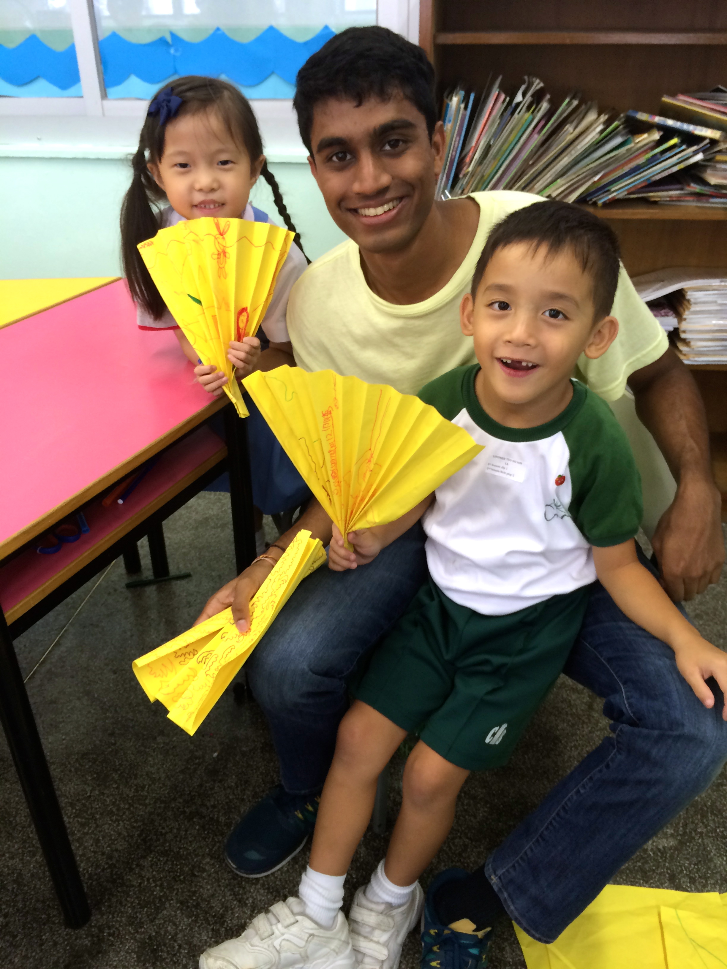

The author with children at The Catholic Mission School in Sheung Wan, where he volunteers weekly.

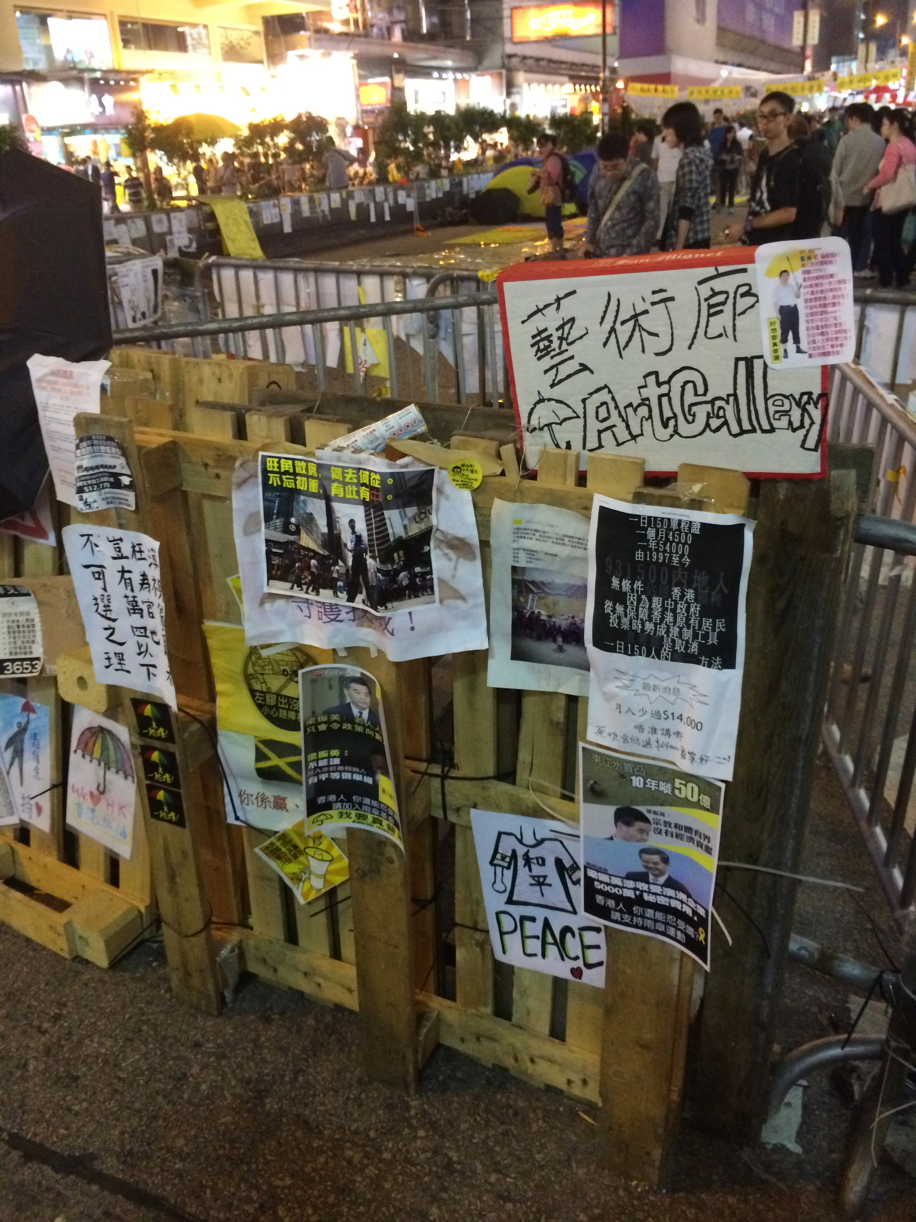

Author’s photo from protest displays in Mong Kok

**About the author**

Rohan Shetty is an international exchange student from Georgetown University in Washington, D.C. in the United States. Originally from Dallas, Texas, he is studying finance and accounting, with a minor in English literature. He has spent the fall semester of 2014-15 studying at the Chinese University of Hong Kong.